Nexus by Innovo — Project Brief
Overview
Nexus by Innovo (the Nexus Platform) is an AI-enhanced digital platform and internal tool developed by Innovo Group to optimize, manage, and transform construction activities and operational workflows across the group's project portfolio. Nexus consolidates data from sensors, cameras, and connected systems on active construction sites into a single, intelligent platform, giving Innovo Group leadership and site teams real-time visibility into equipment, workforce, materials, and site conditions — all from one modern, intuitive interface.
Nexus is a product of Innovo Labs, the Digital and Innovation team's initiative exploring how technology can improve construction delivery. Over nearly 12 months, the Digital and Innovation team has worked closely with Build UAE to establish a portfolio of digital initiatives across live projects — trials, pilots, and proofs of concept that have tested individual sensing and monitoring technologies on-site. Nexus is the platform that brings these initiatives together, providing the framework to link, scale, and operationalize them across the full Innovo Group portfolio.
Background & Problem Statement
Innovo Group runs a portfolio of active construction projects across the UAE, each generating operational data on equipment, workforce, materials, and site conditions. Today this information sits in disconnected systems and site-level records, which slows down decision-making, makes it difficult to compare utilization and performance across projects, and delays the response to incidents or emerging risks.
The Digital and Innovation team identified this gap and, over the past 12 months, has worked with Build UAE to trial a portfolio of digital initiatives on live projects — testing sensors, cameras, and connected systems individually across sites. Nexus is the next step: a single platform to link these proven initiatives together and scale them group-wide, so that data captured on site translates into real-time, portfolio-level visibility and insight.

Objectives
Nexus aims to:
- Provide real-time visibility across the entire portfolio of Innovo Group projects, from a single point of access
- Enable better utilization of equipment and resources across the group by surfacing usage and availability data across sites
- Give quicker access to up-to-date, on-site information so teams can respond to incidents and events sooner and reduce their impact
- Improve decision-making by consolidating operational data into clear, actionable insights for both site and leadership teams
- Make Innovo Group projects safer, higher quality, lower cost, and more productive
Core Capabilities
Nexus draws on sensors, cameras, and connected systems already piloted across Innovo projects, organized into the following capability areas:
Capability | What it covers
Energy monitoring | Real-time energy consumption tracking across sites via iEnergy
Tower crane utilization | Usage rates, idle time, and load data for tower cranes
Workforce management & access control | Site access controls and workforce presence/movement tracking
Concrete delivery tracking | Sensor-tracked concrete deliveries for timing and volume visibility
AI & CCTV real-time visibility | AI-enhanced CCTV camera feeds for real-time site visibility and incident detection
Asset tracking | Location and utilization tracking of buses, forklifts, boom lifts, and trucks
Material management | Tracking of scaffold and formwork materials across sites

Platform Experience
Nexus presents a modern, intuitive user interface centered on an interactive map of the UAE, with all Innovo Group projects plotted across the country. From this portfolio-wide view, users can zoom into any individual project to drill down into equipment, asset, and workforce detail for that site — moving seamlessly between a group-wide overview and site-level specifics within the same interface.

Expected Benefits & Outcomes
- Safety — faster visibility of incidents and unsafe conditions through real-time CCTV and sensor data, enabling quicker response
- Quality — better-informed decisions from consolidated, up-to-date operational data
- Cost — improved utilization of equipment and resources across projects reduces idle time and waste
- Productivity — quicker access to information across the portfolio speeds up response and coordination
- Decision-making — portfolio-wide insight supports better allocation of equipment and resources across Innovo Group projects

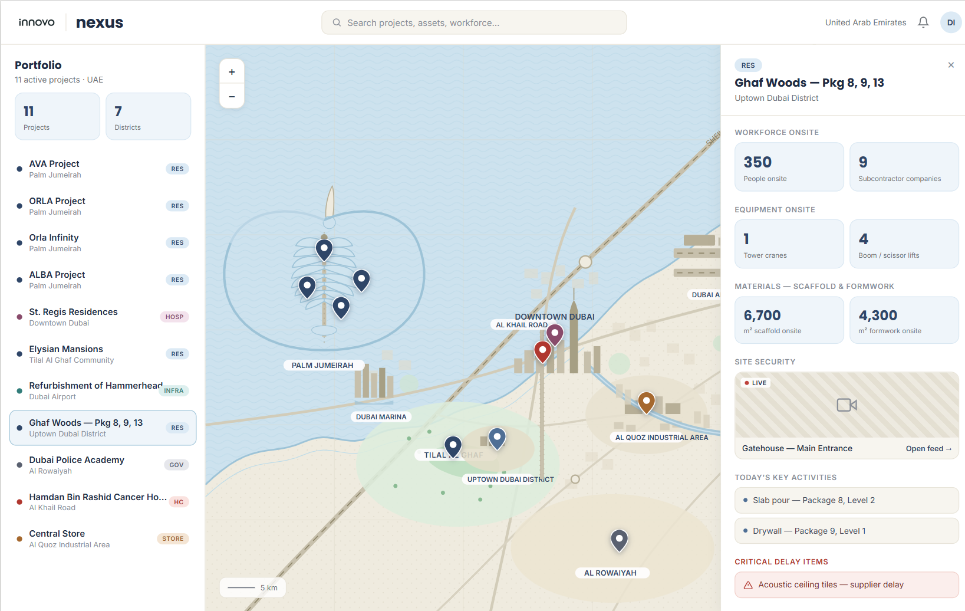
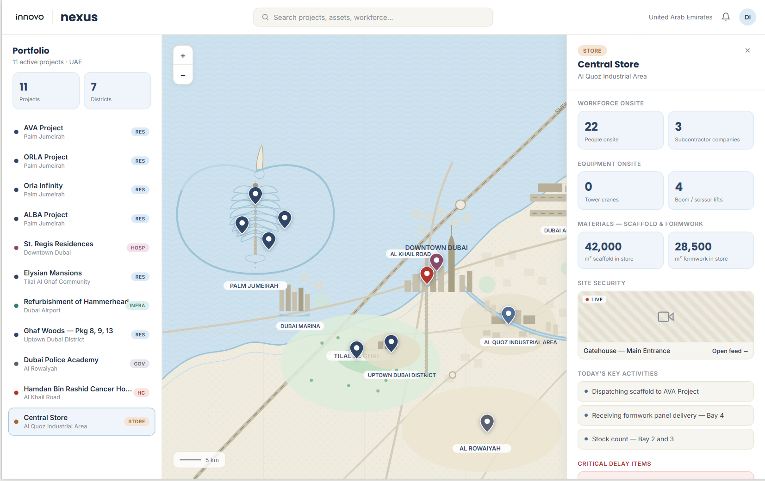
Showing Central Store and materials and recent activities across transfers and stock.

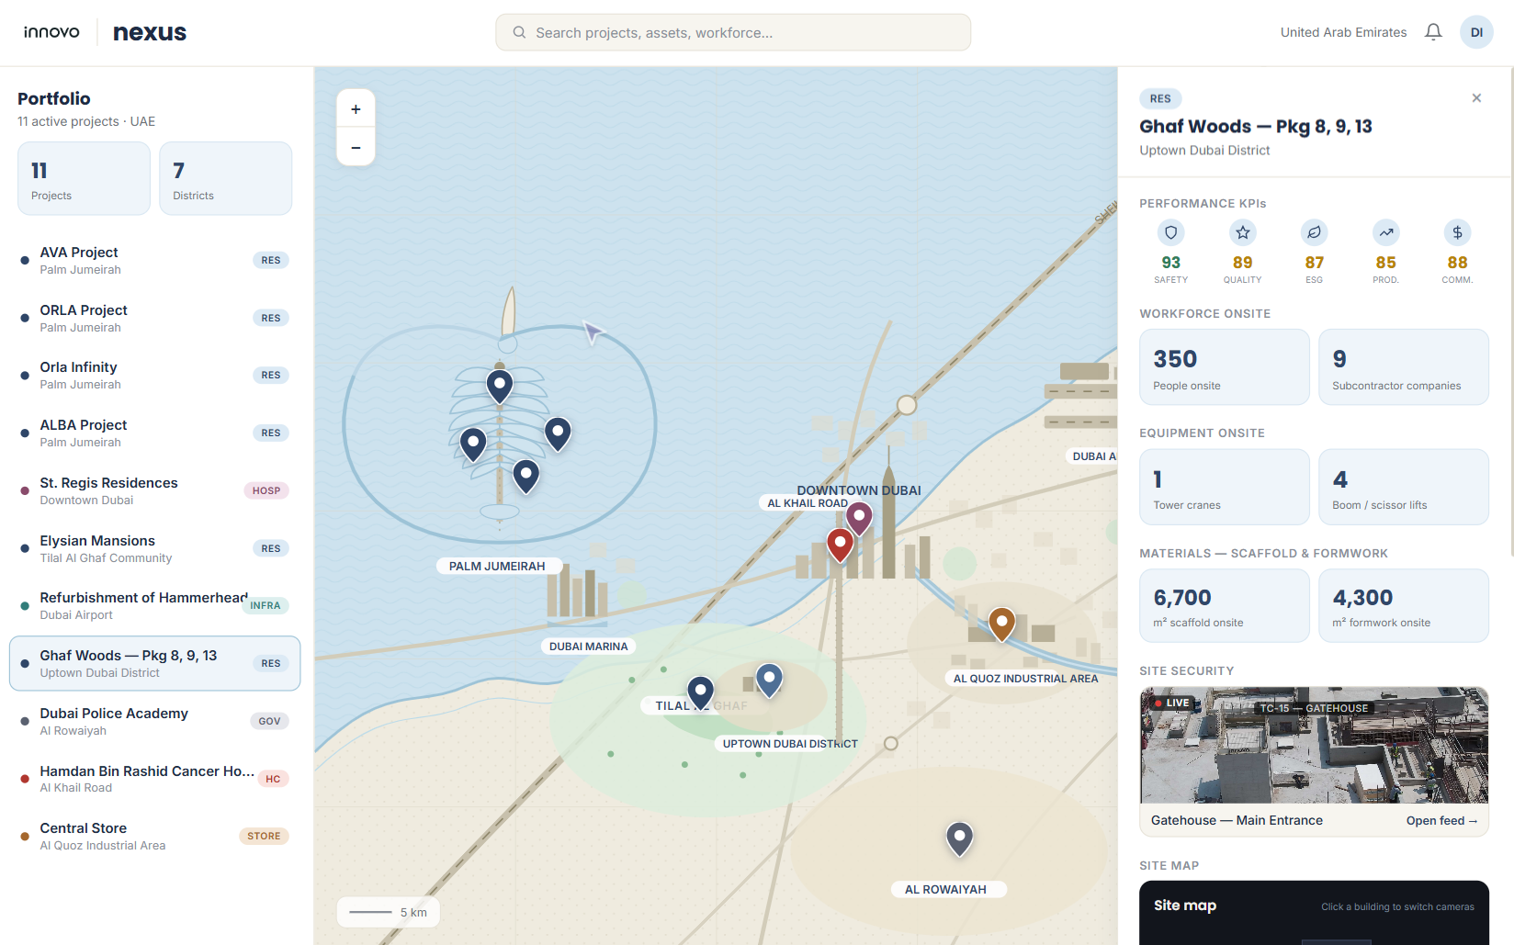
Performance KPI’s for each Innovo project against Safety, Quality, ESG, Productivity ..

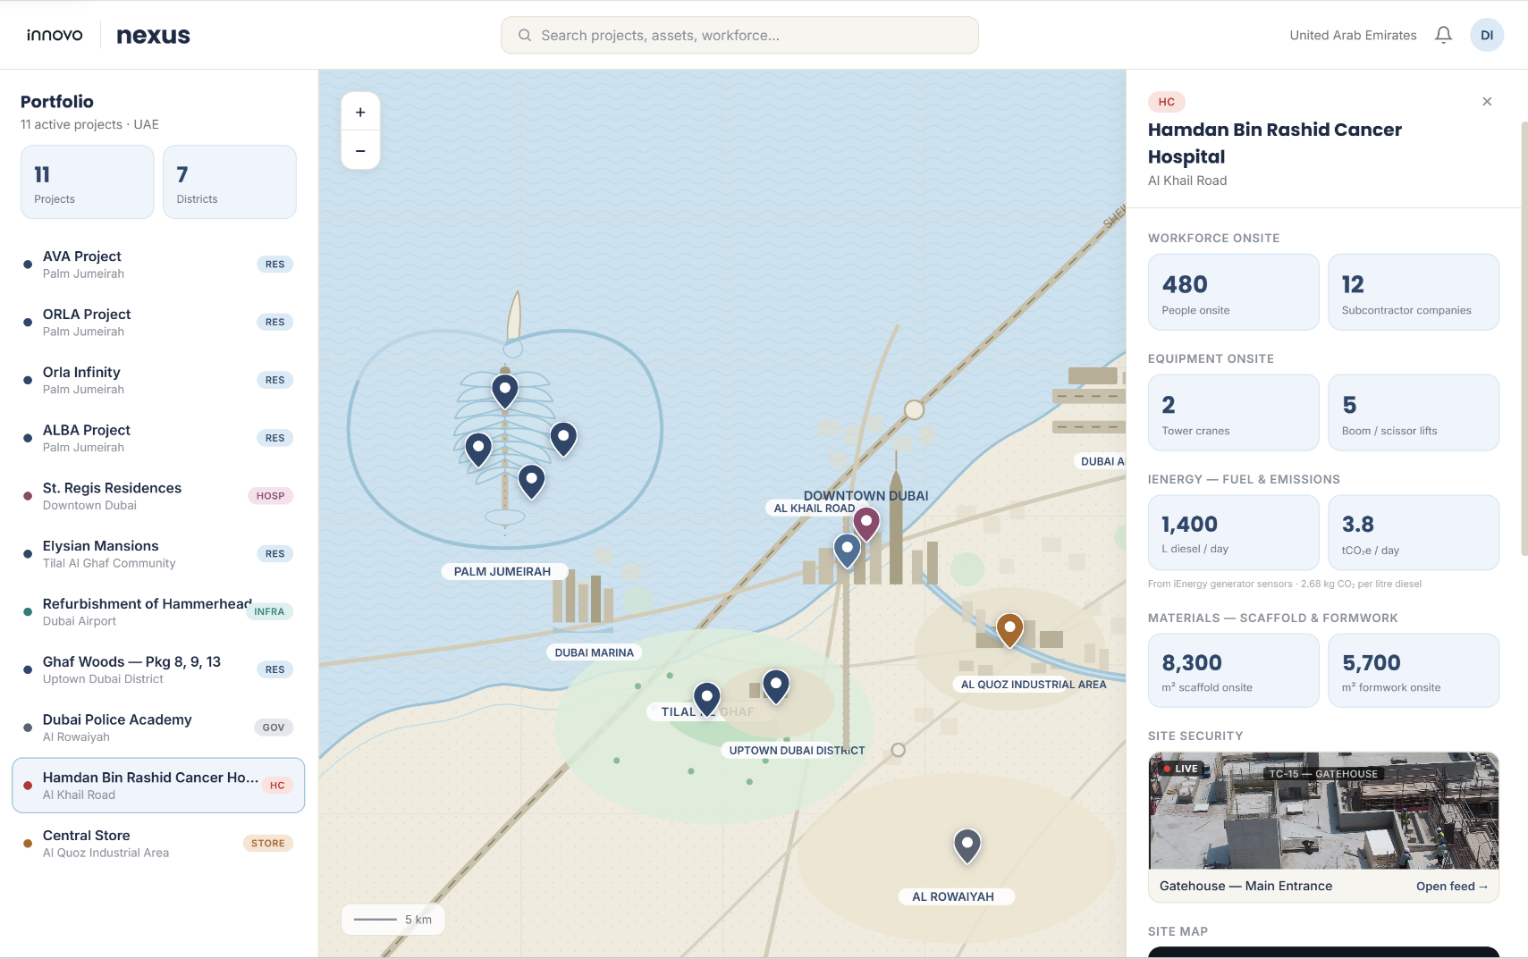
IEnergy fuel and emissions from IoT sensors on project generators. (Datoms)

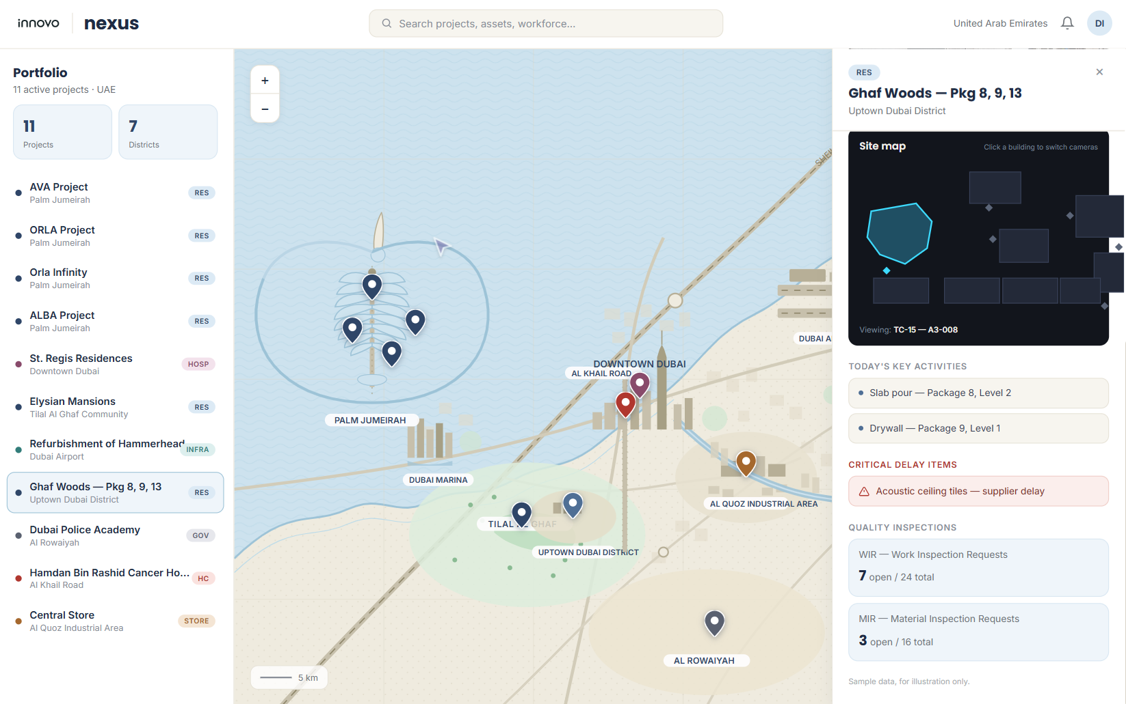
Highlight critical delay items and ability to track and trace delivery timeframes

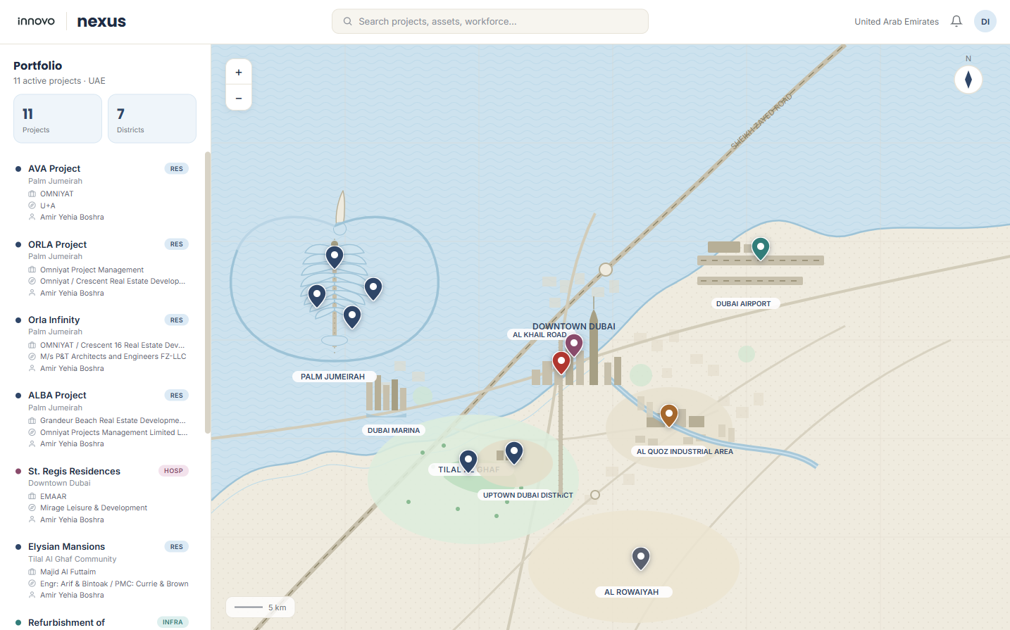
Show key contact information for each project including Contact, Client and Consultant.

