AI Customer Feedback Intelligence System
Prepared by: Ahmed Abdullatif

1. Introduction & Objective
Online retailers collect thousands of customer reviews that are impractical to read manually. This project builds an AI system that automatically reads Women's E-Commerce Clothing reviews, classifies each one as Positive, Neutral or Negative, and groups negative reviews by the underlying complaint so the business can see where quality or fit problems are concentrated.
The project combines Supervised Learning (Logistic Regression and Random Forest, trained on TF-IDF features) to classify sentiment, and Unsupervised Learning (K-Means clustering) to discover recurring complaint themes inside the negative reviews — directly matching the two learning paradigms required by the course brief.

2. Dataset Description & Exploratory Data Analysis
Dataset: Women's E-Commerce Clothing Reviews (the primary dataset recommended in the assignment). The raw file contains 23,486 reviews across 11 columns, including Review Text, Rating (1–5), Recommended IND, Division/Department/Class Name and Positive Feedback Count.

2.1 Column Selection & Cleaning
- Only the columns relevant to the task were kept: Review Text, Rating, Class Name and Recommended IND (later renamed to Product Category and Recommendation Indicator for clarity).
- Rows with missing values were dropped with df.dropna(), reducing the dataset to 22,628 rows.
- Duplicate rows were removed with df.drop_duplicates(), leaving a final cleaned dataset of 22,622 reviews.

2.2 Descriptive Statistics
Average rating across the cleaned dataset: 4.18 / 5. Reviews skew strongly positive, which is the key characteristic that shapes model performance later in the report:
Sentiment class | Rule | Review count | Share
Positive | Rating 4–5 | 17,430 | 77.0%
Neutral | Rating = 3 | 2,823 | 12.5%
Negative | Rating 1–2 | 2,369 | 10.5%

3. Text Preprocessing
Each review's free text was passed through a cleaning function before vectorization:
- Lower-casing the full review text.
- Tokenization with NLTK's word_tokenize.
- Keeping alphabetic tokens only (isalpha()), which drops numbers and punctuation.
- Removing English stopwords using NLTK's stopword list.
- Rejoining the remaining tokens into a cleaned string, stored in a new Clean Review column.
The cleaned text was converted into numeric features with TfidfVectorizer(max_features=5000), fitted on the training reviews only after the train/test split (18,097 × 5,000 training matrix, 4,525 × 5,000 test matrix). A rating-based rule (≤2 → Negative, =3 → Neutral, ≥4 → Positive) was used to derive the sentiment label used for training.

4. Supervised Learning: Model Construction & Evaluation
The cleaned reviews were split into training and test sets before vectorizing (80/20, stratify=y, random_state=42), giving 18,097 training reviews and 4,525 test reviews with the class balance preserved in both sets; the TF-IDF vocabulary and IDF weights were learned from the training set only, so no test-set information leaks into training. Two classifiers were trained and compared, each also re-trained with class_weight='balanced':

4.1 Logistic Regression (max_iter=1000)
Class | Precision | Recall | F1-score | Support
Negative | 0.61 | 0.41 | 0.49 | 474
Neutral | 0.44 | 0.23 | 0.30 | 565
Positive | 0.87 | 0.97 | 0.92 | 3,486
Overall accuracy: 82.0% | Macro-average F1: 0.57 | Weighted-average F1: 0.79

4.2 Random Forest (n_estimators=100, random_state=42)
Class | Precision | Recall | F1-score | Support
Negative | 0.64 | 0.14 | 0.23 | 474
Neutral | 0.44 | 0.02 | 0.05 | 565
Positive | 0.79 | 1.00 | 0.88 | 3,486
Overall accuracy: 78.5% | Macro-average F1: 0.39 | Weighted-average F1: 0.73

4.3 Comparison
Logistic Regression outperforms Random Forest overall (82.0% vs 78.5% accuracy) and on the two minority classes that matter most for the business: it recovers 41% of Negative reviews and 23% of Neutral reviews, versus only 14% and 2% for Random Forest, which is heavily biased toward the majority Positive class (1.00 recall). Re-training with class_weight='balanced' changes the trade-off: Logistic Regression reaches Negative recall 0.58, Neutral recall 0.49 and Macro F1 0.60, while accuracy falls to 77.1%; the balanced Random Forest reaches 81.0% accuracy, Macro F1 0.56 and Negative recall 0.45. Because missing a real complaint is costlier than a false alarm, the balanced Logistic Regression best fits the business goal, while plain Logistic Regression is preferable if overall accuracy is the priority. This choice was made on a single test split, so cross-validation is advisable before deployment.
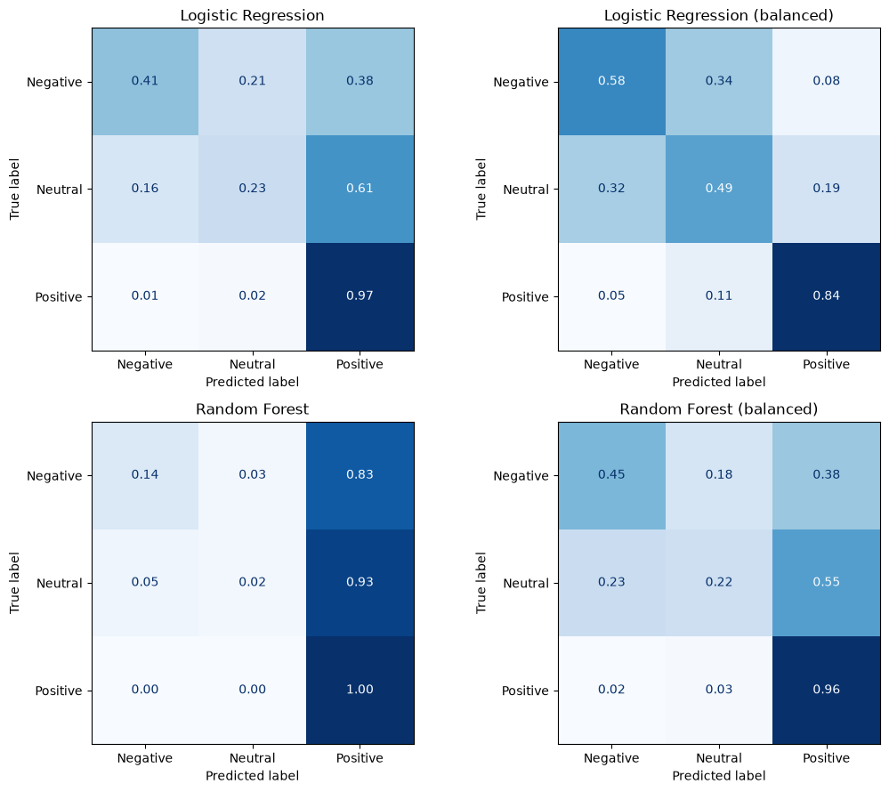
Figure: Row-normalised confusion matrices on the test set (4,525 reviews) for the four model variants.

5. Unsupervised Learning: Complaint Clustering (K-Means)
To understand why customers were dissatisfied, the 2,369 Negative reviews were isolated and re-encoded with the same fitted TF-IDF vectorizer, then clustered with K-Means (n_clusters=5, random_state=42, n_init=10). For each cluster, the ten TF-IDF terms with the highest summed weight were extracted as that cluster's defining vocabulary, giving five interpretable complaint themes (sizing issues, fabric and material quality, boxy or short fit, appearance not matching expectations, and dress-related disappointment). These theme names are interpretations of each cluster's top terms, not manually verified categories that a customer-service team could act on directly. A count plot of reviews per cluster (Complaint Cluster Analysis) shows how the 2,369 negative reviews are distributed across the five themes.

6. Data Visualization
- Sentiment Distribution — count plot of Positive / Neutral / Negative reviews.
- Review Rating Distribution — count plot across the 1–5 star scale.
- Most Common Words — bar chart of the 15 most frequent tokens in the cleaned review text.
- Complaint Cluster Analysis — count plot of negative reviews per K-Means cluster.
Together these charts confirm the dataset's positive skew, surface the vocabulary customers use most often, and show which complaint clusters are largest — turning the model's output into a business-readable picture.

7. Conclusion & Future Work
The system meets the core brief: it cleans and prepares 22,622 real customer reviews, engineers TF-IDF features without test-set leakage, trains and compares two supervised classifiers (with and without class weights), and applies K-Means to unsupervised discovery of complaint themes, with supporting visualizations. Logistic Regression reaches 82.0% accuracy and is the stronger of the two models; class weighting lifts its Negative recall from 0.41 to 0.58 at the cost of accuracy (77.1%). Neutral reviews remain the hardest class, most often predicted as Positive, a consequence of the 77/12/11 class imbalance in the source data.
Recommended next steps:
- Validate the class-weighted models with cross-validation and try resampling (e.g. SMOTE) to lift Neutral/Negative recall further.
- Improve Neutral-class detection, which is most often confused with Positive, for example with a transformer-based model.
- Persist the trained vectorizer and the winning model (e.g. via joblib, as .pkl) so the system can score new reviews without retraining — this is listed as an expected submission deliverable.
- Tune Random Forest (max_depth, class_weight, min_samples_leaf) or try gradient boosting to see whether it can close the gap with Logistic Regression.
- Extend clustering insights with a short label for each of the 5 clusters and break results down by Product Category for a more actionable business dashboard.

