Debug the Code:▶ QEMU implements a gdb connector using a TCP connection. To do so, run the emulator with the correct options -s -S waiting for debugger

* Using gdb to debug program on the circuit

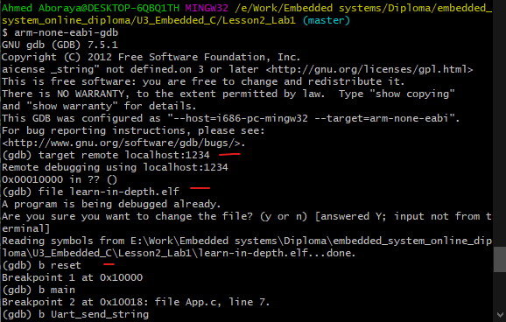

* Gdb commands:
* **“target remote <IPaddress:Portnumber>”:** Connect with gdb server
* **“file <filename>”**: select file to gebug and read symbol table form it.
* **“b <section/symbol/address>”:** add breakpoint at this location.
* **“c”:** continue to the next breakpoint - **“si”:** step instruction .
* **“display/<num>i <location>” :** display number of instruction form a location.
* 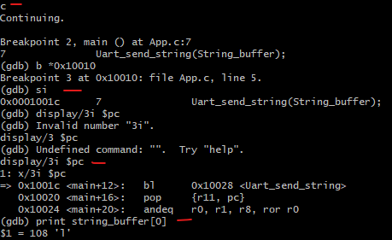**“(gdb) print <var>”:** print value of variable.

Makefile: **(simple way to organize code compilation)**

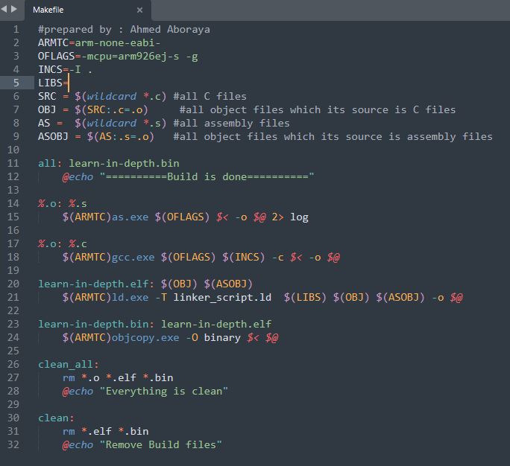

Use make file to build executable file :

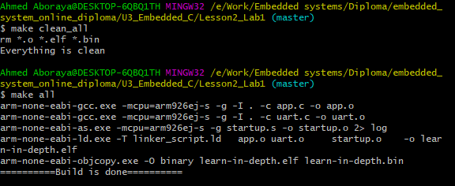

**Lets** **Write embedded C code >>**

* **Baremetal toggle led:**
* 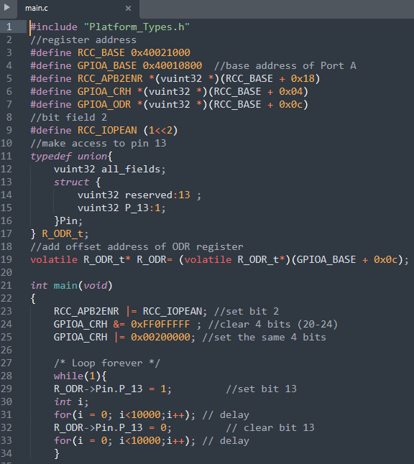main.c : (Platform_Types is header file contain definition of types)
* 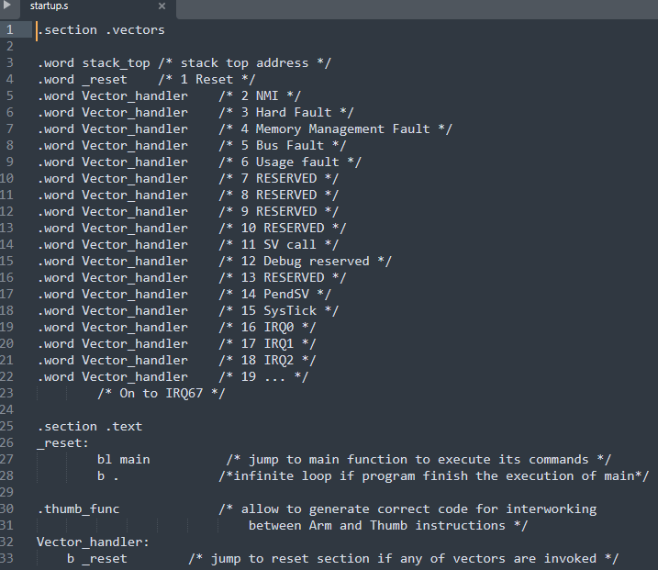Startup.s:
* Makefile :

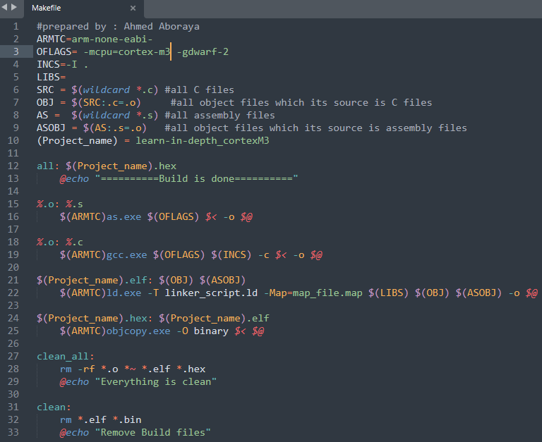

Build files using command make : 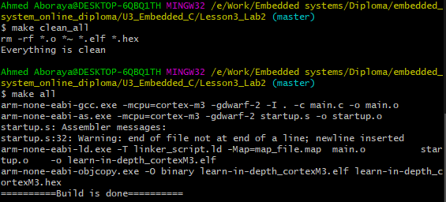

* Run and debug simulation on proteus:

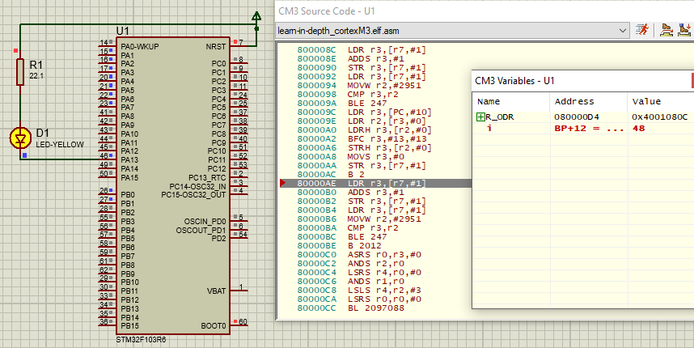

* **write C startup :**

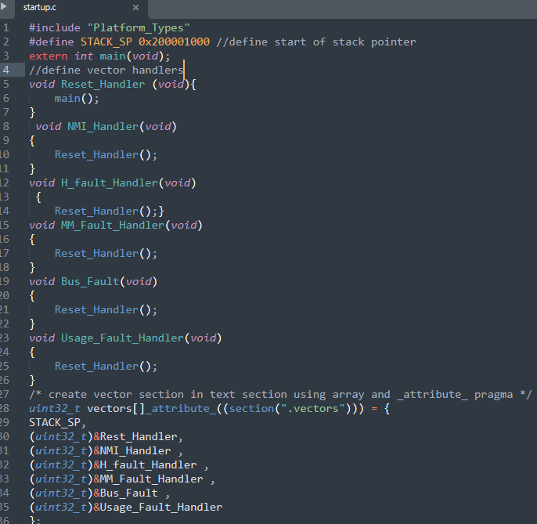

* **Edit startup.c : (more efficient)**
* 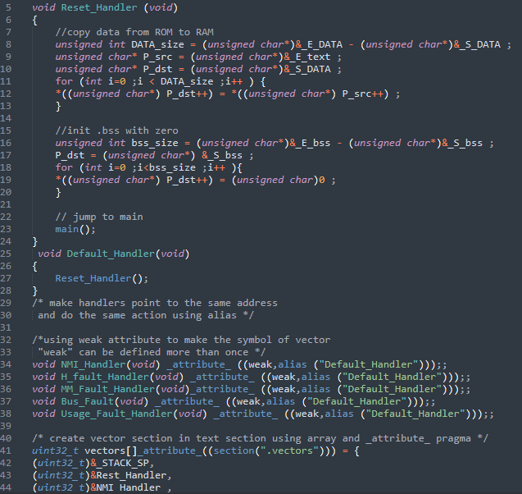copy data from ROM to RAM and initialize bss in RAM
* 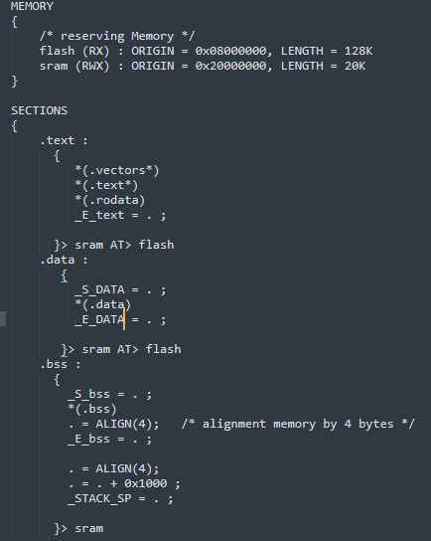**Linker script :**