Lab3 on TM4C123ARM CortexM4

* Writing code of toggle led :

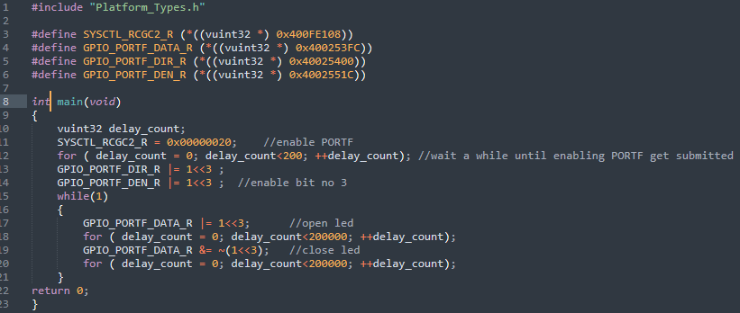

* Startup code in C :

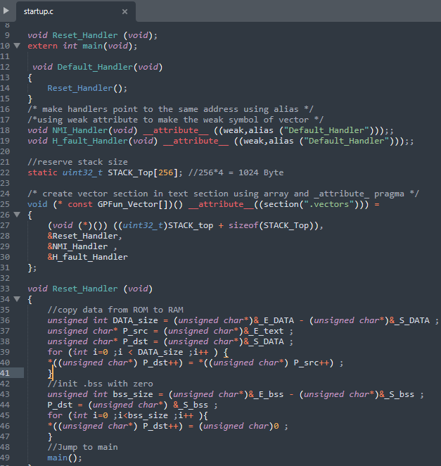

* **Makefile:**

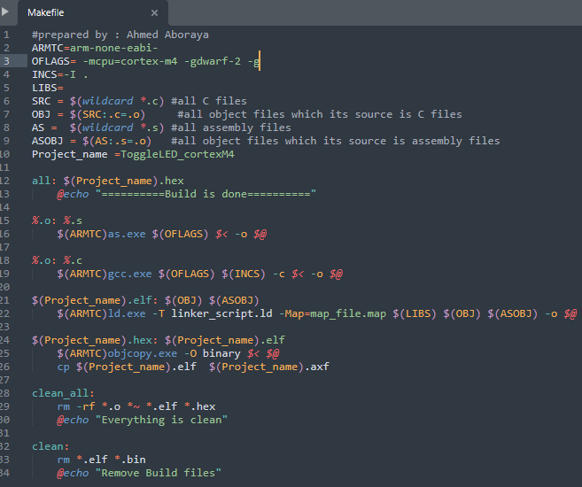

**Make :**

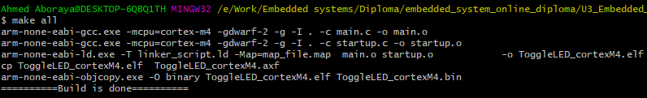

* **Run simulator on Keil uvision :**
* 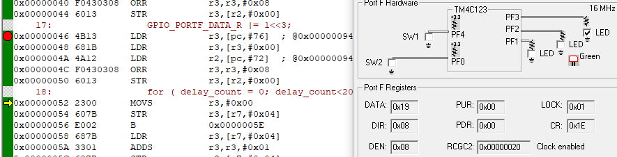**LED is ON ( after command of enable it ):**
* **LED is OFF ( after command of disable it ):**

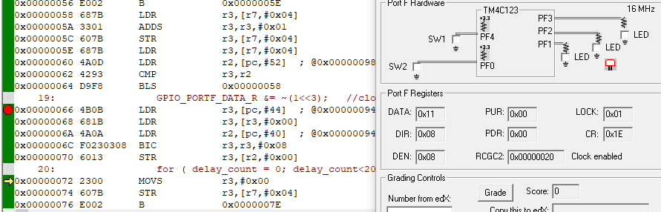

* **Logic Analyzer:**

