Lab2

● Create a new project on your local machine then push it to your
remote repo.

mkdir lab2_repo
cd lab2_repo/
git init
touch f1
git add f1
git commit -m "adding f1"
//make remote repo on github
git branch -M main
git remote add origin git@github.com:AhmedAdel-Elfeky/lab2_remote_repo.git
git push -u origin main

● create two branches (dev and test) then create two files in dev
branch and push this changes to remote repo.

git branch dev
git branch test
git checkout dev
touch fdev1
touch fdev2
git add .
git commit -m "add new dev branch"
git push origin dev
git checkout test
git push origin test

● merge this changes on main branch and then push it to your
remote main branch.

git checkout main
git merge dev
git push origin main

● Tell me how to remove them locally and remotly.
Locally:
git checkout main
git branch -d dev
git branch -D test
remotly:
git push origin :dev
git push origin :test
● Send me invitation on my mail.
Ok
● create an annoted tag with tagname v1.4.

git tag -a v1.4 -m "version 1.4"

● push it to remote server.

git push origin --follow-tags

● tell me how to list tags locally.
git tag
● tell me how to delete tag locally and remotely.
Locally:
git tag -d v1.4
remotely:
git push origin --delete v1.4

● What is git rebase? Give me an example.

rebase is moving a commit to new parent
rebase is a merge can make (merge conflict)

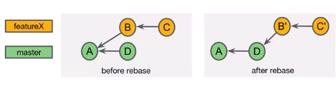

● pull request.
Pull request l:
when you make a local branch then push it to the remote repository. It will be in the pull request and the admin will confirm it and make merge or not.
Pull request ll:
when you fork a remote repository you have two remote repositories one the main and the second is forked when you change in the forked and make new branch the you push this new branch to the admin and he accepts it or not. If accept it will be merged.

● README.md file. Add image at the end of README.md file

