OBSTACLE AVOIDANCE CAR PROJECT

Contents

Project Description 1

Hardware Requirements 1

Software Requirements 1

Project Static Design 2

• Layered Architecture 2

• Layer Modules 2

• Module APIs 2

Flow Charts 3

• System Overview 3

• System in Detailed 4

Project Demo Videos 4

# Project Description

A prototype that mimics the obstacle avoidance vehicles, covers 3 features:

* Avoiding the crashing into obstacles that are on a 50 cm far.
* Printing continually the actual distance on an LCD.
* Avoiding any sudden obstacle appearing.

# Hardware Requirements

* One Atmega32a ECU.
* One 16x2 LCD.
* Four DC Motors.
* One L298 Motor Driver.
* One On/Off Switch.
* One Ultrasonic Sensor.

# Software Requirements

* Ultrasonic sensor added to the Car to detect the obstacles.
* If there were no obstacles detected the Car moves forward.
* If there is an object detected on 50 cm far from the Car then the Car will stop then turn right and continue moving under the same distance and speed criteria
* If there is an object which is detected on less than 50 cm distant from the Car then the Car will stop then moves backward until the distance is 50 cm then stop and turn right and continue moving under the same distance and speed criteria.

# Project Static Design

## Layered Architecture

Figure 1 System Layered Architecture

## Layer Modules

#### **MCAL Layer Modules:**

1. DIO Module.
2. PWM Module.
3. ICU Module.
4. TIMER Module.

#### **HAL Layer Modules:**

1. LCD Module.
2. MOTOR Module.
3. USONIC Module.

#### **APP Layer Modules:**

1. STEERING Module.
2. ROBOT_Control Module.

## Module APIs

Click to follow link [APIs Documentation](APIs_Documentation.xlsx)

# Flow Charts

## System Overview

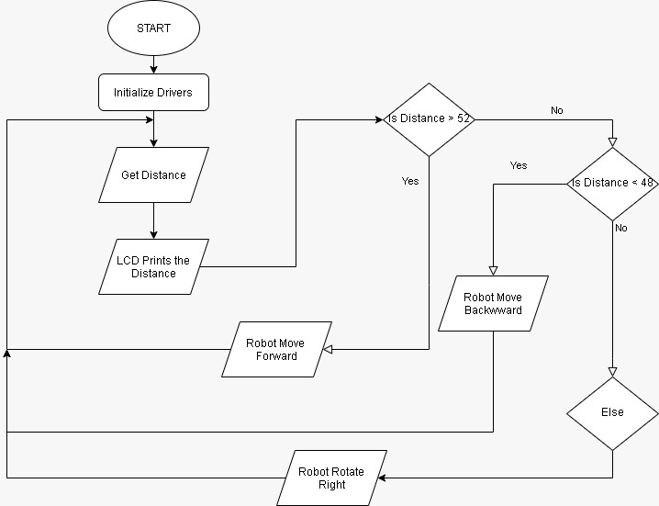

Figure 2 System Overview Flow Chart

## System in Detailed

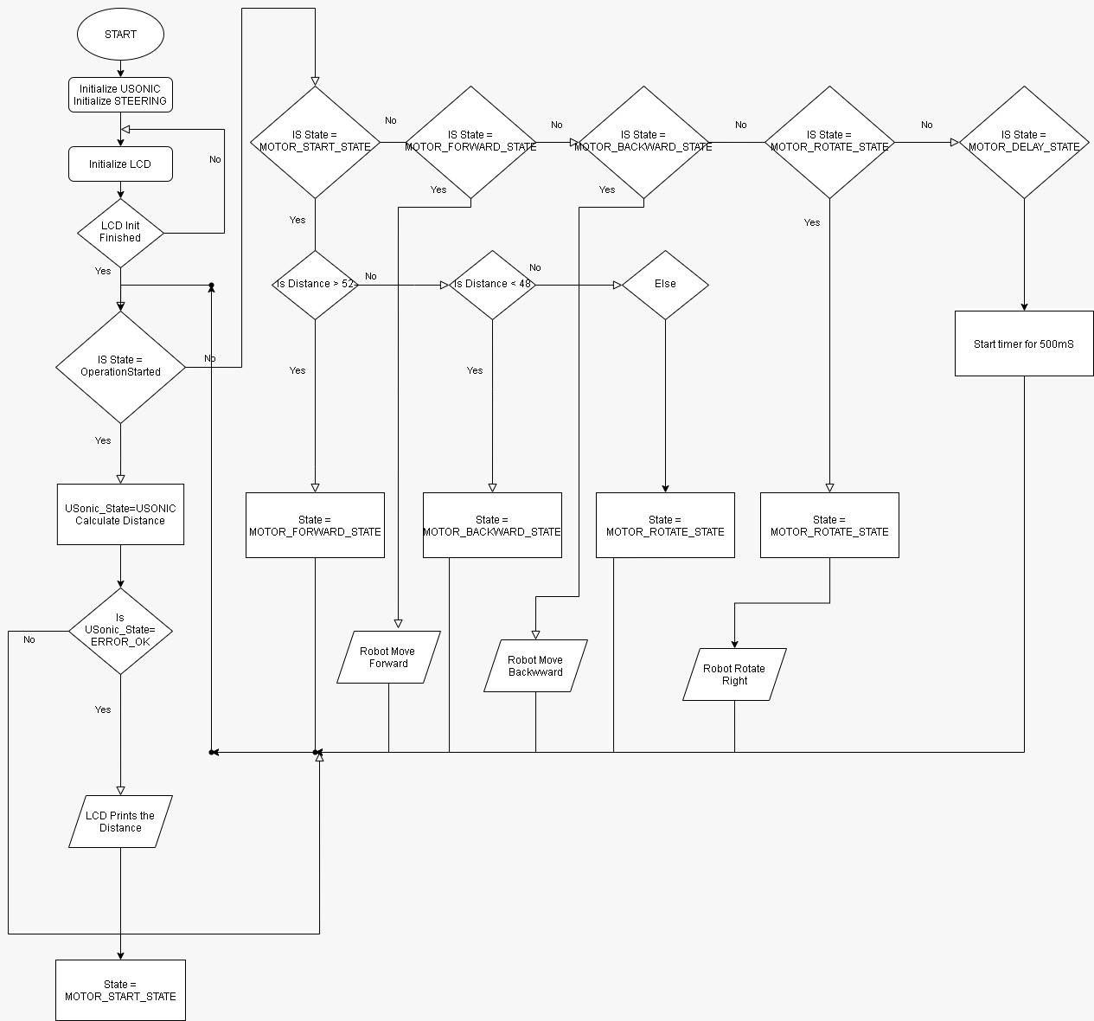

Figure 3 System in Detailed Flow Chart

# Project Demo Videos

Click to follow link [Hardware Demo Video](https://youtu.be/8BZhkoq6TiE)