clocktech-digital clock
project Management plan
Version <1.0>
03/11/2016

VERSION HISTORY
Project Management Plan Template was divided among the team by the manager Seif El-dein Ahmed who approved and tracked the planning process step by step.
Version # | Implemented  By | Revision  Date | Approved  By | Approval  Date | Reason
1.0 | Ahmed Adel  Ahmed AbdelAzim  Anwar AbdelHamid  Norhan Osama  Walaa AbdelGhafa | 02/11/16 | Seif El-dein Ahmed | 03/11/16 | To divide tasks and responsibilities among the team members and be ready for any risks.

TABLE OF CONTENTS
1 Introduction 3
1.1 Purpose of Project Management Plan 3
2 Schedule/Time Management 3
3.1 Milestones 3
3.2 Project Schedule 4
3.2.1 Dependencies 4
3 Cost/Budget Management 4
4 Risk Management 4
5 Procurement Management 5
Appendix A: Project Management Plan Approval 6
APPENDIX C: KEY TERMS 7
APPENDIX D: SUMMARY OF SPENDING 8

Introduction

Purpose of Project Management Plan
The main purpose of the PMP is to divide responsibilities among the team members and to mention the expected time plan and risks that may take place and how to solve them to follow the time plan and to not exceed the targeted cost.
The intended audience of the ClockTech-Digital Clock PMP is all project stakeholders including the project sponsor, senior leadership and the project team.

Objective of the project:
Our main objective is to deliver the project on time for the hardware to be tested and working properly , and for software to be tested and well documented.

2 Schedule/Time Management

Milestones
The table below lists the milestones for this project, along with their estimated completion timeframe.
Milestones | Estimated Completion Timeframe(hour)
DIO | 12
LCD | 12
Timer | 12
Tactile Switch | 12
Hardware | 12
Total hours | 60

Project Schedule
NAME ^{DATE} | 26-3 | 27-3 | 28-3 | 29-3 | 30-3 | 31-3 | 01-4 | 02-4 | 03-4 | 04-4 | 05-4 | 06-4 | 07-4
Ahmed ADEL | APPLICATION DESIGN & API DESIGN |  |  | CODING APPLICATION |  |  |  |  |  | SOFTWARE INTEGRATION TESTING |  | HARDWARE TESTING
Ahmed AbdElazim | CODING DIO DRIVER |  |  |  | CODINDG LCD DRIVER |  |  | CODING TIMER DRIVER
Anwar AbdelHamid | APPLICATION DESIGN & API DESIGN |  |  | CODING TACKTILE SWITCH DRIER |  |  |  |  |  | SOFTWARE INTEGRATION TESTING |  | HARDWARE TESTING
Walaa AbdelGhafaar | CODING DIO DRIVER
Norhan Osma | HARDWARE DESIGN |  |  |  | CODINDG LCD DRIVER |  |  | CODING TIMER DRIVER

Tasks | Progress | Assigned person
Estimation sheet | 100 % | Ahmed adel
Risk sheet | 100% | Ahmed abd elazim
Project plane document | 70 % | Anwr abd elhamid
CI list | 100% | walaa
CRS | 100% | Norhan osama
SRS | 100% | Ahmed adel  Anwar abdelhamid
RTM | 40 % | Walaa
SIQ | 100% | Norhan osama
APPLICATION DESIGN & API DESIGN | 0% | Ahmed ADEL  Anwar abd elhamid
DIO DRIVER | 0% | Walaa AbdelGhafaar  Ahmed abd elazim
TACKTILE SWITCH DRVIER | 0% | Anwar abd elhamid  Walaa abd elghafar
TIMER DRIVER | 0% | Ahmed AbdElazim  Norhan osama
SOFTWARE INTEGRATION TESTING | 0% | Ahmed ADEL  Anwar abd elhamid
HARDWARE TESTING | 0% | Norhan Osma  Ahmed ADEL
CODINDG LCD DRIVER |  | Ahmed AbdElazim

Estimation

1.3 Hardware cost
Item | price (L.E)
pcb | 35
lcd | 35
Micro controller  ATmega32 | 5
Micro controller base | 40
Resistors & switches | 3
TOtal cost | 118

2.3 Sw/hw estimated working hours
module | working hours
DIO | 6
LCD | 6
TIMER | 4
Tactile switch | 6
Pcb design | 3
Hardware design | 6
TOTAL | 31

Procurement Management
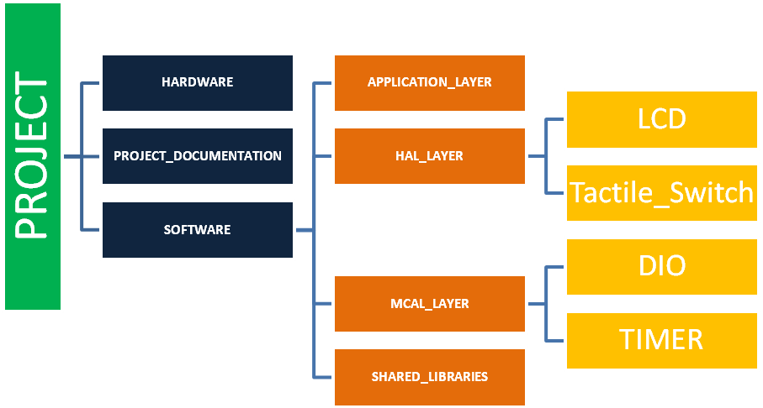
Github Link:
https://github.com/AhmedAdelTolba/SOFTWARE_ENGINEERING_PROJECT

Risk Management
The expected risks and solution mentioned in a separate sheet.

Appendix A: Project Management Plan Approval
The undersigned acknowledge they have reviewed the ClockTech-Digital Clock
Project Management Plan and agree with the approach it presents. Changes to this Project Management Plan will be coordinated with and approved by the undersigned or their designated representatives.

Signature: |  | Date:
Print Name:
Title:
Role:

Signature: |  | Date:
Print Name:
Title:
Role:

Signature: |  | Date:
Print Name:
Title:
Role:

Signature: |  | Date:
Print Name:
Title:
Role:

Signature: |  | Date:
Print Name:
Title:
Role:

APPENDIX C: KEY TERMS
The following table provides definitions for terms relevant to this document.
Term | Definition
PCB | Printed circuit board
LCD | liquid crystal display

APPENDIX D: SUMMARY OF SPENDING
ITEM | PRICE
PCB | 35L.E
LCD | 35L.E
Microcontroller base | 5L.E
Microcontroller | 40L.E
Resistor and switches | 3L.E
Total cost | 118L.E

