**Metro Tickets Reservation**

Supervised by

Dr. Cherry Ahmed

TA. TA Ashraf Mohey

Implemented by

|  |  |
| --- | --- |
| 20170008 | Ahmed Ibrahim Mohamed Abdelmottaleb |
| 20170033 | Ahmed Mostafa Elsayed |
| 20170232 | Mohamed Sameh Omar |
| 20170224 | Mohamed Bakr Abdelhafez |
| 20170253 | Mohamed Mohsen Abdelsallam |

Table of Contents

1. Abstract 2

2. Background 2

3. Technology 2

4. Problem definition 3

5. Related work 3

6. Project specifications 3

6.1. System architecture 3

6.2. Stakeholders 3

6.3. Functional Requirements 3

6.4. Non-functional Requirements 4

6.5. Use-case Diagram 5

6.6. Class Diagram 5

6.7. Sequence Diagram 5

# Abstract

With this large number of Metro passengers, stations become extremely crowded, especially in times previous and after the work day for employees or school day for students, as result of that each person become binding to stay at a too long queue in the station in front of tickets window.

In addition to delays in their journeys and problems that can be created between passengers and each other, in days like we live now (a period of serious illness) the infection becomes more common in this crowded queue, as it happens in this period, since these lines cannot be controlled effectively enough.

Our goal is to solve the extremely crowding of metro stations by handling all the process of booking a ticket by the mobile app, using NFC (Near Field Communication) technology instead of normal tickets, by the same machines in stations which Depend on RFID technology.

# Background

Mobile Applications, or apps, have taken over in terms of user reach. Here are some stats to support our argument:

* An annual report on mobility from Ericsson states that smartphones are poised to reach 6.1 billion users by 2020.
* Gartner predicts that by the end of 2017, mobile apps will have been a downloaded excess of 268 billion times which will generate revenue somewhere over $77 billion.

As a result, organizations or companies are heading to develop mobile applications to make its services easier for users, solve some problems they face or to get more profit by Sponsorship Agreements, given the many users of this application.

# Technology

Though Near Field Communication (NFC) first came to use in the mid-2000s, a far wider population is now familiar with the technology than ever before, and many are using NFC on a regular and frequent basis. And according to LearnBonds and eMarketer estimates there will be 69.4 million NFC mobile payment users by the end of 2020; that number will rise to 80.1 million users by 2023.

Our Mobile Application will be implemented by Flutter framework and Dart programming language to support both Android and IOS Operating Systems.

# Problem definition

# Related work

There are some Applications that similar to our App, for example:

* Q Ticketing: which serving the Greater Houston, Texas region.
* Metrolink: which serving the Southern California.
* Ridlr App: which serving Delhi & Mumbai, India.

All these Applications have common Features like:

* Handling all the process of booking a ticket by the mobile app
* Secure ticket purchasing
* User device is his ticket
* Easy to select User’s origin and destination to purchase

The main difference between our app and all those ones is the NFC technology which will be used rather than QR Code to make it easier to be implemented in the real life since it will be suitable for the same machines in Metro stations which Depend on RFID technology.

# Project specifications

## System architecture

## Stakeholders

## Functional Requirements

* The system shall allow users to register in the Application.
* The system shall allow users to login in the Application.
* The system shall allow users to charge his wallet using payment method.
* The system shall allow users to buy one ticket or more at the same process.
* The system shall allow users to determine the price of a ticket using source and destination.
* The system shall allow users to determine the closest station from a specific destination.
* The system shall allow users to determine estimated time for the entire trip (from Specific Station to another).
* The system shall allow users to get full directions (path) to go from one subway to another.
* The system shall allow users to apply for or renew a normal subscription.
* The system shall allow users to add a subscription by reading Metro subscription card.
* The system shall allow users to apply for or renew an Educational subscription after complete all the verification process.
* There is a map showing all the subways lines.

## Non-functional Requirements

**Performance Requirements:**

The login information shall be verified within less seconds. Response time of the system will not take long time, almost in a few seconds. The system works 24 hours per day 7 days in a week. The passengers’ information must save in the database in few minutes after the end of registration.

Response time of the System should be minimum. The system should show no visible deterioration in response time as the number of users or reservation data increases. The system does not take up too much space in memory to store system’s data.

**Security Requirements:**

This is vital in the design and expectation of any system. It should contain mechanism to protect the integrity and avoid changes or access by unauthorized users.

Consideration of the security of the system has a great advantage for this system, because the database should be secured from the unauthorized users. Only authorized user can get access to the database. To prevent from the unauthorized user, the user should have their username and password that help them to login to the system. Additionally, the users should have to take care of their own username and password. They should have to keep in a secret manner.

**Software Quality Attributes:**

Should be easily maintainable, easy to upgrade and make adjustments as it is known, every system needs to be maintained and modified, so we will try to make the code easily readable and write the comment along with necessary to the codes.

The system will check user inputs to the system to handle error. It handles and show error by displaying the error message when the user enters invalid input.

Our system describes the logical characteristics of each interface between the system and the users.

This may include any graphical user interface (GUI) standards or product family style guides, screen layout constraints, standard buttons and functions that will appear on every screen, error message display standards, and so on. So our system does these all functions in easy and efficient way. In other words the system is user interactive

## Use-case Diagram

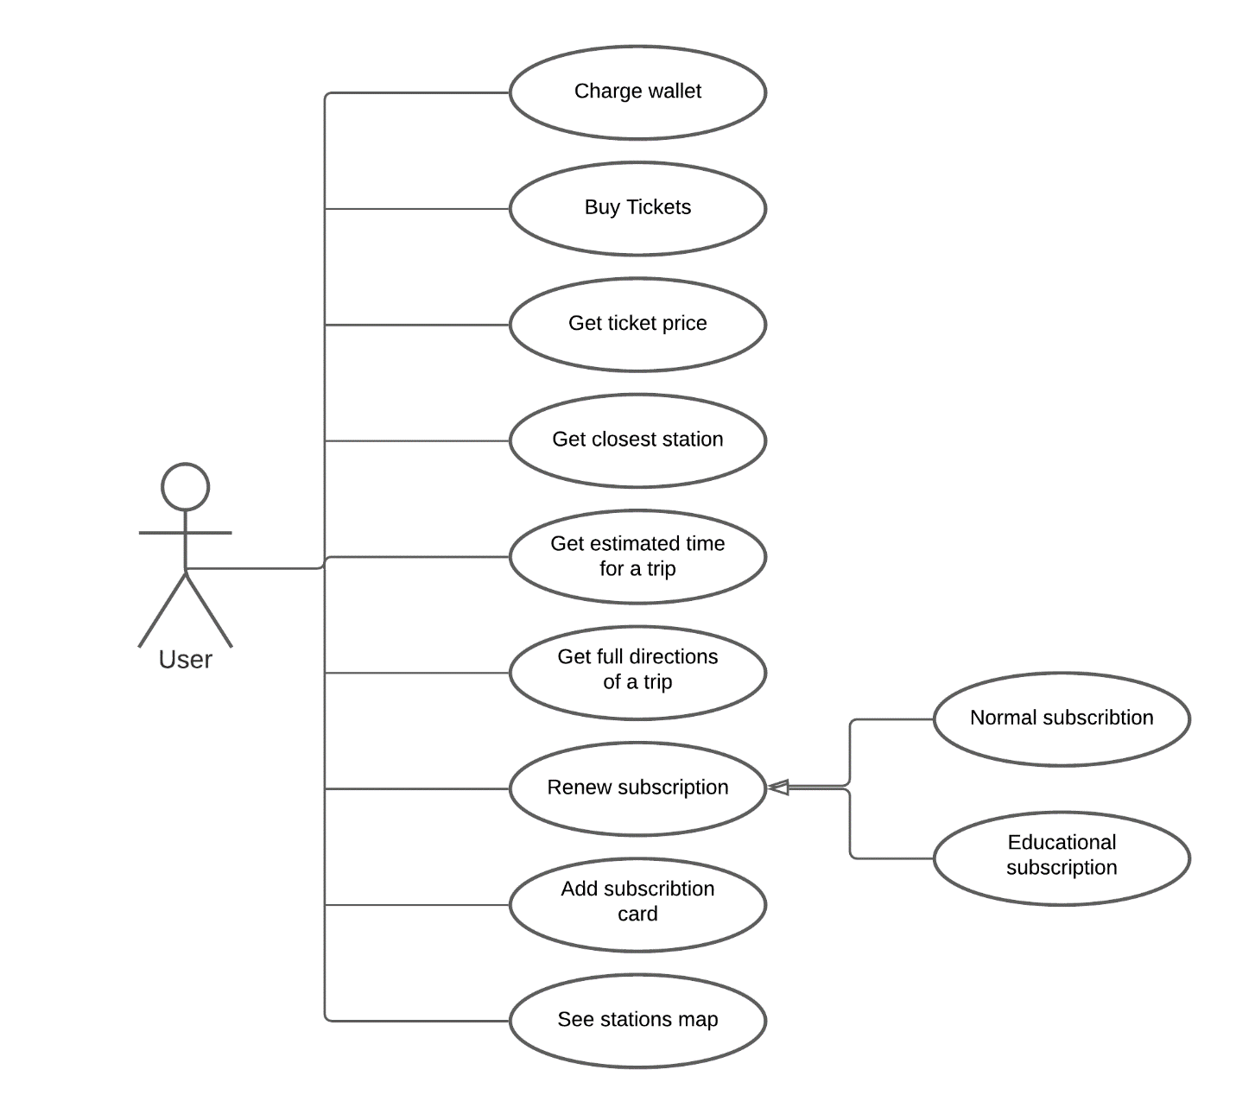

## Class Diagram

## Sequence Diagram