**Use Case Diagrams**

**for**

**SmartShoppers System**

**Version 1.0.0 approved**

**Prepared by A. Akbarali, E. Cong, D. Gill, H. Ho, P. Nguyen**

**EECS4312 Team 11**

**12/11/20**

# 

# 

# 

# Table of Contents

**Table of Contents** **2**

**Customer Use Case Diagram** **3**

Customer Use Cases 4

Use Case #1 : Register Account 4

Use Case #2 : Select Store 5

Use Case #3 : Direct Search Item 5

Use Case #4 : Search by Category 5

Use Case #5 : View Item 6

Use Case #6 : Add Item to List 6

Use Case #7 : View List 7

Use Case #8 : Generate Best Ordered List 7

**Manager Use Case Diagram** **8**

Manager Use Cases 9

Use Case #1: Modify sale items list 9

Use Case #2: Add new item 9

Use Case #3: Remove item 11

Use Case #4: Modify item details 11

Use Case #5: Modify store hours 12

Use Case #6: Modify store Map 12

**System Use Case Diagram** **13**

System Use Cases 14

Use Case #1: Add Manager 14

Use Case #2: Remove Manager 15

Use Case #3: Update Manager 15

Use Case #4: Add Store 16

Use Case #5: Remove Store 16

Use Case #6: Update Store 17

Use Case #7: Add Item 17

Use Case #8: Remove Item 18

Use Case #9: Update Item 18

Use Case #10: View Subject 19

Use Case #11: Create Recommended Item 19

Use Case #12: Set up Sale Items 19

**General Use Cases (For all three diagrams)** **20**

Use Case #1: Login 20

# Customer Use Case Diagram

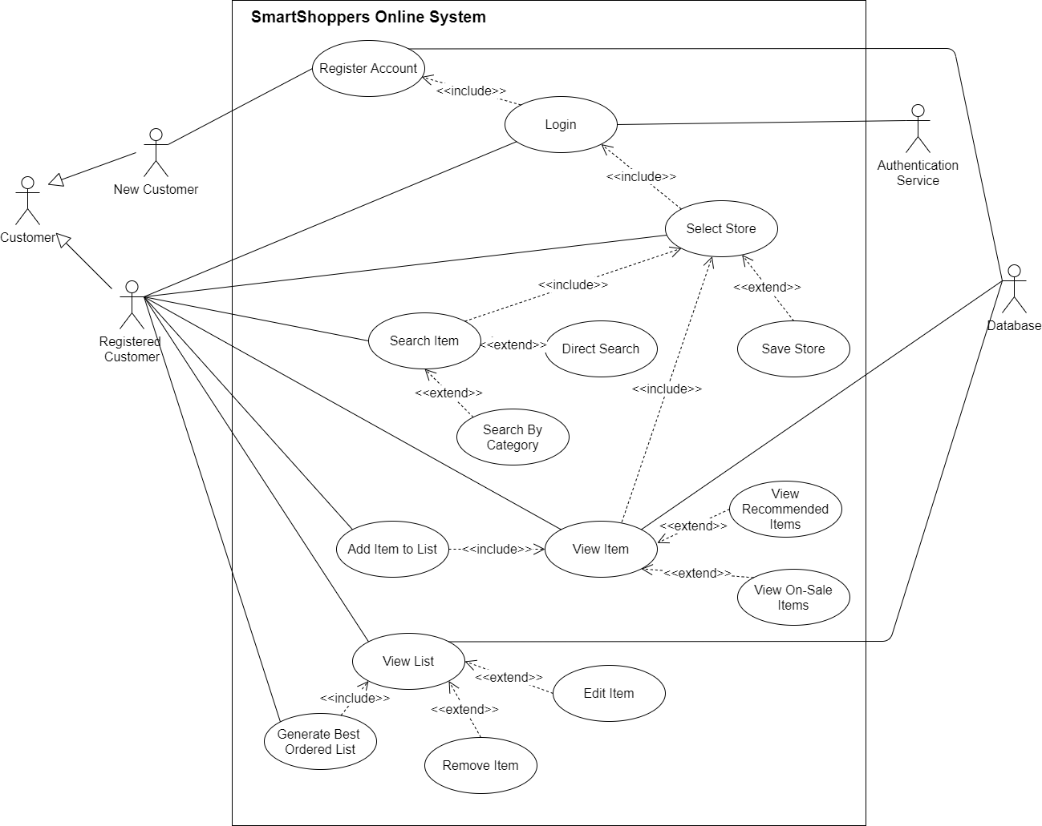

*Figure 1: Customer Use Case Diagram*

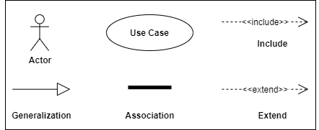

*Figure 2: Legend for Customer Use Case Diagra*m

## **Customer Use Cases**

### **Use Case #1 :** Register Account

**Explanation** : A customer requires an account to allow the system to differentiate between different customers. For this reason, a customer should be able to create an account.

**Description** : This use case allows the customer to register an account with the SmartShoppers online system. The account is created if the provided information is valid and if an account with the same email address doesn’t exist.

**Detailed Steps**:

1. The customer enters a username of their choice.
2. The customer enters a password.
3. The customer enters an email.
4. The system checks if the information is valid.
5. The system registers the customer in the system.

**Exception**

4a. Account with email exists

i. An error is displayed to the customer explaining that an account with the provided email already exists.

ii. The system tells the user to try another email.

iii. The use case continues from step 1.

4b. Account with username exists

i.An error is displayed to the customer explaining that an account with the provided username already exists.

ii. The system tells the user to try another username.

iii. The use case continues from step 1.

### **Use Case #2 :** Select Store

**Explanation**: A customer is required to select a store so that the system can show the correct information to the customer. The system needs to know which store to show items for and which store to use to generate the ordered list.

**Description** : In this use case, the customer selects a store. A customer can also save their store preference in this use case.

**Detailed Steps**:

1. The system requests the customer to provide location information.
2. The customer enters their postal code.
3. The system provides the customer with all the stores which are close to the postal code.
4. The customer selects a store from the provided stores.
5. The system changes the online system to show the selected store’s deals and items.

**Extension**:

4a. Save store preference

i. The customer saves the selected store as their preferred location.

**Alternative Flows**:

Enter city and province

1. The customer enters their city and province.
2. The system provides the customer with all the stores in the provided city.
3. The customer selects a store from the provided stores.
4. The system changes the online system to show the selected store’s deals and items.

### **Use Case #3 :** Direct Search Item

**Explanation** : A customer is required to search the item directly.

**Description** : In this use case, the customer direct searches for an item.

**Detailed Steps**:

1. The customer enters the name of the item that they would like to search in the direct search bar.
2. The customer clicks the search button next to the direct search bar to request the search.
3. The system checks for items in the database with the provided name.
4. The system returns all the items matching with the provided name.

**Exception**:

4a. No items with the provided name are found in the database.

i.The system alerts the customer that there are no items found.

### **Use Case #4 :** Search by Category

**Explanation** : A customer should be able to search for an item through categories. This is useful for a customer who might not exactly remember the name of an item or the customer is browsing for items.

**Description** : In this use case, the customer searches an item by choosing a category.

**Detailed Steps**:

1. The customer chooses to search by category.
2. The system provides the customer with a list of categories.
3. The customer selects a category from the provided list of categories.
4. The system returns all the items in the category to the customer.

### **Use Case #5 :** View Item

**Explanation** : The customer has to be able to view the item in order to get the item information and add the item to their list.

**Description** : In this use case, the customer views a selected item. A customer can also view recommended items and on-sale items.

**Detailed Steps**:

1. The customer has located the item that they want to view.
2. The customer selects the located item to view.
3. The system provides the customer with the item information. The item information includes price, item size, and availability.
4. The customer changes the size of the item to view different size information.
5. The system changes the information according to the selected size.

**Extension**:

1a. View Recommended Items

i. The customer browses the recommended items.

ii. The customer locates an item that they want to view.

1b. View On-Sale Items

i. The customer browses on-sale items

ii. The customer locates an item that they want to view.

### **Use Case #6 :** Add Item to List

**Explanation** : A customer should be able to add items to their list so that they can replicate what they would like to buy in store. Also, a list needs items inside it in order to generate an ordered list.

**Description** : In this use case, the customer adds an item to their list as long as the item is not out of stock.

**Detailed Steps**:

1. The customer selects the item that they would like to add to their list.
2. The customer selects the size of the item if available.
3. The customer selects the quantity of the item to add to their list.
4. The customer requests to add the item to their list.
5. The system adds the item(s) of the selected size to the list.
6. The system updates the customers list.

**Exceptions**:

4a. Item is out of stock.

### **Use Case #7 :** View List

**Explanation** : The customer should be able to view their list so that they can validate what they have added to their list and make changes if needed.

Description : In this use case, the user views their list. The user can also remove items or change item quantity if needed.

**Detailed Steps**:

1. The customer requests to view their shopping list.
2. The system retrieves the customer’s shopping list from the database.
3. The system shows the customer their shopping list.
4. The system provides the user with a total cost amount of the list.

**Extensions**:

5a. Remove items from the list.

i. The customer selects the item to remove.

ii. The customer removes the selected item.

iii. The system updates the list and the total cost.

5b. Change item quantity.

i. The customer selects an item.

ii. The customer changes the quantity of the item.

iii. The system updates the list and the total cost of the list.

### **Use Case #8 :** Generate Best Ordered List

**Explanation** : The customer should be able to generate a list in the best order in which to find the items, starting at the front of the store.

**Description** : In this use case, the customer generates a best ordered list as long as the list is not empty.

**Detailed Steps**:

1. The customer asks for the system to generate a list order.
2. The system uses the customer’s shopping list and the selected store’s data to produce an ordered shopping list in order for the customer to spend the least time shopping at the selected store.
3. The system provides the new ordered list to the customer.
4. The customer views the new ordered list.

**Exception**:

1a. Empty List

# Manager Use Case Diagram

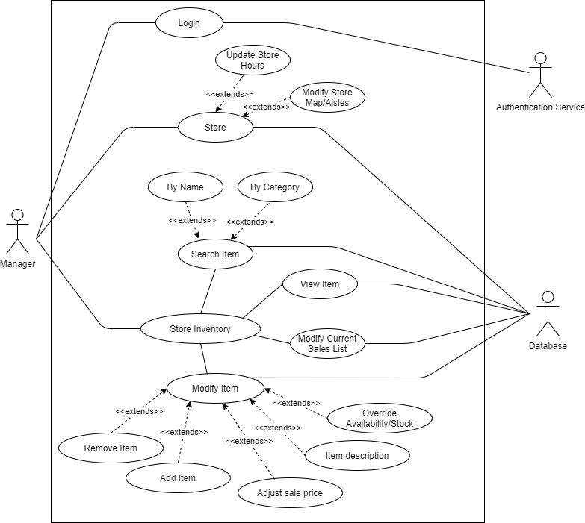

*Figure 3: Manager use case diagram*



*Figure 4: Legend for Manager Use Case Diagram*

## **Manager Use Cases**

### **Use Case #1:** Modify sale items list

**Explanation:** Managers need to update the sales item list, by removing specific items that are not on sale anymore, or adding an item to put on sale.

**Description:** Add/remove a discount for an item, which updates the sale items list.

**Detailed Steps**:

1. The Manager logs into the system with username and password.
2. The system verifies the Manager’s login credentials.
3. The Manager views the sales item list.

4A. The Manager can remove an item from the sales list.

5A.The System resets the item’s price to a non-discounted price and removes the item from the sales list.

4B. The Manager can add an item to the sales list by searching for it in the inventory, and adding a discounted price to the item.

5B. The System changes the price to a discounted price and adds it to the sales list.

**Alternative Flows:**

1A. If verification fails, the System displays an error.

### **Use Case #2:** Add new item

**Explanation:** Managers need to update the item inventory if a new item is being sold in the store.

**Description:** Add a new item to the inventory/ item list.

**Detailed Steps**:

1. After logging in, the Manager can add a new item to the store inventory.
2. The System displays a form for the Manager to fill out details for the item (details in System Use Cases).
3. The Manager fills out and submits the form.
4. The System asks the Manager to verify the information a final time, then adds the item to the store.

**Alternative Flows:**

3A. If the item already exists in the database, the System should display an error.

### 

### **Use Case #3:** Remove item

**Explanation:** A Manager should be able to remove an item from their store if they no longer sell the item at that location.

**Description:** Remove item from store’s item list.

**Detailed Steps**:

1. The Manager views the store’s item list/inventory list and selects a specific item.
2. The Manager chooses to delete the selected item.
3. The System asks the Manager to confirm the deletion, then removes the item from the Store’s item list.

**Alternative Flows:**

### **Use Case #4:** Modify item details

**Explanation:** A Manager should be able to change the details of an item. The details could be outdated or incorrectly input, or the Manager may need to update item price for their specific store.

**Description:** A Manager views the item list and searches/selects an item, the Manager can then choose to modify specific item details, such as item description or item price.

**Detailed Steps**:

1. The Manager views the store’s item list.
2. The Manager can search for an item by its name/ID and then select the item to be modified.
3. The Manager updates the item details and finalizes the changes.
4. The System adds the changes and updates the database.

**Alternative Flows:**

3a. Items may have specific details that a Manager cannot change, if the Manager tries to make such a change, then an error message will be displayed.

### 

### **Use Case #5:** Modify store hours

**Explanation:** A manager can change the hours the store is open. This is necessary so Users can accurately see whether a store is open or not. This is especially important in special circumstances when a store has modified hours, such as a holiday, or an event where hours must be shortened.

**Description:** The store Manager changes the hours of operation that is shown online so Users can accurately see if the store is open without calling or arriving in person.

**Detailed Steps**:

1. The Manager logs in to the system and sees the details of their store.
2. The Manager clicks on the store’s open hours.
3. The Manager may change the operational hours which the System shows Users.

4a. The Manager shows the store as closed on a specific day in which it would normally operate, an example is the store needs to close on a Monday it would normally operate because that specific Monday is a statutory holiday.

4a. The Manager adds operational hours in the event of a schedule change, for example the store was previously closed on Saturdays, but will now be open.

4c. The Manager removes operational hours in the event of a schedule change, for example the store was previously open on Mondays, but will now be closed.

5. The System asks the Manager to confirm the changes, then updates the store hours online that Users will see.

**Alternative Flows:**

### **Use Case #6:** Modify store Map

**Explanation:** Each store may have a different layout in terms of which items are in which aisles. A Manager can update the store’s map according to the aforementioned layout, which helps the System generate a shopping route for a User.

**Description:** A Manager changes the online store Map when items get moved around in the store.

**Detailed Steps**:

1. The Manager logs in and views the store’s online Map.
2. The Manager selects specific aisles and modifies the items located in the specific aisle.
3. The System asks the Manager to confirm the changes, then updates the store’s map/aisles .

**Alternative Flows:**

# 

# 

# System Use Case Diagram

# 

*Figure 5: System use case diagram*

## 

*Figure 6: Legend for System Use Case Diagram*

## **System Use Cases**

### Use Case #1: Add Manager

**Explanation**: The System supports a functionality such that the Administrators can add a new Manager into the system.

**Description**: The System contains a Manager Form for a new Manager account. The Administrator can have access to the form and fill in the necessary information about the new Manager and submit the Form. The System would validate the form, create the Manager account in the database, inform the Administrator with the temporary password for the new Manager. Administrator can assign a specific Store to the Manager afterwards.

**Detailed Steps**:

1. The Administrator accesses the Manager Form in the System.
2. The System would display the Manager Form.
3. The Administrator fills in the information about the managers such as first name, last name, address, PIN and selects the location of the store that Manager is in charge of as well as the working shift .
4. The Administrator checks the information, confirms with the system and submits the Manager Form.
5. The System creates the account based on the form and grants the access privileges to the Item and Store Management of the Store where the Manager works at .
6. The System outputs the temporary password for the new Manager to the Administrator.

**Alternative Flow**:

4a. The System gives an error message when there’s invalid information about the manager’s address or the store address

5a. If the account already exists, the System cancels the account creation and grants the privilege to that account.

## 

### Use Case #2: Remove Manager

**Explanation**: The System supports a functionality that allows the Administrator to remove a certain existing Manager within the System.

**Description**: The Administrator can search the Manager by his/her ID number and choose that Manager for removal. The System would wait for the Administrator confirmation and execute the removal in the databases. The System then informs the Administrators about the successful removal of a particular Manager.

**Detailed Steps**:

1. The Administrator searches by ID and selects the Manager in the Manager Board.
2. The Administrator selects the Remove Manager option in the board and confirms the action.
3. The System finds the account and retrieves the Manager’s access privilege on that account.
4. The System informs the Administrator about the removal.

**Alternative Flow**:

3a. If the account does not exist, the System reports an error to the User.

### Use Case #3: Update Manager

**Explanation**: The System provides a functionality that permits the Administrator to update the information of the Manager.

**Description**: The System would display a Manager Board that the Administrator can search and choose a Manager to update his/her information. In detail, the Administrator can update the address of the Manager and the Store assignment.

**Detailed Steps**:

1. The Administrator chooses a Manager in the Manager Board in the System
2. The System displays all features containing all information about the Manager in the Manage page.
3. The Administrator selects the Update option in the page.
4. The System presents editable fields in the page for the Administrator to modify.
5. The Administrator modifies the fields and confirms the changes.
6. The System saves the changes in the databases

**Alternative Flow:**

2a. View Manager:

View Subject

5a. If there’s an invalid input, the System notifies and redirects the Administrator back to the edit table.

## 

### Use Case #4: Add Store

**Explanation:** The System supports a functionality that enables the Administrators to add a new Store to the System.

**Description:** Administrators can add a new SmartShopper store to the system with the relevant information such as name and address of the Store, opening and closing hours. The System would then create a Store entry and save it in the databases.

**Detailed Steps:**

1. The Administrator accesses the Store Form in the System.
2. The Administrator enters the information about the name and address of the Store into the corresponding textbox.
3. The Administrator selects the availability along with the opening and closing hours of the store.
4. The Administrator uploads the electronic map of the Store into the Form.
5. The Administrator confirms the information with the System and submit the Form.
6. The System generates a Store entry with the information from the Form, saves it in the database.
7. The System informs the Administratorupon completion..

**Alternative Flow:**

6a. If the store already exists, the System notifies the User and cancels the operation.

### Use Case #5: Remove Store

**Explanation:** The System provides the Administrator the ability to remove a specific Store in the System.

**Description**: Administrator can remove a specific Store from the system. The System would then remove the Store from the databases.

**Detailed Steps:**

1. The Administrator enters the ID of the Store that needs to be removed from the System and chooses the Remove Store option.
2. The System connects the database to find the Store based on ID, displays a brief description of the Store and requests a confirmation from the Administrator.
3. The Administrator confirms the removal of the Store.
4. The System removes the Store from the database and informs back to the Administrator upon completion.

**Alternative Flow:**

2b. If the store does not exist, the System notifies the User and cancels the operation.

### 

### Use Case #6: Update Store

**Explanation:** The System provides the Administrators the ability to update all Stores in the System. For Managers, they are also granted the authority to update the Store which they are assigned by the Administrators.

**Description**: The System displays a list of Stores in the System to the Administrators. The Administrators can choose a Store, update the information and confirm the changes to the System. For Managers, they can only update some features of the Store of which they are assigned. The User in the steps represents both Administrators and Managers.

**Detailed Steps:**

1. The Administrator accesses the list of features of a particular Store and selects the Update option..
2. The System displays all features in the editable mode for the User to modify.
3. The User modifies the features and confirms the change.
4. The System saves the changes in the databases.

**Alternative Flow:**

1a. If the User is an Administrator, the System presents a list of all Stores within the System for the User to choose.

2a. View Store:

View Subject

### Use Case #7: Add Item

**Explanation:** The System provides the User who has the appropriate privilege to add a specific Item to the System.

**Description:** Privileged users (Administrators and Managers) can add a specific Item to the System. The System then collects the information about the Item, creates an Item entry and adds it to the database. The Users in the steps are Administrators and Managers.

**Detailed Steps:**

1. The Administrator accesses the Item Form in the System.
2. The Administrator enters the information of the Item such as the name, the description, the price, the list of size and item ID code to the according textbox in the Form.
3. The Administrator rechecks the information and confirms the new Item to the System.
4. The System adds the Item into the database and confirms back to the Administrator upon completion.
5. The System requests the Administrator to select the Stores that will have the Item available from a list of existing Stores.
6. The Administrator chooses and confirms the Stores within the System.
7. The System adds the Item to the Stores.

**Alternative Flow:**

4a. If the Item already exists, the System notifies the Administrator and cancels the operation.

## 

### Use Case #8: Remove Item

**Explanation:** The System provides a functionality such that the Administrators can remove any items in the System.

**Description:** Administrators can remove the Item based on the Item ID. The System then deletes the Item from the database.

**Detailed Steps**:

1. The Administrator enters the Item ID in the search bar within the Item Table in the System.
2. The System connects to the Database, retrieves the Item with the ID along with a brief description.
3. The Administrator confirms the Item and chooses the Remove Item option.
4. The System connects to the database and removes the specified Item.
5. The System removes the Item from the Store that contains the Item.
6. The System informs the Administratorupon completion of removal.

**Alternative Flow:**

4a. If the Item does not exist, the System notifies the Administrator and cancels the operation.

### Use Case #9: Update Item

**Explanation:** The System provides a functionality such that Administrators can update the information of the Items in the Store.

**Description:** Administrators can select an Item within the Store. Administrators can choose a Store in the System. The System presents an option to update the information of the Item. Both Manager and Administration can update the name, the price, the size of the Item. Once the Item has been updated, it would be saved in the database.

**Detailed Steps:**

1. The Administrator connects to the specific Store in the System.
2. The System displays a list of Items that are sold in the Store.
3. The Administrator selects an Item from the list and executes the Update Item option in the Item Board.
4. The System presents all relevant features of that chosen Item in the editable mode.
5. The Administrator updates the features and confirms the changes.
6. The System saves the changes in the database

**Alternative Flow:**

4a. View Item:

View Subject

5a. If there’s invalid input, the System notifies and redirects the Administrator back to the edit table.

## 

### Use Case #10: View Subject

**Explanation:** The System provides the Administrators the ability to view a particular Subject within the System. The Subject can be an Item that Customers want to buy, a Store that Customer can go to and a Manager who is in charge of Item Management as well as Store Management.

**Description:** The System displays all relevant information about the Subject in detail.

**Detailed Step:**

1. The Administrator chooses a particular Subject.
2. The System directs the Administrator to the Subject Page that contains all features of the Subject with a short description.
3. The Administrator accesses a feature in the Subject Page.
4. The System expands the feature with the full description to the Administrator.

**Alternative Flow:**

2a. If the Subject is an Item, the page contains the Item ID, the name, the description, the price of the Item

2b. If the Subject is a Store, the page contains the Store ID, the name, the location, the opening and closing hours, a list of Items at the store along with its availability and the Manager of the Store.

2c. If the Subject is a Manager, the page contains the Manager ID, name, address, PIN, and the Store where the Manager works.

### Use Case #11: Create Recommended Item

**Explanation:** The System presents customers with a list of recommended items based on the current items in the customers shopping cart and other customers’ searches who have also looked at the items in the customers’ shopping list and the most popular items in the store. **Description:** The system displays a list of items that customers have searched for when also searching for items in the current customers shopping list and the most popular items at the store.

**Detailed Steps:**

1. The System collects search history of Customers.
2. The System runs the algorithms with the current shopping list along with the search history and creates a new list with the items that are not included in the current shopping list based on popular items and similar items in other customers’ search history.
3. The System displays the new list with the best order to the Customer.

**Alternative Flow:**

### Use Case #12: Set up Sale Items

**Explanation:** The System should have a list of items on sale at each store, with a sale price. Customers should be able to search for items based on this feature. **Description:** The system outputs the list of items on sale.

**Detailed Steps:**

1. The System assigns sale property to items on sale.
2. System creates a list of items with this property.

**Alternative Flow:**

# General Use Cases (For all three diagrams)

### Use Case #1: Login

**Explanation:** The System requires all Users to login before using any services or management sites within the System.

**Description:** In order to utilise the full benefits of the System, each User is required to login to the System. The User can be Administrator, Managers and Customers of the SmartShopper. Depending on the role he or she has, the System would direct the User to the suitable window designed for each role.

**Detailed Steps**:

1. The User accesses the Login section of the System.
2. The User enters the username and password to login.
3. The System runs the authentication and verification steps towards the given username and password.
4. The System directs the User to the User Profile.

**Alternative Flow**:

3a. If there’s an invalid input, the System shows an error message.

3b. When the System detects the wrong username or password, the System indicates and displays the corresponding error message.

3c. The customer is alerted to try logging in again.