Faculty of engineering

Ain Shams university

CESS Program

**CSE 223: Operating Systems**

**Assignment 2**

**Submitted by:**

Ahmed Hesham Mohamed AlSaey - 16P6000

Sherif Ashraf Ahmed Morsy - 16P9033

**Submitted to:**

**Group:** 2

**1. Assumptions**

**1.1 General assumptions**

1. Assume that the randomly generated reference string is always bigger than the page frame because if it is not, then the algorithms would be of no use (values will be added sequentially all the time)
2. Assume that the random reference string maximum size is 300, and it is randomly filled with values ranging from 0 to 99
3. Assume that the random page frame number can vary from 1 to 20

**1.2 Algorithm specific assumptions**

1. **LFU**Assume that if more than one value in the frames have the same use frequency, apply FIFO on these values
2. **Second chance**

Assume that each time we reference a value from the reference string, we apply FIFO but if the reference string of the first in value is 1, we change it to 0 and move on to the next value in the FIFO queue.

1. **Enhance second chance**

Assume that there is a next victim pointer that loops through the page frame in a circular path (when It reaches the last frame, the next victim frame will be the first), this pointer loops until it finds a candidate victim frame, this happens each time a new reference is taken from the reference string, also, assume that when looking whether or not the reference value is in the page frame, we do not move the next victim pointer. Actual algorithm explained below

**2. How to test the code**

Below you will see the main() function of the program

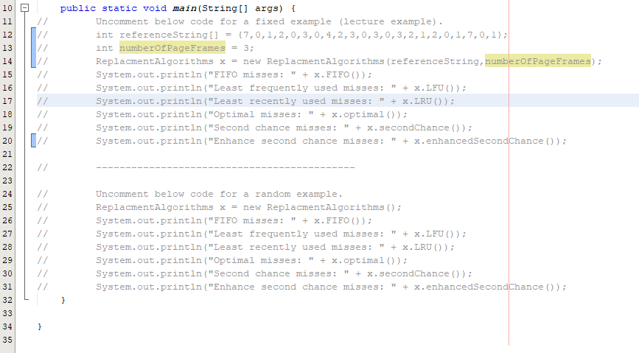

As mentioned in the comment, you can uncomment different parts of the code depending on whether or not you need to test a random or a fixed example.

Although possible, it is not recommended to uncomment multiple algorithms for testing to avoid confusion of different outputs, instead, please uncomment the code section with only one print statement at a time.

Output interpretation will be explained below.