Cairo University  
Faculty of Computers and Information



**CS251**

**Software Engineering I**

Science Academy

Software Design

Mega Minds

12 & 2016

Contents

Team 3

Document Purpose and Audience 3

System Models 4

I. Class diagrams 4

II. Sequence diagrams 10

Class - Sequence Usage Table 14

Ownership Report 14

# Team

|  |  |  |  |
| --- | --- | --- | --- |
| **ID** | **Name** | **Email** | **Mobile** |
| 20140292 | Noura Mohamed Arafa | nouraarafa95@gmail.com | 01113600147 |
| 20140278 | Menna Allah Ali Mohamed | mennaali365@gmail.com | 01141155710 |
| 20140313 | Yasser Mohamed Abdel Hameed | co2yasser@gmail.com | 01115658342 |

# Document Purpose and Audience

**Purpose**

This document is talking about software design (class diagrams and sequence diagrams) of web applications system which provide educational games to students and allow teachers to add games.

**Audience**

There are 2 main audiences:

1-Developers(Students)

2-Customers(TAs)

# System Models

## I. Class diagrams

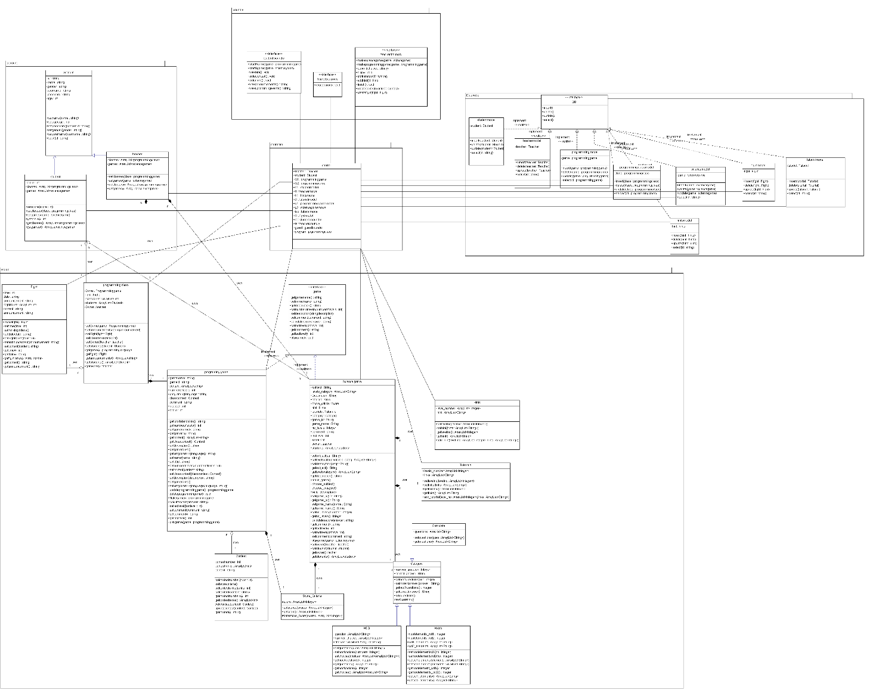

| **Class ID** | **Class Name** | **Description & Responsibility** |
| --- | --- | --- |
| 1 | Game | It is an interface and contain some functions   * Play game function * Make game function * Set game name * Set number of levels * Set description * Get comments * Get rates * Calculate score |
| 2 | Science game | It implements the functions of the Game interface and responsible for:   * Choose subject * Choose category |
| 3 | Category | It contains 3 types of category which is (MCQ, Choose, Complete) and responsible for:   * Set number of questions * Set correct answer * Get number of questions * Get correct answer * Add questions |
| 4 | MCQ | It is one of the categories of the science game which responsible for:   * Set questions * Set no of choices * Set choices * Get them |
| 5 | Match | It is one of the categories of the science game which responsible for:   * Set column 1 elements * Set column 2 elements * Get them |
| 6 | Complete | It is one of the categories of the science game which responsible for:   * Set questions * Get questions |
| 7 | Hints | It contains attributes for  Responsible for:   * Set hint * Get level number * Get hint * Add hint |
| 8 | Tutorials | It makes teacher to add new tutorial and responsible for:   * Get level number * Set tutorial * Add tutorial |
| 9 | Score criteria | Determine criteria of the scoring  Responsible for:   * Determine score |
| 10 | Programming | It implements the functions of the Game interface and responsible for:   * Set rank * Set programming language * Set class content * Update programming game * Delete programming game |
| 11 | Programming class | Contains teacher who make the game and contains the students who play this game  And responsible for:   * Set game * Set announcement * Set class rank * Set fight for that class * And get them |
| 12 | Fight | It is fight done between student of specific class  Responsible for:   * Make fight * Set time * Set ranking critical * Set announcement of this fight * Set data * Set content * And get them |
| 13 | Contest | It is contest done in public so any student can enter it by register in it  Responsible for:   * Set contents * Set score criteria * Add contest * Update contest |
| 14 | Account | It contains information about the user which will be Student or Teacher  Responsible for:   * Set name * Set age * Set password * Set gender |
| 15 | Student | It saves information about students and his joined games  Responsible for:   * Set scores for the student * Set classes he joined * Set his games * And get them |
| 16 | Teacher | It saves information about the teacher and his classes/games  Responsible for:   * Set class * Set game * Get them |
| 17 | Control | It links between the database and classes/GUI |
| 18 | Student model | It contains information of the students  Responsible for:   * Insert new student * Update * Delete student * Select any attributes for specific student |
| 19 | Teacher model | It contains information of the teacher  Responsible for:   * Insert new teacher * Update * Delete teacher   Select any attributes for specific teacher |
| 20 | Programming model | It contains information of the programming game  Responsible for:   * Insert new programming games * Update * Delete programming game * Select any attributes for specific programming game |
| 21 | Science model | It contains information of the science games  Responsible for:   * Insert new science game * Update * Delete science game * Select any attributes for specific science game |
| 22 | Fight model | It contains information of the fights  Responsible for:   * Insert new fight * Update * Delete fight * Select any attributes for specific fight. |
| 23 | Hints model | It contains information of the hints  Responsible for:   * Insert new hint * Update * Delete hint * Select any attributes for specific hint |
| 24 | Student boundary | It used to view data to the student and link between student and the system  Responsible for:   * Start programming game * Start science game * View rate * Enter contest * Enter fight * View announcement * View upcoming events |
| 25 | Teacher boundary | It used to view data to the teacher and link between teacher and the system  Responsible for:   * Make programming game * Make science game * Submit * Skip * Add tutorials * Add hints * Create contest * Create fight * Finish |

## II. Sequence diagrams

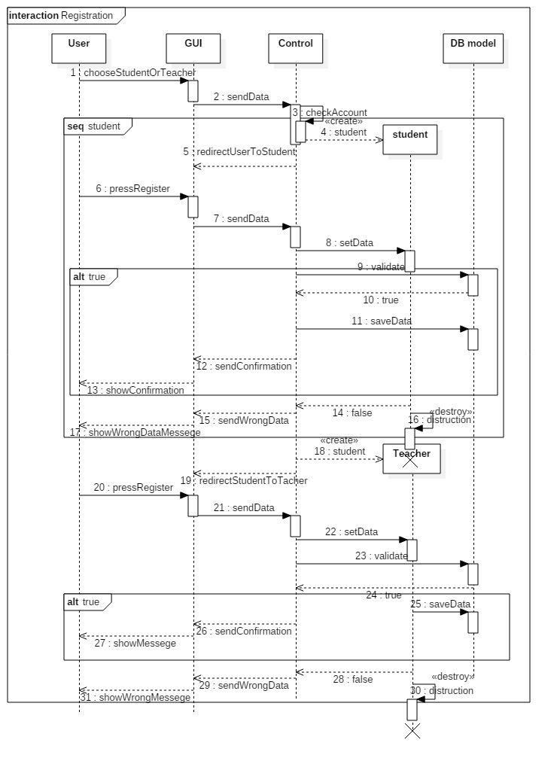

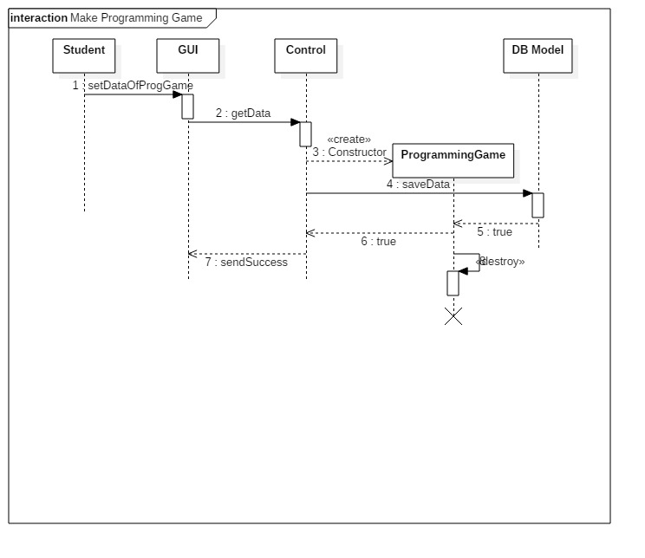

### 

### 

### 

### Class - Sequence Usage Table

Play Game =>ID 4

Making Programming Game =>ID 3

Making Science Game =>ID 2

Registration =>ID 1

| **Class Name** | **Sequence Diagrams** | **Overall used methods** |
| --- | --- | --- |
| DB Model | 1,2,3,4 | saveData,updateData,selectData |
| GUI | 1,2,3,4 | sendData,showData,redirectUsers |
| Control | 1,2,3,4 | createObjects,checkGames,makeGames,playGames and all objects methods |
| Student | 1,4 | Constructor, setters, getters |
| Teacher | 1,3,4 | Constructor, setters, getters |
| ProgrammingGame | 3,4 | Constructor, setters, getters |
| Science Game | 2,4 | Constructor, setters, getters |

# Ownership Report

|  |  |
| --- | --- |
| **Item** | **Owners** |
| Document Purpose and Audience | *Yasser Mohamed* |
| Class Diagrams | *Menna Allah Ali and Noura Mohamed Arafa* |
| Descriptions and responsibilities of the class | *Noura Mohamed* |
| Sequence Diagram | *Yasser Mohamed* |
| Class - Sequence Usage Table | *Yasser Mohamed* |

# GitHub:

<https://github.com/Noura-arafa/Science-Academy>