**REPORT**

**TWITTER vs BOTS**

Introduction: Twitter is a popular social media platform used by millions of people worldwide. Unfortunately, the platform is also home to a significant number of bots that can spread misinformation, amplify fake news, and manipulate public opinion. Detecting these bots is a crucial task to maintain the integrity of the platform and the trust of its users.

In this report, we will explore some of the techniques and tools used to detect Twitter bots.

Types of Twitter Bots: Twitter bots can be classified into different types based on their behavior and purpose. Some common types include:

1. Spam bots: These bots are designed to flood the platform with spam messages and links.
2. Malware bots: These bots use fake links to infect users with malware.
3. Political bots: These bots are used to spread propaganda, influence public opinion, and manipulate political discussions.
4. Follower bots: These bots are used to boost follower counts artificially and make an account appear more popular.

Techniques to Detect Twitter Bots: There are several techniques used to detect Twitter bots. Here are some of the most common:

1. Account Characteristics: One way to detect a bot is by looking at its account characteristics. Some characteristics that are often associated with bots include low tweet count, no profile picture or description, and low follower count.
2. Activity Patterns: Another way to detect a bot is by analyzing its activity patterns. Bots tend to post at regular intervals, and their tweets often have similar patterns and content.
3. Content Analysis: Analyzing the content of a tweet can also help detect bots. Bots tend to use similar phrases and hashtags, and their tweets often lack context or personalization.
4. Network Analysis: Network analysis can help detect bots by looking at the connections between accounts. Bots tend to form clusters or groups, and they often follow or retweet each other.

Tools to Detect Twitter Bots: Several tools can be used to detect Twitter bots. Here are some of the most popular:

1. Botometer: Botometer is a tool developed by Indiana University that uses machine learning to analyze Twitter accounts and detect bots.
2. Bot Sentinel: Bot Sentinel is a platform that uses artificial intelligence and machine learning to detect bots on Twitter.
3. Social Bearing: Social Bearing is a tool that allows users to analyze Twitter data, including detecting bots.

Conclusion: Twitter bots can pose a significant threat to the platform and its users. Fortunately, there are several techniques and tools that can be used to detect these bots. By using these tools and techniques, users can stay safe on the platform and help maintain its integrity.

**------------------------**

**Introducing BENFORD To ML**

In the context of detecting Twitter bots, Benford's law can be used to identify unusual patterns in the distribution of numbers associated with Twitter accounts, such as the number of followers or the number of tweets. The idea is that if a large number of Twitter accounts are created by bots, they may follow a pattern that deviates from what would be expected according to Benford's law.

To implement this approach, one would need to collect data on Twitter accounts, extract the relevant numerical data, and analyze it using statistical tools to check whether the data follows Benford's law. If the data does not follow the law, then it may suggest the presence of Twitter bots in the data.

However, it is important to note that the use of Benford's law alone may not be sufficient to accurately detect Twitter bots. Other statistical methods and machine learning techniques may also be required to achieve a high level of accuracy. Additionally, Twitter may have mechanisms in place to prevent or identify bots, so it may be necessary to take those into account as well.

**DATASET**

There are many publicly available datasets of Twitter accounts that can be used for research, analysis, or machine learning purposes. Some popular datasets include:

1. Twitter's API: Twitter provides access to their API which can be used to extract data on specific accounts or tweets. However, this requires a Twitter developer account and may have limitations on the amount of data that can be accessed.
2. Twitter User Dataset: This is a dataset that contains over 88,000 user profiles scraped from Twitter. It includes information such as user IDs, usernames, account creation date, follower/following count, and location.
3. Fake News Corpus: This dataset contains a collection of tweets labeled as either fake news or real news. The dataset can be used to train machine learning models to classify tweets as real or fake.
4. GeoSocial Gauge Dataset: This dataset contains geolocated tweets from various cities around the world. It can be used to analyze the sentiment of tweets from different locations.
5. Sentiment140 Dataset: This dataset contains 1.6 million tweets that are labeled as either positive, negative, or neutral. It can be used to train sentiment analysis models.

**----------------------------**

**Tools and Utilities**

Additionally to previous ones like: Botometer, Bot Sentinel, Social Bearing; There are a few machine learning tools that can be used in conjunction with Benford's law to detect bot profiles on Twitter. Some of these tools are:

1. Data preprocessing tools: Preprocessing the data is an important step before applying any machine learning algorithm. There are several tools available for data preprocessing, such as Python's Pandas library or Excel. These tools can be used to extract the relevant numerical data from Twitter profiles and prepare it for analysis.
2. Statistical analysis tools: Once the data has been preprocessed, statistical analysis tools can be used to check whether the data follows Benford's law. These tools include R, Python's SciPy library, and Excel. These tools can be used to plot the data, calculate the distribution of first digits, and compare it with the expected distribution according to Benford's law.
3. Machine learning algorithms: After analyzing the data using statistical tools, machine learning algorithms can be applied to detect bot profiles. One such algorithm is Random Forest, which is a classification algorithm that can be used to classify Twitter profiles as either bot or human based on the features extracted from their numerical data. Other algorithms that can be used include Support Vector Machines (SVMs) and Neural Networks.
4. Visualization tools: Visualization tools can be used to visualize the data and the results of the analysis. These tools include Python's Matplotlib and Seaborn libraries, R's ggplot2 library, and Excel.

**----------------------------**

**how to use machine learning to analyze and differ between real accounts and bot accounts(STEPS)**

1. Data Collection: Collect a large dataset of Twitter account data. This should include attributes such as the number of followers, the number of tweets, the frequency of tweeting, the sentiment of the tweets, the account creation date, and other features that can be used to distinguish between real accounts and bots.
2. Data Preprocessing: The data must be preprocessed and cleaned to remove any duplicates or irrelevant information. The data must also be normalized to make it suitable for machine learning algorithms.
3. Feature Engineering: Extract features from the data that can be used to train a machine learning model. For instance, features such as the frequency of tweeting, the sentiment of the tweets, the account creation date, and the number of followers can be used to train a model to distinguish between real accounts and bots.
4. Model Selection: Choose a suitable machine learning model for the classification task, such as decision trees, support vector machines (SVM), random forest, or deep learning models. These models can be trained on the features extracted from the data.
5. Model Training: Train the selected model on the preprocessed data. This involves dividing the data into training and testing sets and fitting the model to the training data.
6. Model Evaluation: Evaluate the performance of the trained model using evaluation metrics such as accuracy, precision, recall, and F1 score. The model may need to be retrained or optimized based on the evaluation results.
7. Model Deployment: Deploy the trained model to classify new Twitter accounts as either real accounts or bot accounts.

-STEP ONE: is more or less completed (must be revised and completed but only when we’re able to know which type of data we intend to be using -we’ve already gathered a considerable number of useful datasets + we have acquired a Twitter developer account which enables us to use the Twitter API to scrape their data but it can be limiting since our study requires sometimes a wide range of data -)

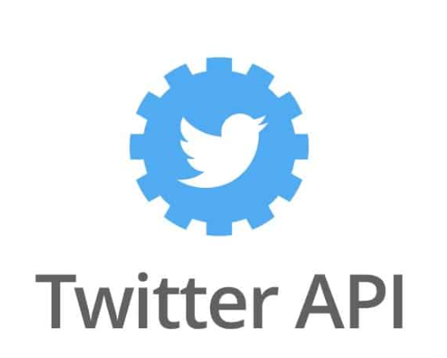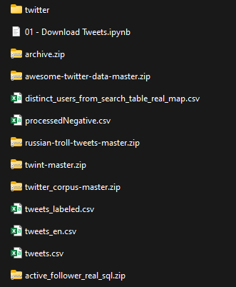

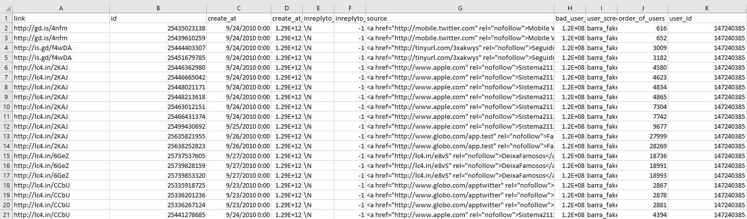

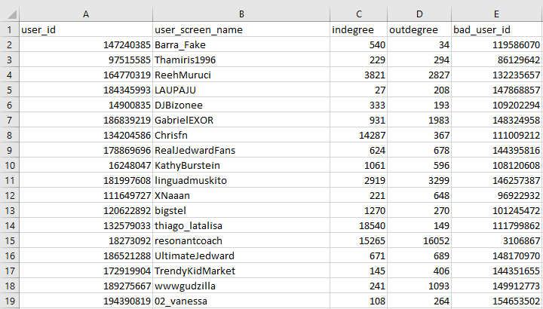

-Some samples of the collected data

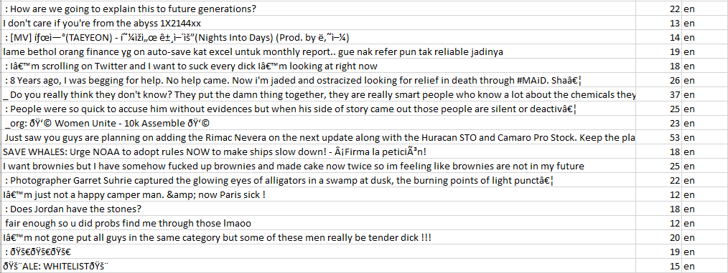

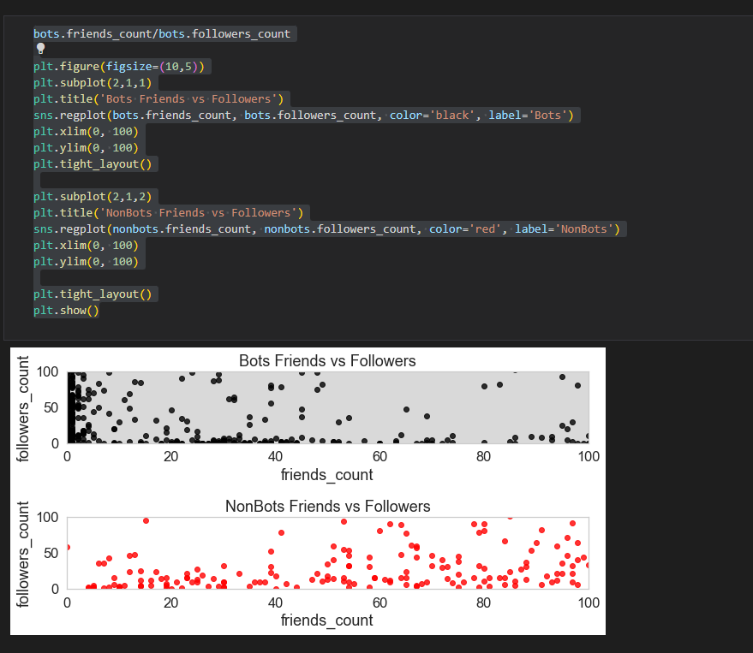-STEP TWO: since we found some Implementation of the path we similarly out to be following (different at various points); we have an idea of how the data should be shaped in the preprocessing , but with the change of the tools to be used in the procedure, the shape of data could be radically changed (can’t be confirmed until further information on what tools are going to be used next)

-Implementing Different Models (Decision Tree Classifier)

