**Mini Case Study**

*select the most popular client_Type based on a count of the number of users who have at least 50% of their events from the following list: ‘video call received’, ‘video call sent’, ‘voice call received’, ‘voice call sent’.*

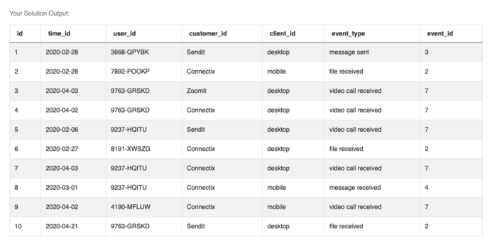

CREAT DATA

WITH MSevents

AS

(

SELECT id , time_id , user_id , customer_id , client_id , event_type , event_id

FROM(VALUES

(1,'366-QBG','2020-02-28', 'Sendit', 'Desktop', 'message sent' , 3),

(2,'367-QBG','2020-02-28', 'Connectix', 'mobile', 'file received' , 2),

(3,'368-QBG','2020-04-03', 'Zoomit', 'Desktop', 'video call received', 7),

(4,'366-QBH','2020-04-02', 'Connectix', 'Desktop', 'video call received', 7),

(5,'362-QBG','2020-02-06', 'Sendit', 'Desktop', 'video call received', 7),

(6,'316-QBG','2020-02-27', 'Connectix', 'Desktop' , 'file received' , 2),

(7,'456-QBG','2020-04-03', 'Connectix', 'Desktop', 'video call received', 7),

(8,'366-FBG','2020-03-01', 'Connectix', 'mobile' , 'message received' , 4),

(9,'366-QMG','2020-04-02', 'Connectix', 'mobile', 'video call received', 7),

(10,'336-QBG','2020-04-21', 'Sendit' , 'Desktop', 'file received' , 2))

Val(id , time_id , user_id , customer_id , client_id , event_type , event_id))

select * from MSevents

--write your code here

SELECT *

FROM tab