# Ahmed Almaskari

**CCNP Switching project**

# ALS1:

Show int trunk

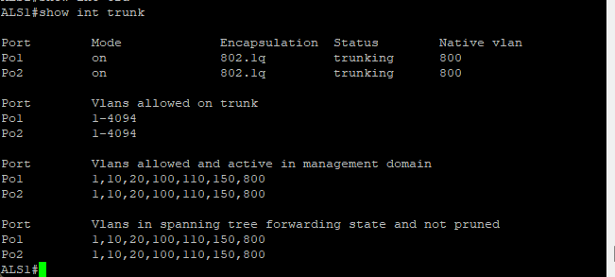

Show etherchannel sum

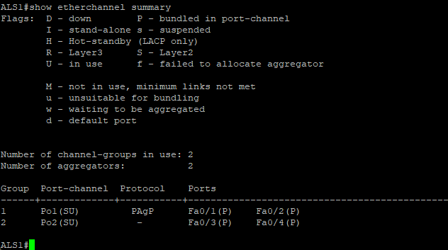

Show vtp status

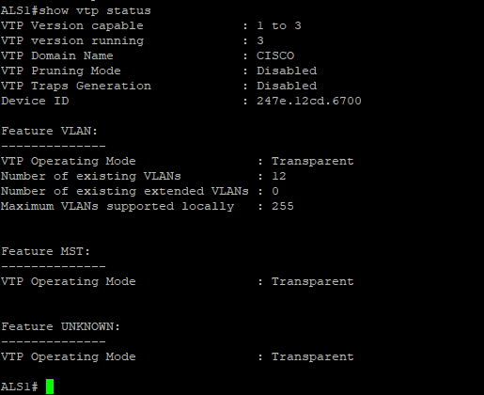

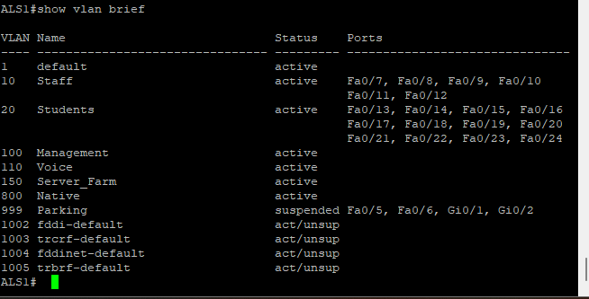Show vlan bri

Show span mst config

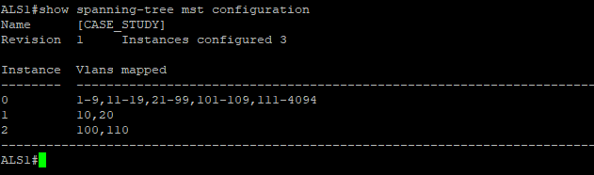

Show span root

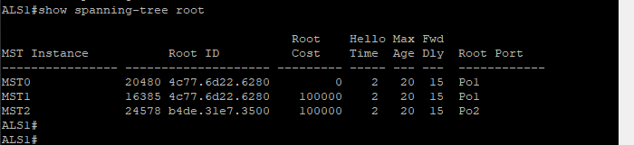

Show run | section span

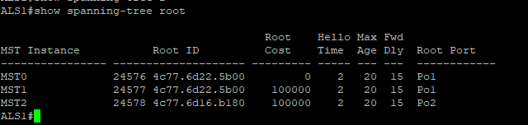

Show ip int brie | exclude unassigned

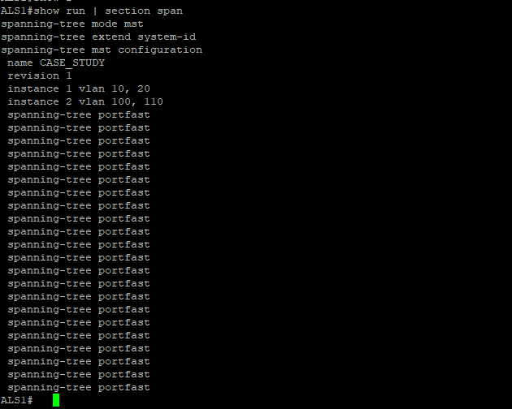

Sh ip dhcp snooping

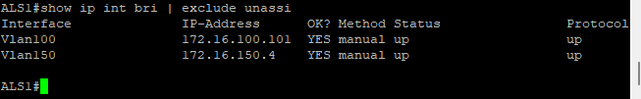

Show port-security

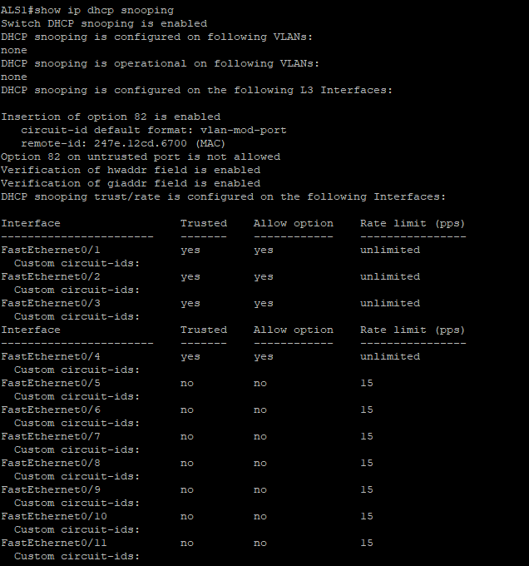

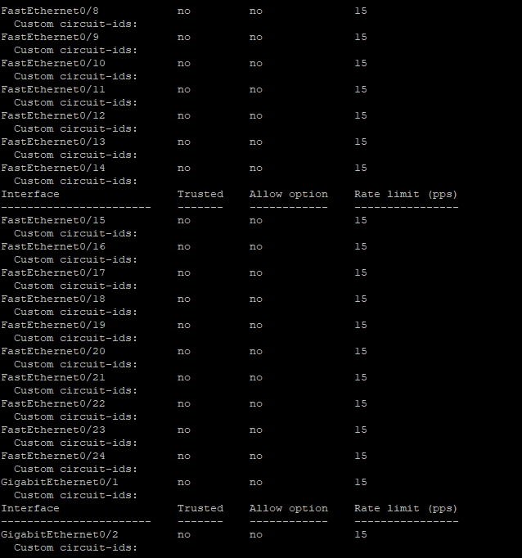

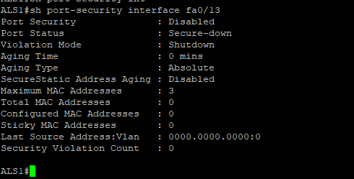Shpw access-list

Show ip int | include line | list

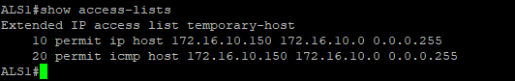

Show run | section vlan access-map

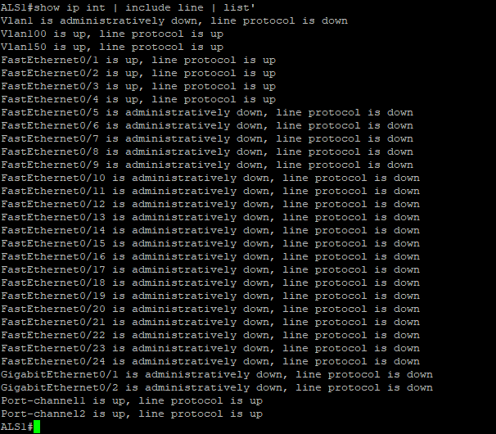

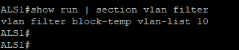Show run | section vlan filter

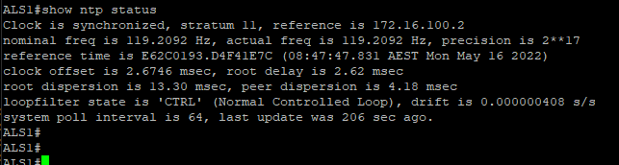Show ntp status

Show ntp association

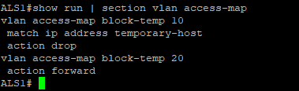

# ALS2

Show int trunk

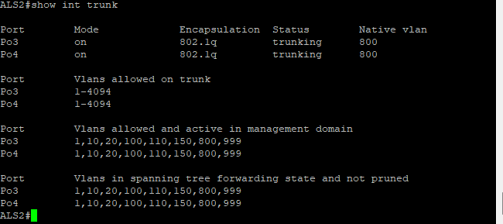

Show etherchannel sum

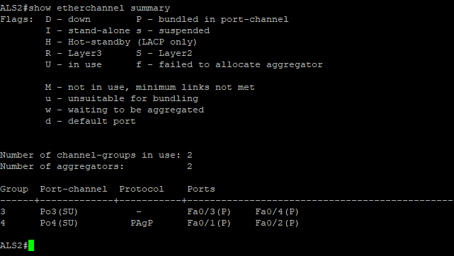

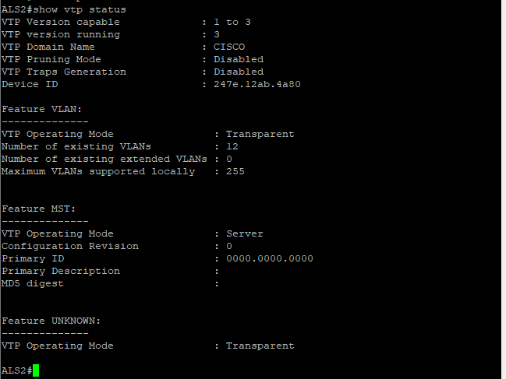Show vtp status

Show vlan bri

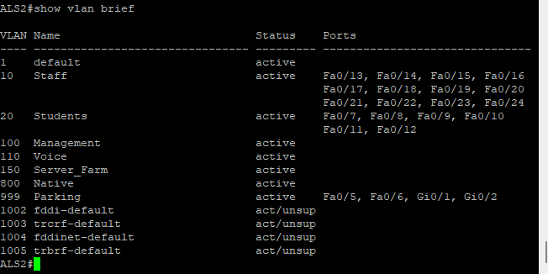

Show span mst config

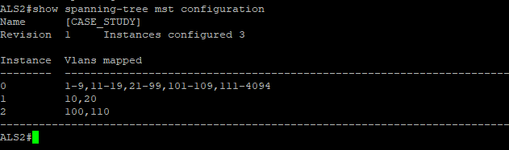

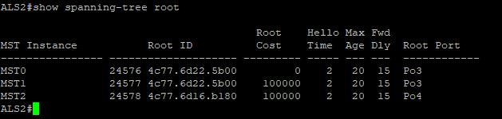Show span root

Show spanning-tree root

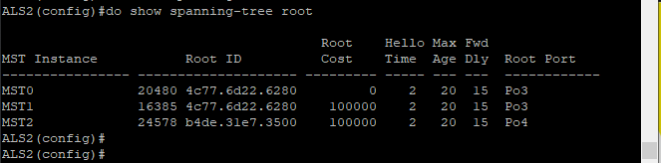

Show run | section span

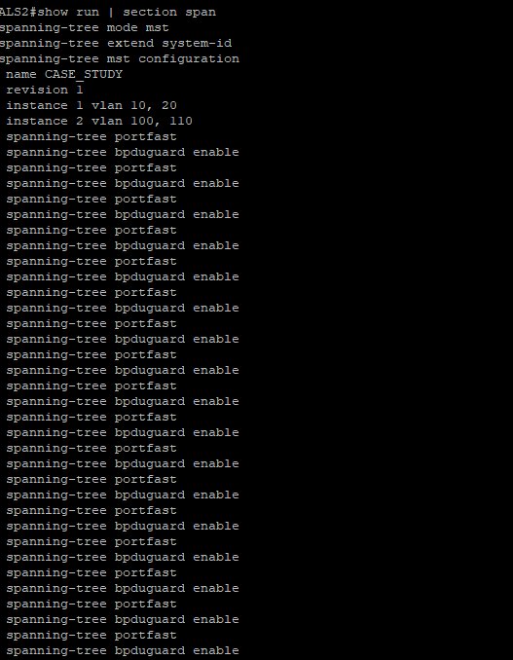

Show ip int brie | exclude unassigned

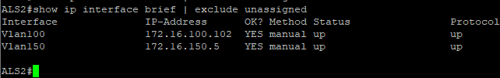

Sh ip dhcp snooping

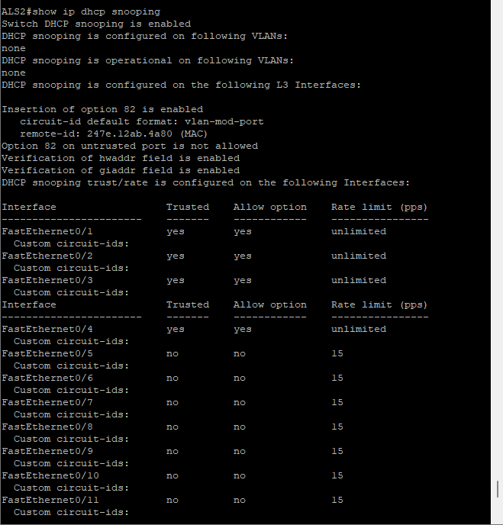

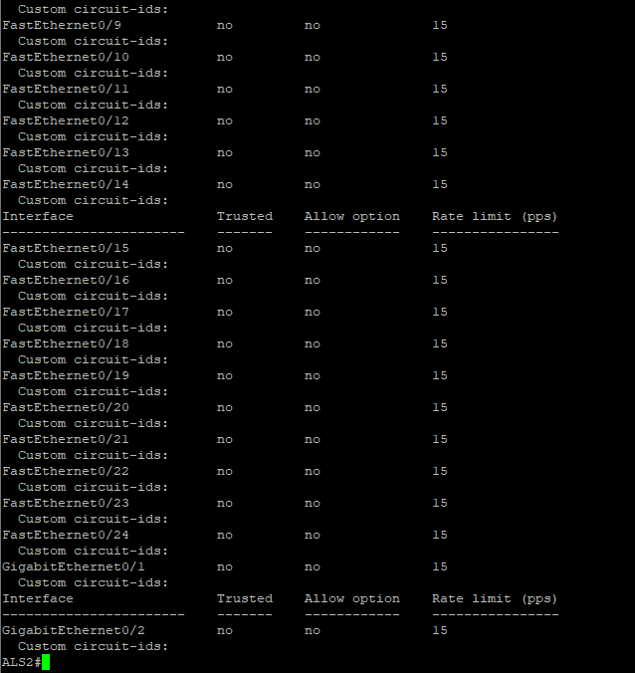

Show port-security

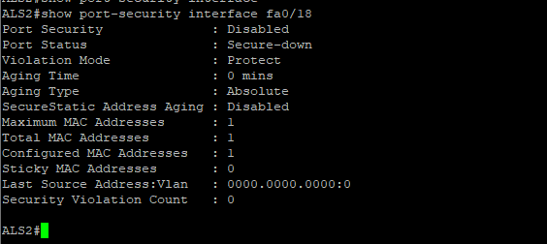

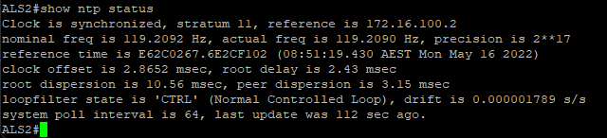show access-list

Show ip int | include line | list

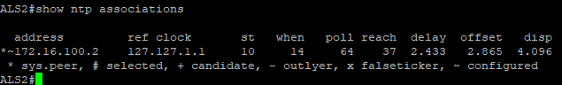

# DLS1

Show int trunk

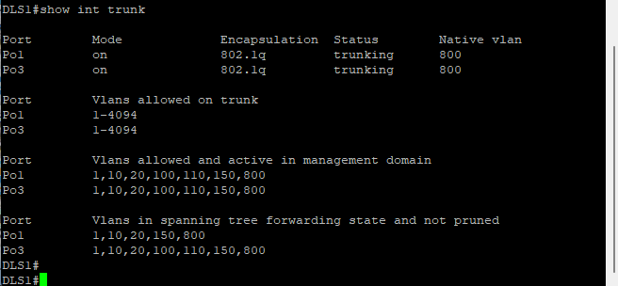

Show etherchannel sum

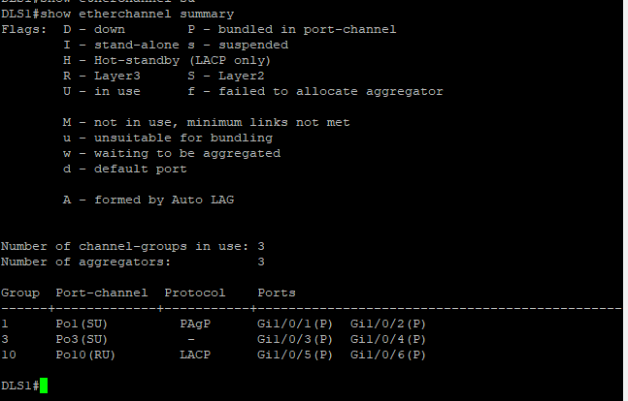

Show vtp status

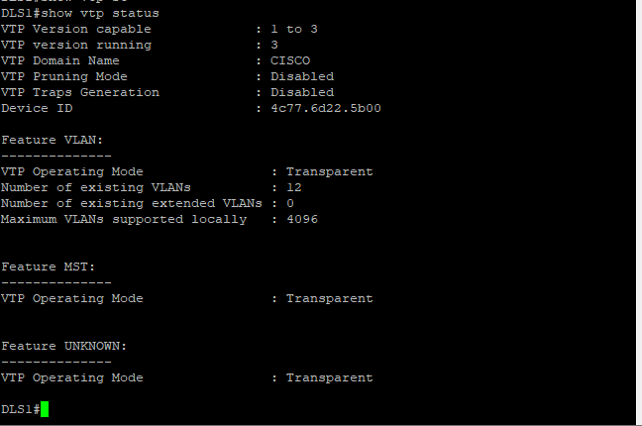

Show vlan bri

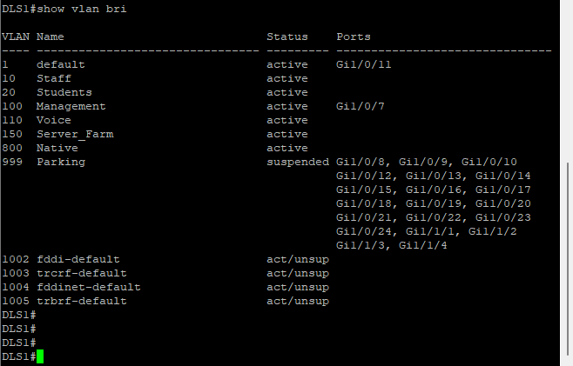

Show span mst config

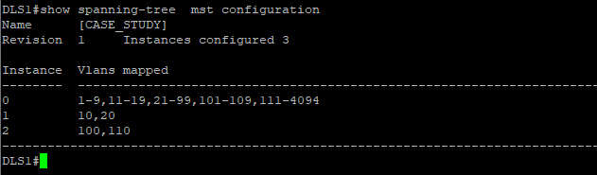

Show spanning-tree root:

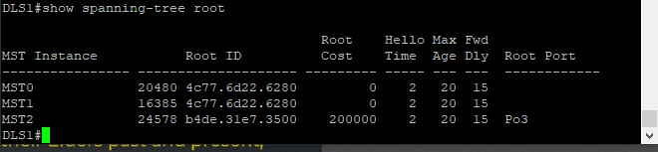

Show run | section span

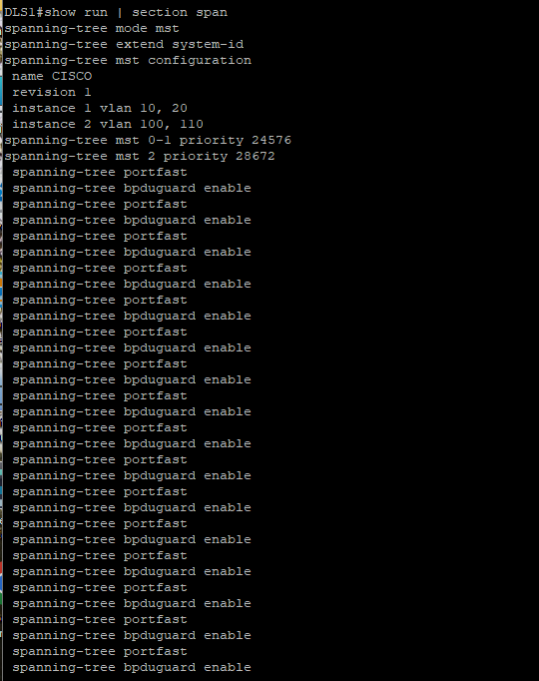

Show ip int brie | exclude unassigned

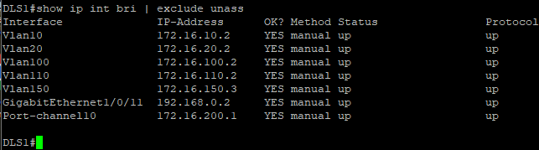

Sh stand bri

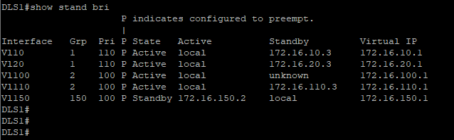

Show run | section track

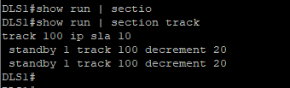

Show run | section ip dehcp relay



Show access-lists

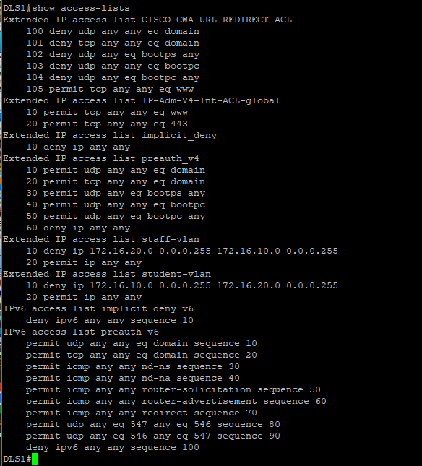

Show ip int | include line | list

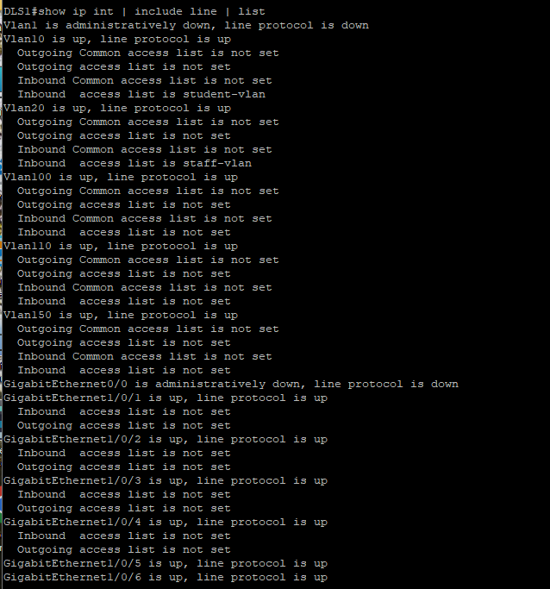

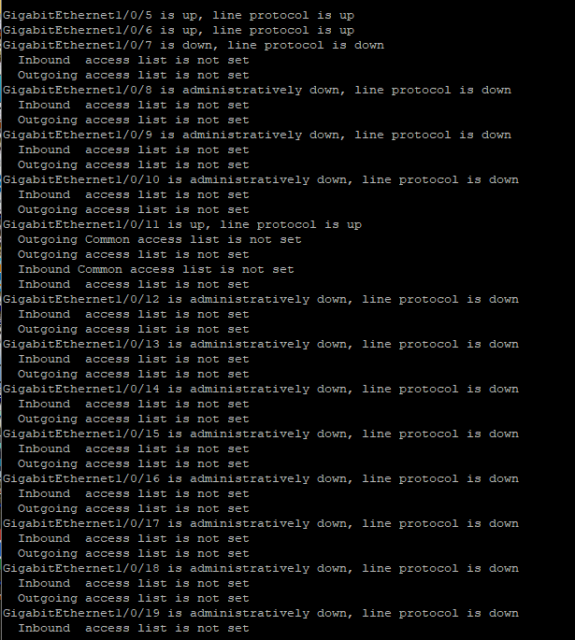

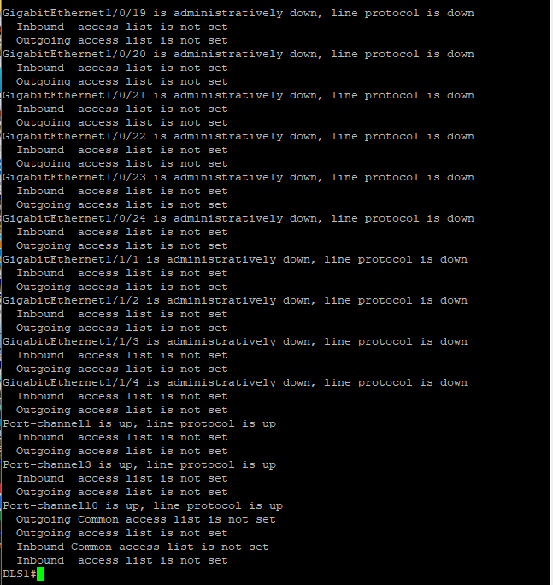

Show vtp status

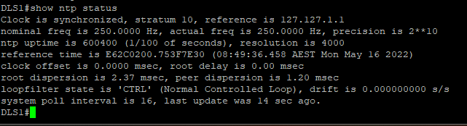

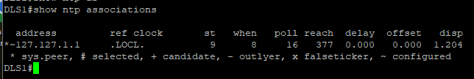Show vtp associations

Show ip route:

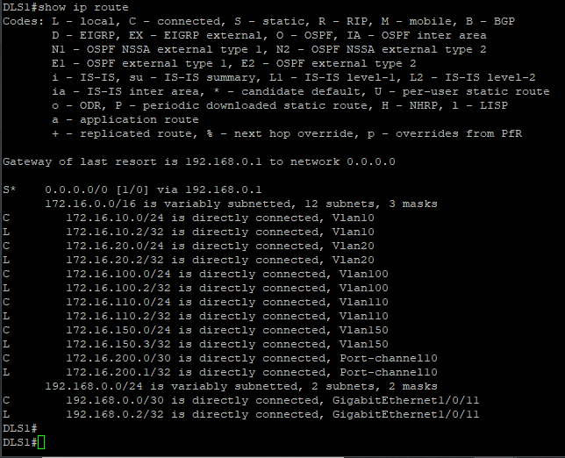

# DLS2

Show int trunk

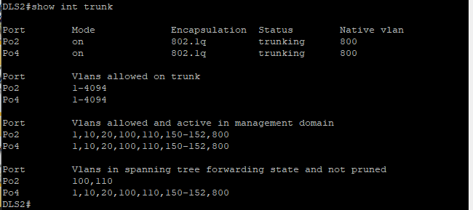

Show etherchannel sum

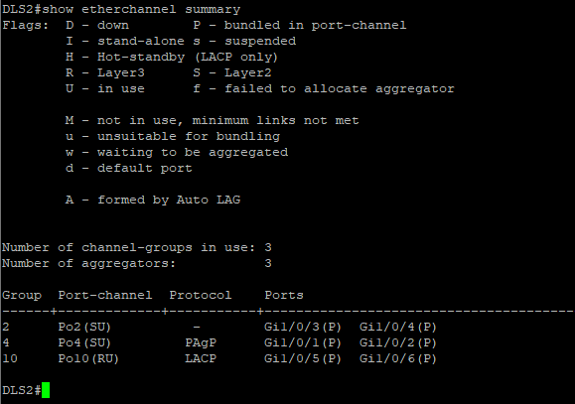

Show vtp status

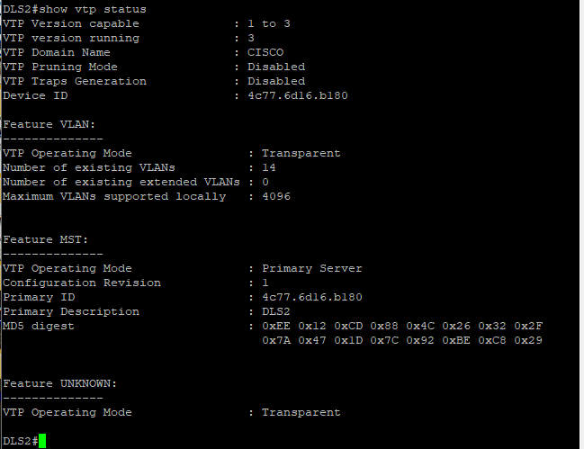

Show vlan bri

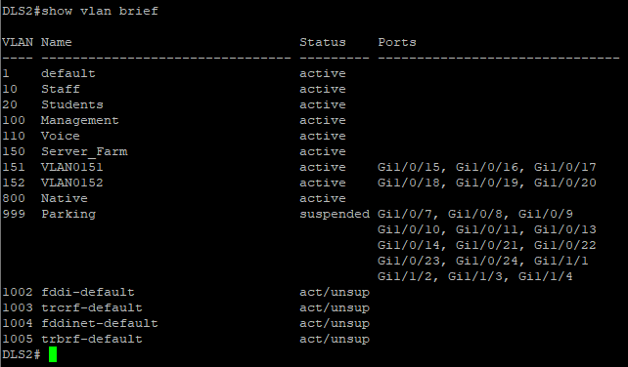

Show span mst config

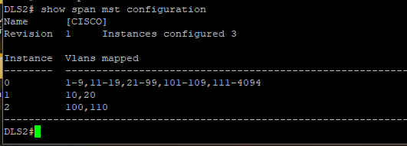

Show spanning-tree root

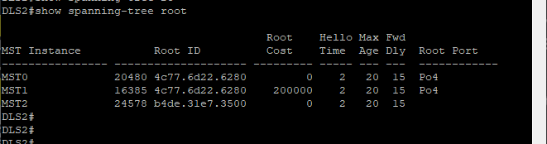

Show run | section span

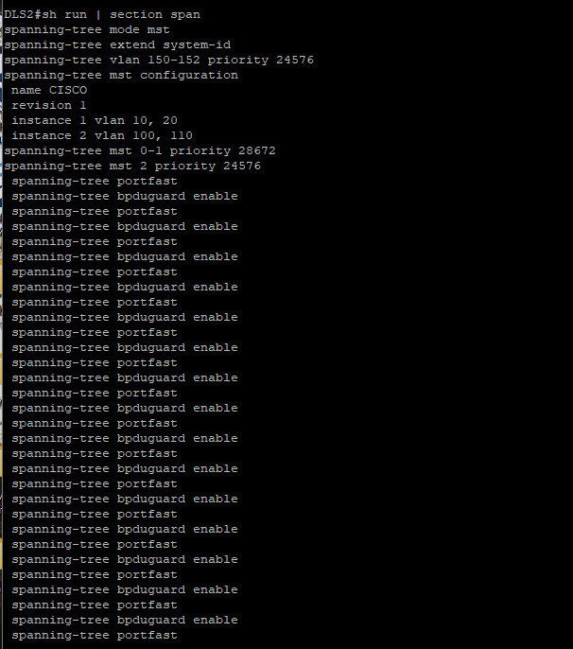

Show ip int brie | exclude unassigned

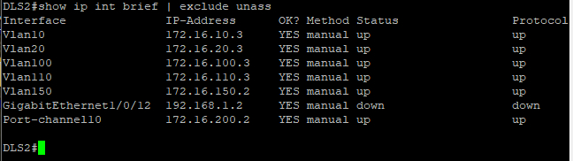

Show stand bri

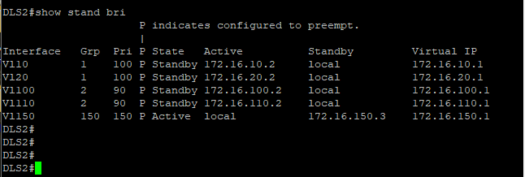

Show run | section track

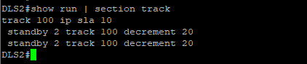

Show run | section ip dhcp relay



Show access-lists

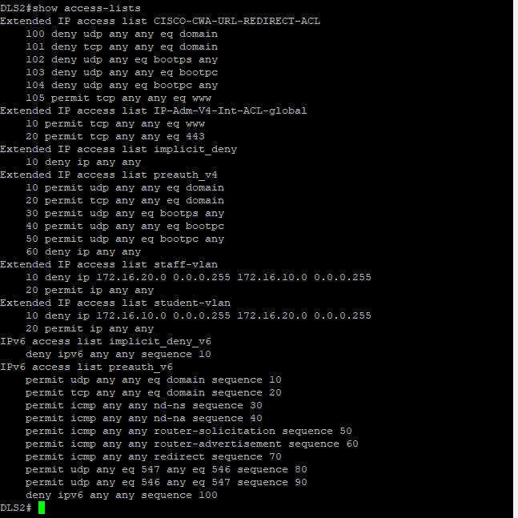

Show ip int | include line | list

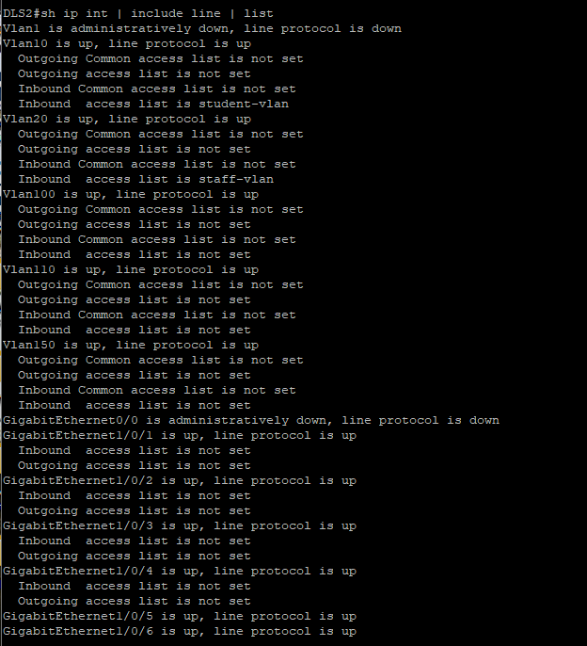

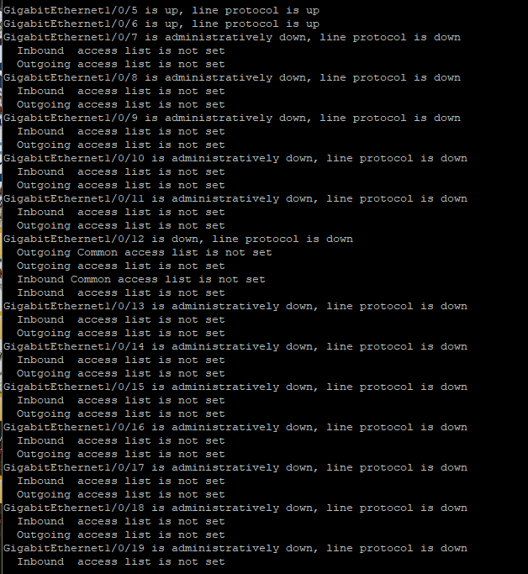

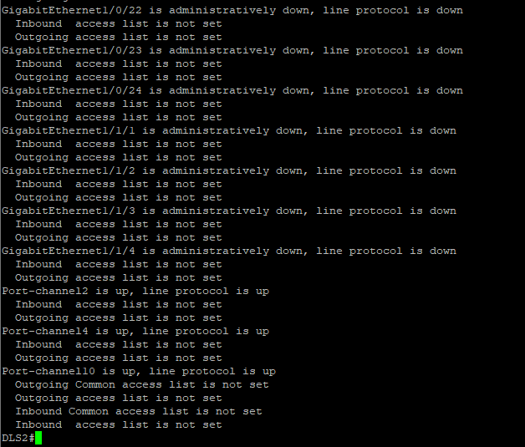

Show ntp status:

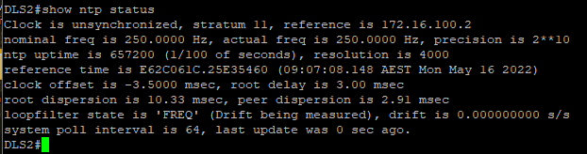

Show ntp associations

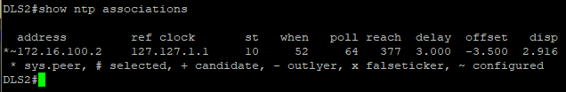

Show vlan private-vlan

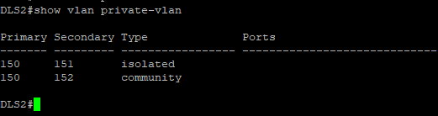

Show vlan private-vlan type

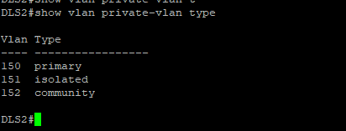

Show ip route

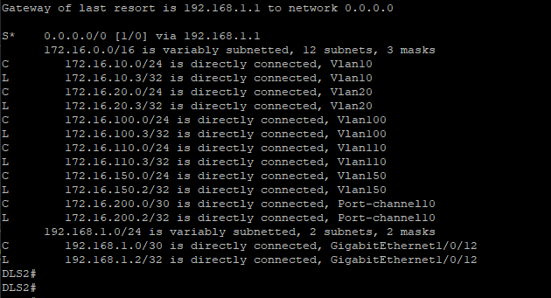

# GATEWAY

Show ip route :

