FALCON test case: PT_H_fluxBC

Author: Yidong Xia (INL)

Description: P-T based simple mass balance (normalized parameters). Fix flux BC (a fixed value of **q•n**) is prescribed to the left boundary.

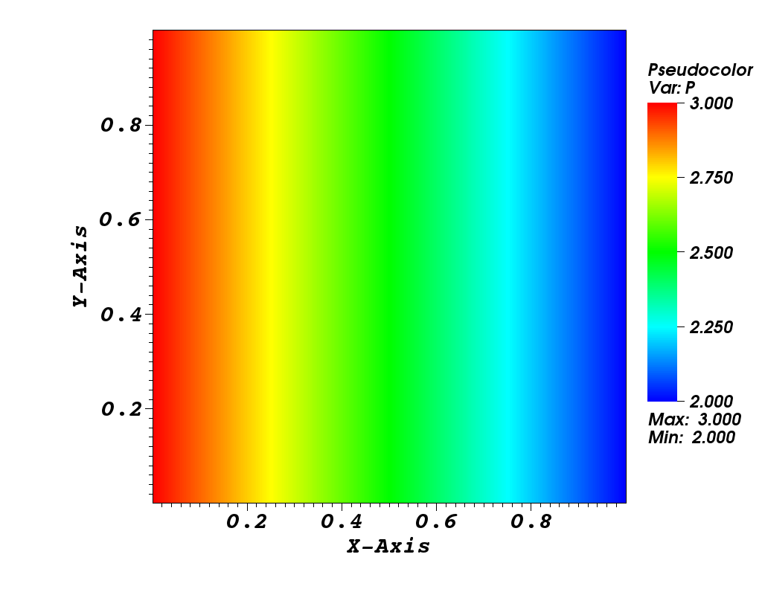

Pressure distribution