FALCON test case: PT_H_gravity

Author: Yidong Xia (INL)

Description: P-T based simple mass balance due to gravity

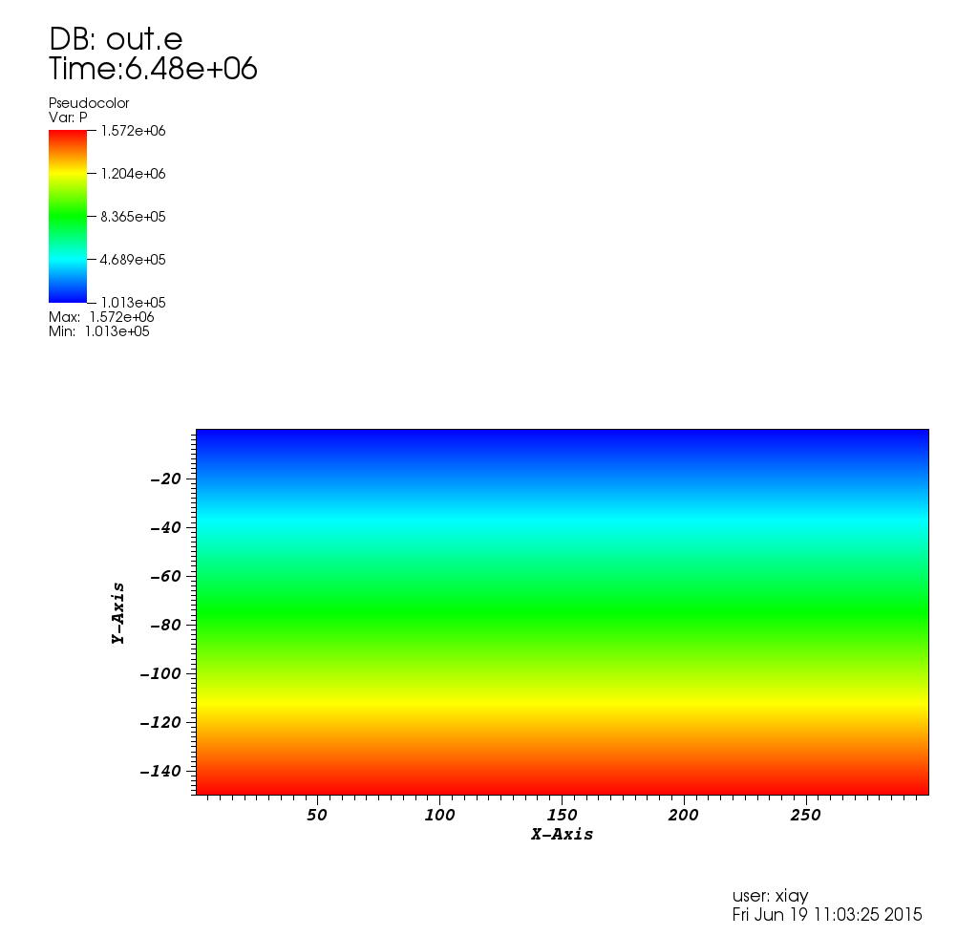

Pressure distribution