FALCON test case: PT_TH_faust

Author: Yidong Xia (INL)

Description: P-T based coupled mass & energy balance (using water-steam EOS)

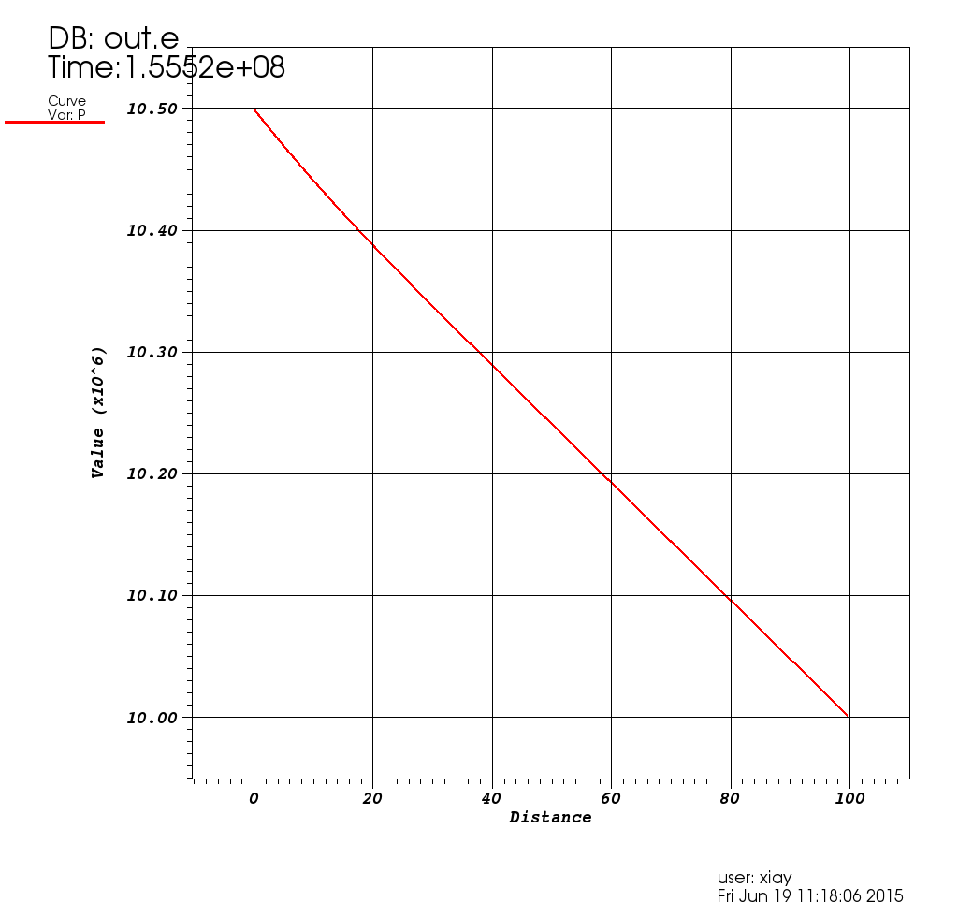

Pressure distribution

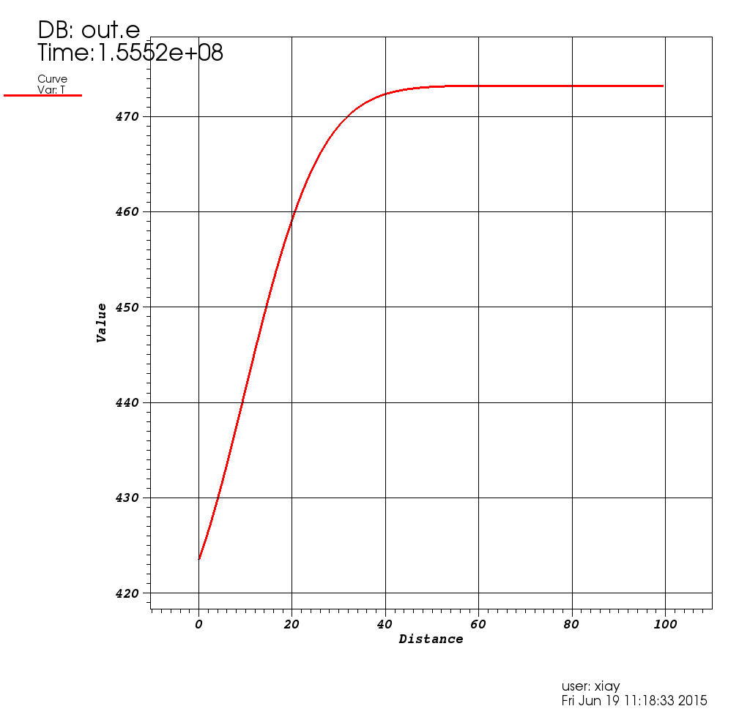

Temperature distribution