FALCON test case: PT_T_conduction

Author: Yidong Xia (INL)

Description: P-T based simple energy conduction.

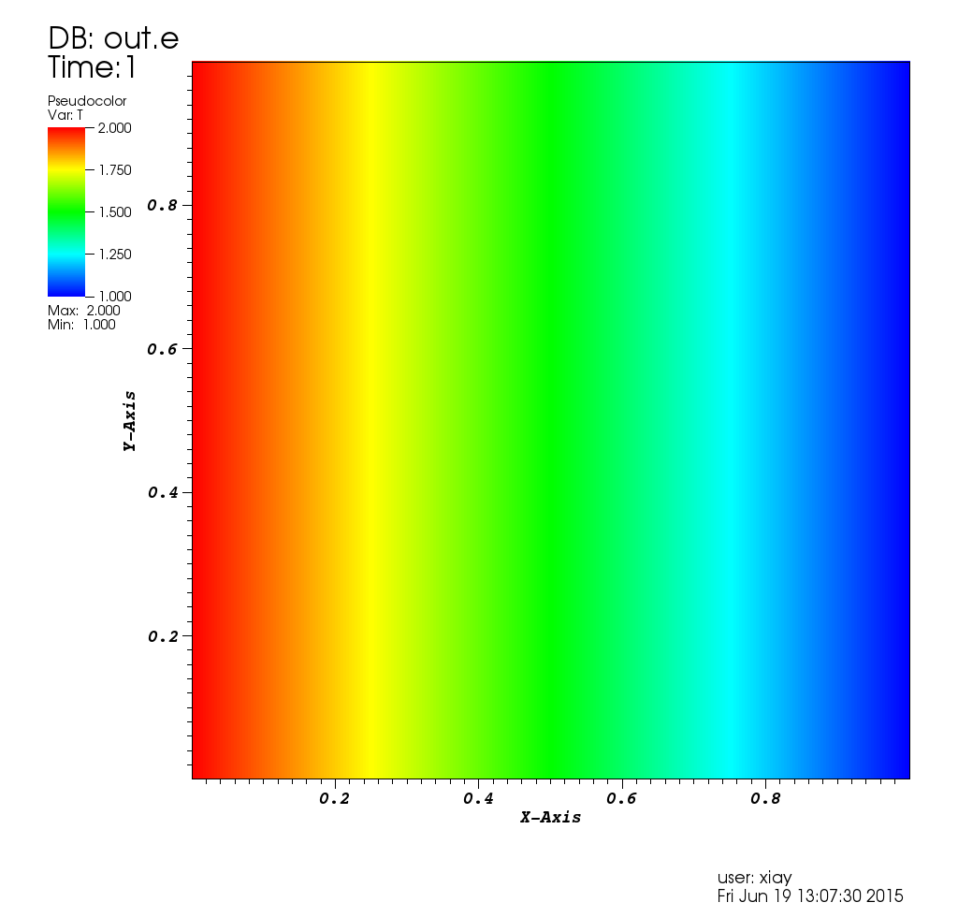

Temperature distribution