FALCON test case: PT_H_diffusion

Author: Yidong Xia (INL)

Description: P-T based simple mass balance (normalized parameters)

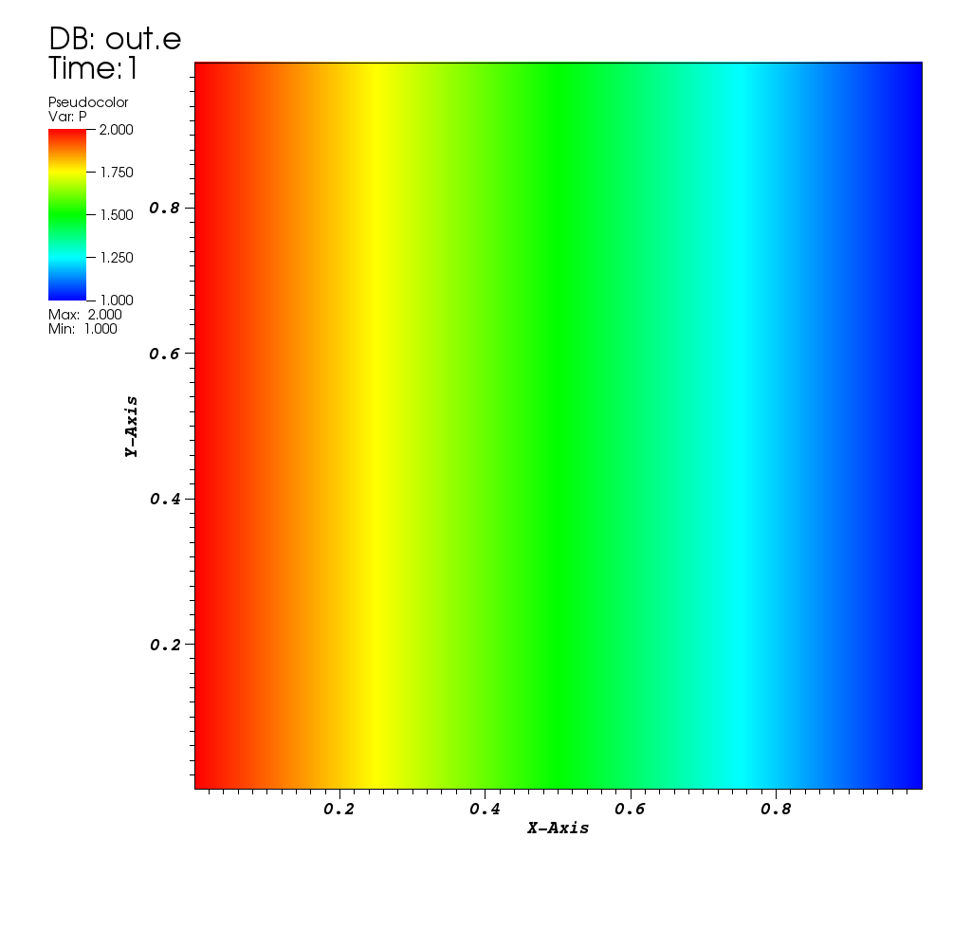

Pressure distribution