FALCON test case: PT_TH_elder

Author: Yidong Xia (INL)

Description: P-T based coupled mass & energy balance – thermally induced buoyant convection and instability (using water-steam EOS)

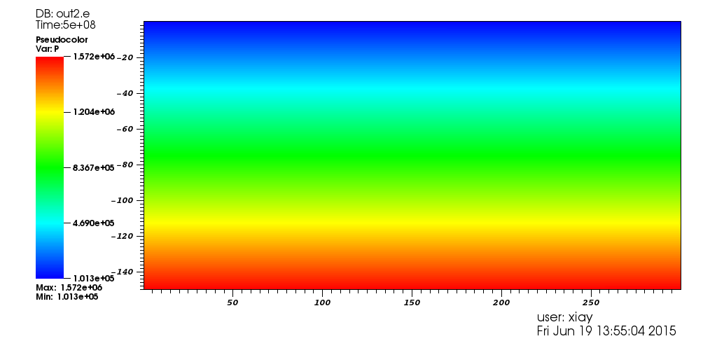

Pressure distribution

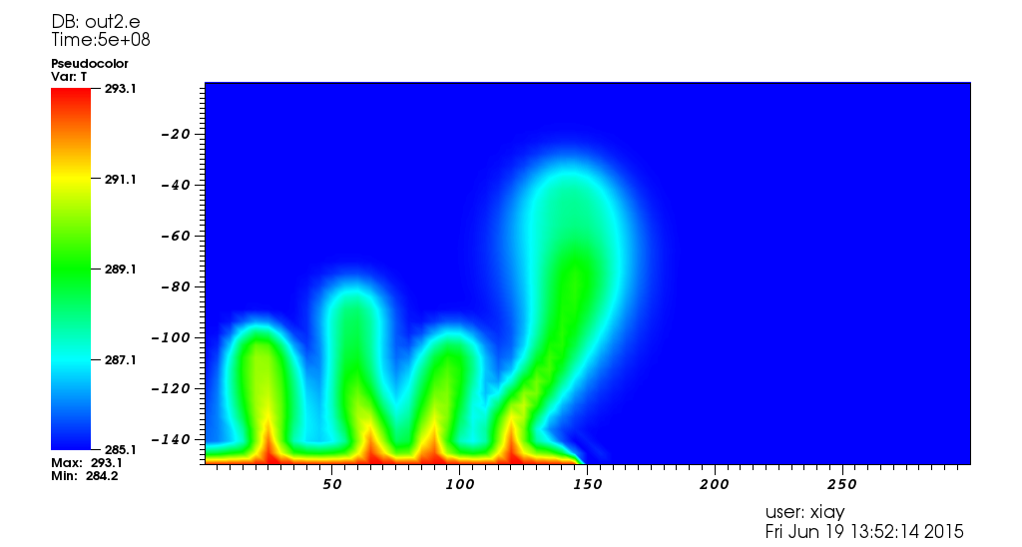

Temperature distribution