FALCON test case: PT_T_convection

Author: Yidong Xia (INL)

Description: P-T based energy convection.

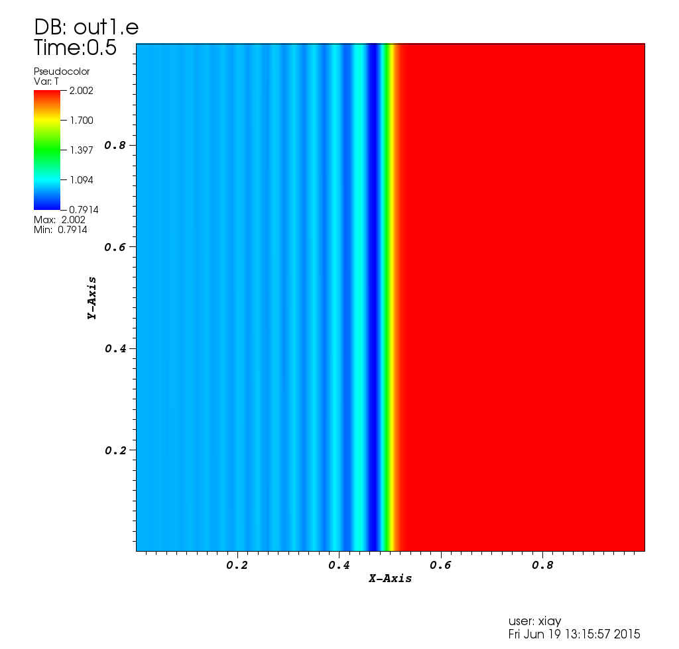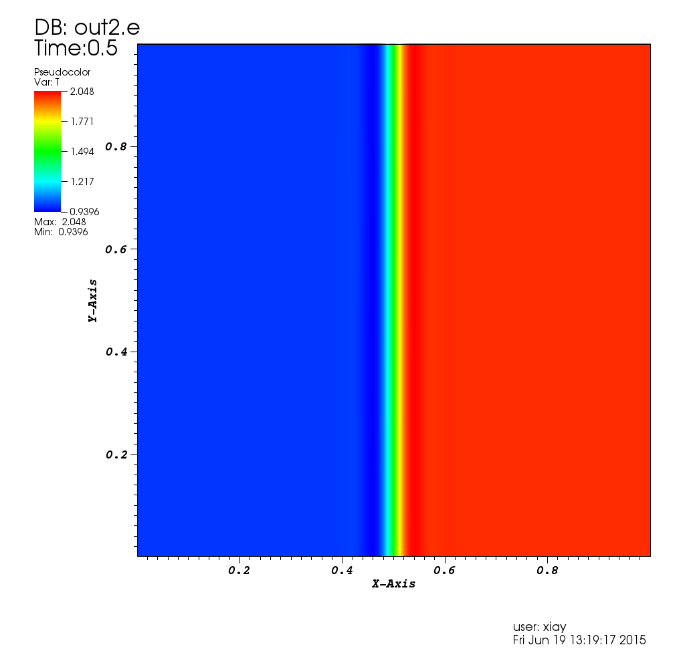

Left: no stabilization; Right: SUPG stabilization

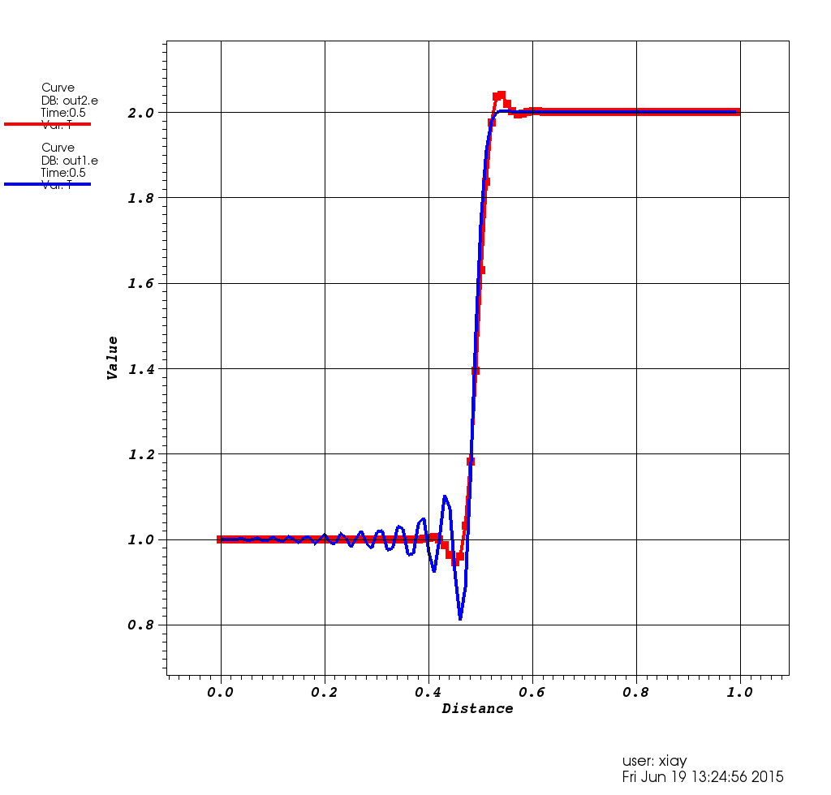

Blue curve: no stabilization; Red curve: SUPG stabilization