PT_CONST_FR_2D_1:

Problem Description

THM problem - thermal stimulation of multiple intersecting non-uniform fractures. Cold water is injected, causing contraction of the surrounding rock and dilation of the fractures. A predefined fracture distribution is provided (265mX710m_varying_fractures.txt) and mesh adaptivity used to accurately capture the discrete fractures. During simulation time, adaptive mesh refinement/coarsening is used to refine the mesh in regions of high temperature gradient jumps. Simulation time is 1e9 seconds (31.7 years).

Model Set-Up

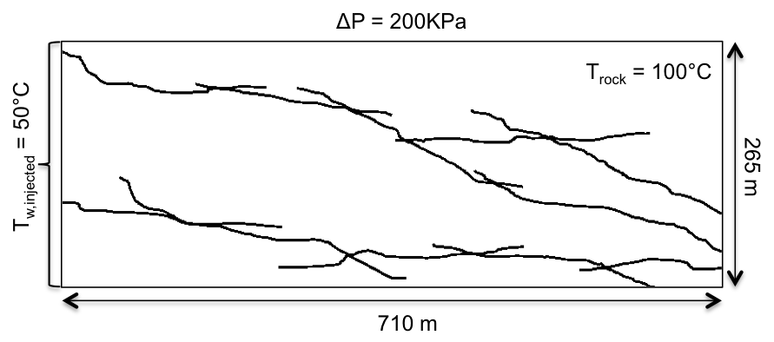

Properties

|  |  |  |  |
| --- | --- | --- | --- |
|  | Rock Matrix | Fractures | Unit |
| Porosity | 0.01 | 1.00E-05 | [n/a] |
| Permeability | 1.00E-17 | 1.00E-11 | [m^2] |
| Density (rock) | 2500 | 2500 | [kg/m^3] |
| Density (water) | 1000 | 1000 | [kg/m^3] |
| Specific Heat (rock) | 920 | 920 | [J/kg] |
| Specific Heat (water) | 4186 | 4186 | [J/kg] |
| Thermal Conductivity | 2 | 100 | [W/m.K] |
| Thermal Expansion | 2.00E-05 | 4.20E-02 | [1/K] |
| Youngs Modulus | 1.00E+10 | 1.50E+07 | [Pa] |
| Viscosity | 1.00E-03 | 1.00E-03 | [Pa.s] |
| Strain Perm. Change | no | no |  |