PT_CONST_STD_2D_1:

Problem Description

THM problem - thermal stimulation of a single horizontal fracture. The fracture is modeled by a 1m thick high permeability porous media region (block 2), making it equivalent to a 1e-5 m fracture, capped by two low permeability regions (block 1 & 3). Cold water is injected, causing contraction of the surrounding rock and dilation of the fracture. Mesh and time step adaptivity are used.

Model Set-Up

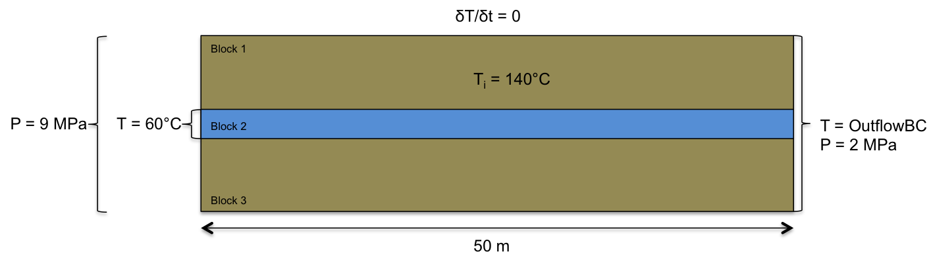

Block Properties

|  |  |  |  |
| --- | --- | --- | --- |
|  | Block 1 & 3 | Block 2 | Unit |
| Porosity | 0.01 | 1.00E-05 | [n/a] |
| Permeability | 1.00E-17 | 1.00E-11 | [m^2] |
| Density (rock) | 2500 | 2500 | [kg/m^3] |
| Density (water) | 1000 | 1000 | [kg/m^3] |
| Specific Heat (rock) | 920 | 920 | [J/kg] |
| Specific Heat (water) | 4186 | 4186 | [J/kg] |
| Thermal Conductivity | 2 | 0.58 | [W/m.K] |
| Thermal Expansion | 2.00E-05 | 4.20E-02 | [1/K] |
| Youngs Modulus | 1.00E+10 | 1.50E+07 | [Pa] |
| Viscosity | 1.00E-03 | 1.00E-03 | [Pa.s] |
| Strain Perm. Change | no | yes |  |