


VMware Vsphere Cluster Project
Prepared by:
Adham Mamdouh El-Sherbini
Ahmed Mahmoud Amer
Marwan Yasser Sabry
Mohamed AbdelRahman Anwar
Under Supervision of:
Eng.Ekram Abdelwahabnour

Table of Contents:

Introduction: 3
Architecture Overview: 3
Configuring static IPs for all servers: 4
On ESXI servers: 4
On NFS server: 8
Deploying vCenter appliance: 8
Adding ESXI hosts to Cluster: 17
Configuring HA for the vSphere cluster: 22
Configuring vSphere DRS: 23
Network Configuration: 24
NFS Shared Storage Setup: 27
Creating Content Library: 31
Creating a New Virtual Machine: 34
Clone an Existing Virtual Machine: 40
Create a snapshot of VM: 44
Convert a VM to a template: 45
Testing Migration: 46
Testing HA: 50
Testing Fault Tolerance: 52

Introduction:
This project aims to design and implement a VMware vSphere environment by deploying multiple ESXi hosts and a centralized vCenter Server. The setup demonstrates core virtualization concepts such as clustering, shared storage, networking, and advanced features like vMotion, High Availability (HA), Distributed Resource Scheduler (DRS), and Fault Tolerance (FT). The environment provides a practical lab for managing virtual machines and validating enterprise level virtualization capabilities.

Architecture Overview:
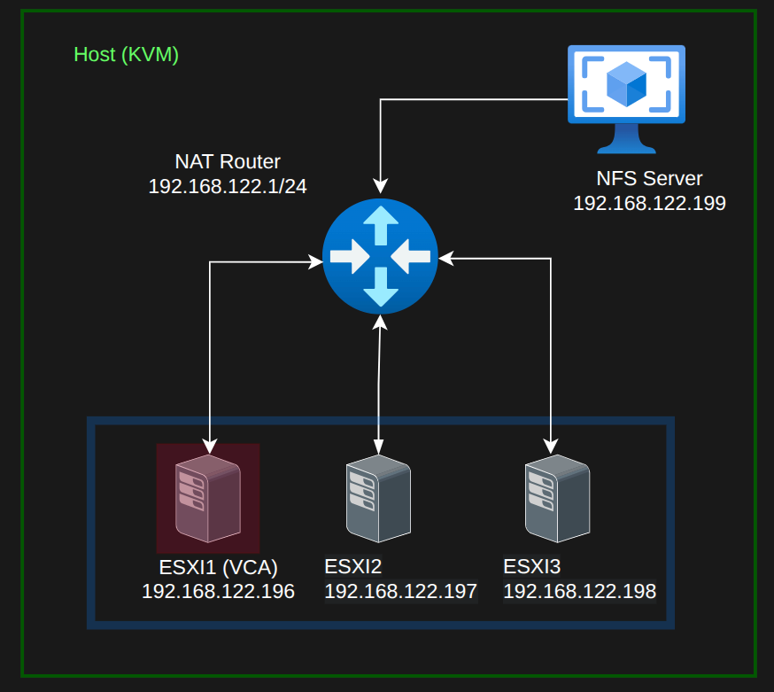

- ESXI Hosts:
- ESXI1 hosts the vCenter Server Appliance and has 4 vCpus, 20 GB of RAM and 500GB of storage on 2 drives (50 GB for the hypervisor and 500 GB for additional storage).
- ESXI2, ESXI3 each server has 4 vCpus, 4 GB of RAM and 100GB of storage on 2 drives (50 GB for the hypervisor and 50 GB for additional storage).
- NFS Server: RHEL 9 Server to act as an NFS shared Datastore for the ESXI cluster and it is configured with 2 vcpus and 2 GB of RAM.
- All of these servers have 2 NICs and are virutalized on a Linux system (Fedora 43) using KVM and are connected to each other using a NAT network setup.

Configuring static IPs for all servers:

On ESXI servers:
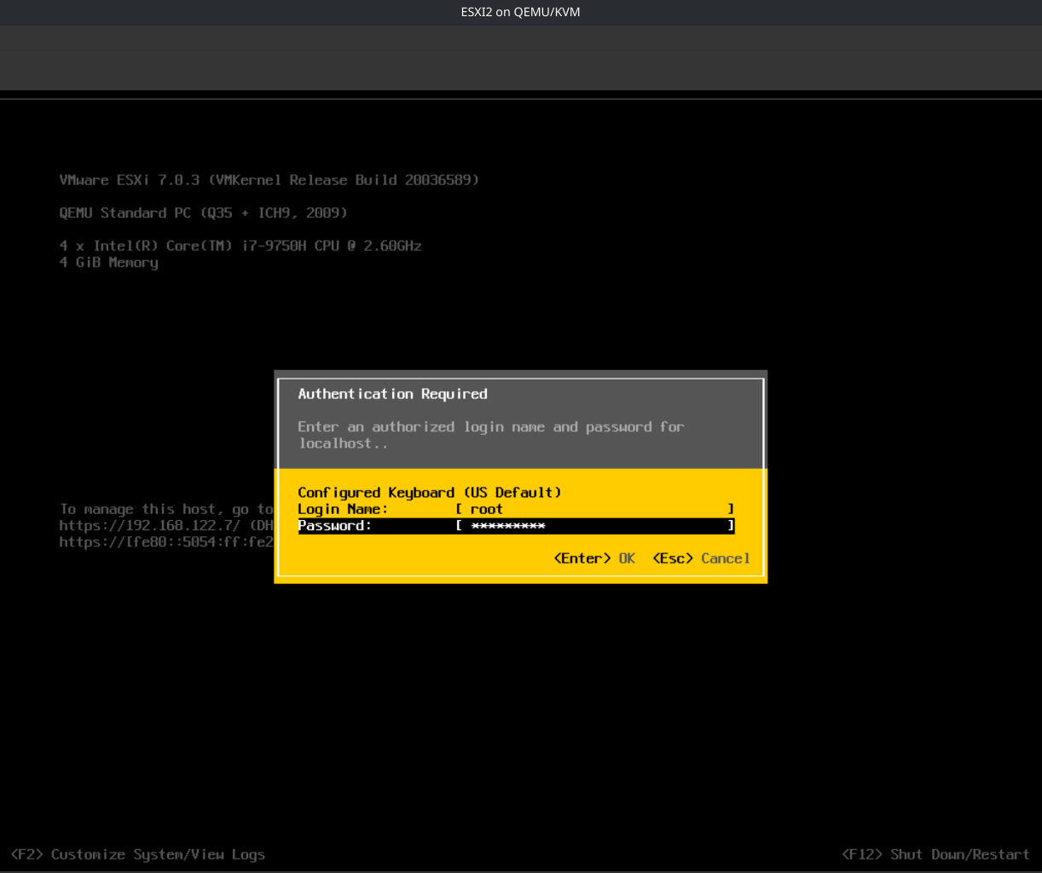

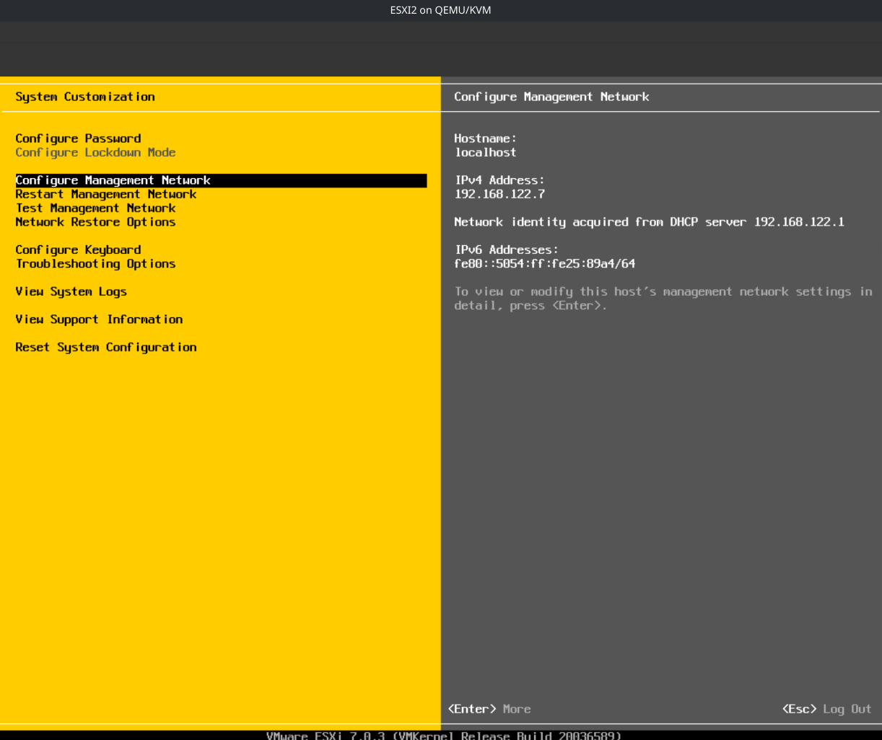

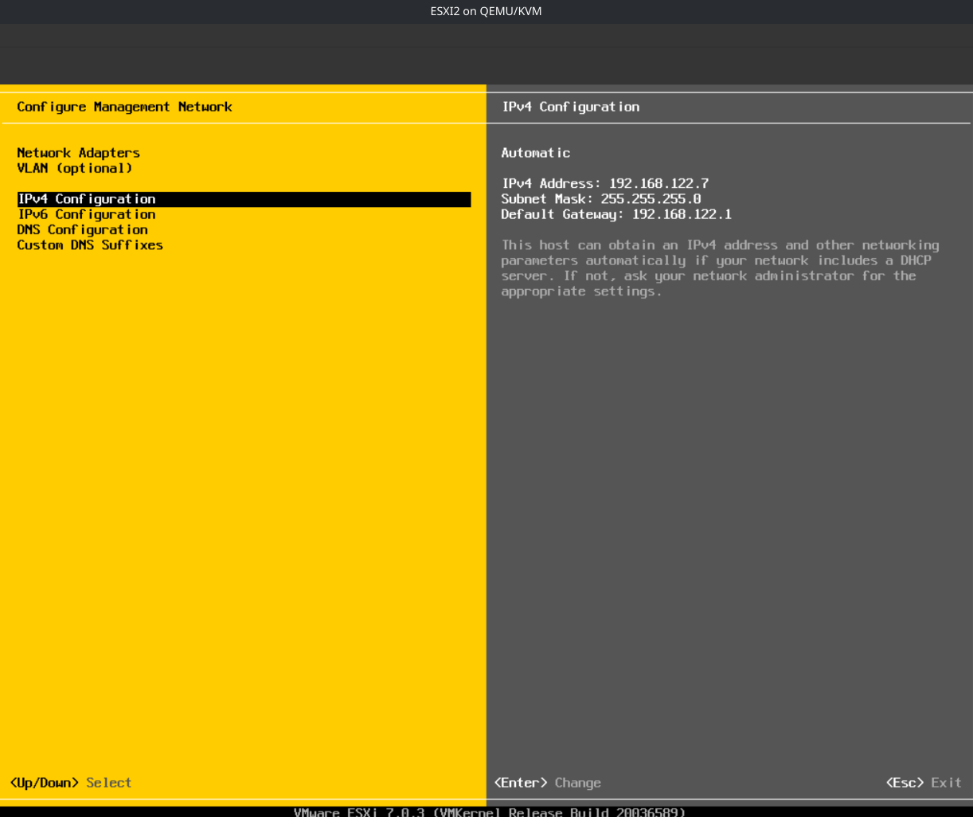

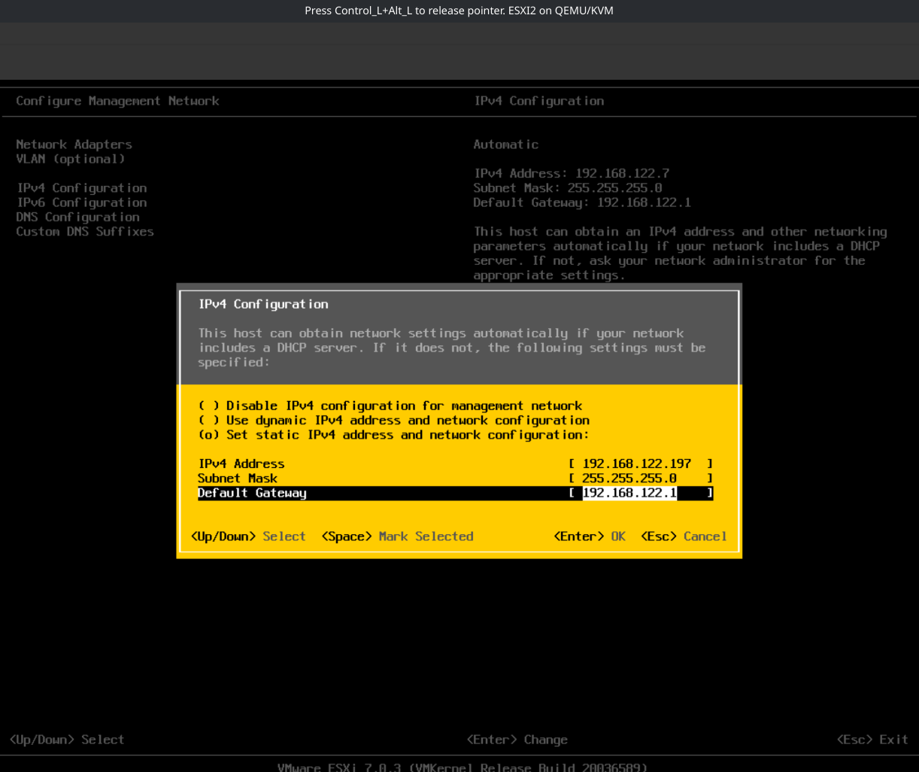

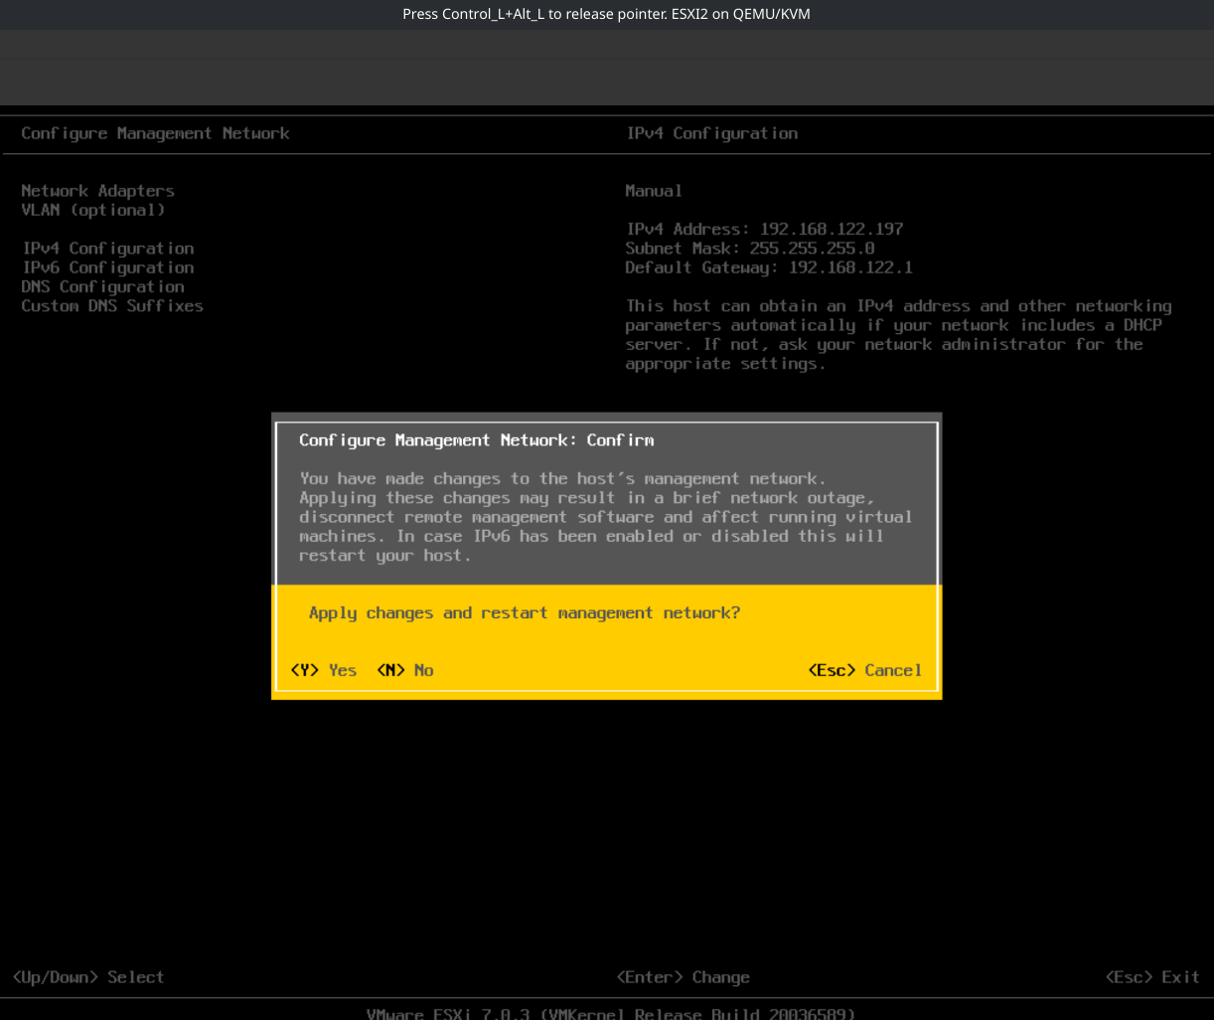

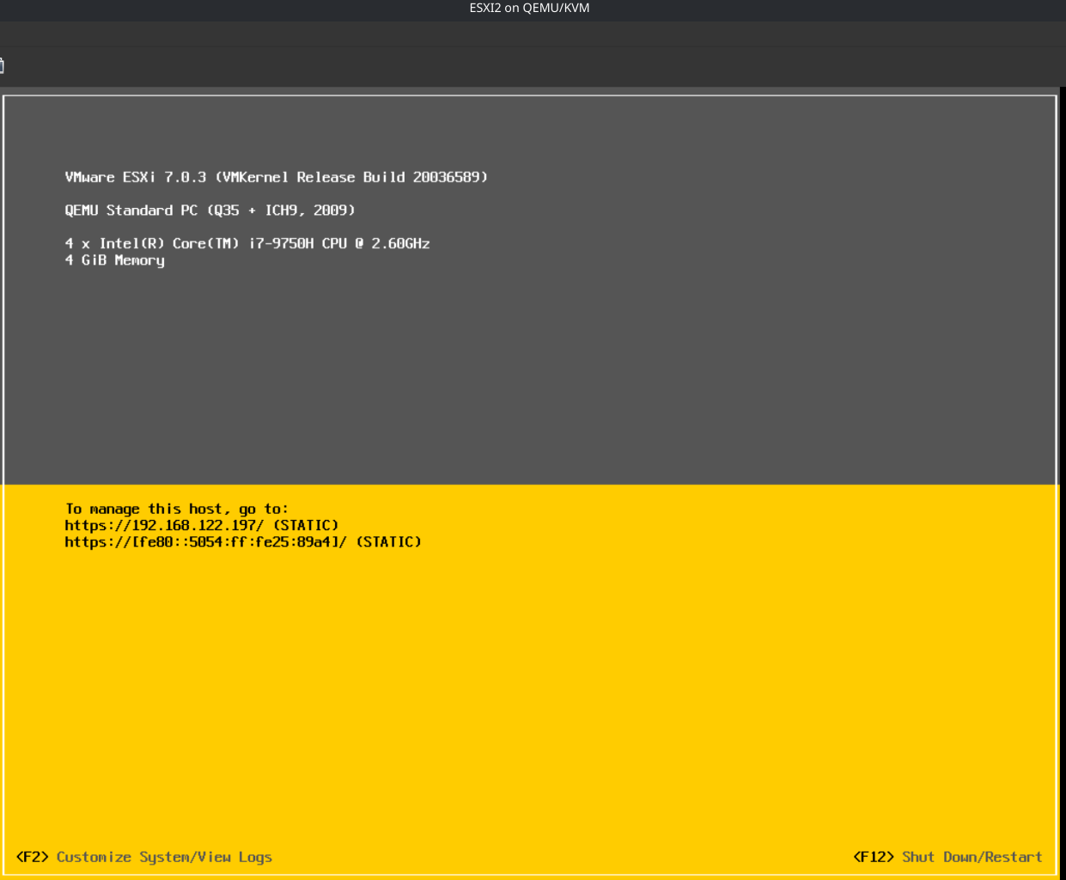

On NFS server:
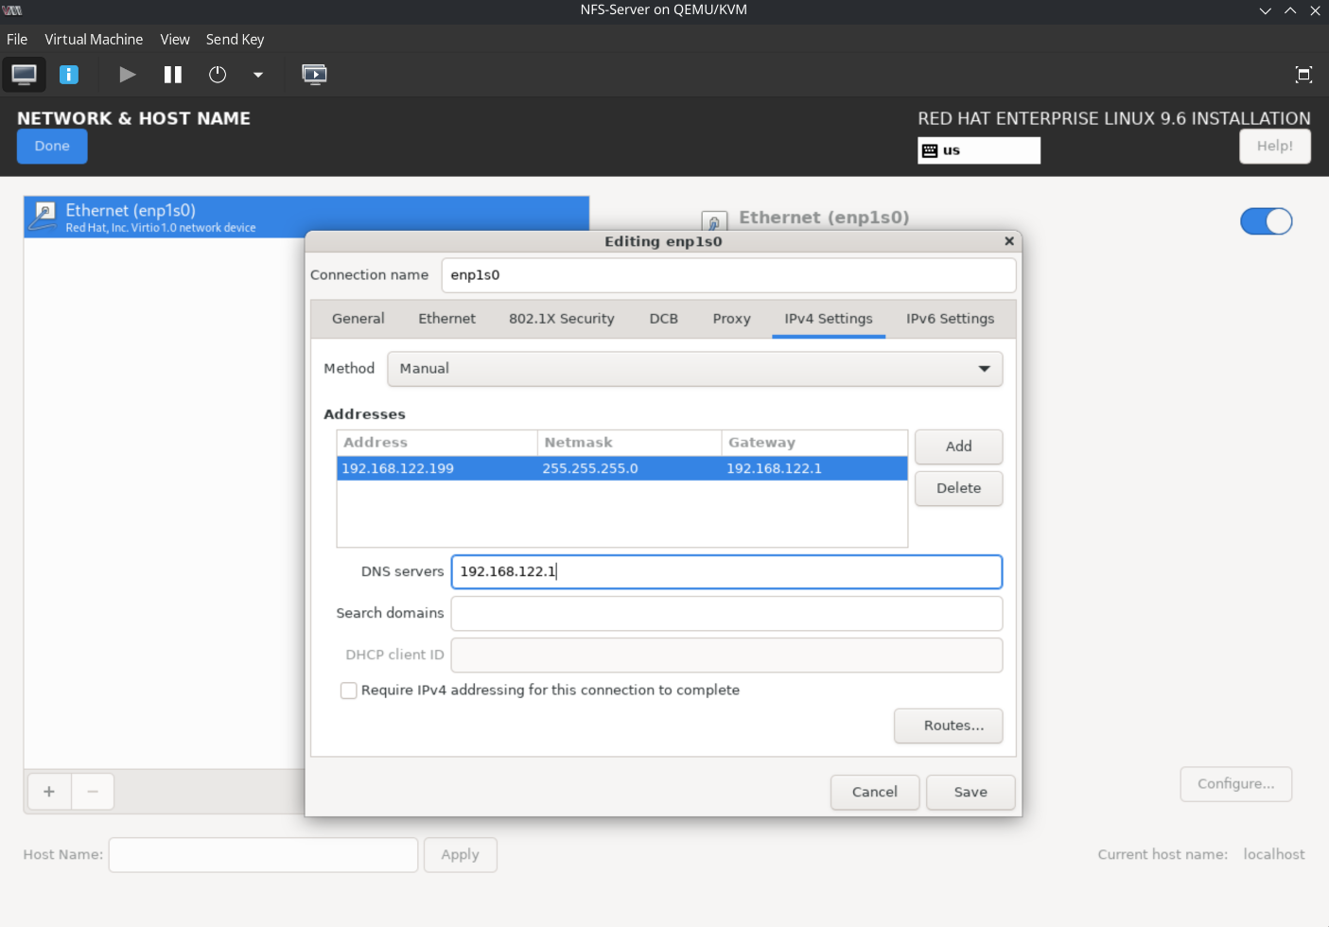

Deploying vCenter appliance:
We first create a data store from the 500GB disk
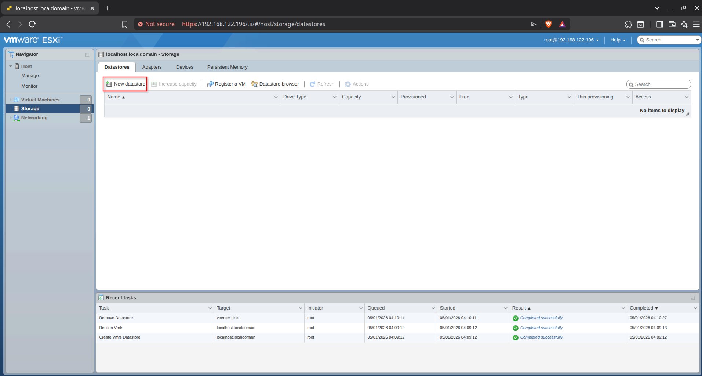
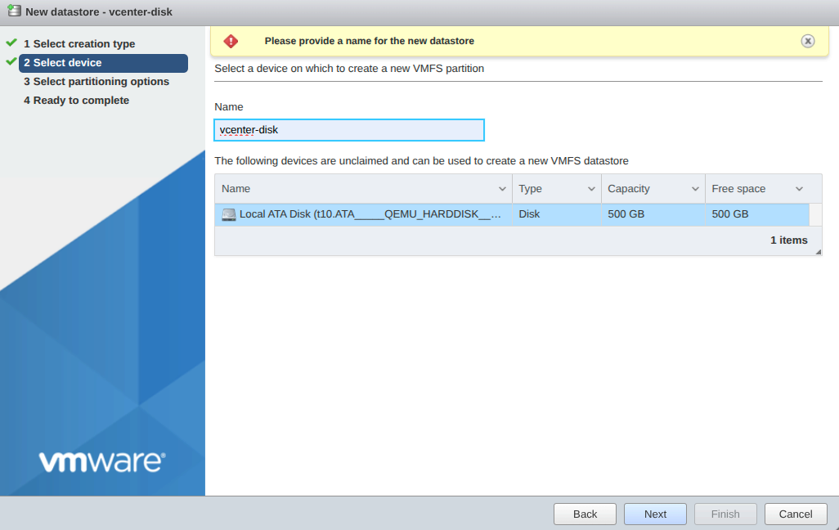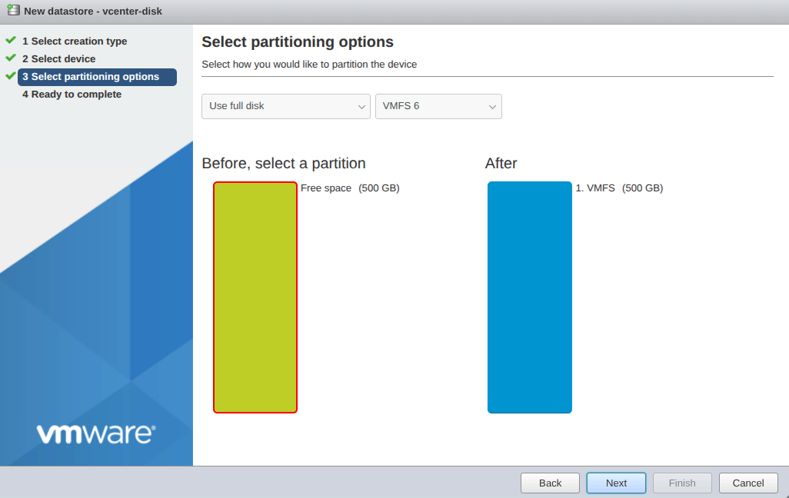

And then we create the VM that will host vServer appliance using the OVA file.
Note that the UI installer for VCA does not work well on modern linux distros.
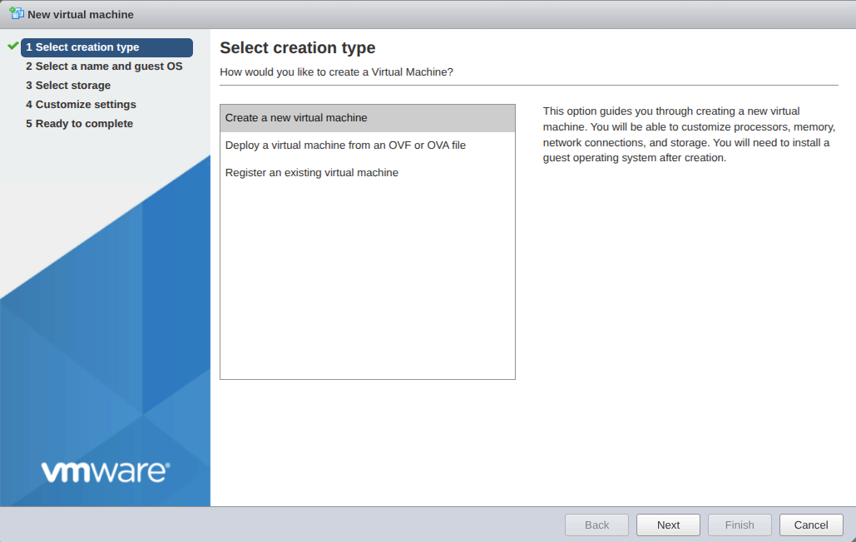
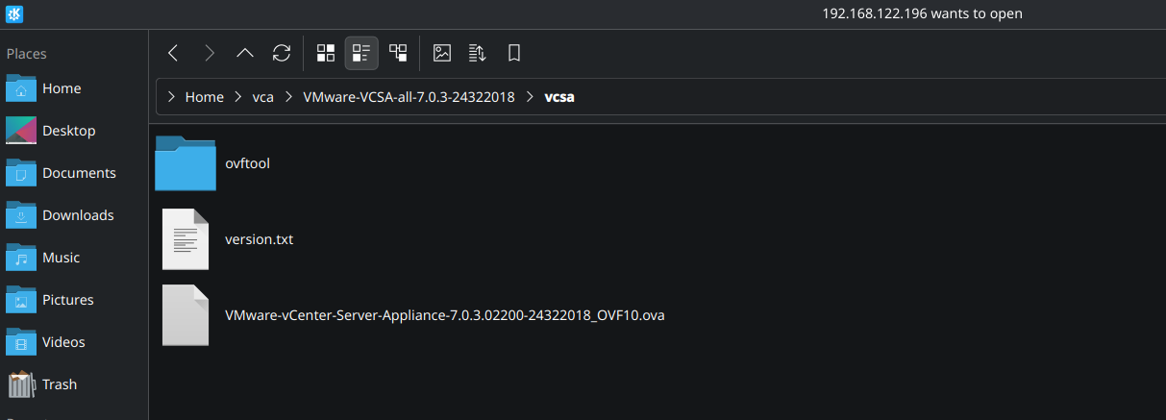

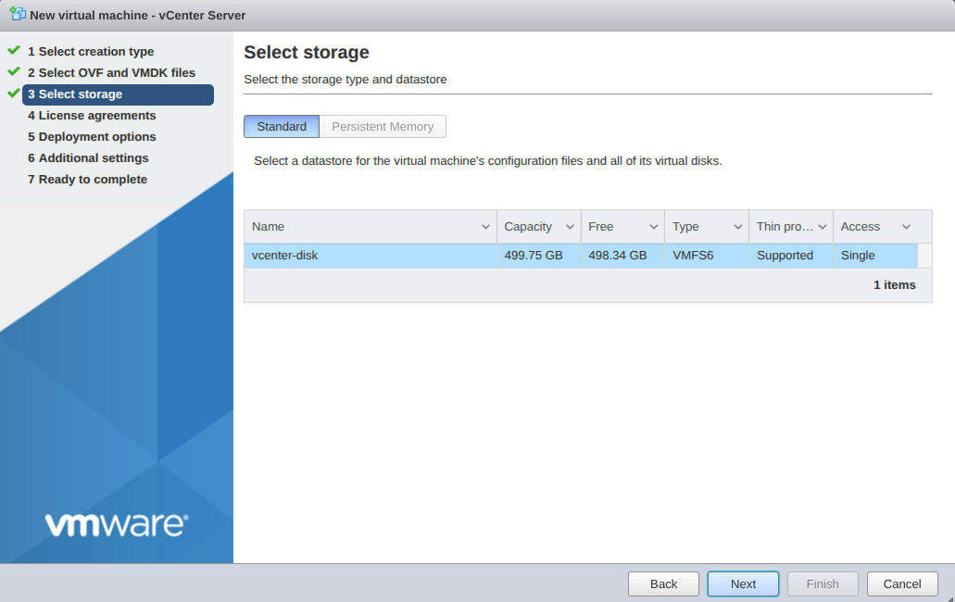

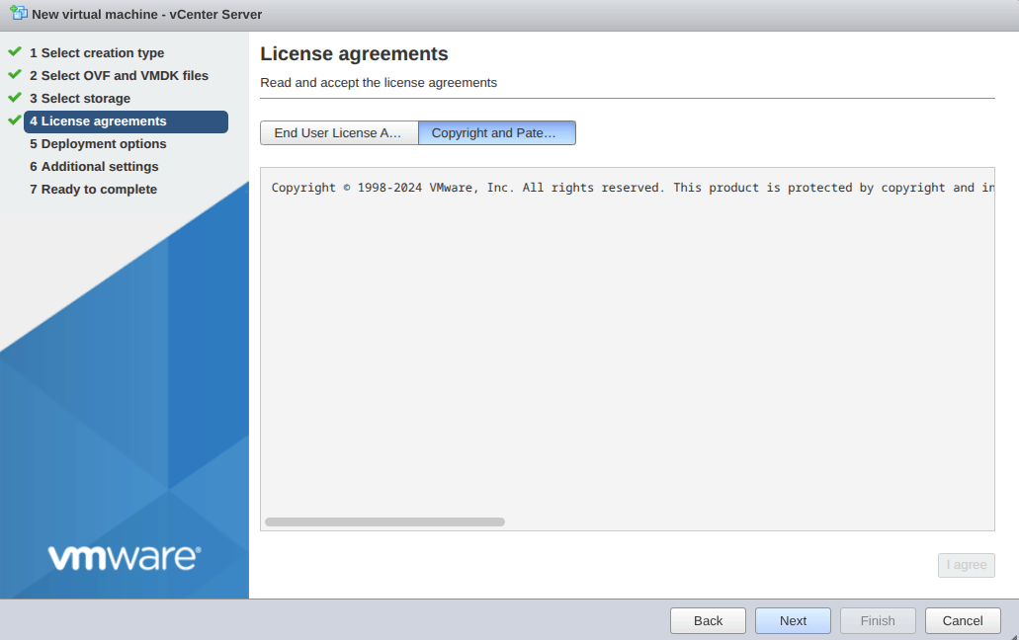
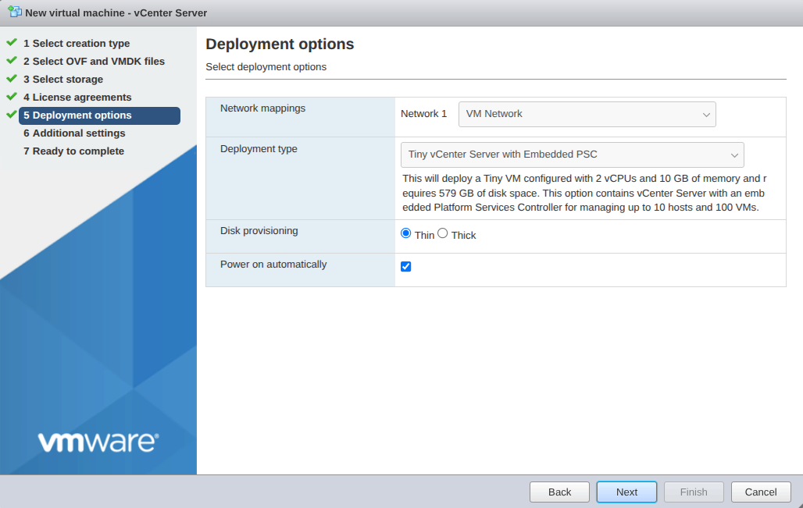
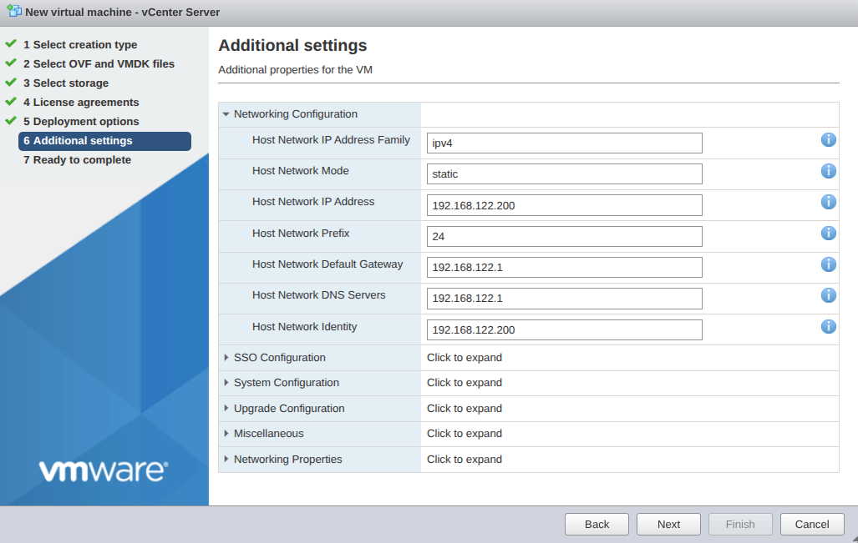
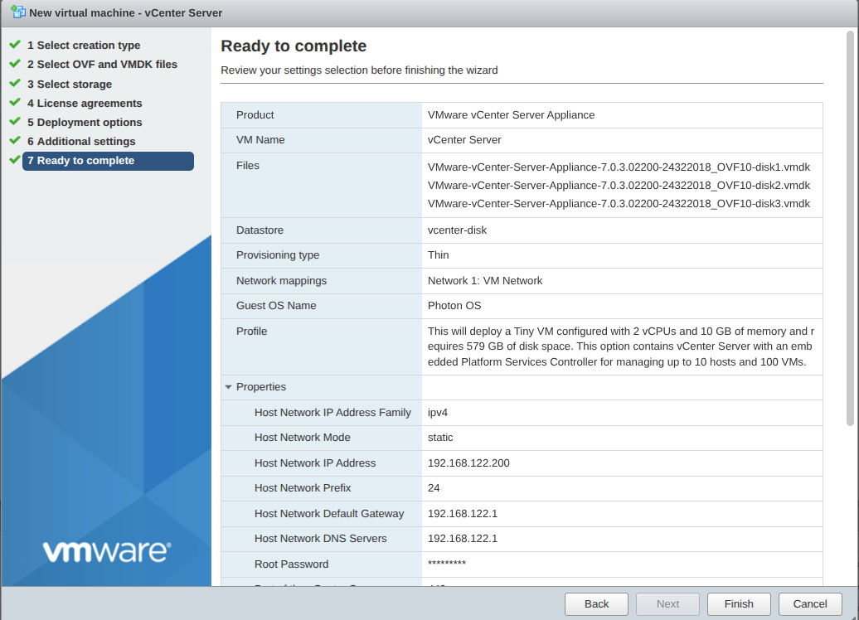
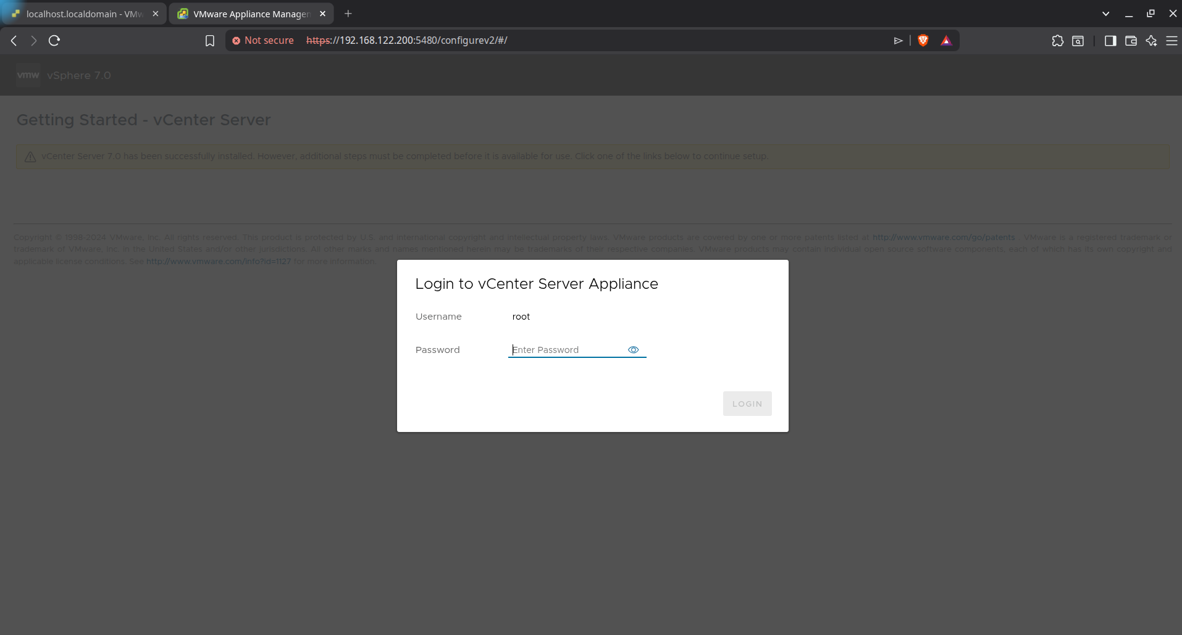
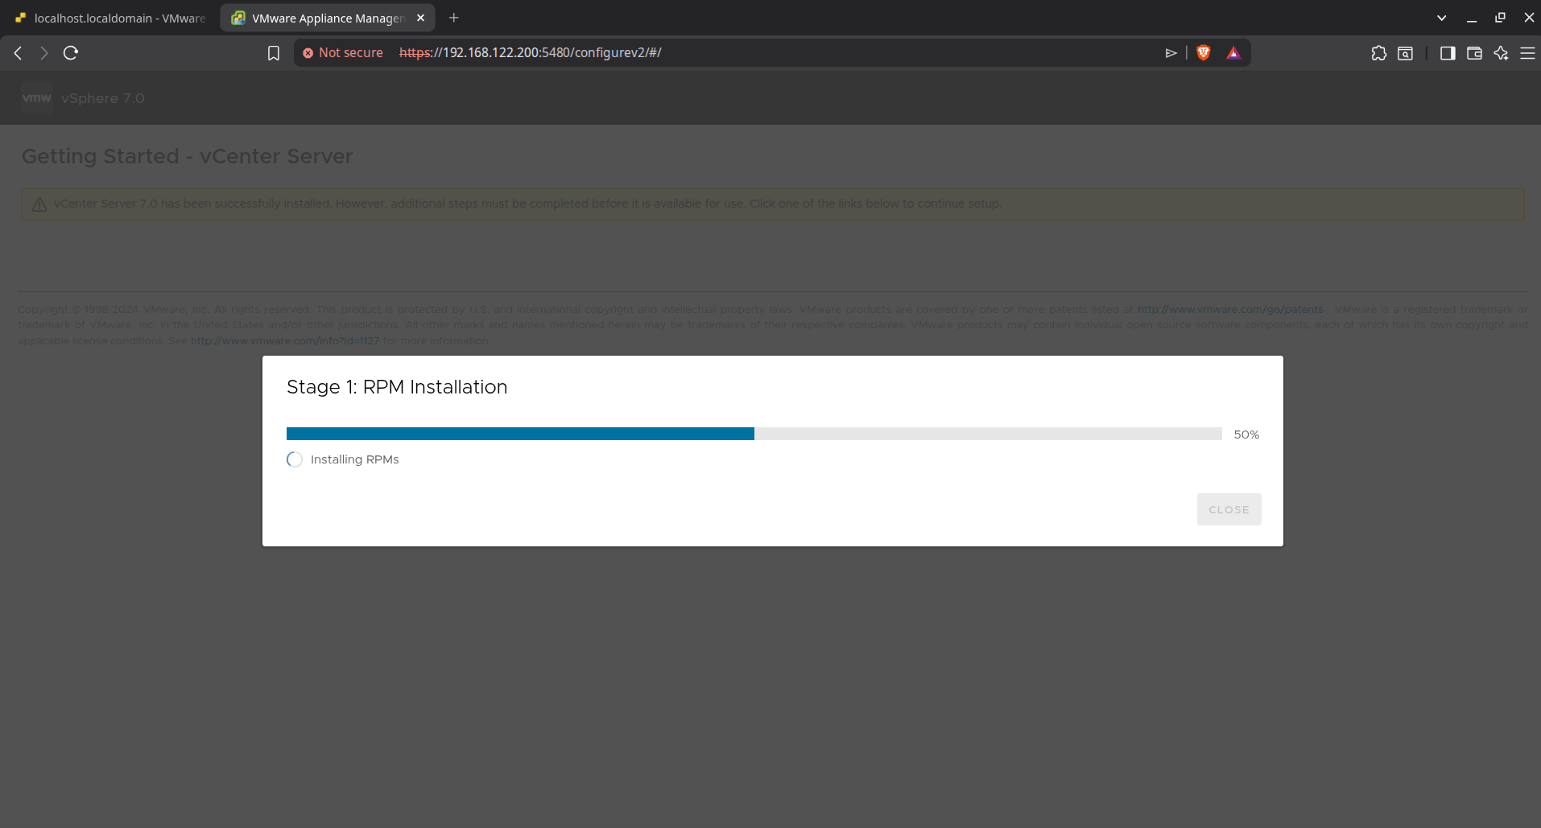
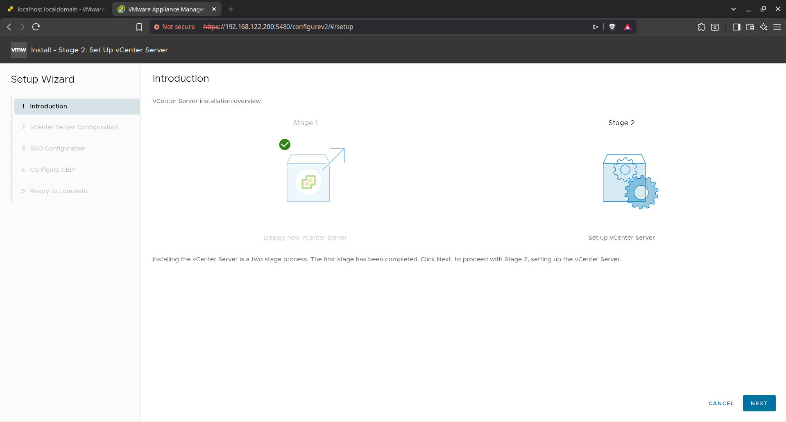
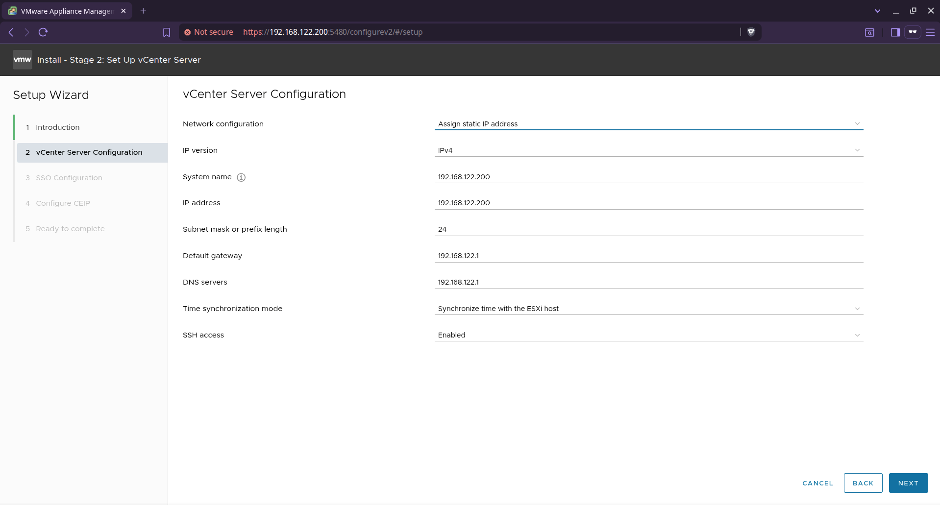

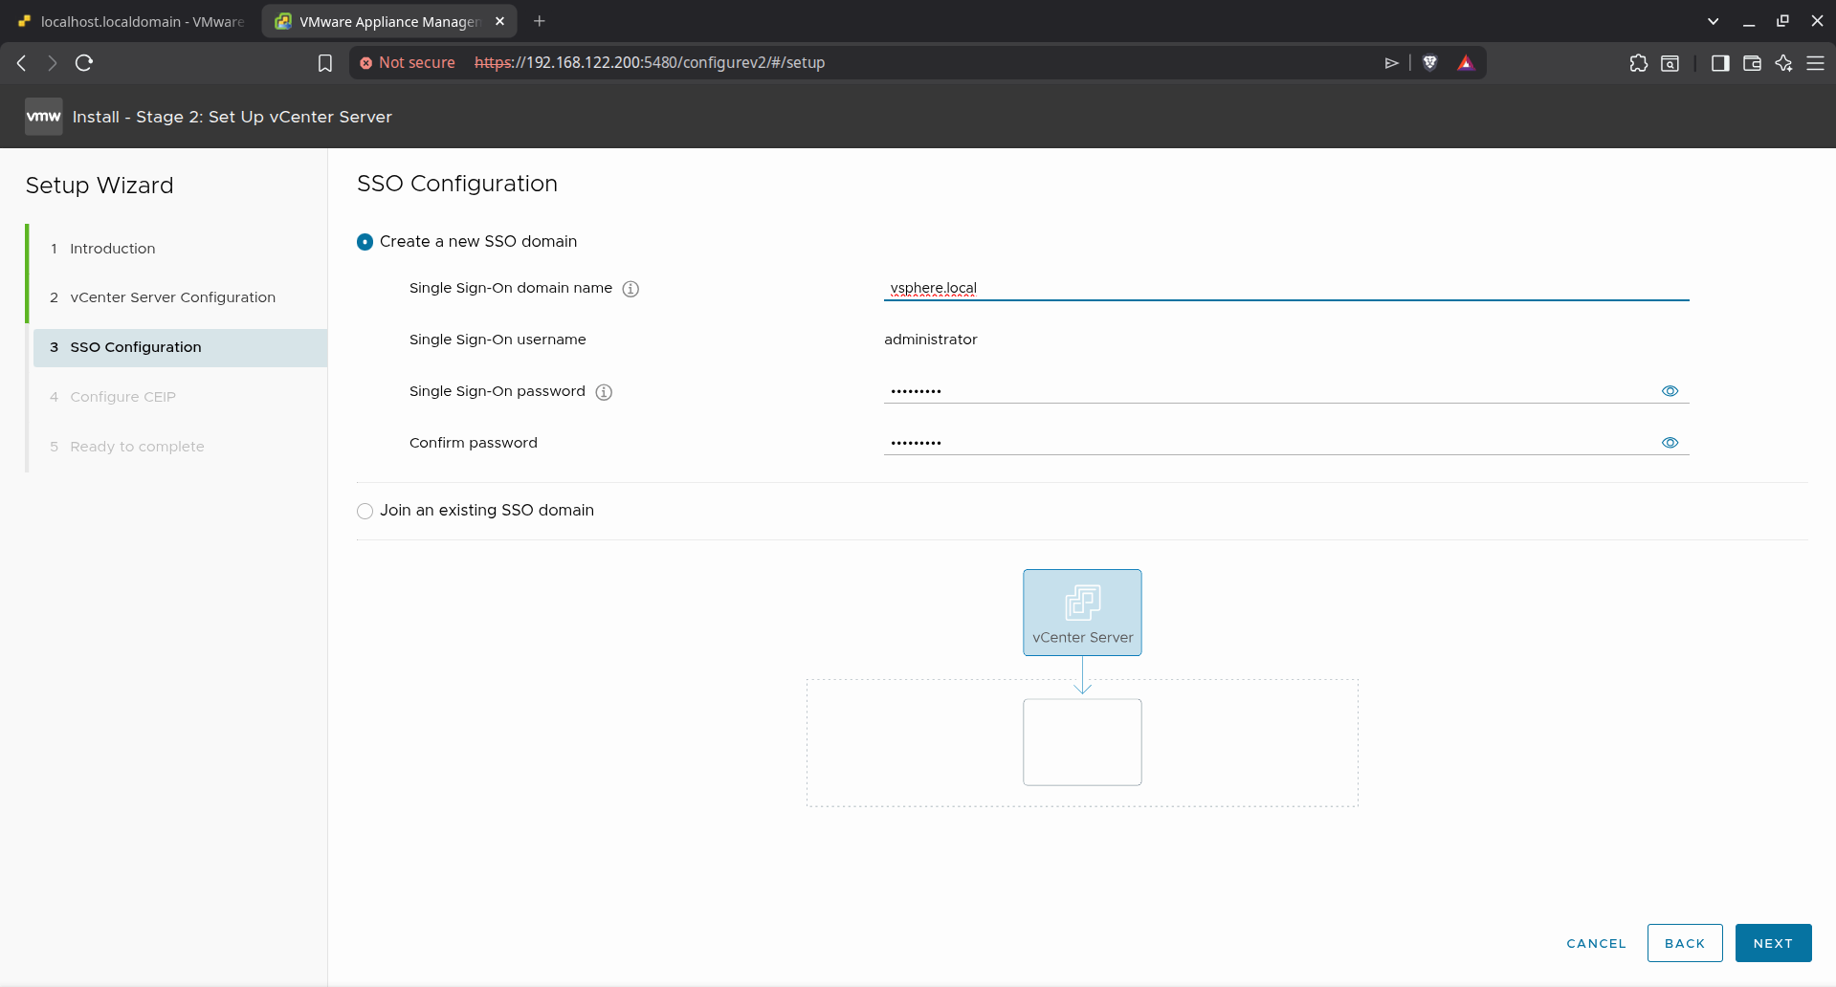
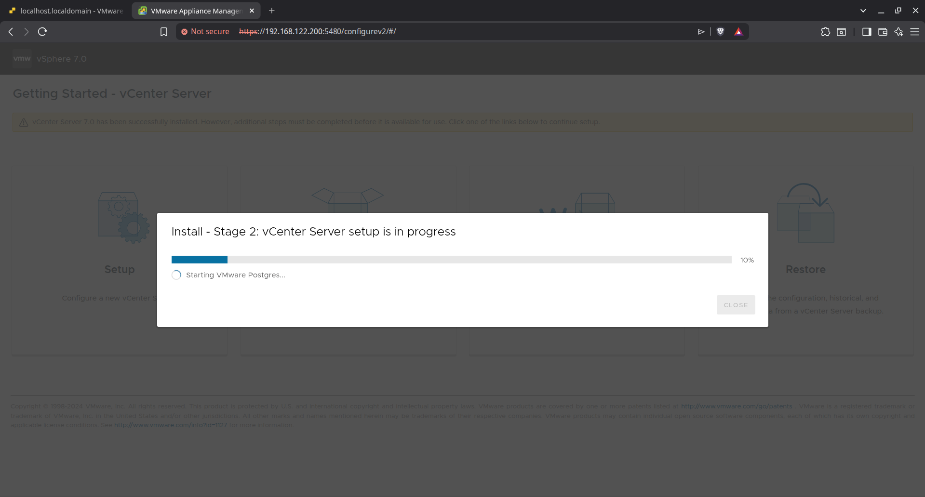
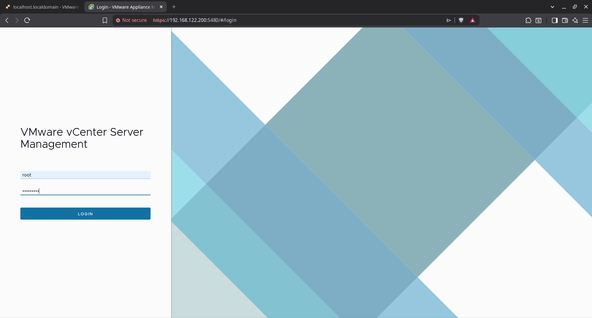

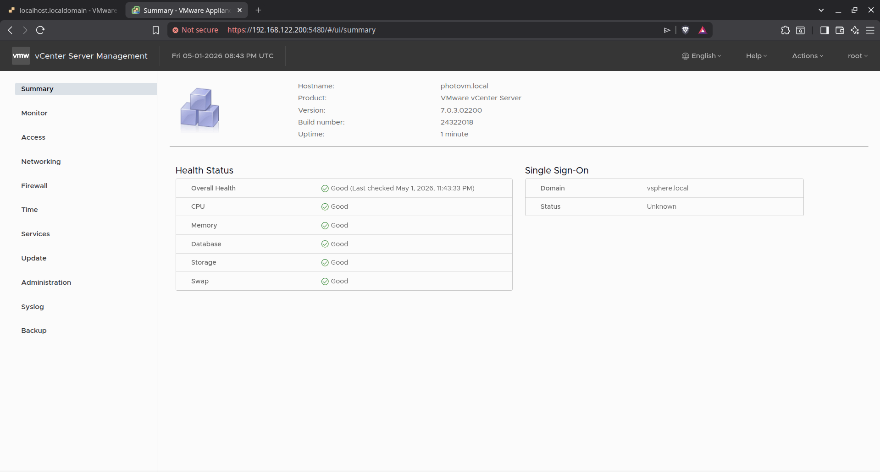

Adding ESXI hosts to Cluster:
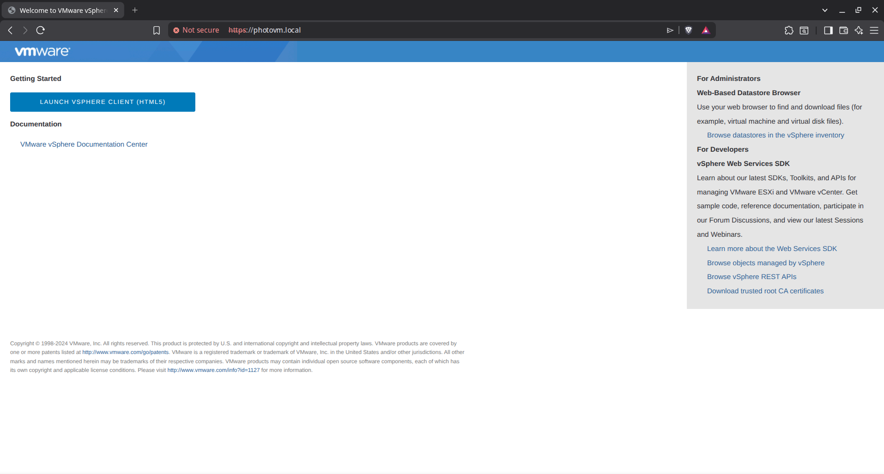
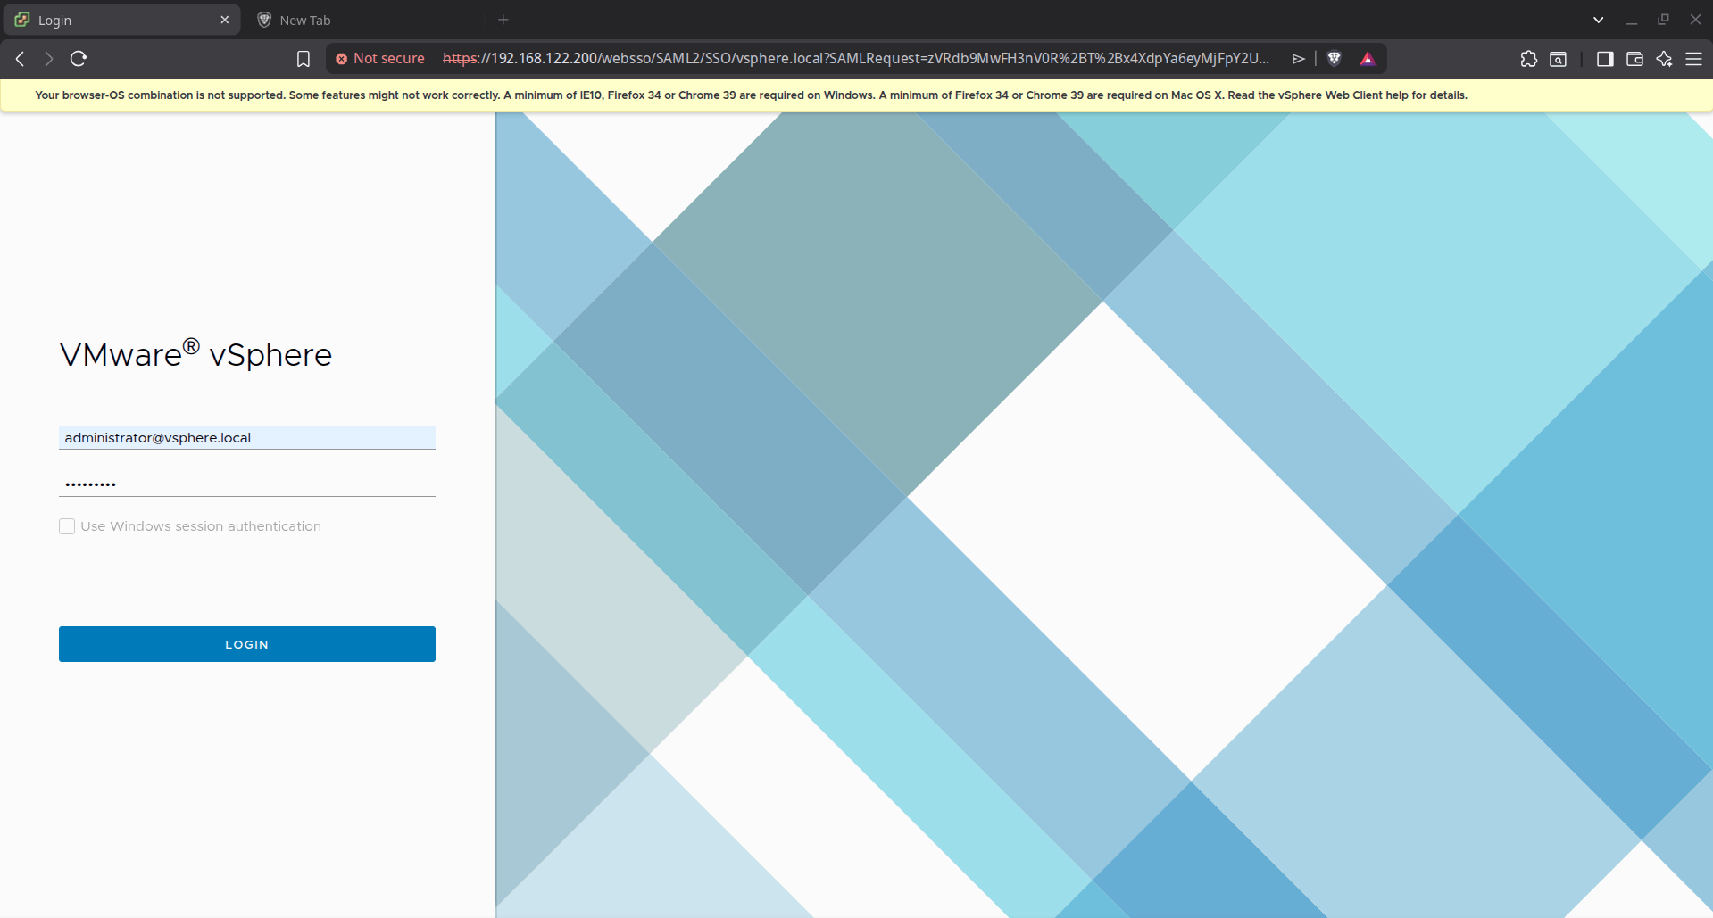
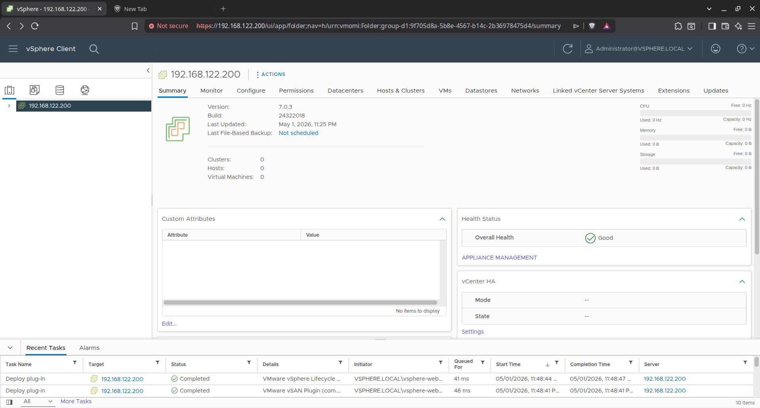
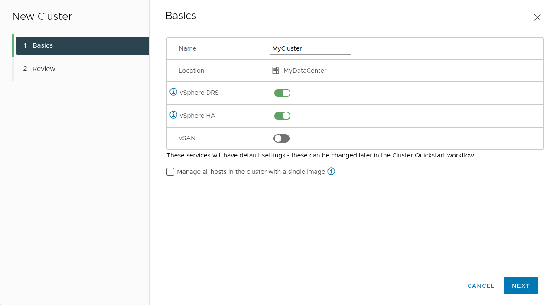

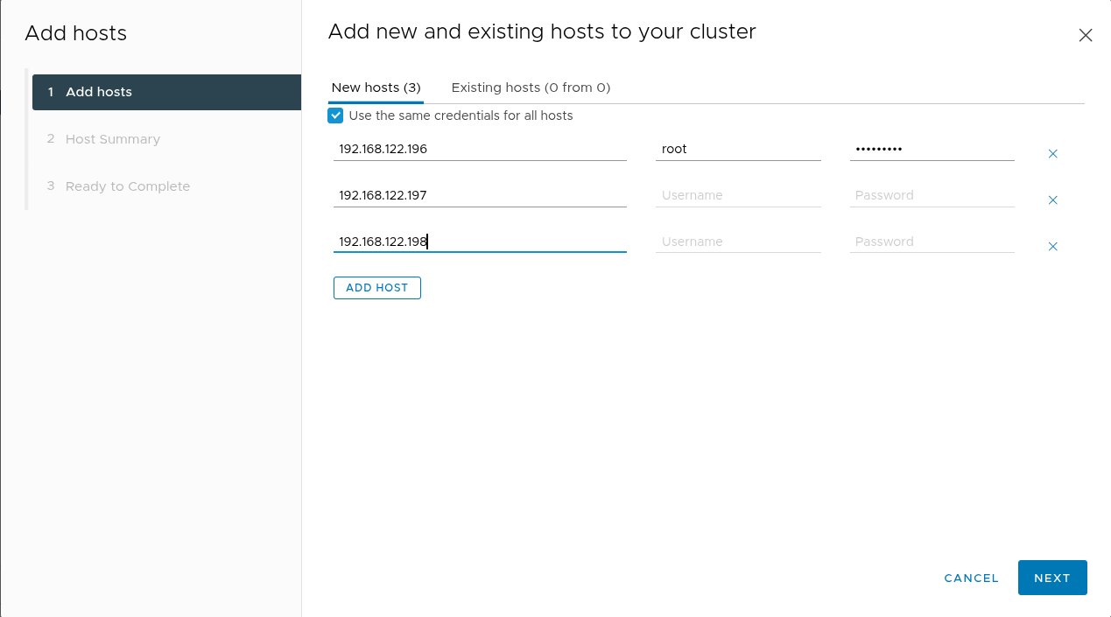
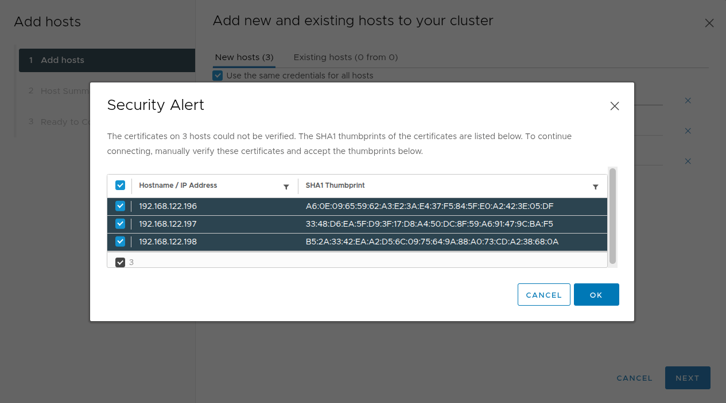

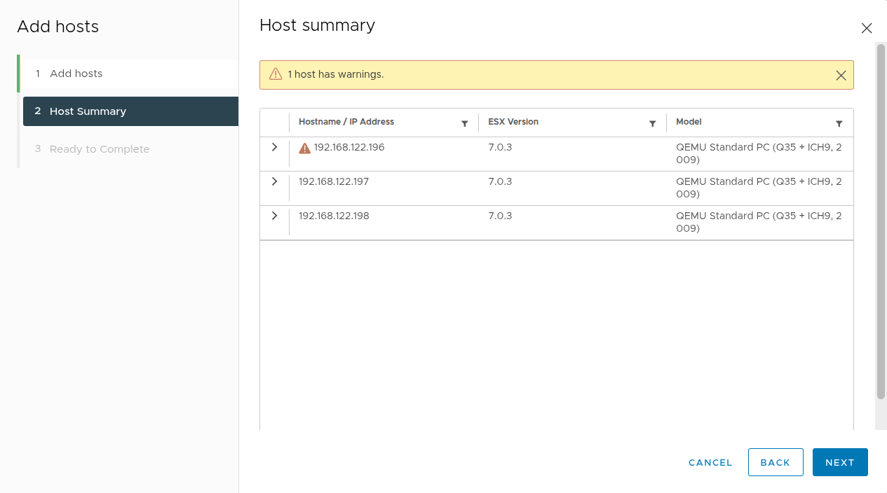

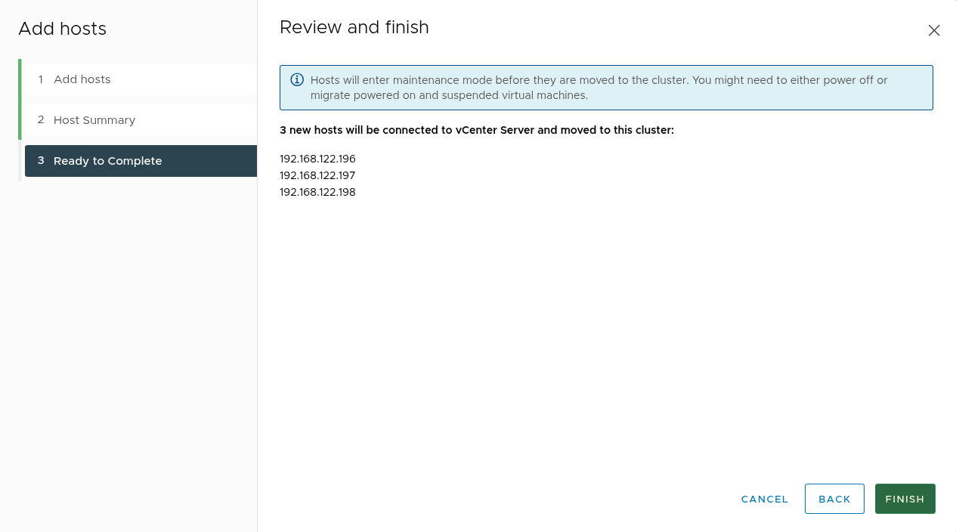

Configuring HA for the vSphere cluster:
Configuring the High Availability (HA) settings for the cluster. We enable "Host Monitoring" and set the "Host Failure Response" to Restart VMs, ensuring that if a physical server fails, its virtual machines will automatically reboot on another healthy host.
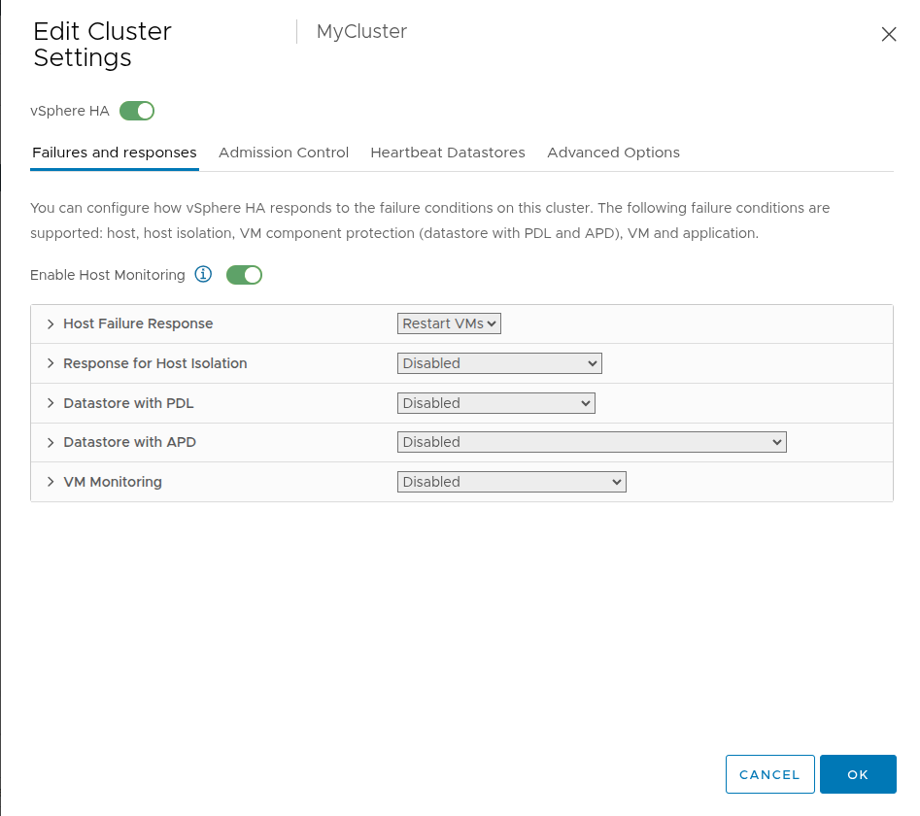

Configuring vSphere DRS:
Activating the Distributed Resource Scheduler (DRS) to automate workload balancing. The automation level is set to Fully Automated, allowing vSphere to live-migrate VMs (via vMotion) between hosts to optimize CPU and Memory utilization without manual intervention

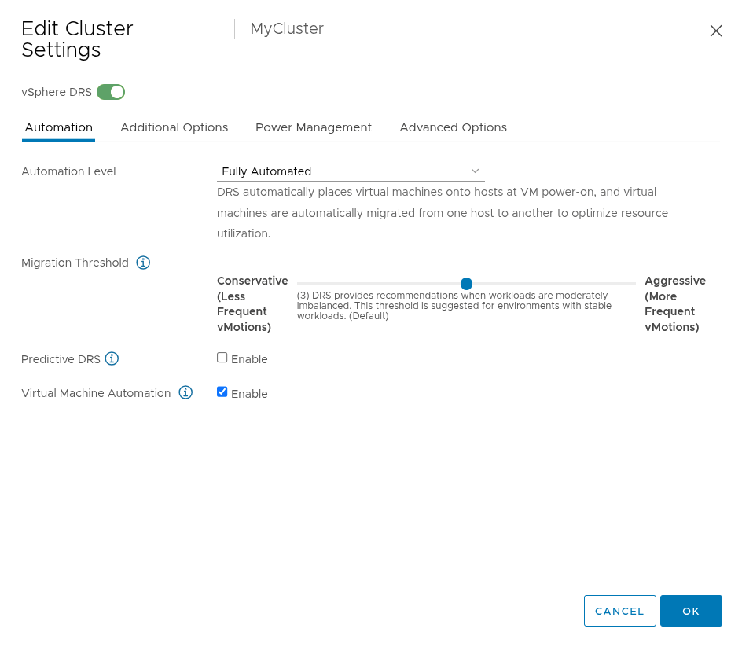

Network Configuration:
Creating a new Standard Switch (vSwitch1) on host 192.168.122.196 (VCA host) and assigning a free physical adapter (vmnic1) to handle specialized traffic.
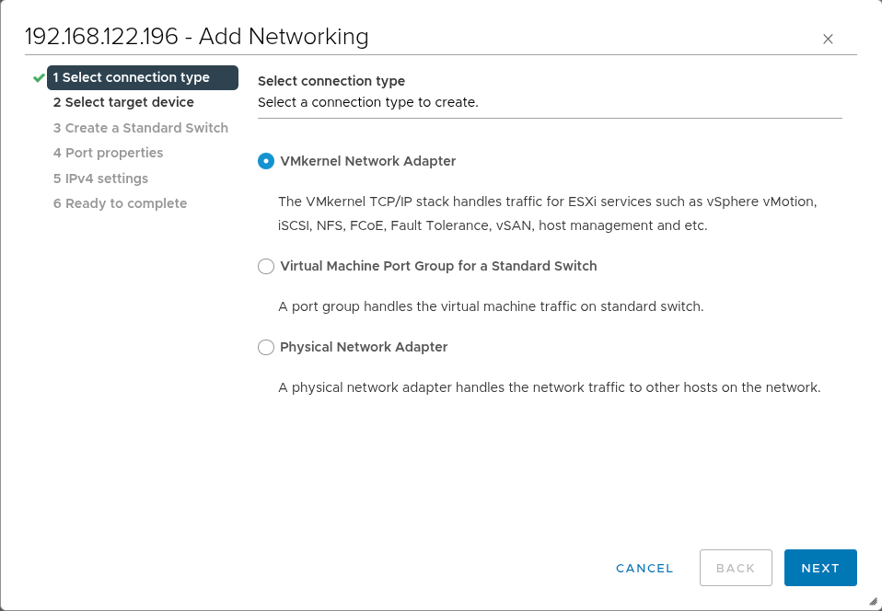
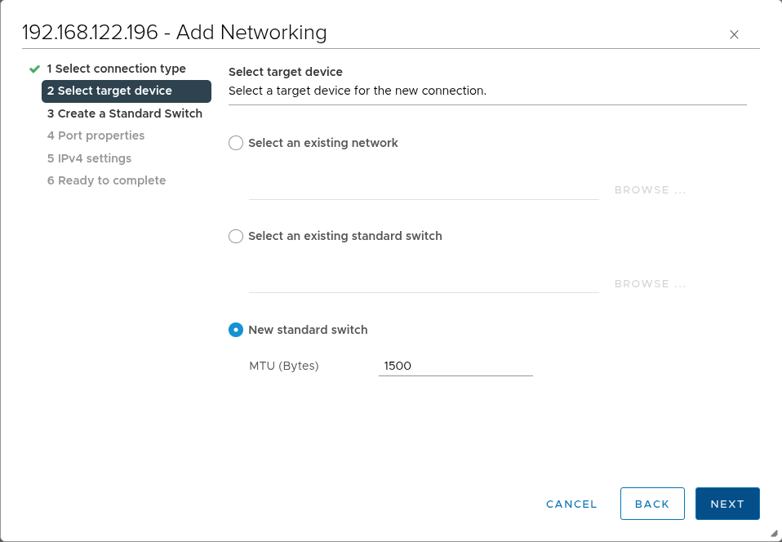

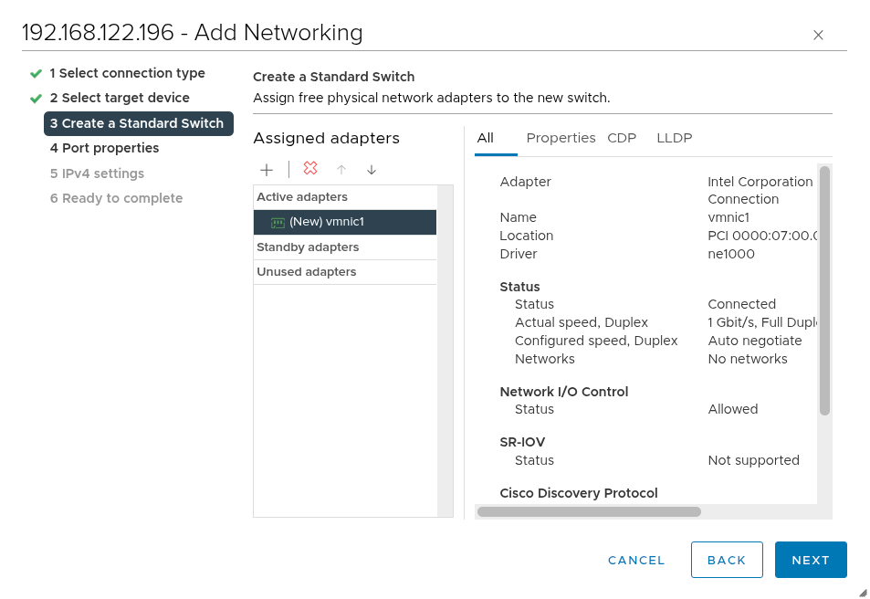by Configuring the VMkernel port properties. We enable specific services like vMotion (for live migration) and vSAN to sure the host can communicate effectively within the cluster.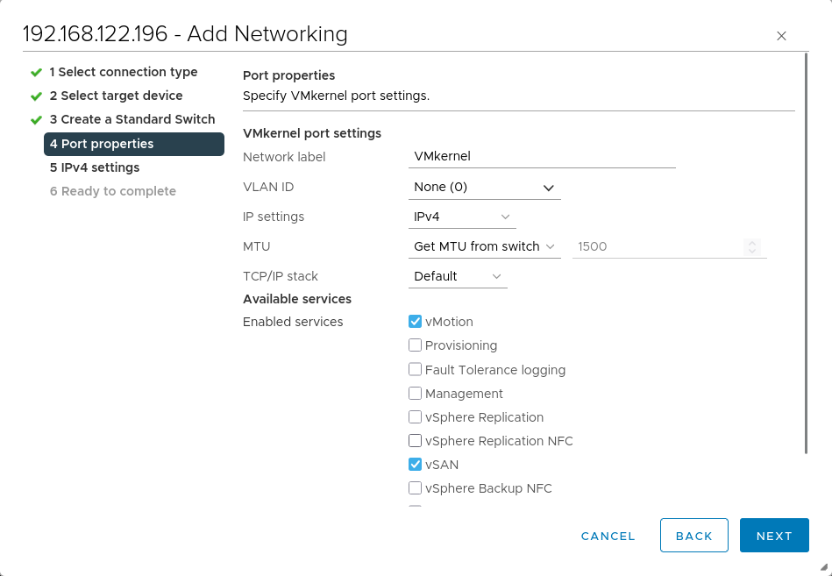
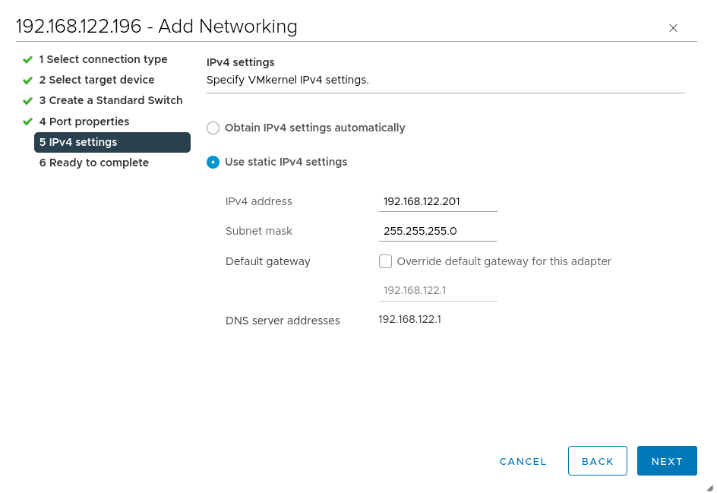
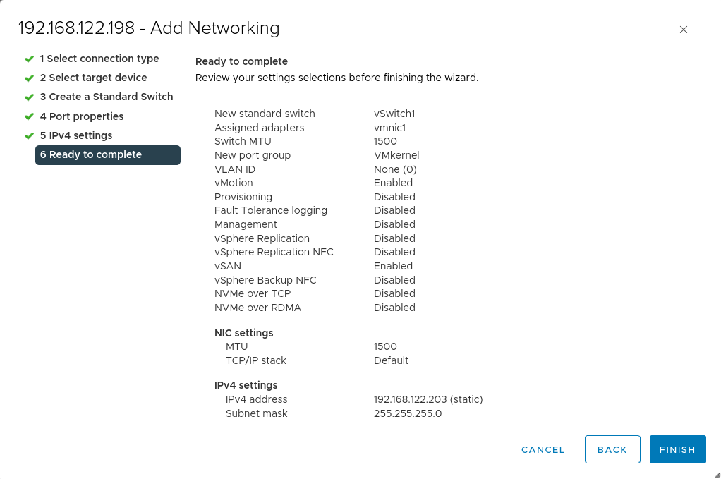
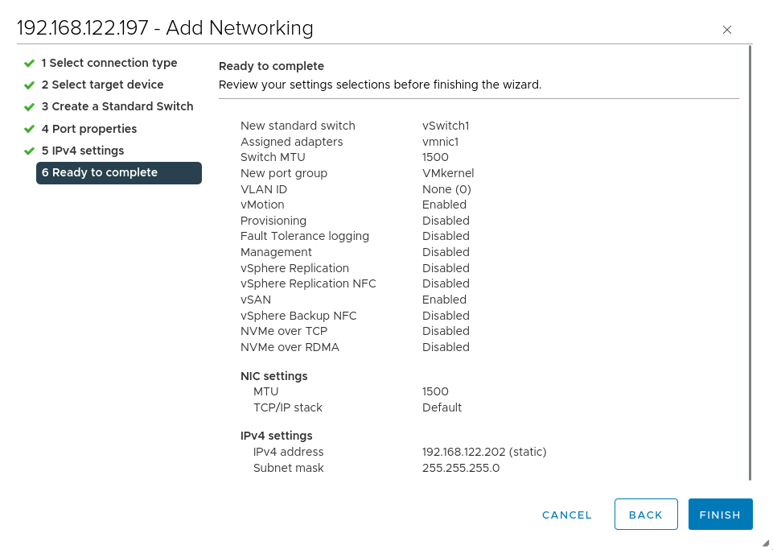
We will do a similar configuration to the remaining 2 ESXi hosts

NFS Shared Storage Setup:
This phase involves preparing a Linux-based (RHEL) server to act as the NFS server. This server
will host the files for the vSphere datastore.
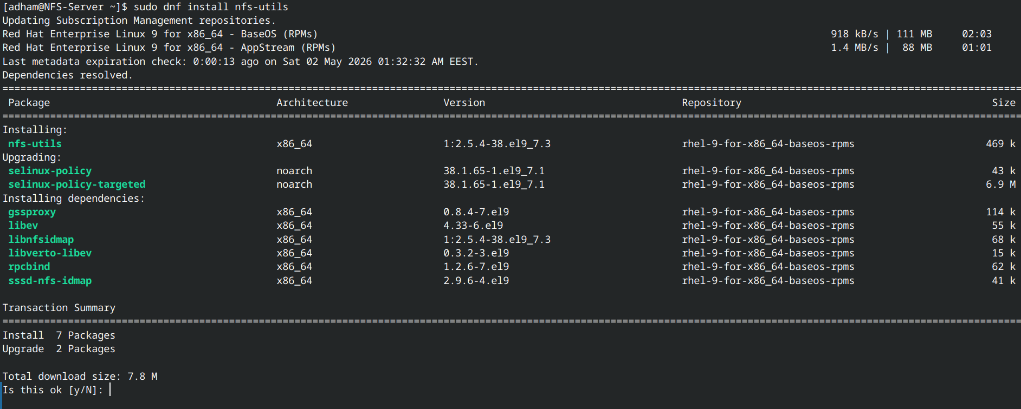
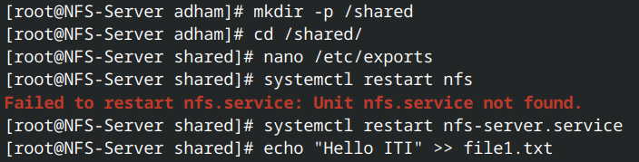
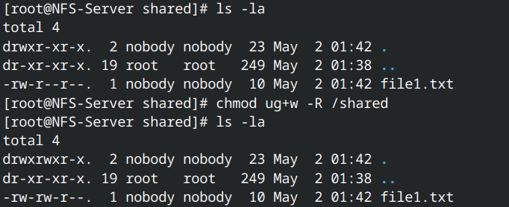
In the vSphere client we right click on the datacenter —> storage —> new datastore.
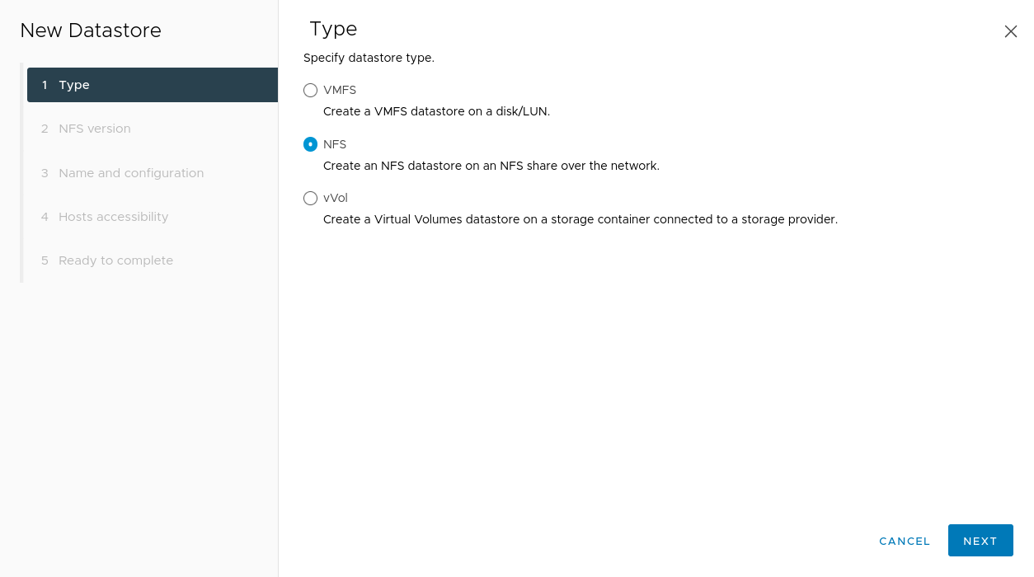
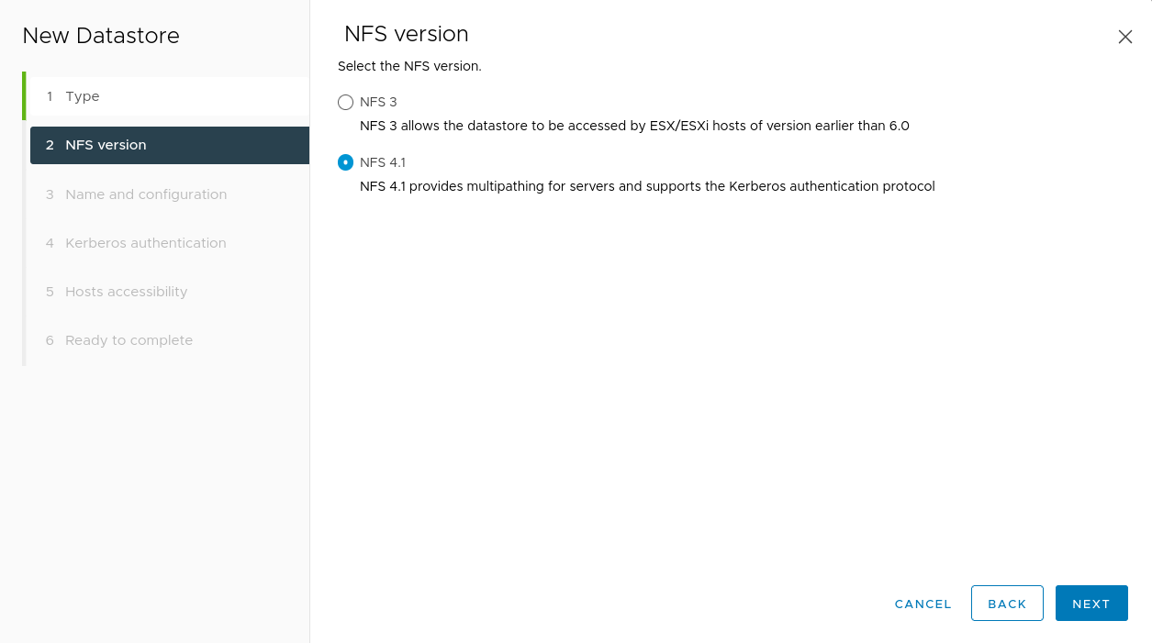

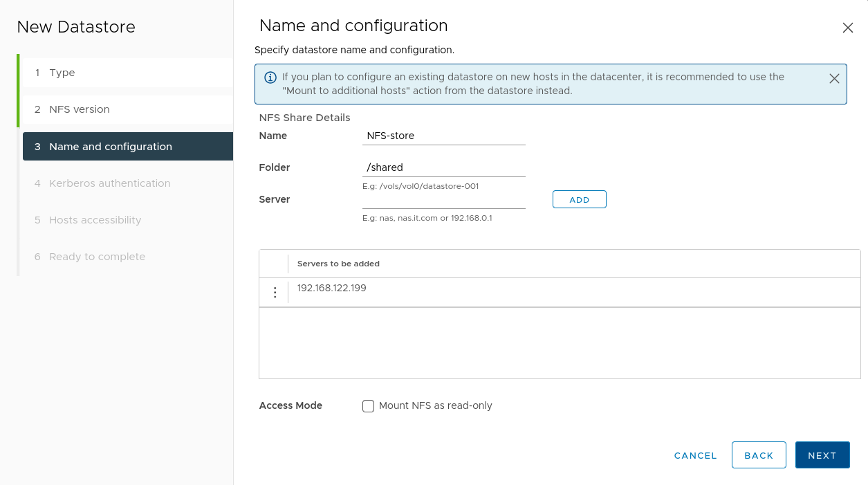
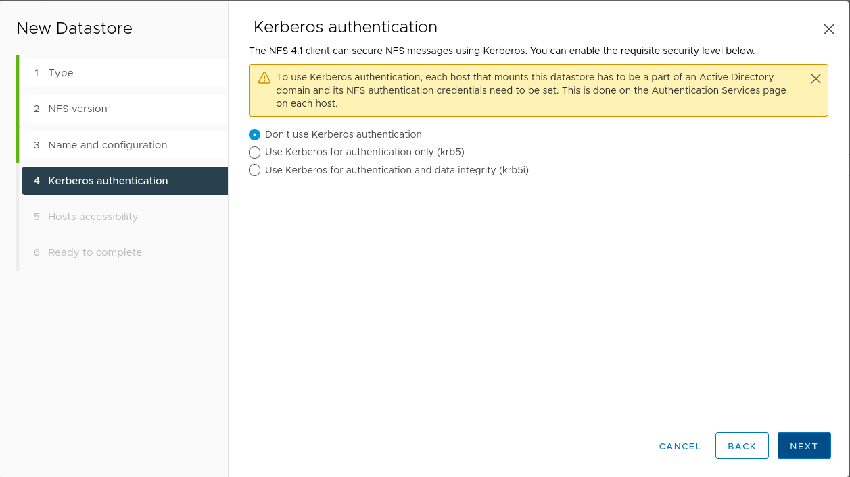

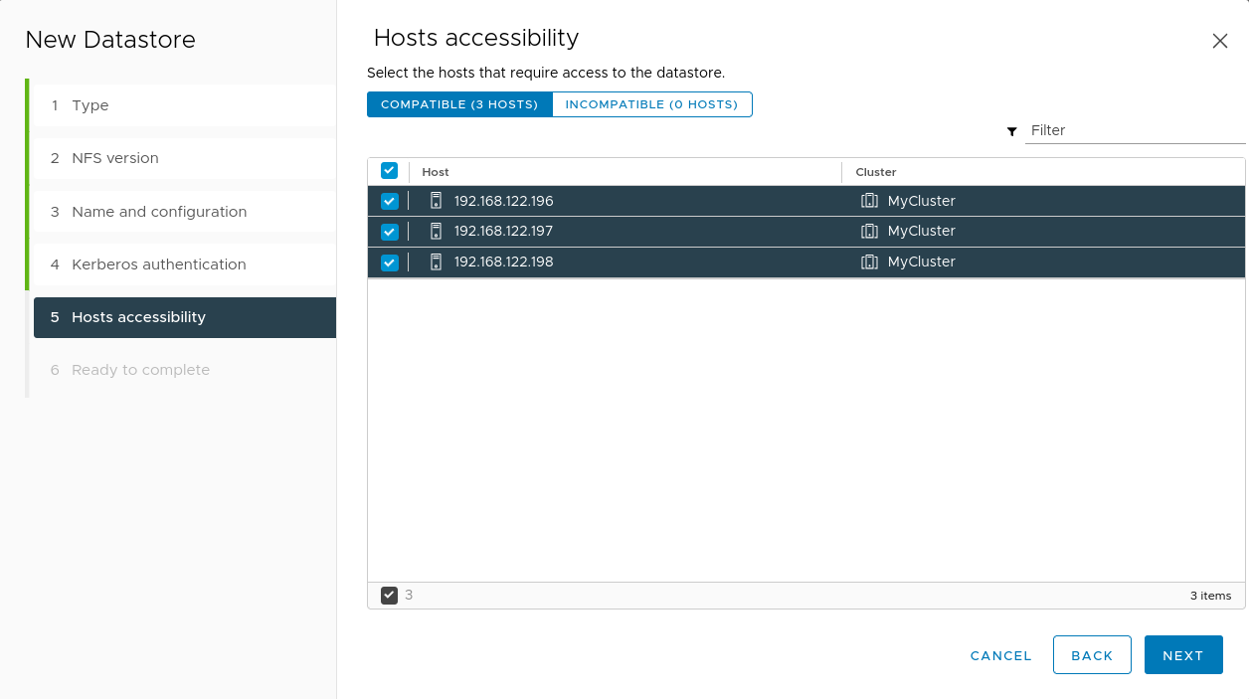

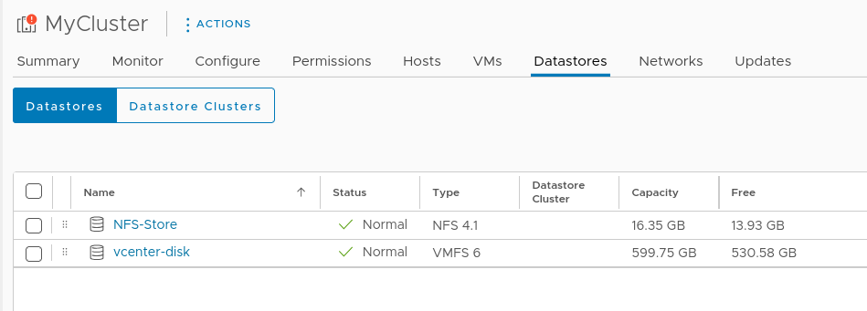

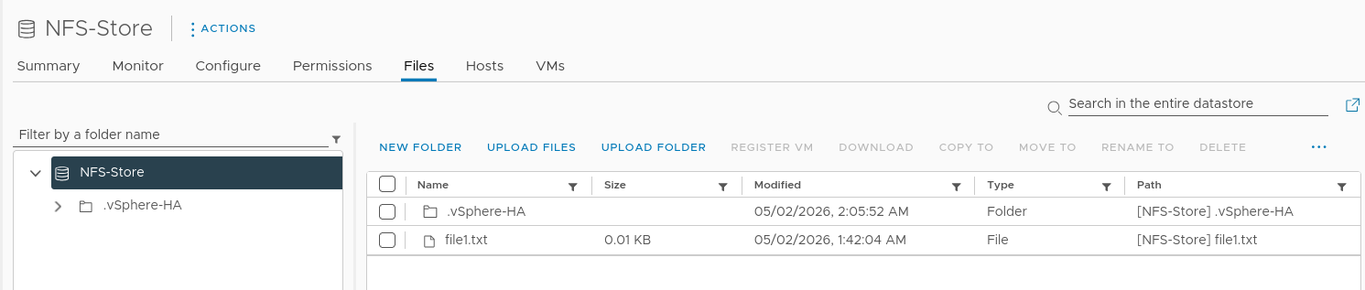

Creating Content Library:
First, you initiate the "New Content Library" wizard from the vSphere Client. This involves naming the library and configuring its type (e.g., a local library).
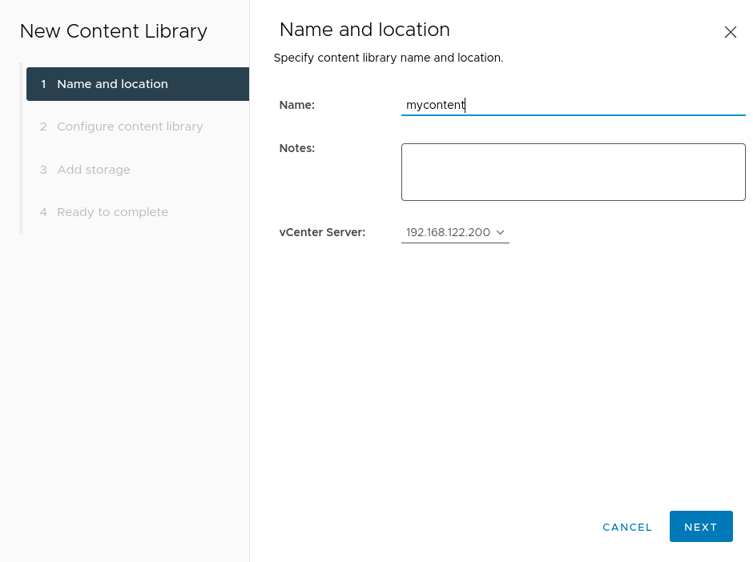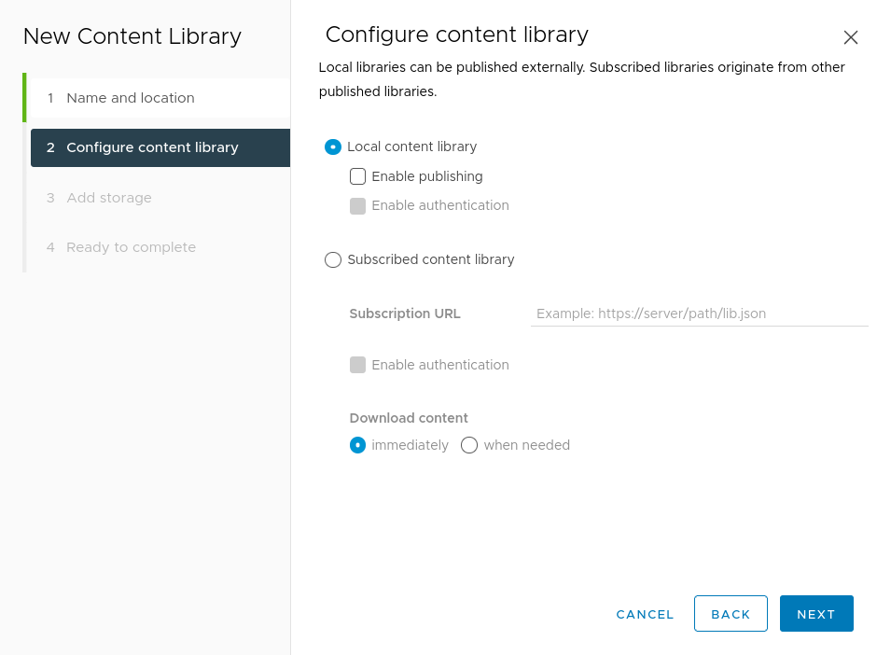
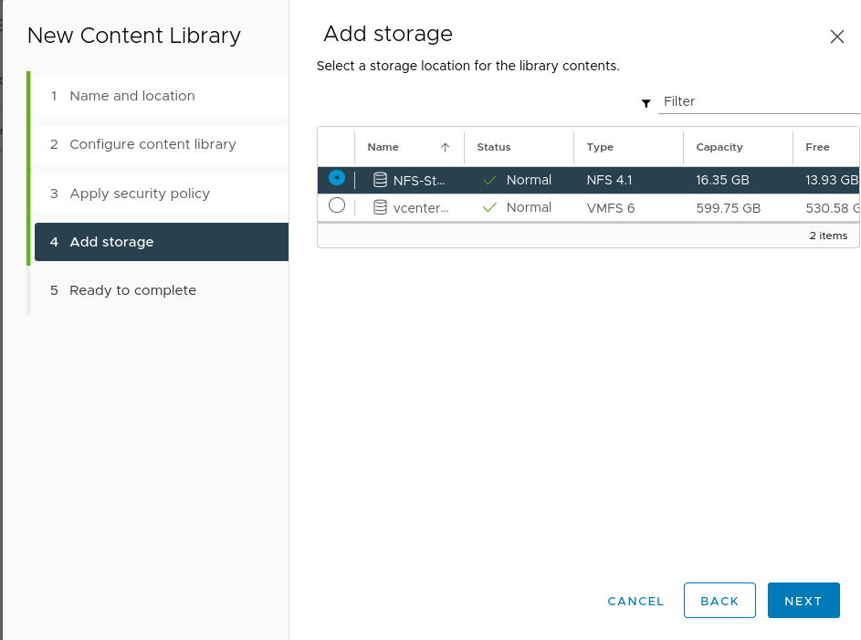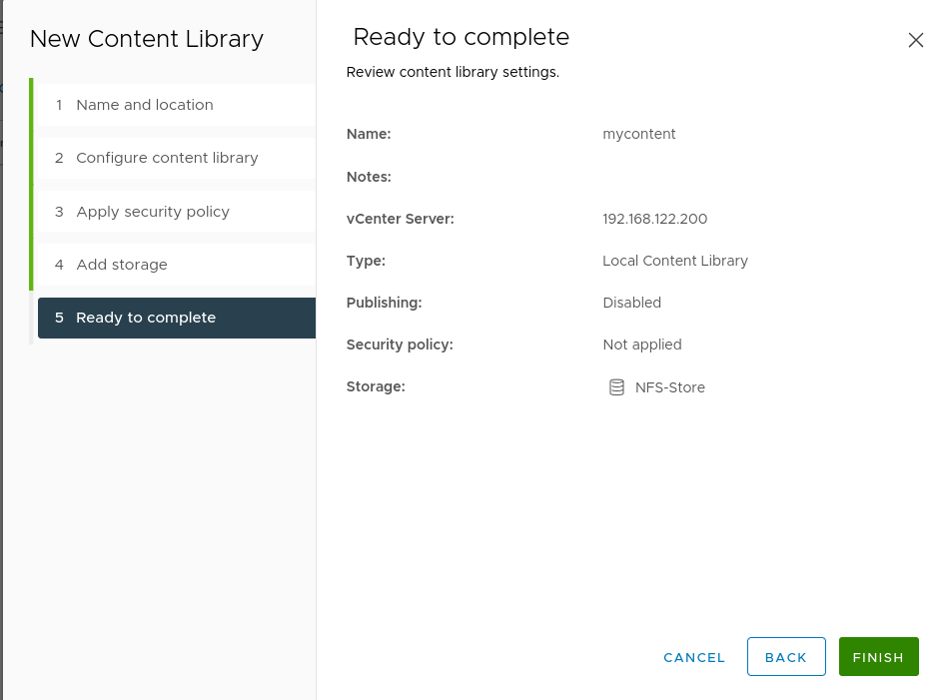
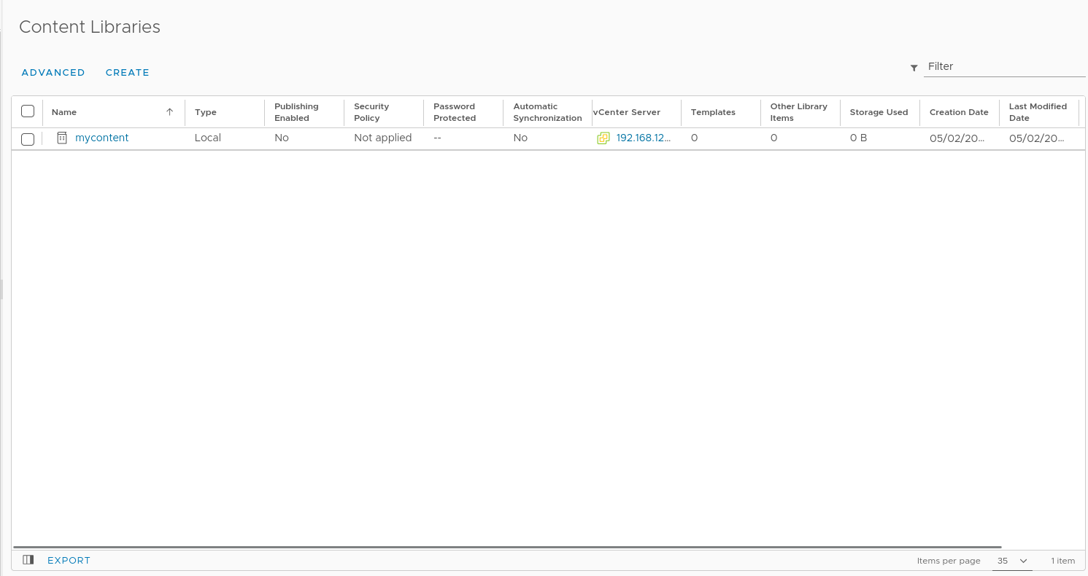
Now let upload an Ubuntu-server iso:
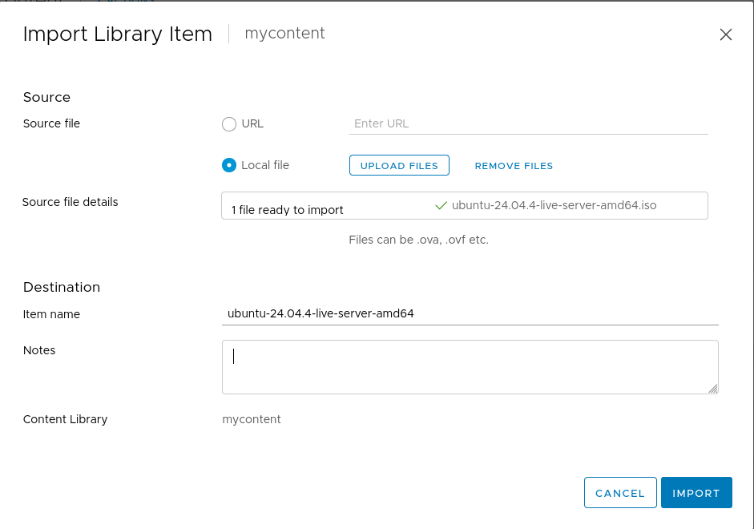

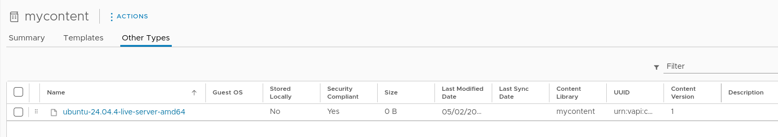

Creating a New Virtual Machine:
Before we can create a VM we need to first create a datastore from the secondary 50GB on both ESXI2 and ESXI3
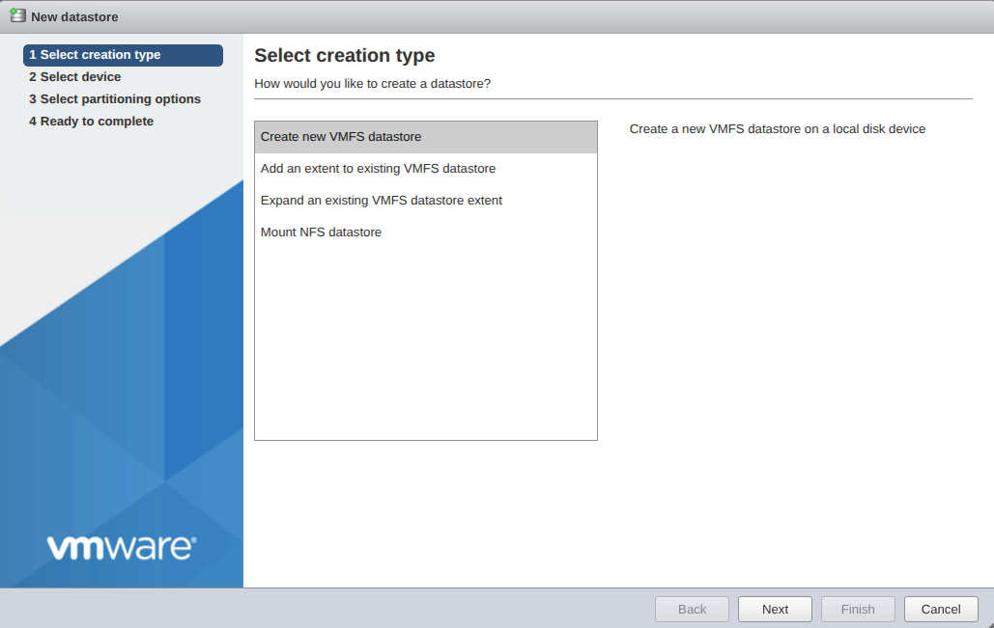
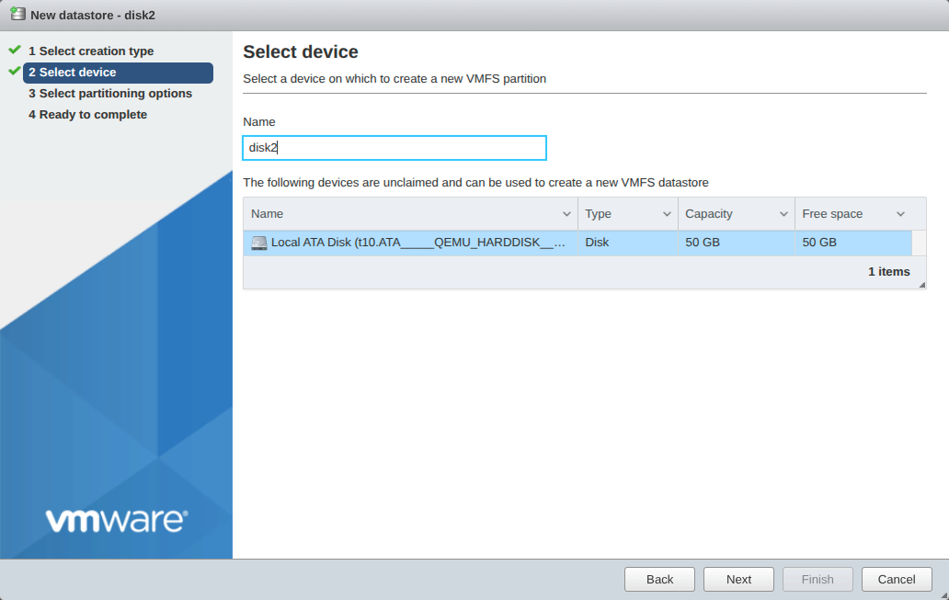

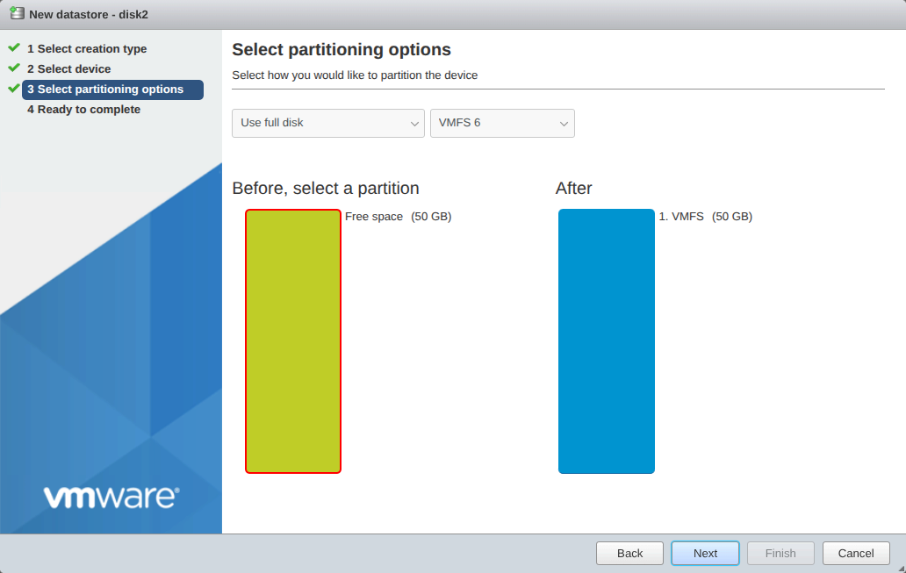
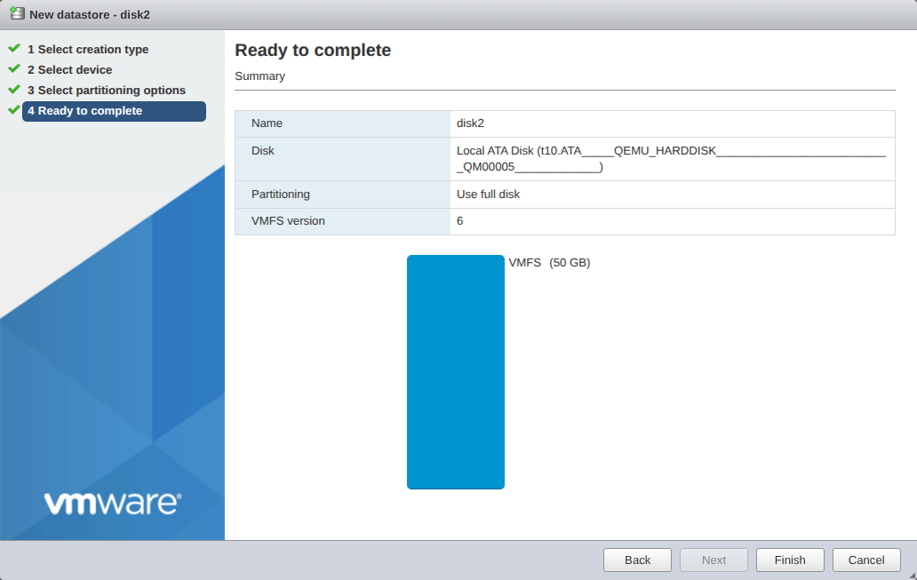

We are going to deploy this VM on ESXI3 (192.168.122.198)
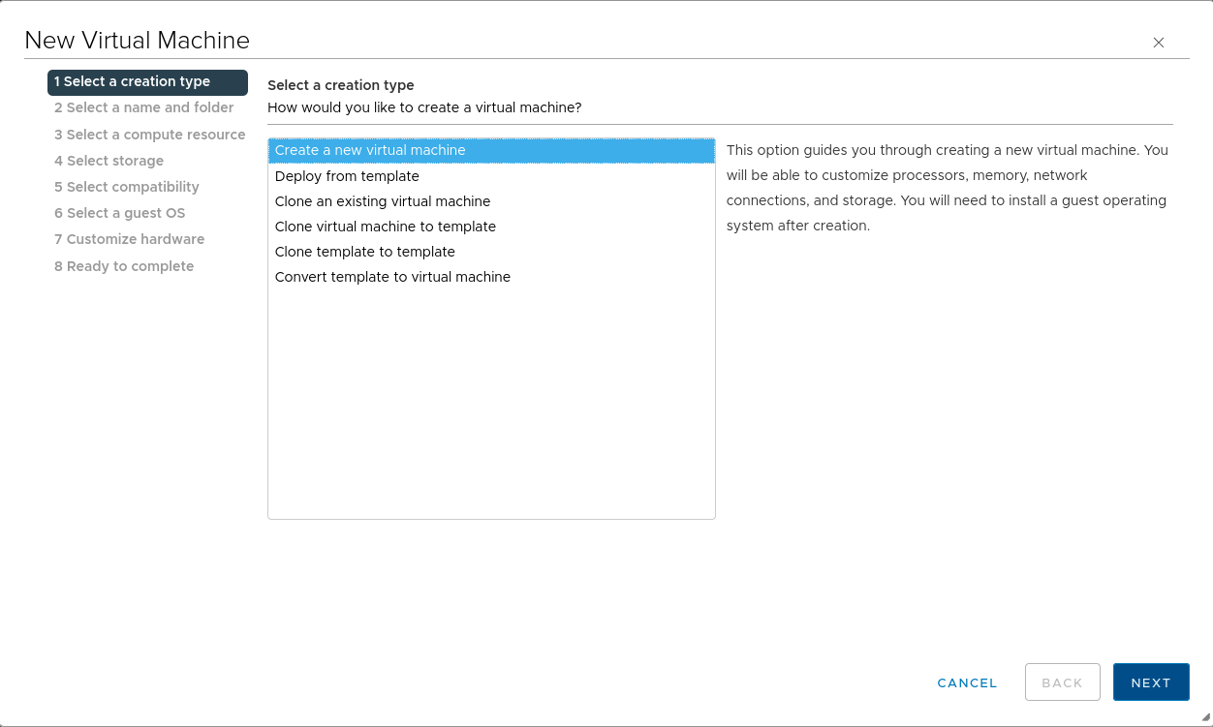

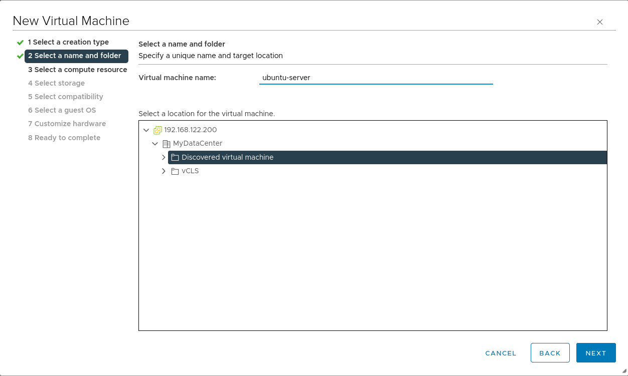

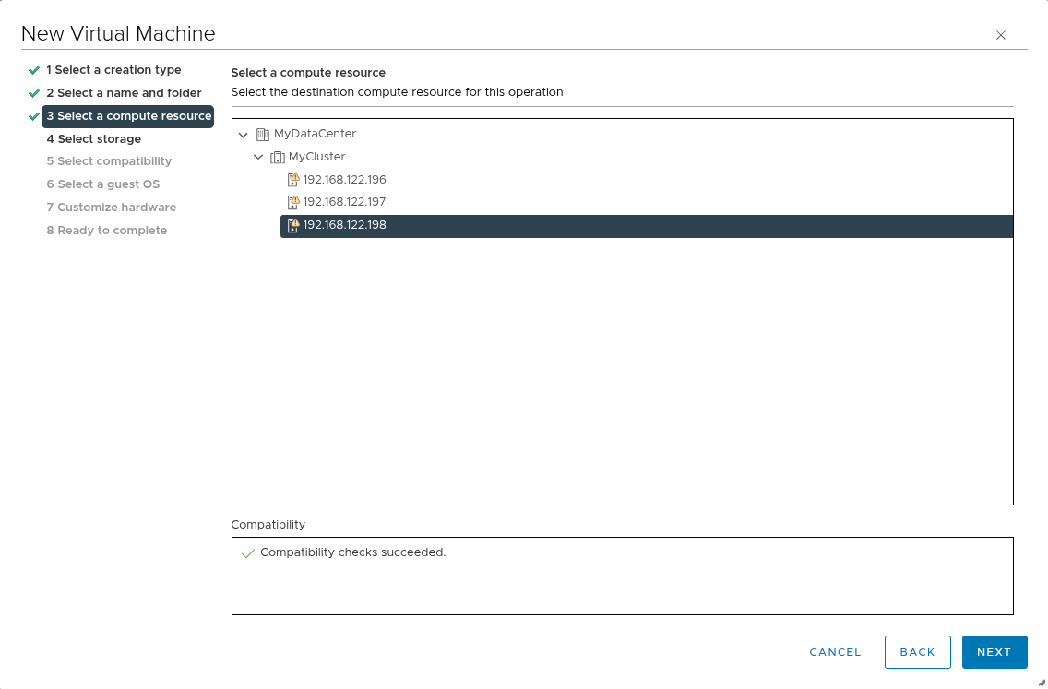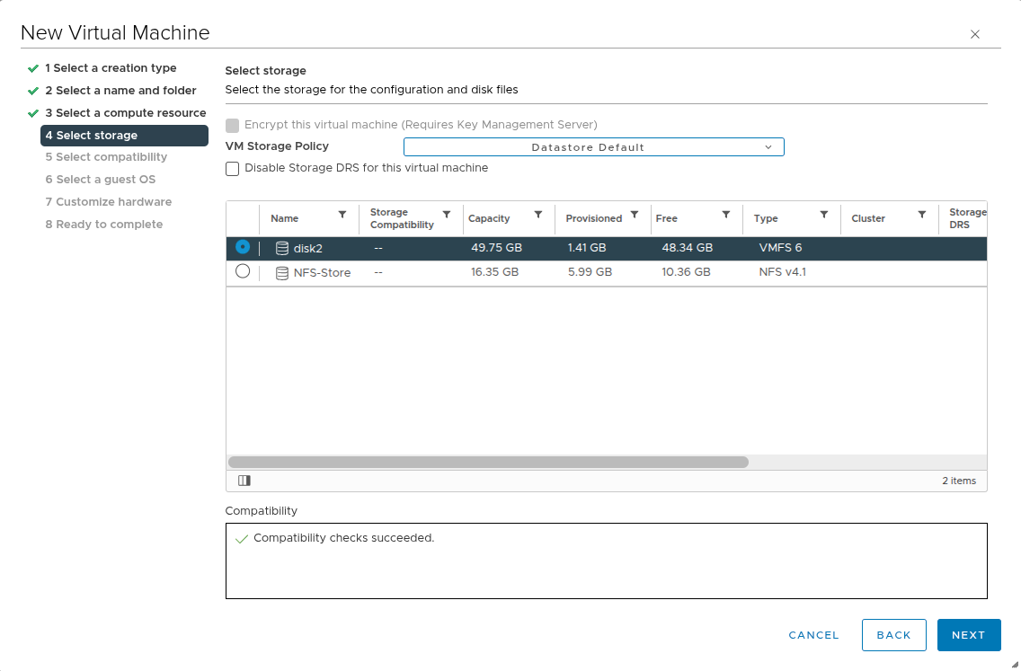
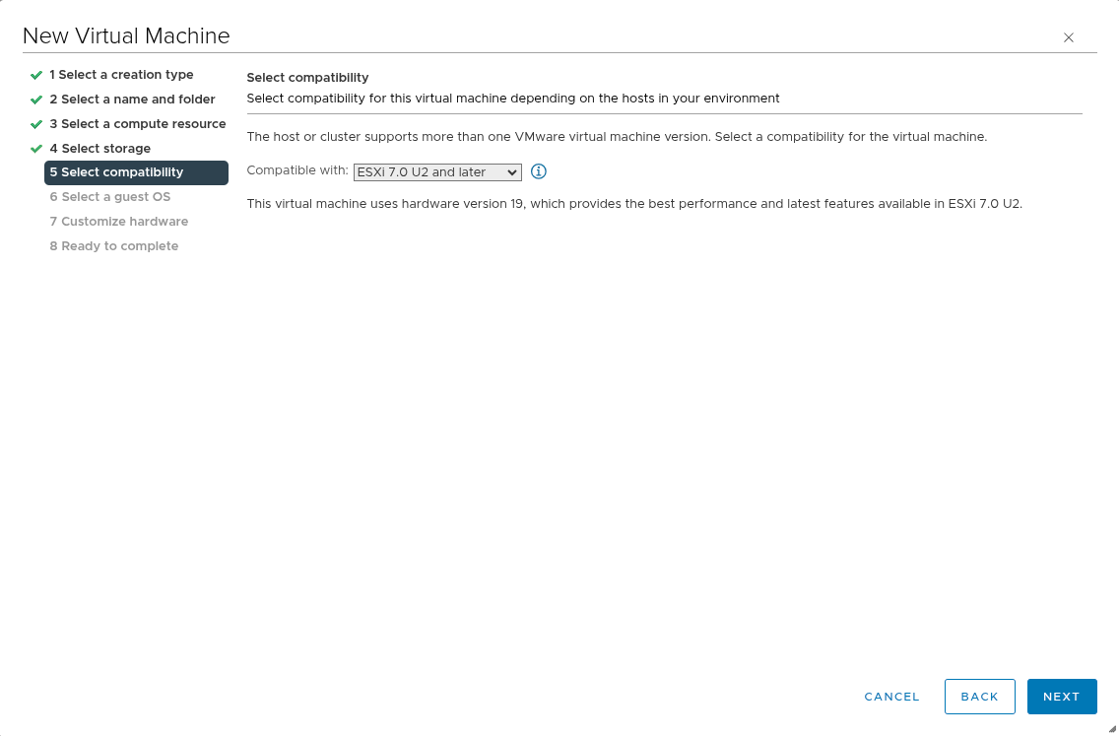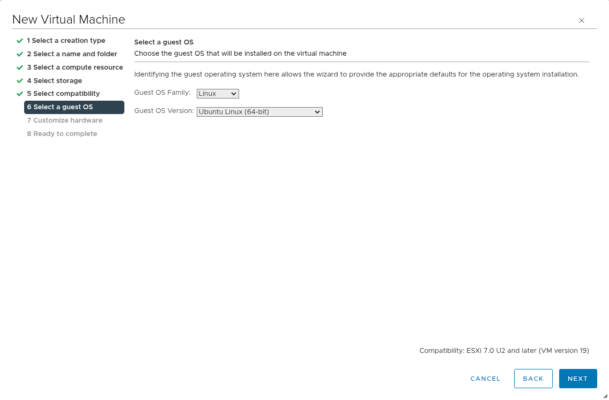

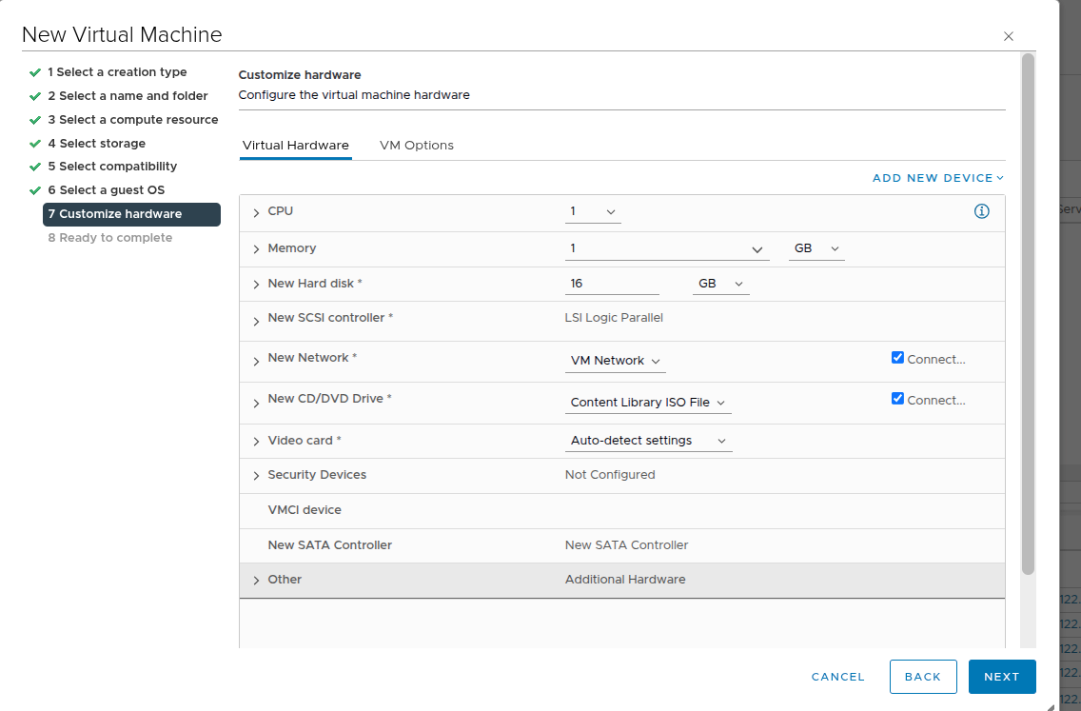
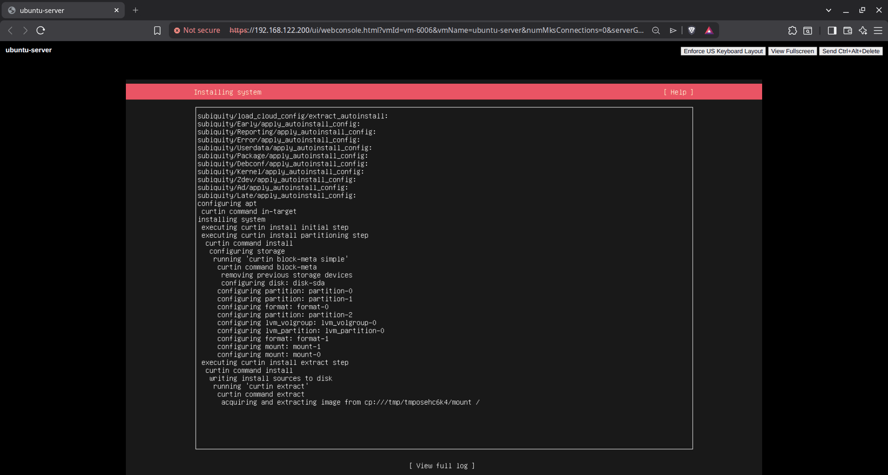

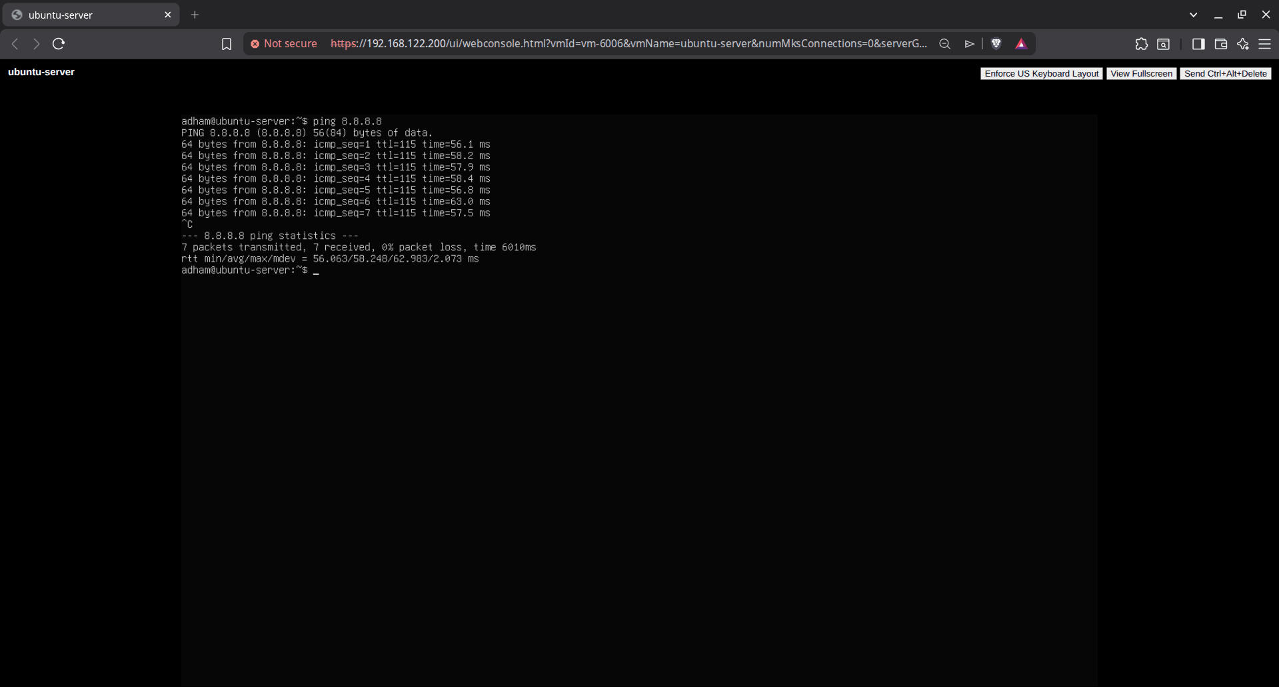

Clone an Existing Virtual Machine:
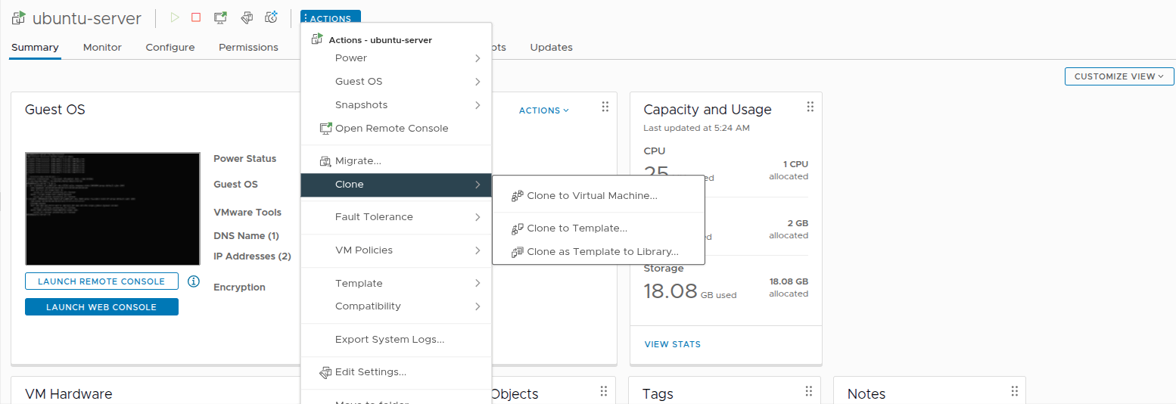

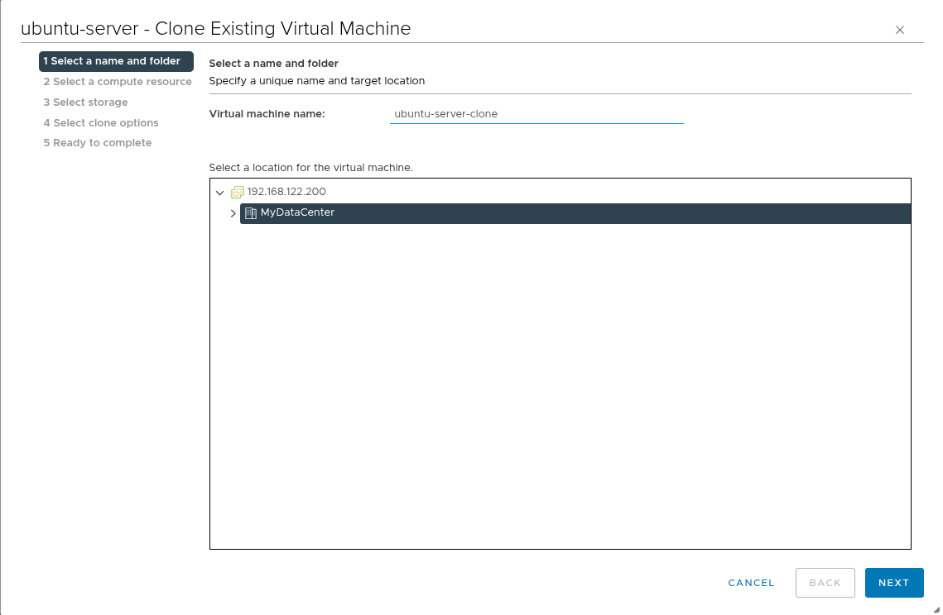

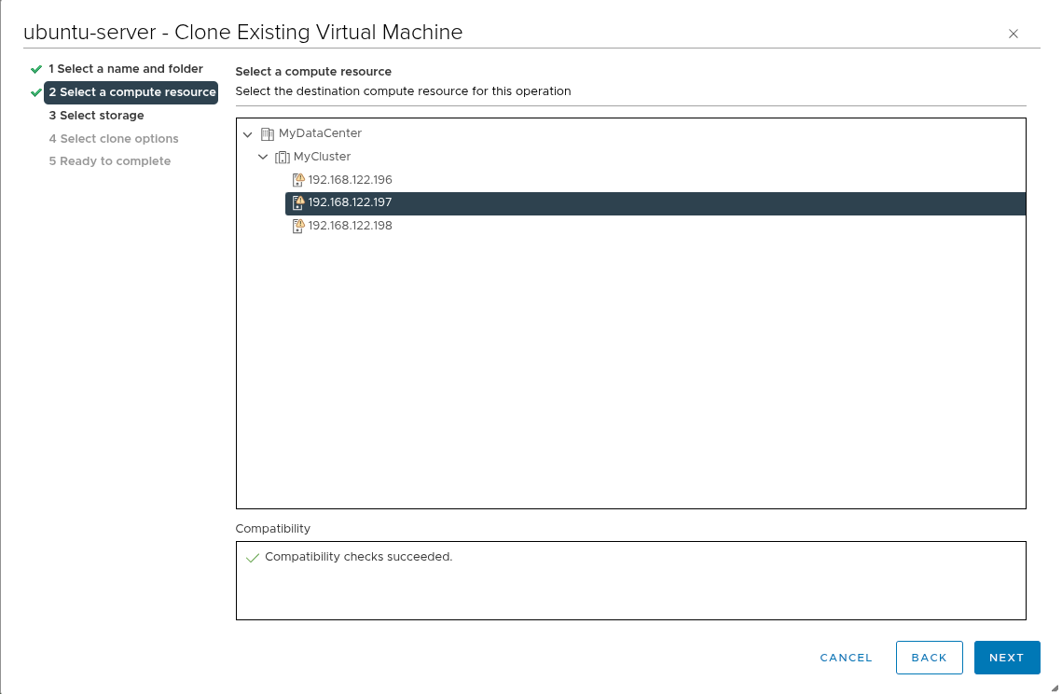
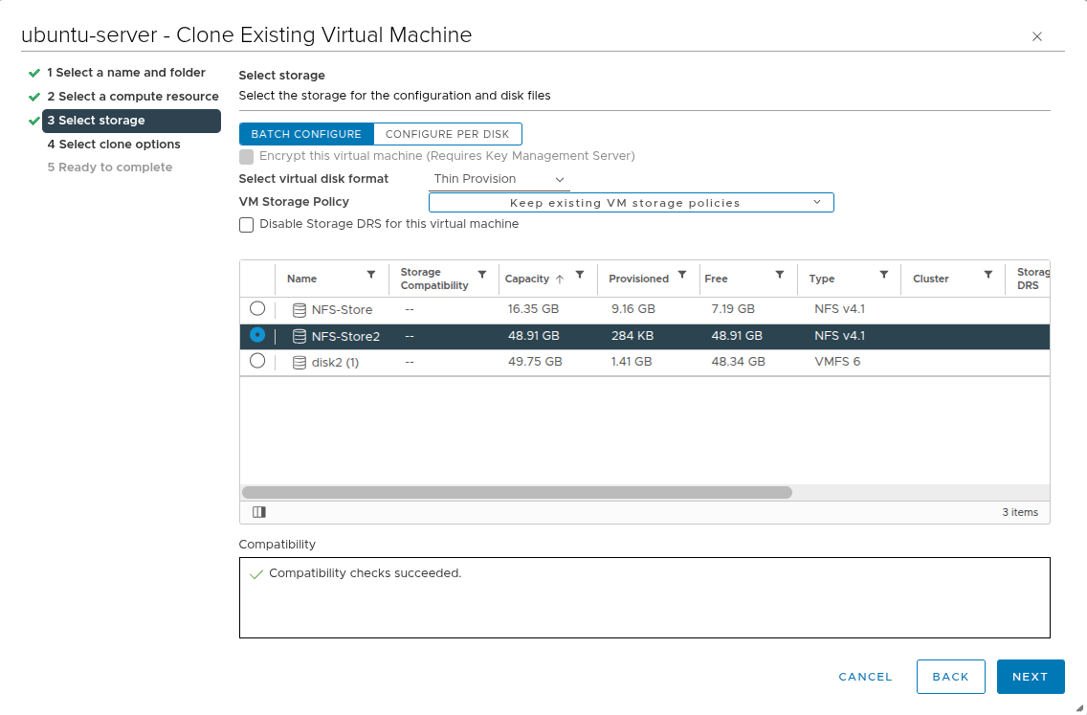

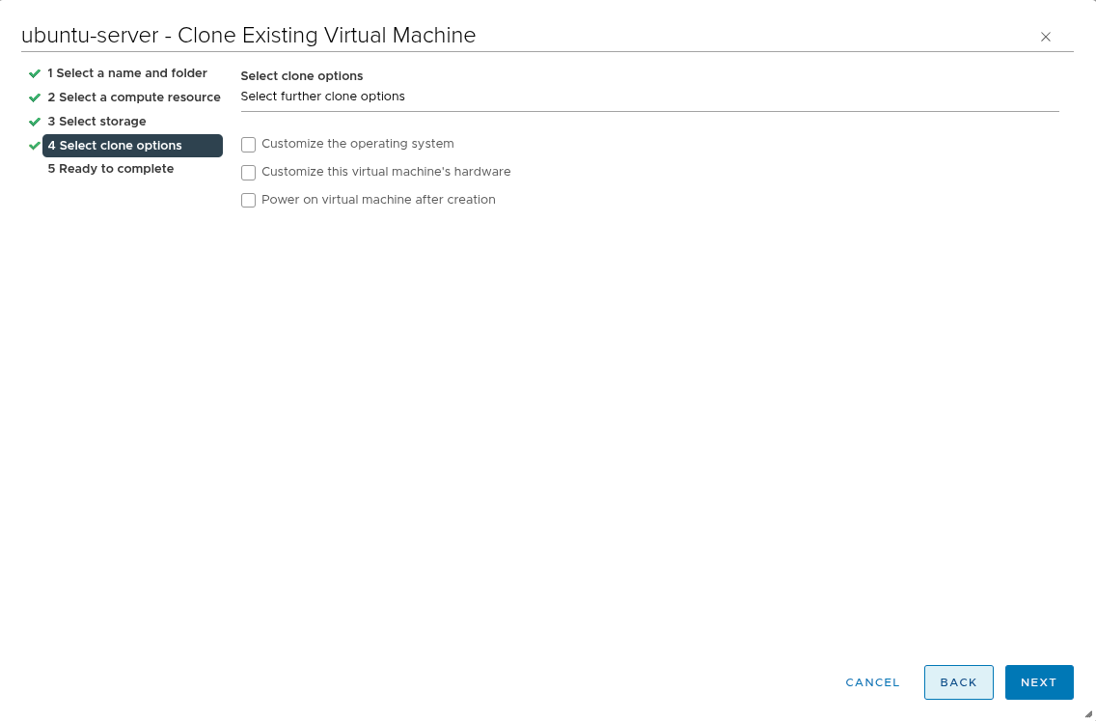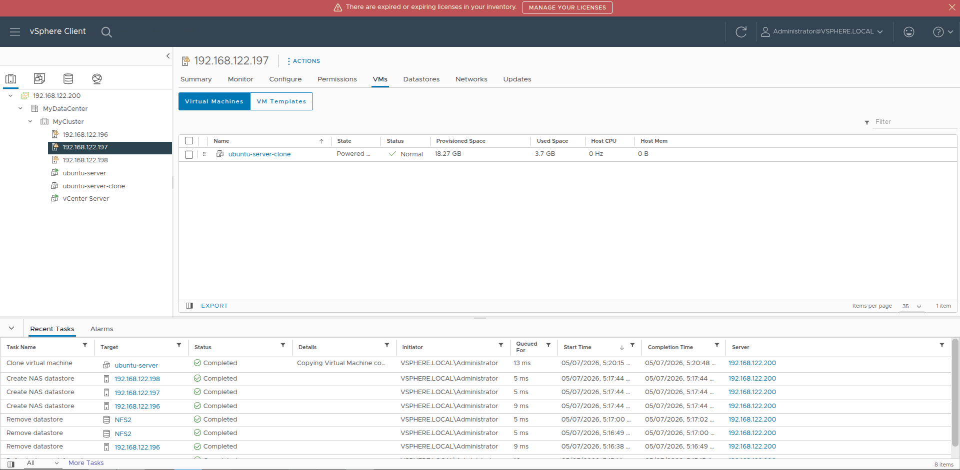

Create a snapshot of VM:
We first take a snapshot of the VM before creating a text file.
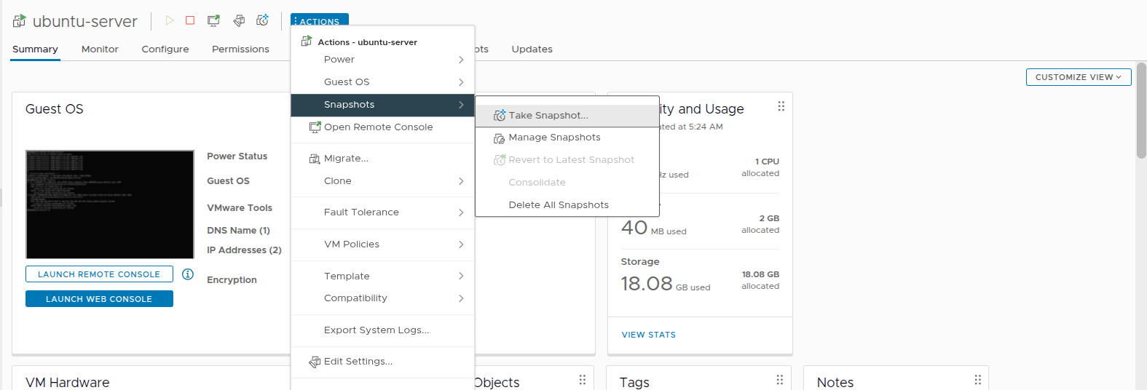
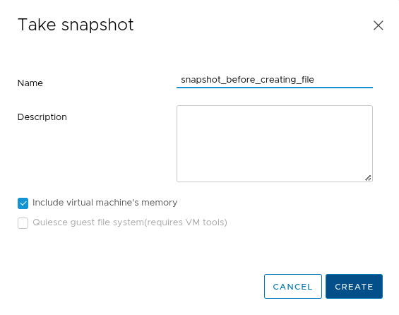
Then we create the test file.
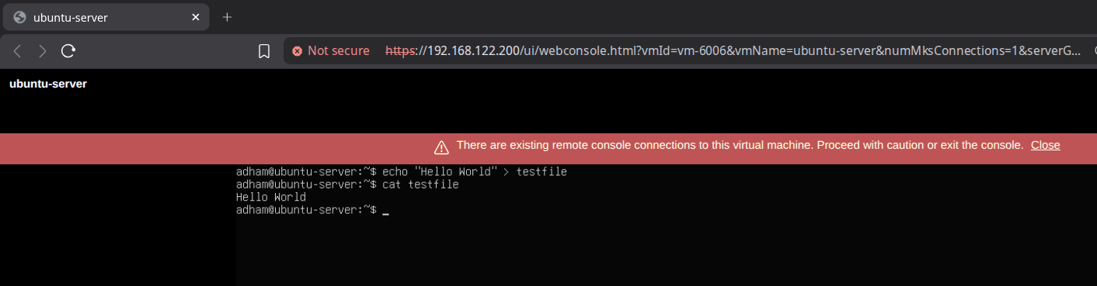

Then we revert back to the snapshot and test file should not exist.
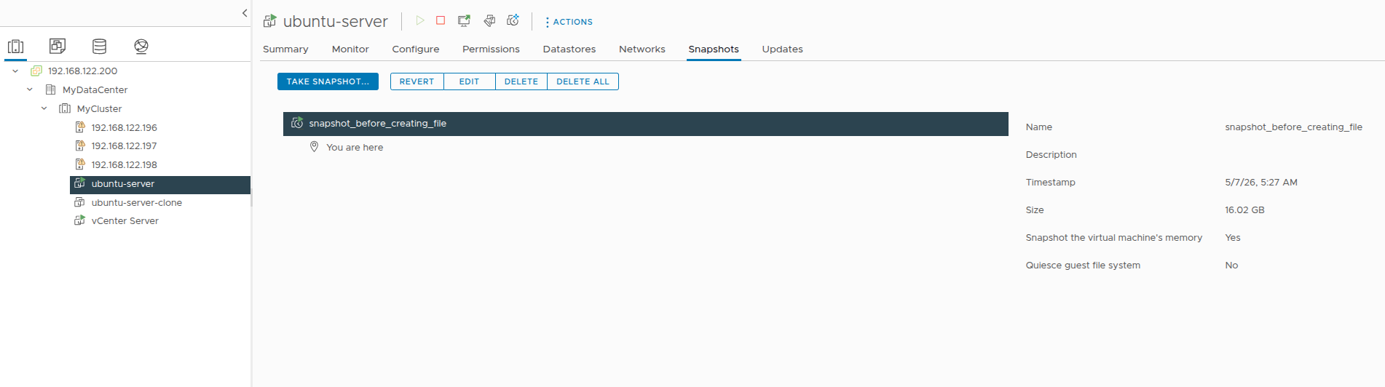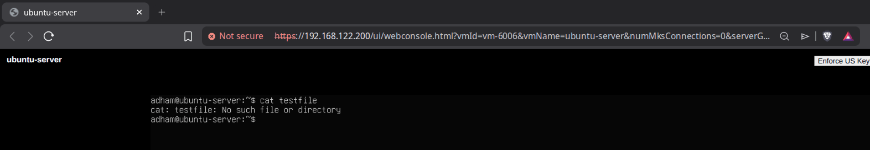

Convert a VM to a template:
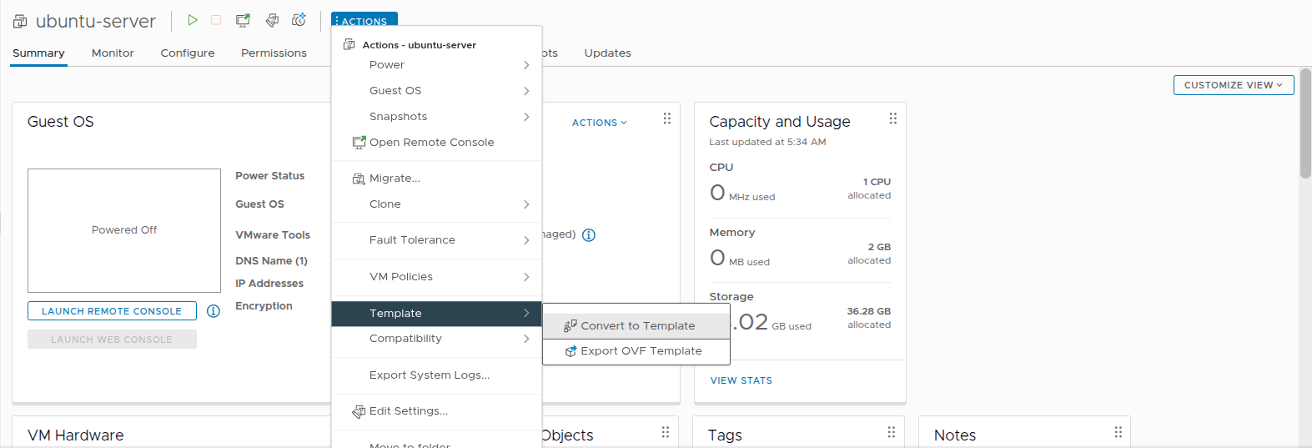

Testing Migration:
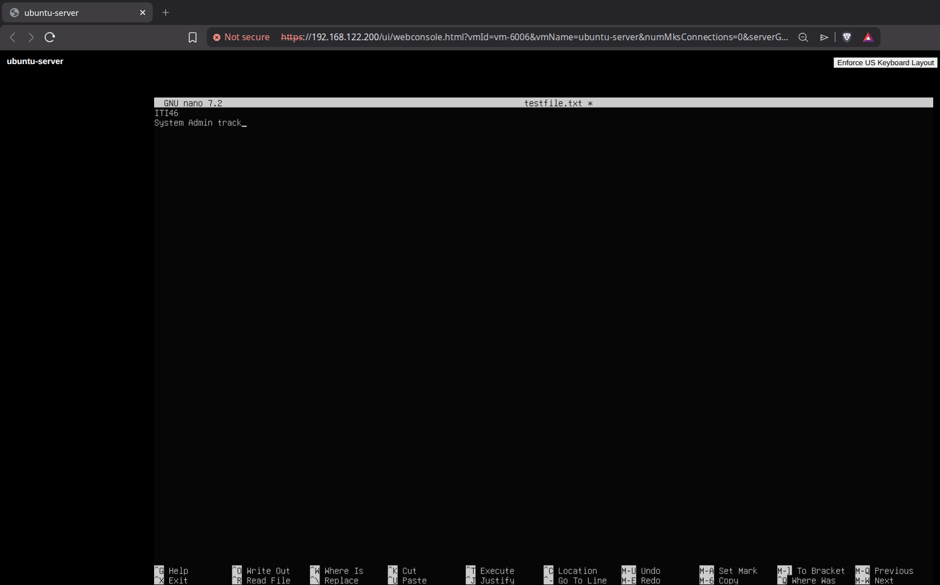
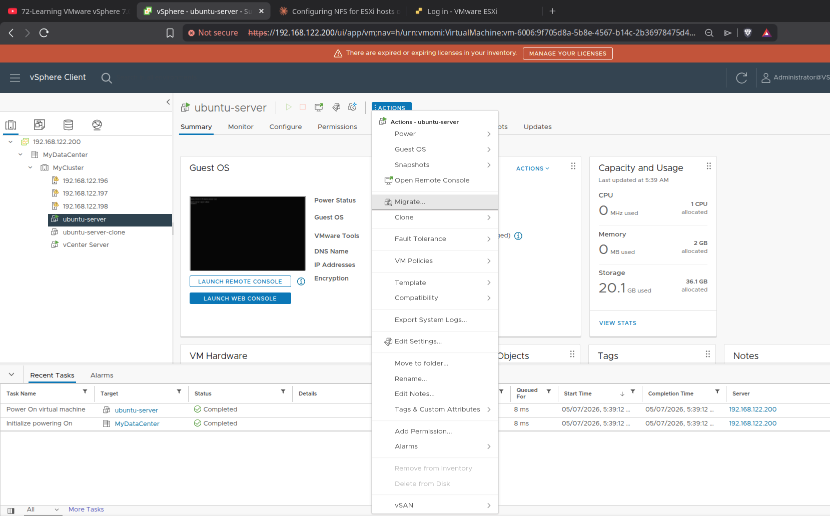

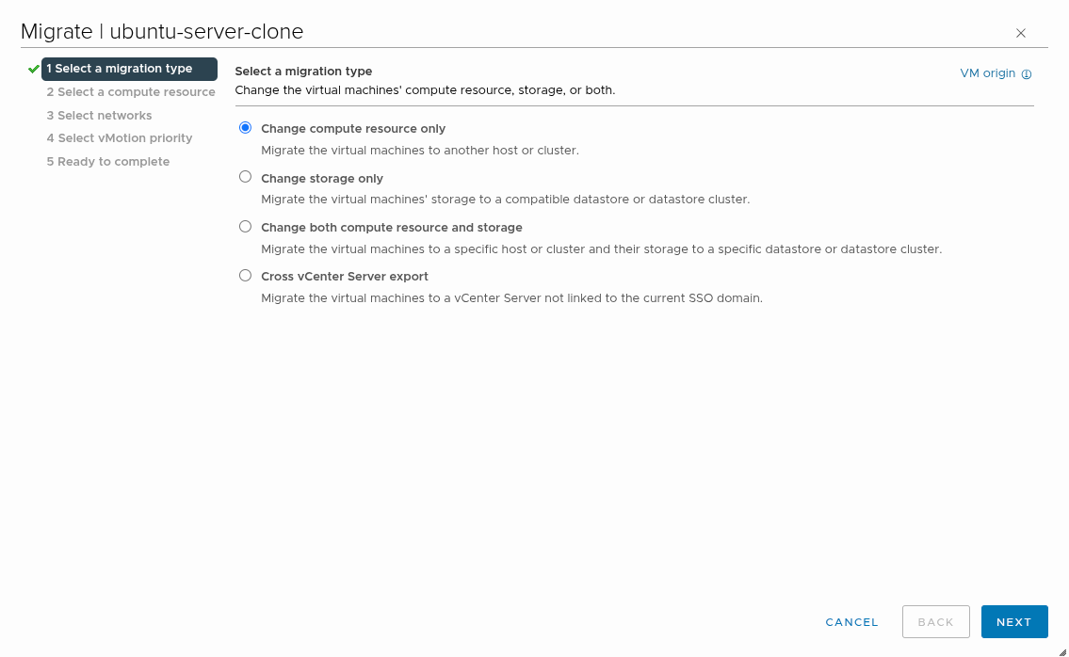
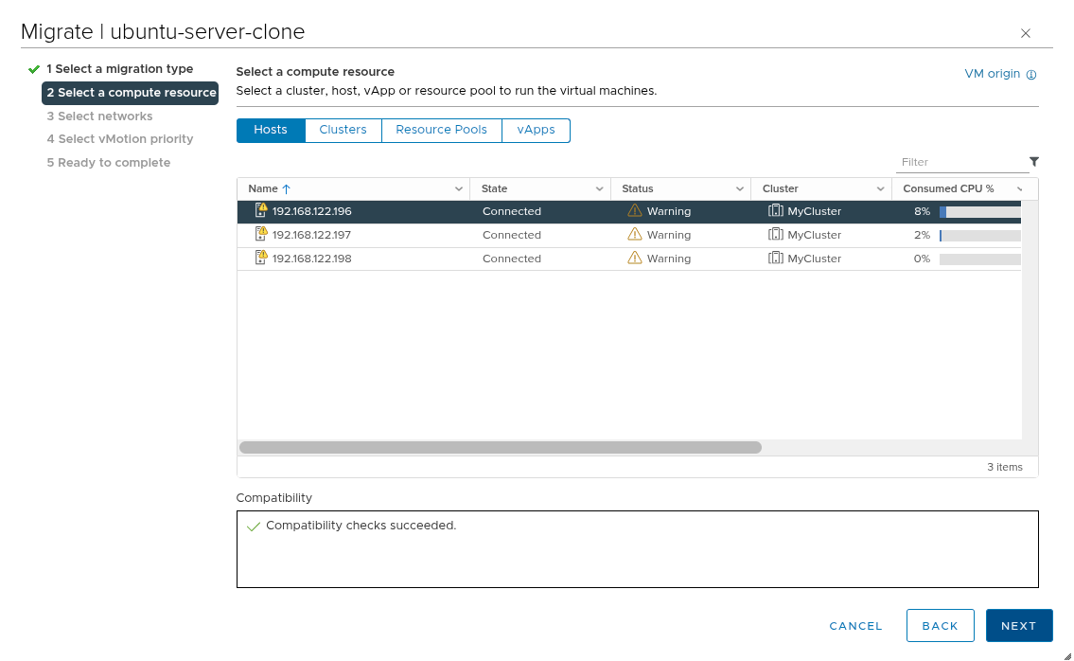

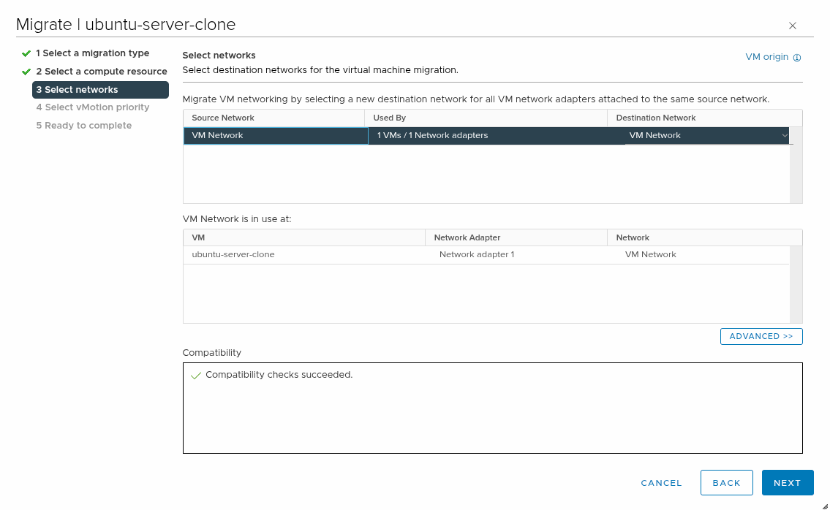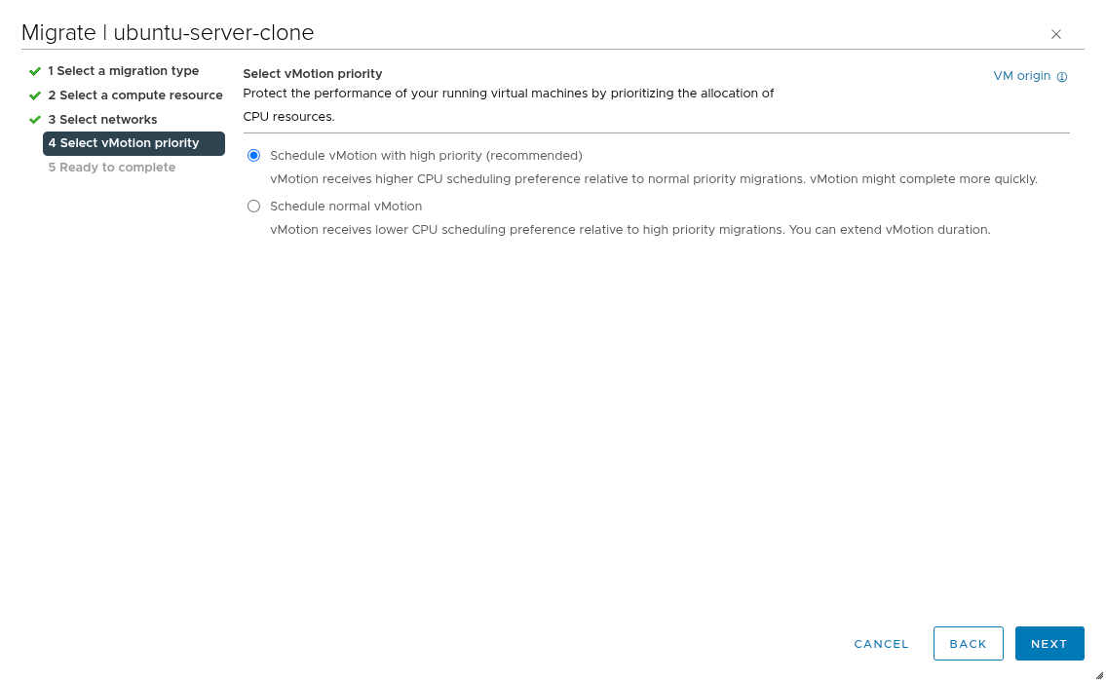

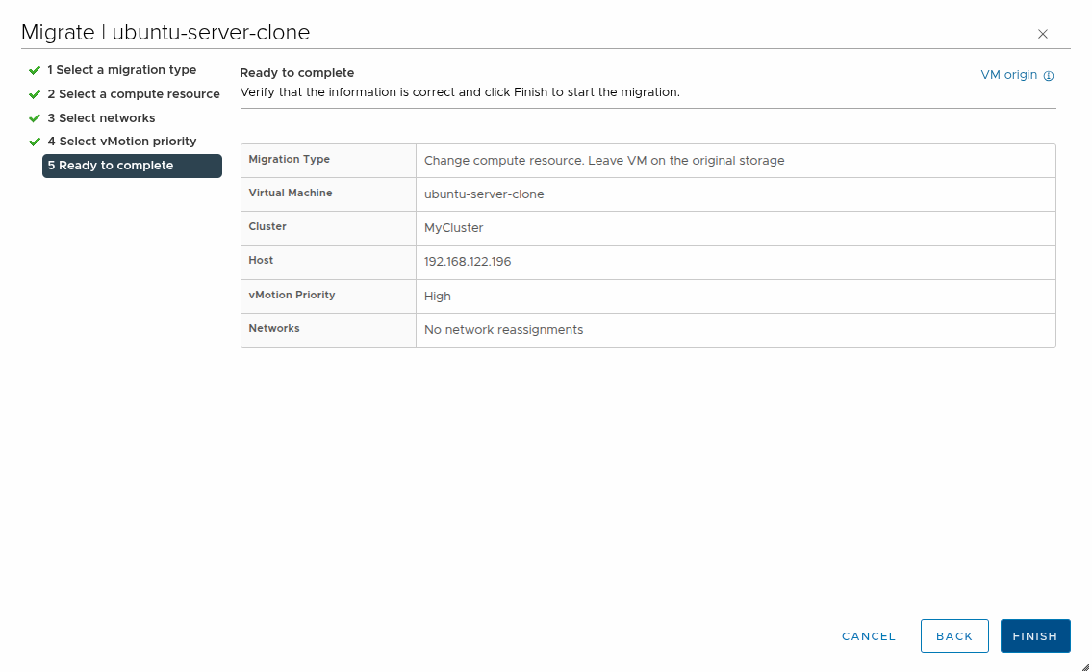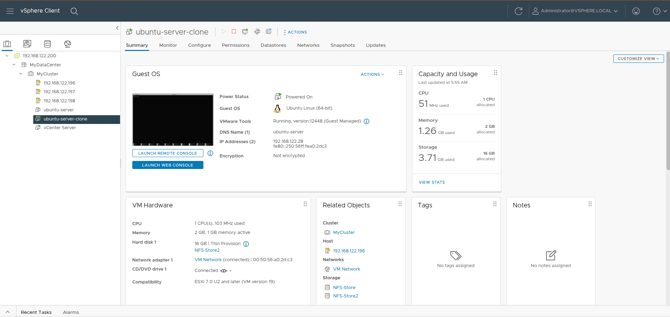


Testing HA:
We start with ubuntu-server-clone VM running on ESXI2 (192.168.122.197) and then we shutdown ESXI2 to induce a host failure so that the VM will restart on another ESXI (in this case ESXI3).
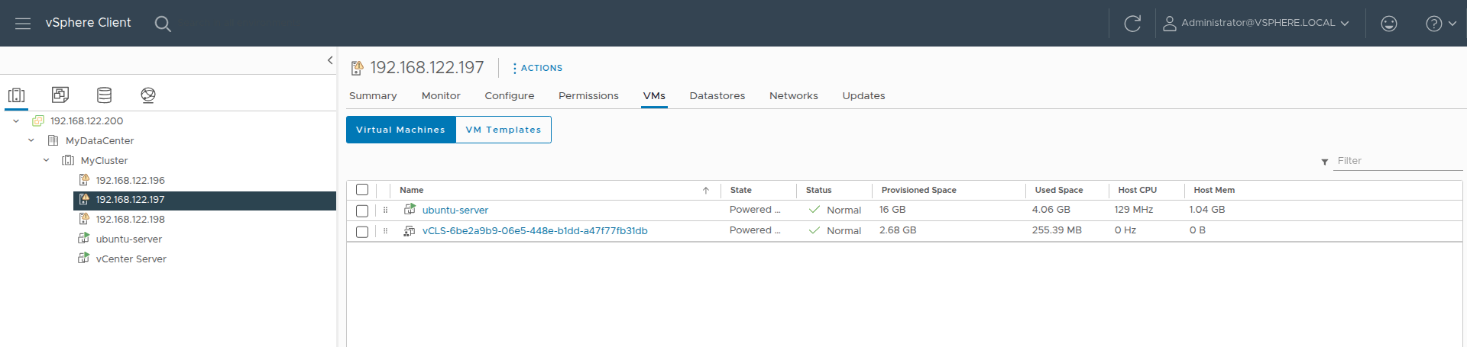

We get an HA alarm that restarts the VM on ESXI3 (192.168.122.198)
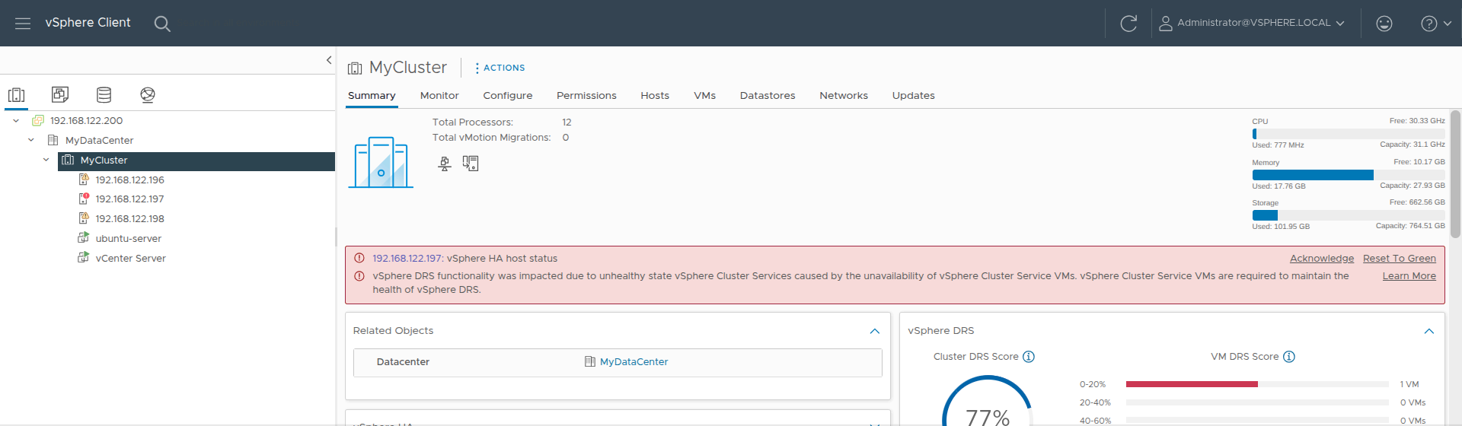
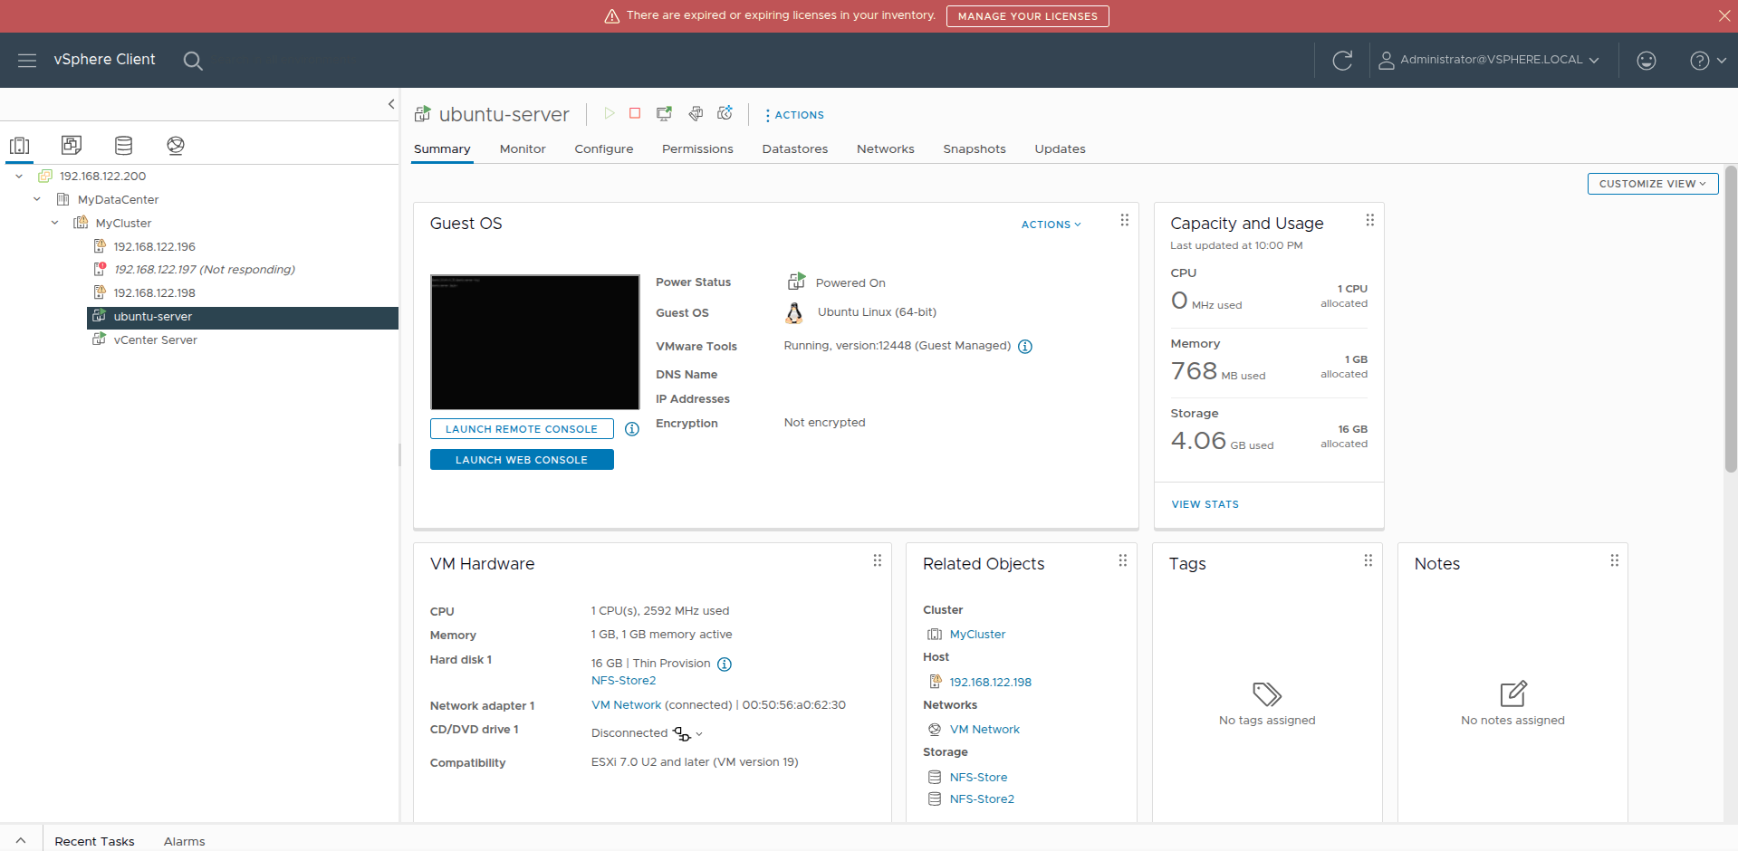
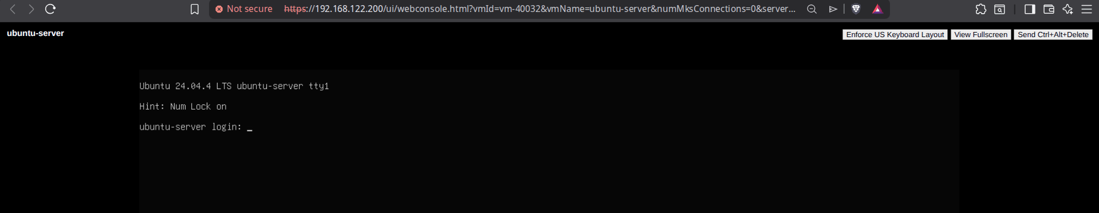

Testing Fault Tolerance:
We first edit the vmkernel created so that it passes Fault tolerance logging traffic.
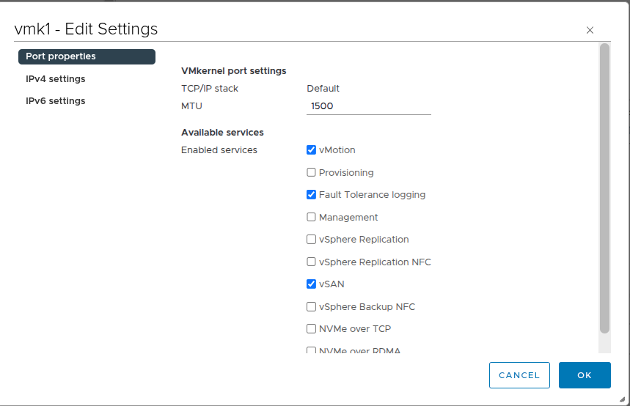
Then we start the ubuntu server on ESXI3 and run nano to write a text file and leave it in this state.
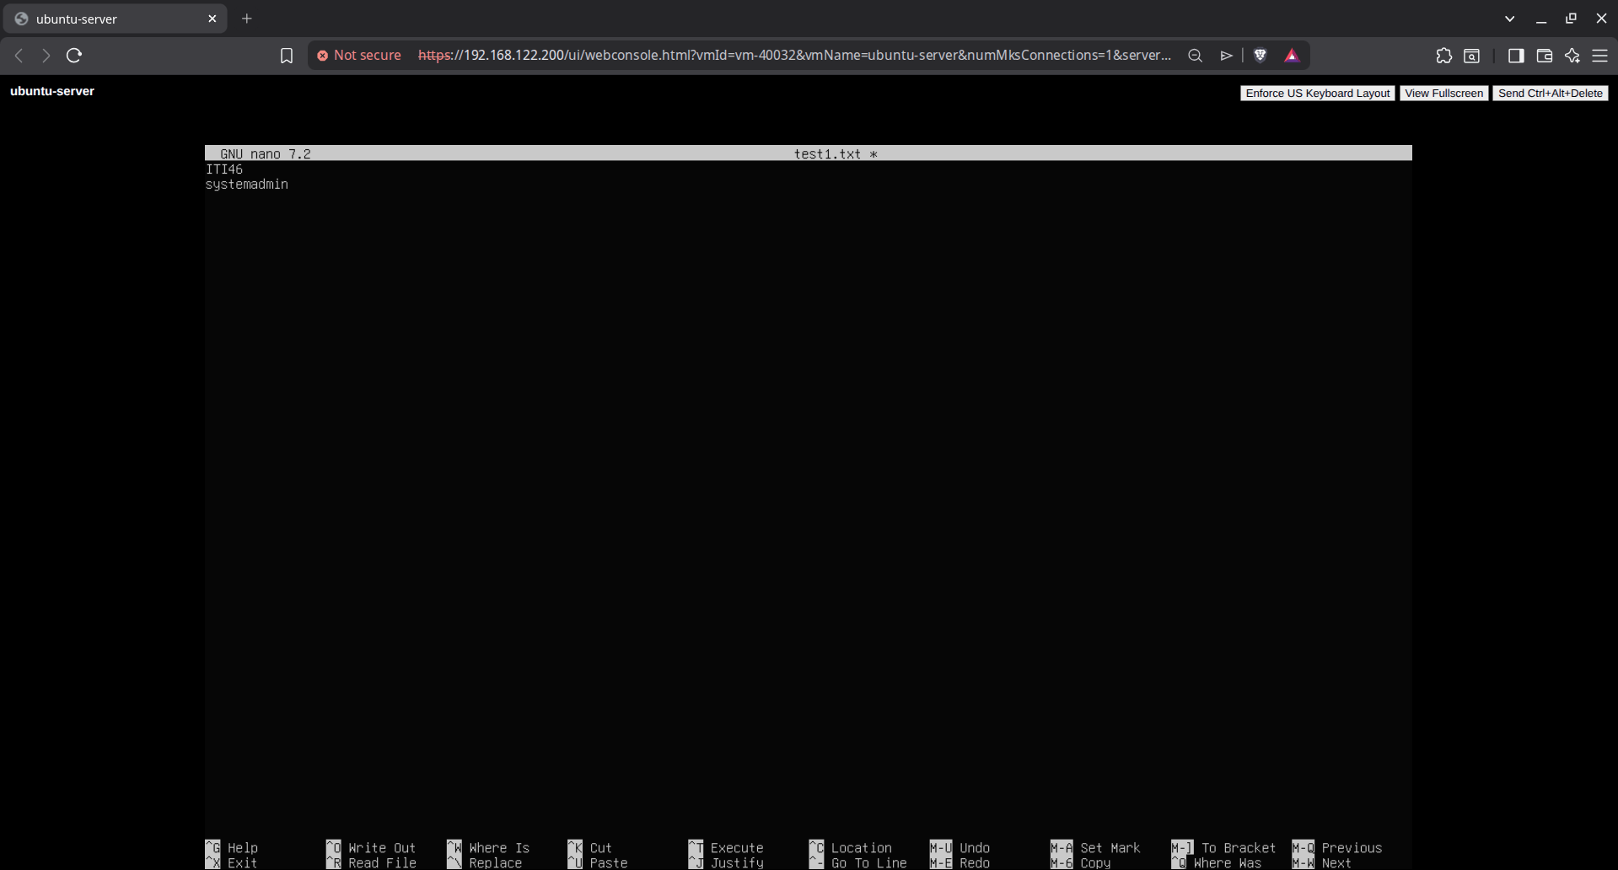
Then we create a secondary standby of this VM on ESXI2
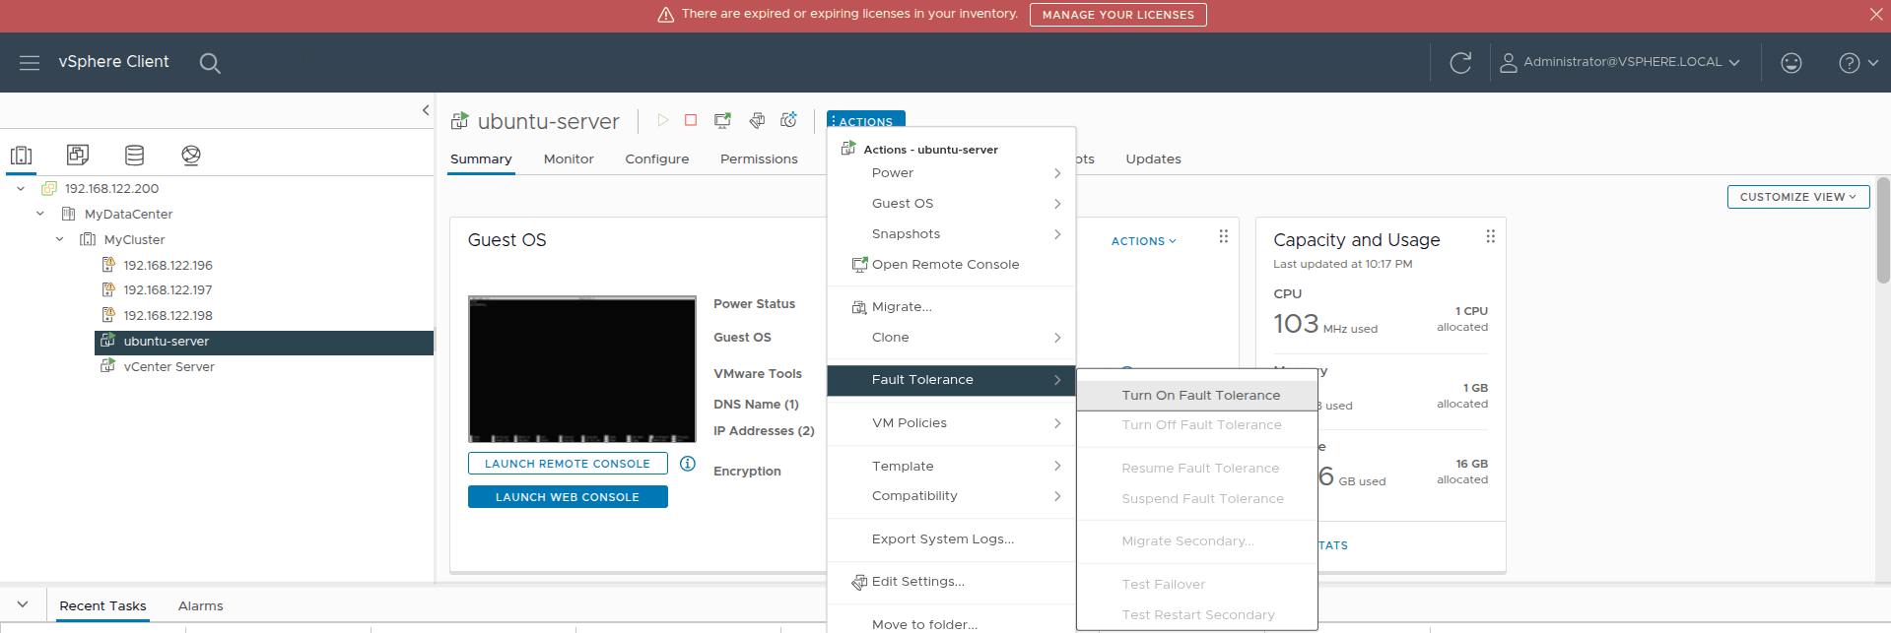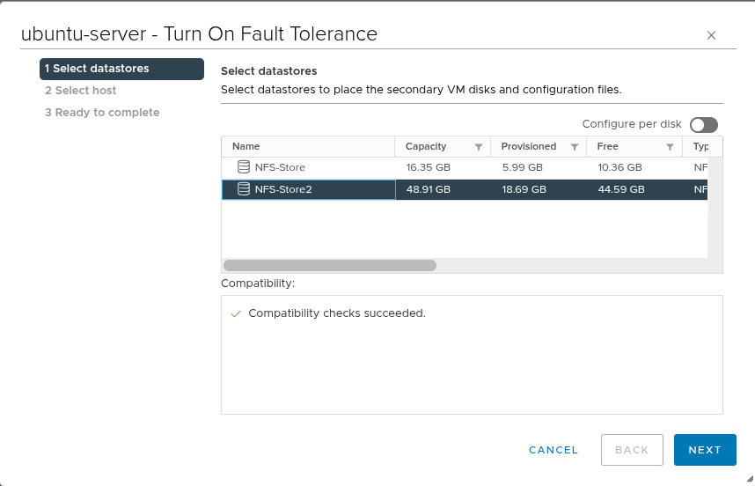
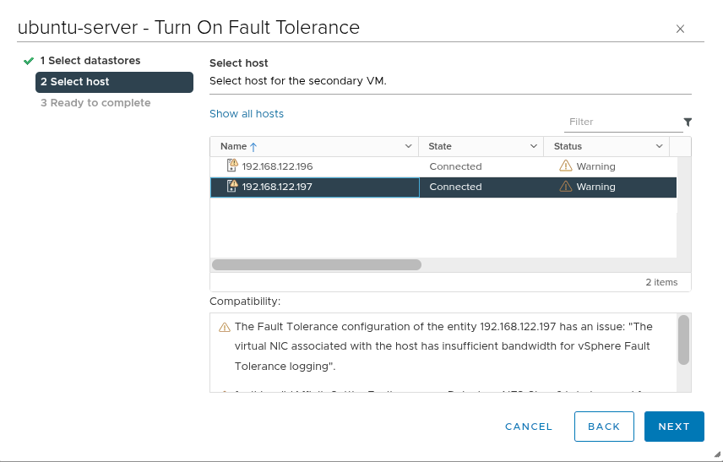
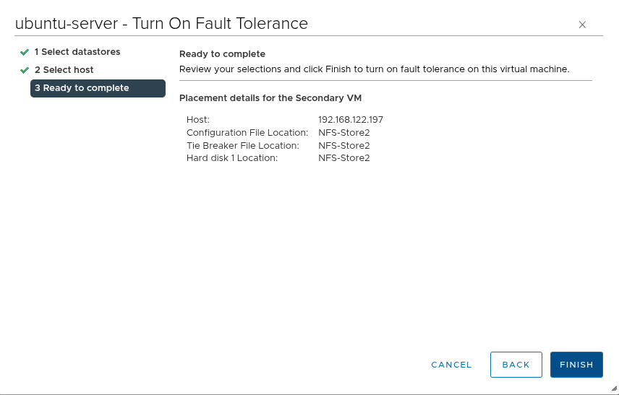

Now we shutdown ESXI3 and it should make the standby VM run on ESXI2 with zero downtime.


