# **ARTIFICAL INTELLIGENCE LAB**



**2024**

**CS 351**

Submitted by**: AHMED AMJAD**

Registration No.: **2022063**

Faculty: **FCSE**

“On my honor, as student of Ghulam Ishaq Khan Institute of Engineering Sciences and Technology, I have neither given nor received unauthorized assistance on this academic work.”

Submitted to:

**Sir Usama Janjua**

**Date: 24 September, 2024**

Slot 1:

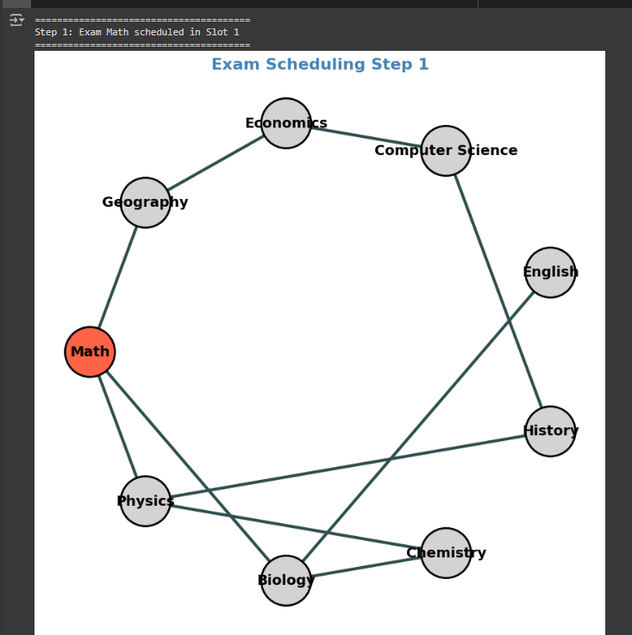

Slot 2:

Slot 3:  
  
  
  
  
  
  
  
  
  
  
Slot 4:

Slot 5:  
  
  
  
  
  
  
  
  
  
  
Slot 6:

Slot 7:  
  
  
  
  
  
  
  
  
  
  
Slot 8:  
  
  
  
  
  
  
  
  
  
  
Slot 9:

