FU_ES

Ahmedamr7787@gmail.com

**v2v**

System Requirements

* **System Design**
* Main Vehicle
* Assistant Vehicle

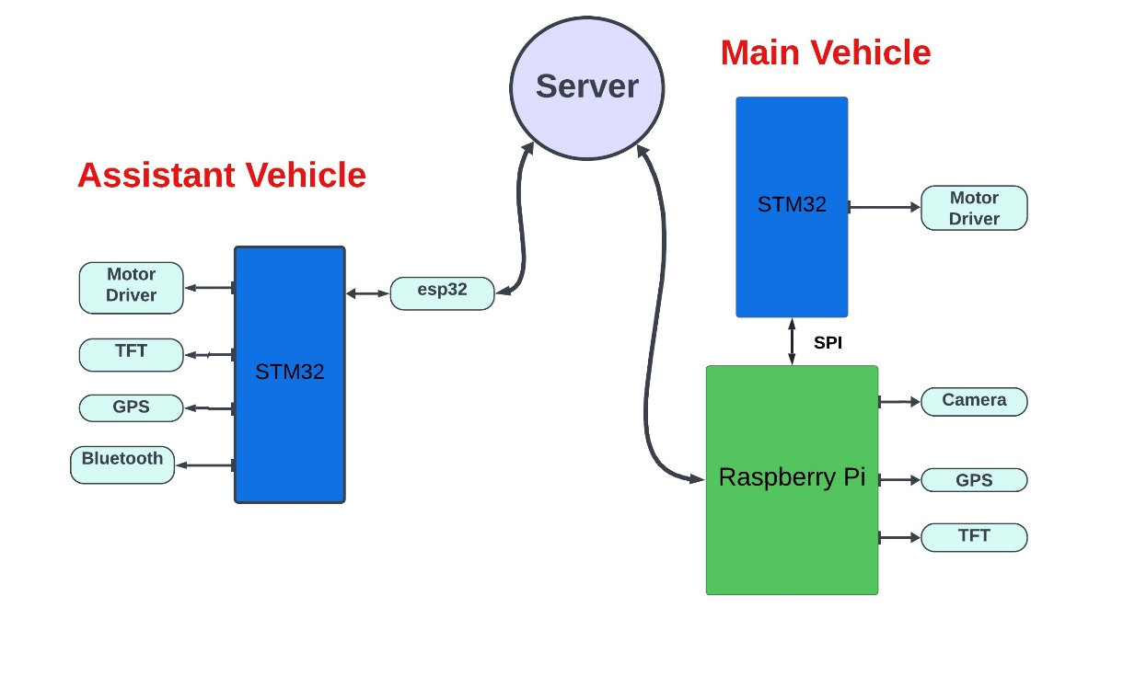

* **Main Vehicle**

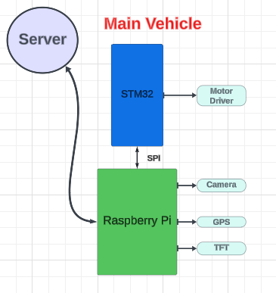

**Needed Functions:**

**Vehicle Motion**

void HMOTOR_voidInit (void);

void HMOTOR_voidStop (void);

void HMOTOR_voidMoveForward (uint16_t Copy_uint16Speed);

void HMOTOR_voidMoveBackward (uint16_t Copy_uint16Speed);

void HMOTOR_voidMoveRight (uint8_t Copy_uint8SDirection);

void HMOTOR_voidMoveLeft (uint8_t Copy_uint8SDirection);

**Connection between STM and Raspberry pi (Using SPI1)**

HAL_StatusTypeDef HAL_SPI_Init(SPI_HandleTypeDef *hspi);

HAL_StatusTypeDef HAL_SPI_Transmit_IT(SPI_HandleTypeDef *hspi, uint8_t *pData, uint16_t Size);

HAL_StatusTypeDef HAL_SPI_Receive_IT(SPI_HandleTypeDef *hspi, uint8_t *pData, uint16_t Size);

**Interfacing with the Camera**

void HCamera_voidInit (void);

void HCamera_voidGetImage (uint16_t *Copy_ uint16pictureData);

**Interfacing with the TFT**

void HTFT_voidInit (void);

void HTFT_voidDisplayImage (const uint16_t *Copy_ uint16pictureData);

void HTFT_voidFillColor (u16 Copy_u16Color);

void HTFT_voidDrawShape (Shape Dimensions);

**Interfacing with the WIFI**

void ESP_voidInit (void);

void ESP_voidConnectToWifi (u8 *Copy_Pu8WifiName , u8 *Copy_Pu8WifiPassword);

void ESP_voidConnectToServer (u8 *Copy_Pu8ServerIP);

void ESP_voidWriteData (u8 *Copy_Pu8Data , Path);

void ESP_voidReadData (u8 *Copy_Pu8Data , Path);

**Interfacing with the GPS**

……………

……………

* **Assistant Vehicle**

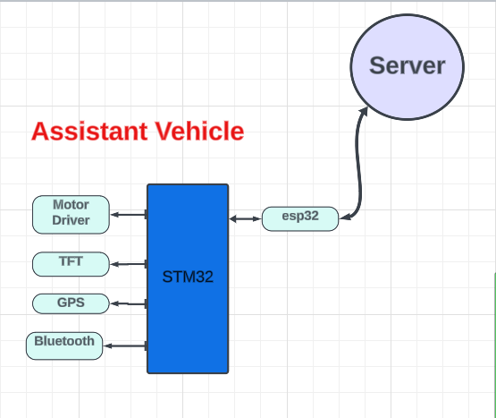

**Needed Functions:**

**Vehicle Motion**

void HMOTOR_voidInit (void);

void HMOTOR_voidStop (void);

void HMOTOR_voidMoveForward (uint16_t Copy_uint16Speed);

void HMOTOR_voidMoveBackward (uint16_t Copy_uint16Speed);

void HMOTOR_voidMoveRight (uint8_t Copy_uint8SDirection);

void HMOTOR_voidMoveLeft (uint8_t Copy_uint8SDirection);

**Interfacing with the TFT**

void HTFT_voidInit (void);

void HTFT_voidDisplayImage (const uint16_t *Copy_ uint16pictureData);

void HTFT_voidFillColor (u16 Copy_u16Color);

void HTFT_voidDrawShape (Shape Dimensions);

**Interfacing with the WIFI**

void ESP_voidInit (void);

void ESP_voidConnectToWifi (u8 *Copy_Pu8WifiName , u8 *Copy_Pu8WifiPassword);

void ESP_voidConnectToServer (u8 *Copy_Pu8ServerIP);

void ESP_voidWriteData (u8 *Copy_Pu8Data , Path);

void ESP_voidReadData (u8 *Copy_Pu8Data , Path);