

**BONAFIDE CERTIFICATE**

Certified that this Internship report “DATA ANALYTICS USING MICROSOFT POWER BI” is the bonafide work of “AHMED ASLAM (210171601006)” who carried out the internship under my supervision. Certified further, that to the best of our knowledge the work reported herein does not form part of any other internship report or dissertation on the basis of which a degree or award was conferred on an earlier occasion on this or any other candidate.

*SIGNATURE*

**Mrs. PREETI VERMA**

Assistant Professor

Department of CSE

B.S. Abdur Rahman Crescent

Institute of Science and Technology

Vandalur, Chennai – 600 048.

**INTERNSHIP CERTIFICATE**

 

**VIVA VOCE EXAMINATION**

The viva voce examination of the Internship titled **“DATA ANALYTICS USING MICROSOFT POWER BI ”,** submitted by **AHMED ASLAM M (2010171601006)** is held on ________________.

**INTERNAL EXAMINER**

**ACKNOWLEDGEMENT**

### I sincerely express my heartfelt gratitude to Prof. Dr. T. MURUGESAN, Vice chancellor and Dr. N. THAJUDDIN, Pro-Vice Chancellor, B.S. Abdur Rahman Crescent Institute of Science and Technology, for providing me an environment to carry out my internship successfully.

I sincerely thank **Dr. N. RAJA HUSSAIN**, Registrar, for furnishing every essential facility for doing my internship.

### I thank Dr. SHARMILA SANKAR, Dean, School of Computer Information and Mathematical Sciences for her motivation and support.

I thank **Dr. W. AISHA BANU**, Professor and Head, Department of Computer Science and Engineering, for providing strong oversight of vision, strategic direction and valuable suggestions.

I obliged my class advisor **Mrs. PREETI VERMA,** Assistant Professor, Department of Computer Science and Engineering for her professional guidance and continued assistance throughout the internship period.

I thank **Mrs. Nandhi**, project manager, **Intrainz** for his/her guidance and encouragement throughout the internship period and without his/her guidance this project would not have been a successful one.

I thank all the **Faculty members** and the **System Staff** of the Department of Computer Science and Engineering for their valuable support and assistance at various stages of internship completion.

**(AHMED ASLAM M)**

**TABLE OF CONTENTS**

|  |  |  |
| --- | --- | --- |
| **CHAPTER NO.** | **TITLE** | **PAGE NO.** |
|  | **LIST OF FIGURES** | **7** |
| **1** | **COMPANY OVERVIEW** | **8** |
| 1.1 | Company Overview | **8** |
| 1.2 | Company Website | **8** |
| **2** | **ROLE AND RESPONSIBILITY** | **8** |
| 2.1 | Role | **8** |
| 2.2 | Responsibility | **9** |
| **3** | **PROJECT OVERVIEW** | **9** |
| **4** | **THEORETICAL ANALYSIS** | **9** |
| 4.1 | Introduction to Power BI | **9** |
| 4.2 | Characteristics of Power BI | **10** |
| 4.3 | Types of Power BI | **11** |
| 4.4 | Basic operations in Power BI | **11** |
| **5** | **DESIGN AND IMPLEMENTATION** | **12** |
| 5.1 | Dataflow | **12** |
| 5.2 | Dataset and Importation | **13** |
| 5.3 | Power query | **15** |
| 5.4 | Visual | **15** |
| **6** | **RESULT AND ANALYSIS** | **19** |
| **7** | **CONCLUSION** | **20** |
| **8** | **REFERENCES** | **20** |

**LIST OF FIGURES**

|  |  |  |
| --- | --- | --- |
| **FIGURE NO.** | **TITLE** | **PAGE.NO** |
| 1 | Dataflow chart | 15 |
| 2 | Excel dataset | 15 |
| 3 | Create report | 16 |
| 4 | Import dataset | 16 |
| 5 | Power Query | 17 |
| 6 | Report visual page | 18 |
| 7 | Task1 visual answer | 18 |
| 8 | Task2 visual answer | 19 |
| 9 | Task3 visual answer | 20 |

1. **COMPANY OVERVIEW**
   1. **Company Overview :**

IntrainzInnovation Private Limited (IIPL) is a Private Limited Indian Non-Government Company incorporated in India on 22 September 2022 (One year and one month old). Its registered office is in Bangalore, Karnataka, India. The Company is engaged in the Education & Learning Industry. Intrainz aims to prep university students to become industry ready. They do this by providing students an opportunity to create specialized skill sets for them in domains with high market demand. This is achieved by our combination of an in-depth industrial training program under the mentorship of experienced industry professionals along with certified live internship projects which together enable the student to receive the adequate industrial project experience in order for them to land a good job in the corporate world.

* 1. **Company Website :**

[**https://www.intrainz.com/about.html**](https://www.intrainz.com/about.html)

1. **ROLE AND RESPONSIBILITY**
   1. **Role :**

I'm a data analyst who uses Microsoft Power BI to turn complex data into easy-to-understand insights. I create visual reports and dashboards, helping make smarter decisions. My skills include analysing trends and using data to improve overall performance.

* 1. **Responsibility :**

In my role as a data analyst utilizing Microsoft Power BI, I am responsible for transforming raw data into accessible insights. I design and develop interactive dashboards and reports, enabling to make informed decisions. I identify trends and patterns to provide valuable recommendations and completing the assigned tasks is a key responsibility.

1. **PROJECT OVERVIEW**

This data analytics project, undertaken in collaboration with Intrainz Company, centres on analysing an online retail dataset using Microsoft Power BI. With the flexibility to select a relevant dataset, I will delve into the intricacies of online retail dataset. Responsibilities encompass comprehensive analysis, ensuring data accuracy, and fulfilling tasks assigned by Intrainz. The project's core involves crafting dynamic dashboards and reports, integrating diverse visual elements and ultimately providing Intrainz with actionable insights for strategic decision-making.

**4 THEORITICAL ANALYSIS**

**4.1 Introduction to Power BI :**

Power BI is a cutting-edge business intelligence platform developed by Microsoft, designed to transform raw data into compelling visualizations.

With its user-friendly interface and powerful data visualization capabilities, Power BI empowers users to create dynamic charts, graphs, and dashboards that distil complex information into easily digestible insights.  
  
 From interactive reports to real-time analytics, Power BI's visualizations enable businesses to make informed decisions and drive meaningful outcomes, unleashing the true potential of their data.

**4.2 Characteristics of Power BI :**

1. User-friendly interface: Power BI offers an intuitive, drag-and-drop interface, making it accessible to users with varying technical expertise.

2. Data connectivity and integration: It seamlessly connects to various data sources, enabling consolidation of diverse data for comprehensive analysis.

3. Interactive visualizations: Power BI provides a rich set of customizable charts and graphs that respond dynamically to user interactions, facilitating deeper insights.

4. Real-time analytics: Users can monitor and analyse data in real-time, allowing for agile and proactive decision-making.

5. Data sharing and security: Power BI supports easy report sharing and collaboration while implementing robust security measures to protect sensitive information.

**4.3 Types of Power BI :**

1. **Power BI Desktop:**

Free, downloadable application used to create data models, reports, and visualizations on a local machine.

1. **Power BI Service:**

Cloud-based service that allows users to publish, share, and collaborate on reports and dashboards created in Power BI Desktop.

1. **Power BI Mobile:**

Mobile apps (iOS, Android) for accessing and interacting with Power BI reports and dashboards on the go.

**4.4 Basic operations in Power BI :**

1. Connect to Data Source:

* Data source connectivity, allowing users to seamlessly import and analyze data from various platforms, databases, and file formats.

2. Accessing Power Query Editor:

* Power Query in Power BI is a data transformation tool that enables users to connect, transform, and shape data from various sources, facilitating efficient data preparation for analysis and visualization.

3. Data Transformation:

* Filtering Data: Remove rows/columns, filter specific values.
* Transforming Data Types: Change data types (e.g., text to number), format columns, or split/merge columns.
* Handling Errors and Duplicates: Remove duplicate rows, replace or handle errors in data.
* Adding Custom Columns: Create new columns using formulas or functions (e.g., calculated columns using M language).

4. Loading Data:

* Once you're done with transformations, load the data into Power BI.

5.Visualizations:

* Provides a rich library of customizable visualizations (charts, graphs, maps) for data representation.

6.Dashboards and Reports:

* Enables the creation of interactive dashboards and detailed reports to visualize insights.

7. Outcome:

* Reports and dashboards provide concise insights, aiding informed decision-making. Visualizations and data summaries enhance understanding, enabling stakeholders to grasp key trends, make strategic choices, and drive organizational success.

**5 DESIGN AND IMPLEMNETATION**

**5.1 Dataflow :**

Data flow in Power BI involves importing datasets from various sources, such as databases or Excel files. Once imported, users can utilize Power Query to transform, clean, and shape the data, ensuring its suitability for analysis. After data preparation, users create reports and dashboards, leveraging Power BI's visualization capabilities. Reports offer detailed analyses and visual representations of the data, while dashboards provide concise, interactive overviews. The seamless transition from importing data to creating insightful reports and dashboards streamlines the analytics process, enabling users to derive meaningful insights and make informed decisions based on a well-organized and visually appealing presentation of the data.

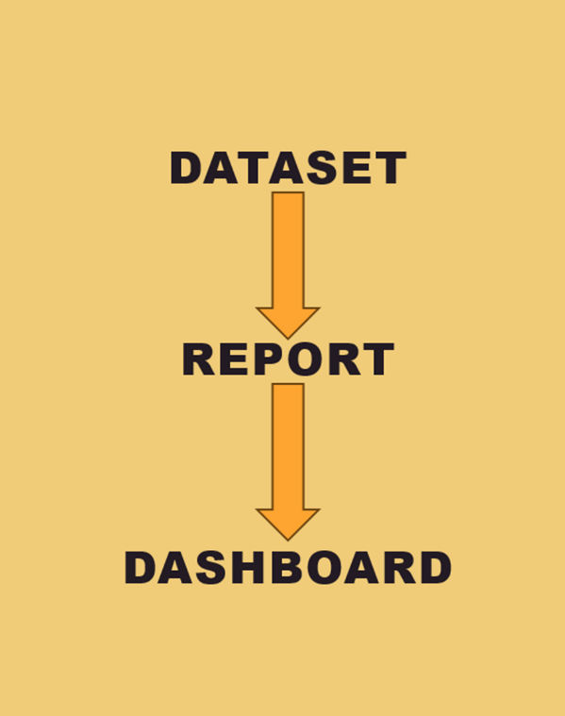

**Fig.1**

**5.2 Dataset and Importation:**

Online Retail dataset  
The dataset consists of the following fields:

InvoiceNo, StockCode, Description, Quantity, InvoiceDate, UnitPrice and Customer Country

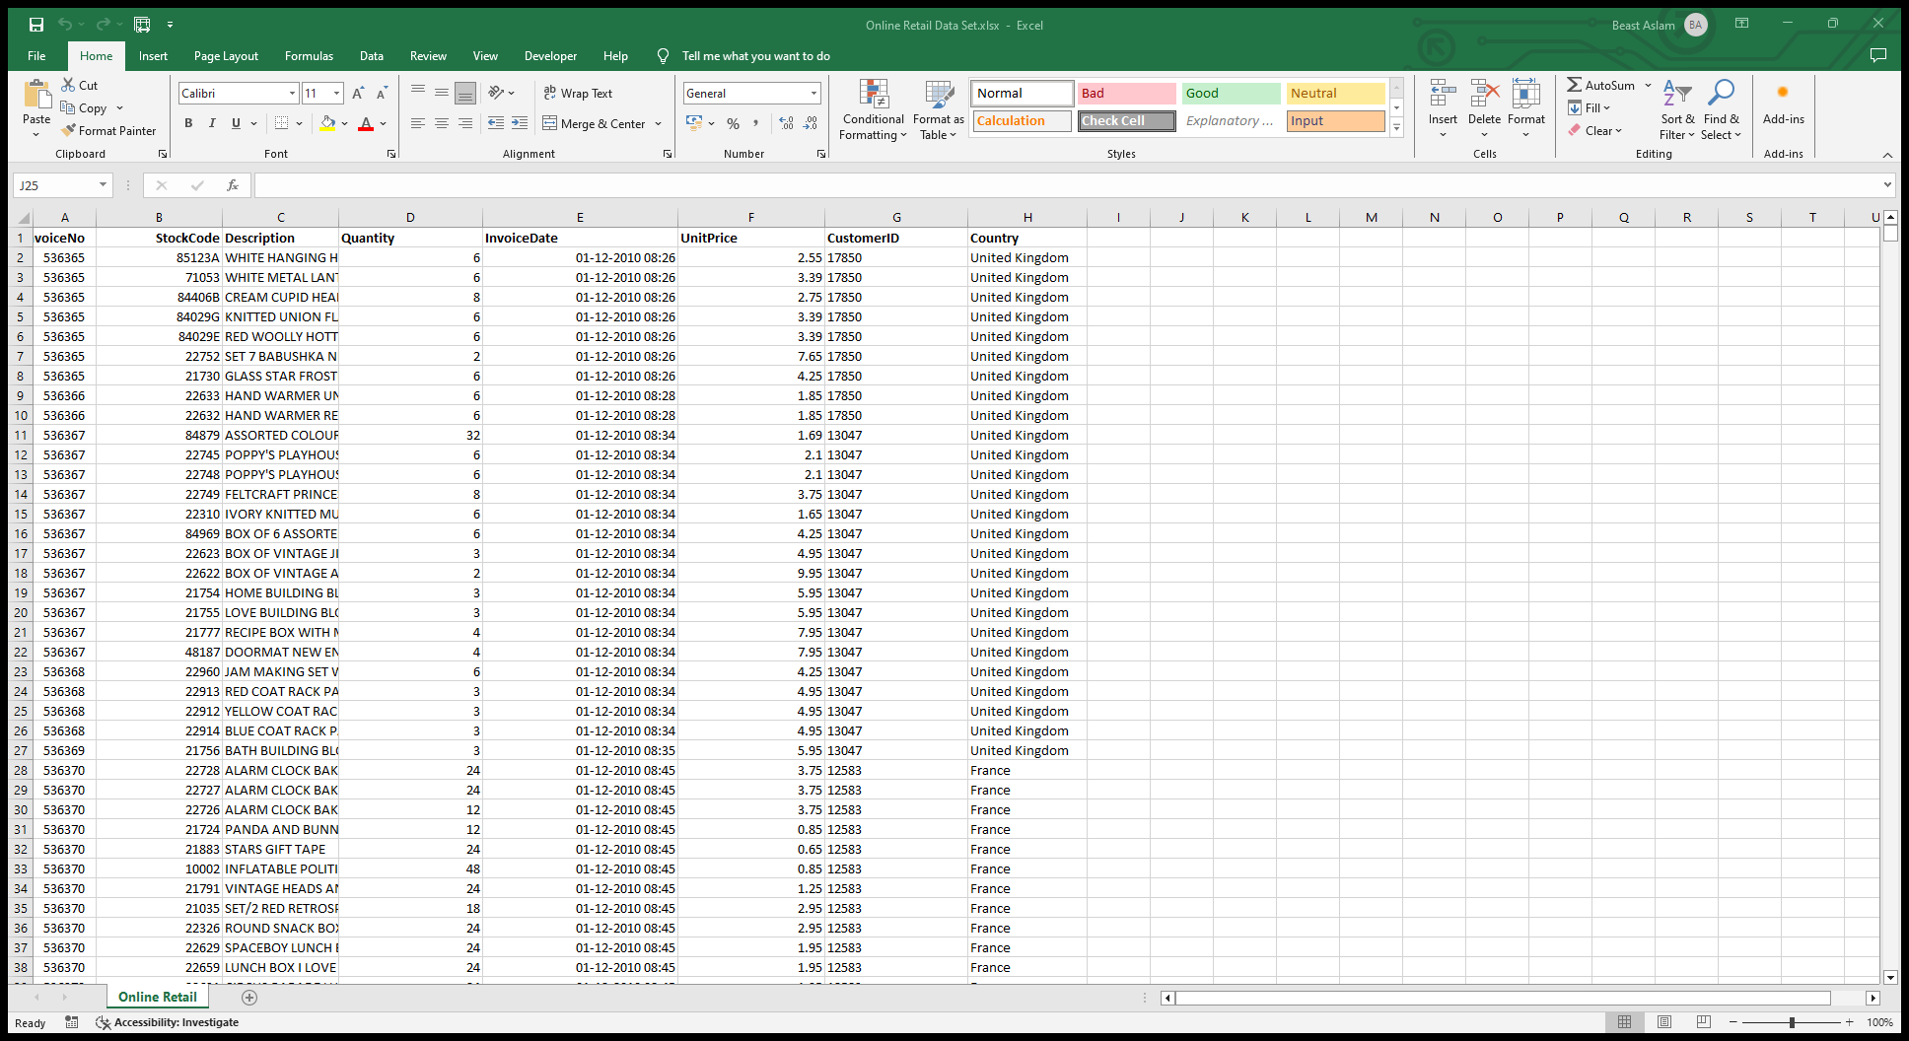

**Fig.2**

**Importing dataset:**

**Create new report**

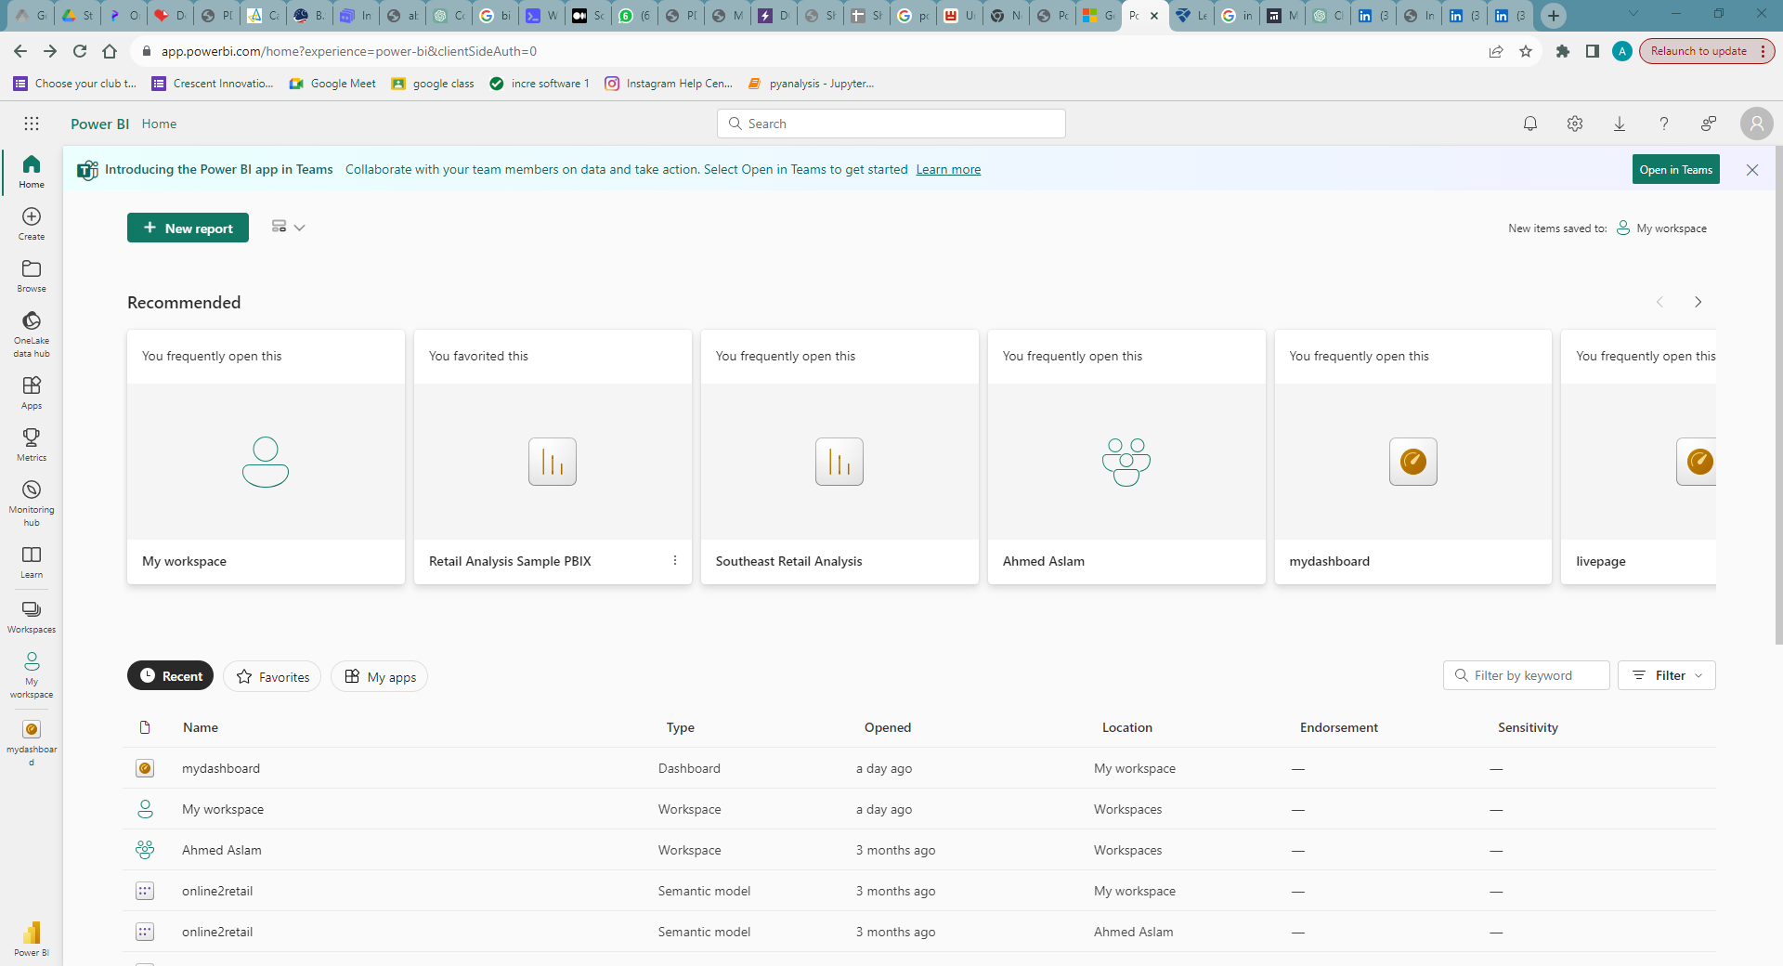

**Fig.3**

**Paste the dataset**

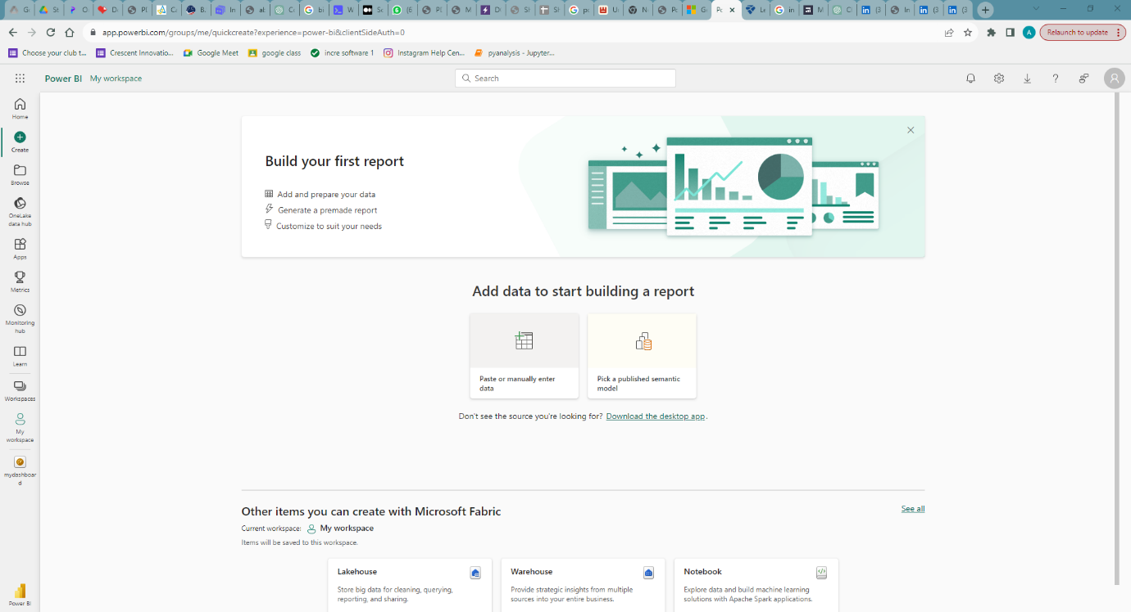

**Fig.4**

**5.3 Power query**

In Power Query, enhance dataset quality by removing missing and negative values from selected columns. Transform the data by creating a new "Revenue" column, calculated as the product of "Quantity" and "UnitPrice." These steps optimize the dataset for Power BI analysis, ensuring accurate insights

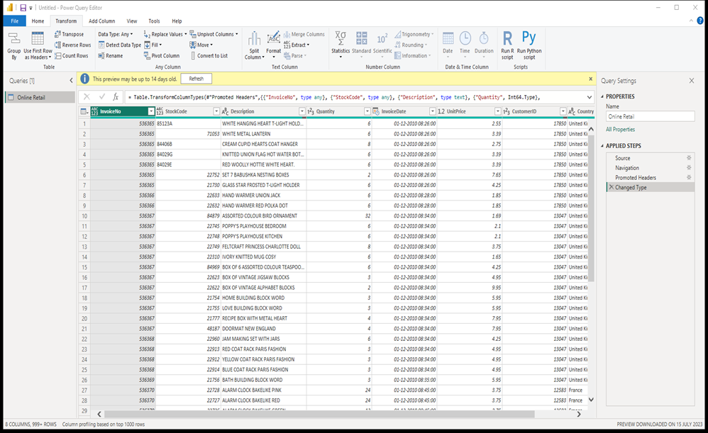**Fig.5**

**5.4 Visuals:**

Power BI offers a versatile array of customizable charts and graphs that dynamically respond to user interactions, enabling users to delve into data with precision. The interactive features allow users to drill down into specific details, apply filters, and explore diverse dimensions effortlessly. This dynamic responsiveness enhances the depth of insights, fostering a more immersive and tailored analytical experience. Whether it's exploring trends, comparing data points, or uncovering patterns, Power BI's interactive visualizations empower users to extract meaningful information and make informed decisions. The platform's flexibility in chart customization ensures a tailored presentation of data, optimizing clarity and comprehension.

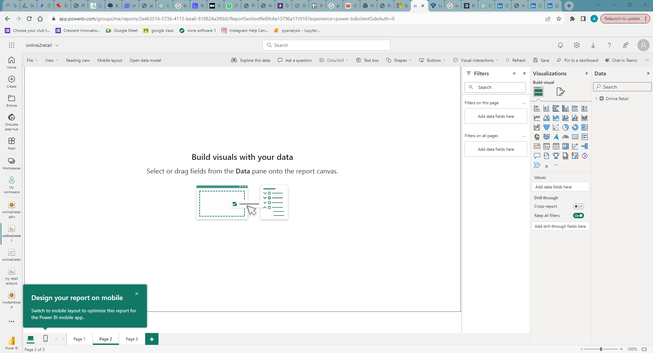

**Fig.6**

**TASK 1**

**The CEO of the retail store is interested to view the time series of the revenue data for the year 2011 only. He would like to view granular data by looking into revenue for each month. The CEO is interested in viewing the seasonal trends and wants to dig deeper into why these trends occur. This analysis will be helpful for the CEO to forecast for the next year.**

Implemented visual:

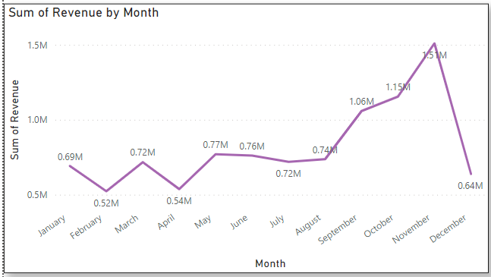

**Fig.7**

**TASK 2**

**Revenue analysis is important to the CEO as top-level executives are always focused on earnings and how to increase it. Here, the CEO is interested in the viewing revenue by the regions, to assess which regions are generating the highest revenue and which regions are generating lower revenue. Using the data and  
analysis, the CEO will be able to decide on how to further generate revenue in the regions that are already generating the most revenue. For the regions that are not generating enough revenue, the CEO will then study the reasons why there is a lack of sales in those regions and try to improve the products and make them more  
suitable for those regions.**

Implemented visual:

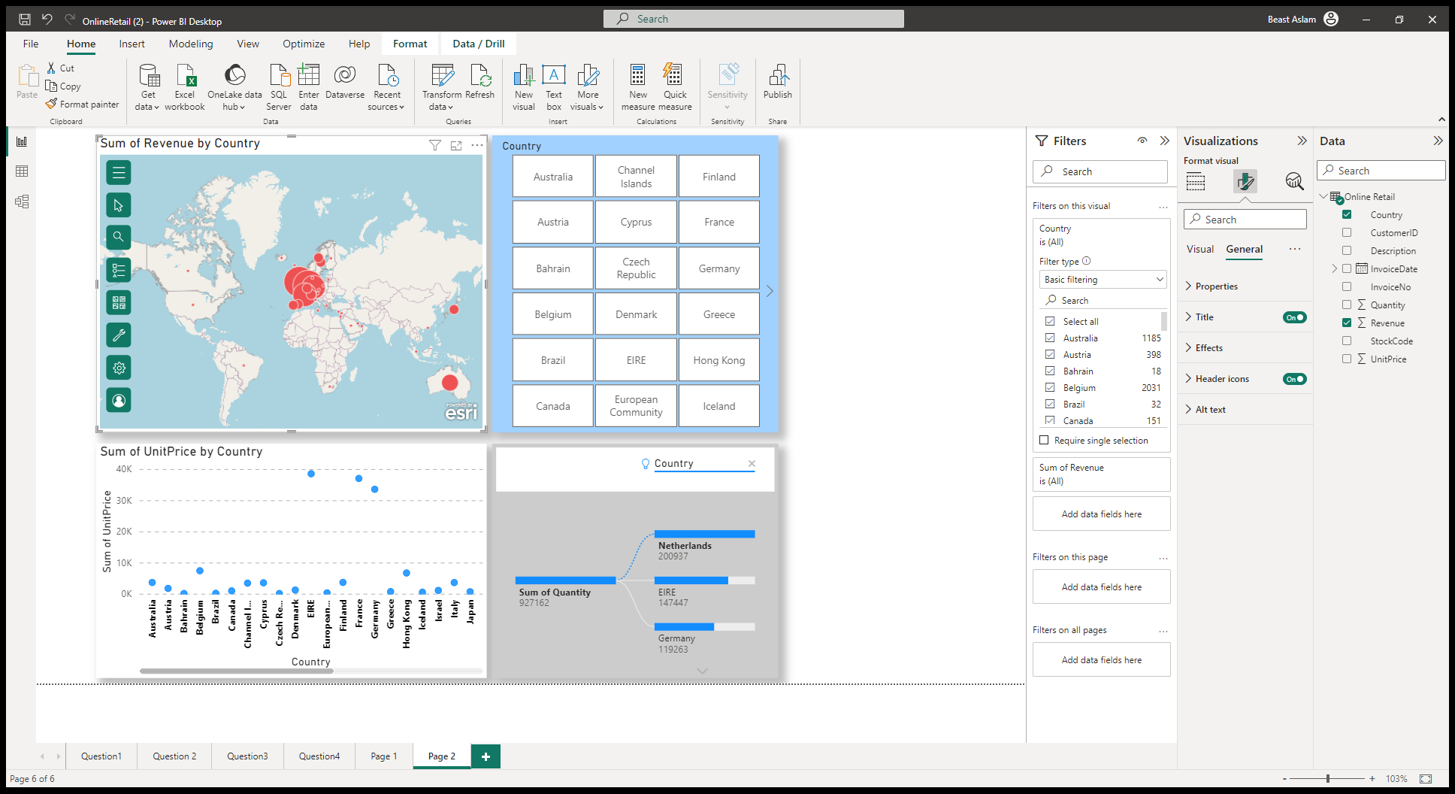

**Fig.8**

**TASK 3**

**This analysis is highly important as it would enable the CEO to identify what the main drivers are behind the total revenue. Looking at the top customers of the retail store would provide an idea of which customers are contributing the most to the revenue. The store can then derive a strategy where the top customers can be targeted with more products that they can buy. This will ensure higher revenue for the store as these customers are the top buyers from the store.**

Implemented visual:

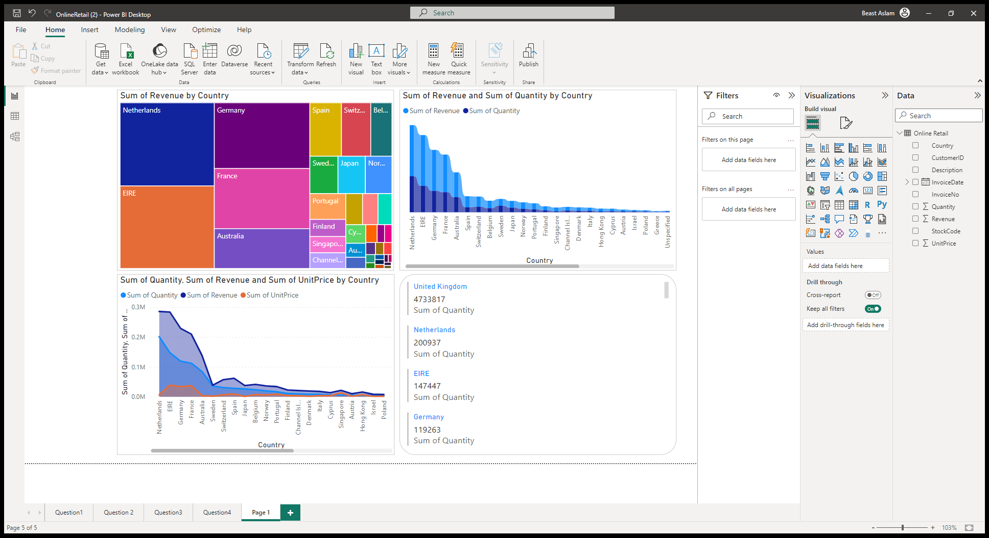

**Fig.9**

**6 RESULT AND ANALYSIS**

IN Figure 7, we have used the line char, a type of chart used to show information that changes over time. Here using the dashboard visual created we can analyse and make informative conclusion that month of November has the peak of revenue which will be helpful for the CEO to understand the seasonal trend and forecast for the next year

IN Figure 8, we have used map visual, It uses geospatial information to show data points, regions, or routes, making it easy to visualize location-based insights. These visual enables users to analyse data patterns, trends, and correlations geographically, enhancing data-driven decision-making by the CEO.

IN Figure 9, we have used the tree chart which display hierarchical data as a set of nested rectangles. Each level of the hierarchy is represented by a coloured rectangle called a branch node. Each branch contains smaller rectangles called leaf nodes. Here using the dashboard visual created helps the CEO to get notified of the diversification of the customers so that he can plan ahead of time. In cases where the business is highly dependent on a few customers, the plan would be to increase the customer base and target more customers that would bring more revenue to the store.

**7 CONCLUSION**

In conclusion, the Power BI report distils complex data into actionable insights, empowering stakeholders to make informed decisions. Through a visually compelling presentation of interactive charts, graphs, and tables, the report offers a comprehensive overview of key performance indicators and trends. The dynamic nature of the visualizations allows users to explore data, drill into specific details, and extract valuable information. The integration of diverse data sources ensures a holistic perspective, enabling a nuanced understanding of organizational dynamics. Moreover, the report's customization and flexibility in design optimize clarity, facilitating effective communication of findings.

By leveraging Power BI's robust analytical capabilities, this report transforms raw data into a strategic asset. Whether examining sales trends, the insights gleaned empower users at all levels to drive meaningful action.

**8 REFERENCE**

[**https://learn.microsoft.com/en-us/power-bi/fundamentals/power-bi-overview**](https://learn.microsoft.com/en-us/power-bi/fundamentals/power-bi-overview)

[**https://www.linkedin.com/feed/update/urn:li:activity:7086294571894132736/?originTrackingId=8zqo46fCS7y7BDYC0itcvw%3D%3D**](https://www.linkedin.com/feed/update/urn:li:activity:7086294571894132736/?originTrackingId=8zqo46fCS7y7BDYC0itcvw%3D%3D)

[**https://www.simplilearn.com/tutorials/power-bi-tutorial/what-is-power-bi**](https://www.simplilearn.com/tutorials/power-bi-tutorial/what-is-power-bi)