**Digital Signal Processing**

Dual Tone Multi Frequency Project

Preparation: Ahmed Ayman Abdelnaby

# **Abstract**

In telecommunication, a caller needs to enter a phone number of the person which he wants to talk with. Modern versions of phones have a keypad in the phone when the person push a button in keypad, he hears a different sound from each digit he pushed. From where this sound come?

# **Introduction**

The goal of this project is to develop a DTMF synthesizer function using MATLAB software. First let me to ask you two questions. First: What is DTMF? DTMF stands for “Dual Tone Multi Frequency” is a method of representing digits with tone frequencies to transmit them over an analog communication network such as telephone network. Second: What is DTMF used to? DTMF is used to encode dial trains and other information and it’s the basis for voice communications control.

DTMF signals consists of the sum of two sinusoids – or tones- with frequencies taken from two mutually exclusive groups. these groups chosen to prevent harmonics from being incorrectly detected by receiver as some other DTMF frequency. Each pair of tones contains one frequency of the low group and one of frequency of high group.

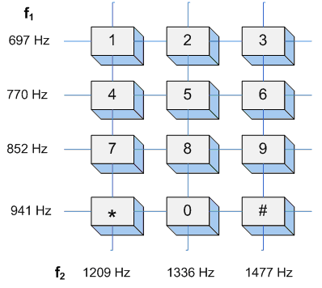

## 

# **Algorithm**

* Generate DTMF signals with combination of frequencies
* DTMF is applied to decoder
* Apply FFT to each signal to analyze the repeated pattern in the signal
* Get information about the button pressed

# **Main Functions**

*SS_DTMF1(key,time,timeStep)*

Key: is the digit for which the DTMF signal is to be generated.

Time: the time instants at which the DTMF signal *x*(*t*) is evaluated

timestep: the time change.

This function used to produced the signal

*SS_DTMF (number,delta,nd,np)*

Number: The phone number to be dialed, entered as a vector

Delta: The time increment to be used in computing the amplitudes of the DTMF signal

nd: Parameter to control the duration of the DTMF signal for each digit.

Duration of each digit is Td = nd*delta

np: Parameter to control the duration of pause between consecutive digits

Duration of pause is Tp= np*delta

In this function I used ss_dtmf1() to produce the signal, then hear the sound for a digit

Script_Test_D

This Script to test the ss_dtmf()

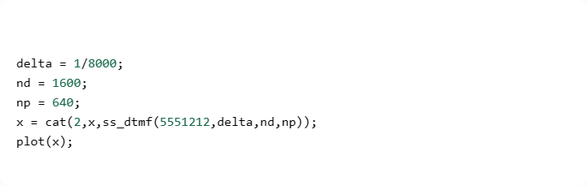

*Fourier Transform Script*

Script A

In this screen we show the script that compute the signal in time interval 0 ≤ t ≤ 0.2 with a time increment ∆t = 1/8000s

I used 2 built-in functions

* Plot
* sound

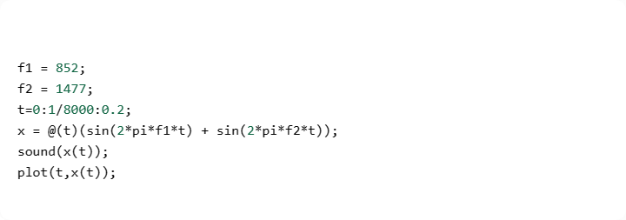

GUI

When pressed on button ‘2’:

* Hear sound from the signal of button ‘2’
* Plot the signal of the button

When pressed on button Sound All:

* Hear sound from all signals
* Plot the signal

