

**Faculty of engineering - Shoubra**

**Benha University**

**Research Article / Research Project / Literature Review**

in fulfillment of the requirements of

|  |  |
| --- | --- |
| **Department** | **Engineering Mathematics and Physics** |
| **Division** | **-----------------** |
| **Academic Year** | **2019-2020 Preparatory** |
| **Course name** | **Engineering Drawing** |
| **Course code** | **MDE001** |

**Title: -**

**Computer Engineering Role in COVID-19 Pandemic?**

By:

|  |  |  |  |
| --- | --- | --- | --- |
|  | Name | Edu mail | B.N |
| 1 | **احمد ايمن حسينى محمد** | ahmed195031@feng.bu.edu.eg | 30 |

**My Name in GitHub :AhmedAyman576**

**GitHub pages :** <https://ahmedayman576.github.io/html-project-Repository/>

**GitHub :** <https://github.com/AhmedAyman576/html-project-Repository>

Screenshots :

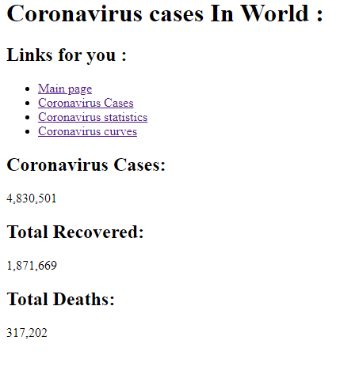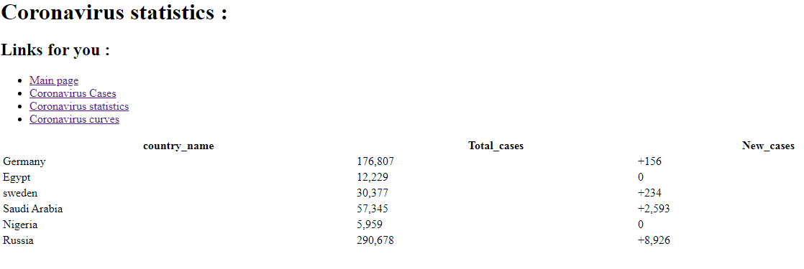

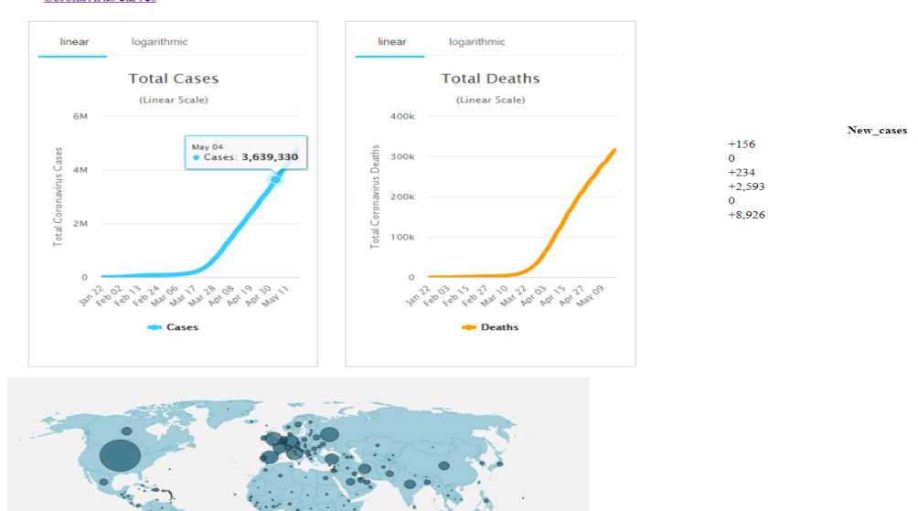

Source Code :

1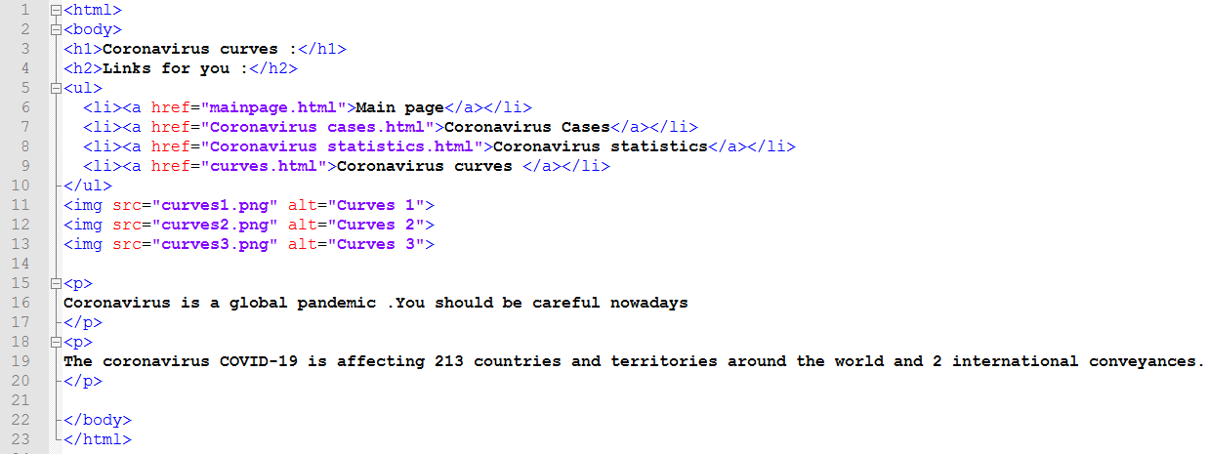2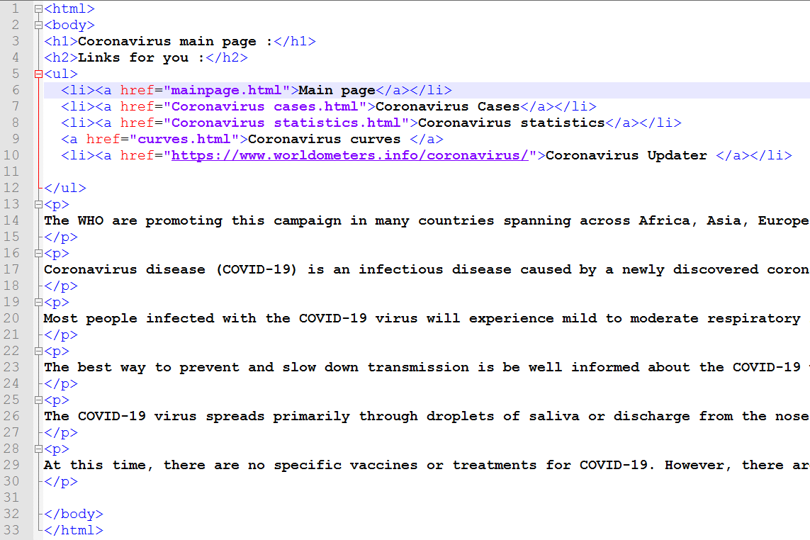

3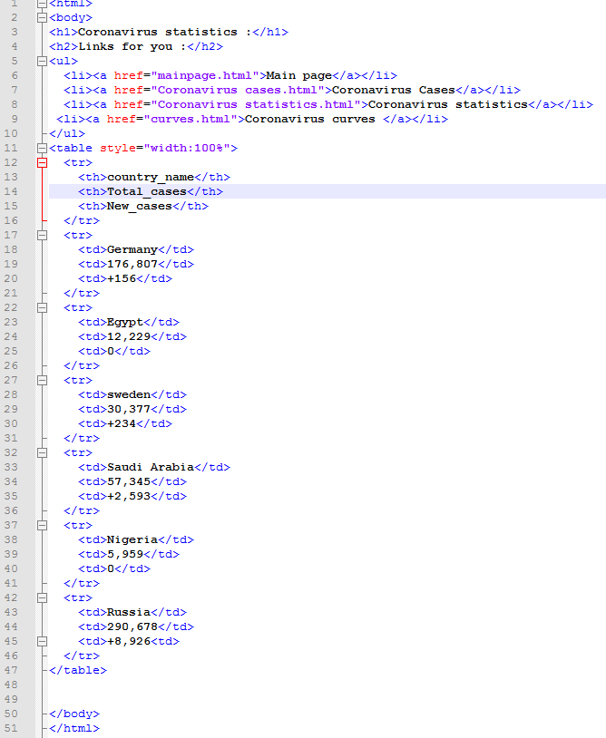4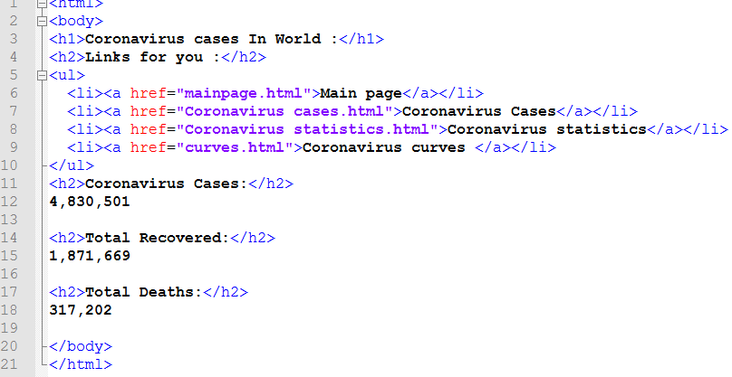

**Research objectives**

* After the spread of the Corna virus around the world and the emergence of the extreme difficulty to confront this virus, the world has turned to computer engineering and what is known as artificial intelligence to counter this virus
* Study and clarify the role and efforts of scientists in employing computers to combat the Corona virus
* Computer Engineering Role in COVID-19 Pandemic
* Explain the role of computers and artificial intelligence to discover the vulnerability of this virus to find appropriate treatment for the Corona virus

**Abstract**

Since IT professionals around the world are doing their best to support a suddenly far away workforce, many technology and corporate workers are also collaborating in mitigating the COVID-19 crisis in various ways, including developing and tracking anti-virus products.

Predicting its spread, and protecting hospitals from cyber-attacks.

Computers are used to confront and solve this virus

**Table of contents**

|  |  |
| --- | --- |
| **Subject / section** | **Page** |
| **Computer Engineering Role in COVID-19 Pandemic!** | **6** |
| **Results and discussion** | **10** |
| **References** | **11** |

**Introduction**

Artificial intelligence technology is preparing to play a role in the fight against the outbreak of Coronavirus globally, especially in light of the lack of medical personnel, supplies, and devices used in the detection of HIV-infected cases.

Artificial intelligence can help to recognize the location of existing covid 19 virus ceels on the human body through facial recognition technologies, and neural netwok can also be avoided or attempted to learn the available treatment from the netwok and to avoid increased covid 19 cells on the human body.

Covid-19's rapid spread has forced states to use every trick in the book to contain the disease. Some countries have done a better job, such as South Korea and Singapore than, say, Italy and Spain.

Asian countries have used a variety of technologies to combat the pandemic, raising questions about excessive surveillance and the violation of the privacy of the citizens. Here's a snapshot of some of the tech tools deployed in various countries.

**Literature Review**

**Computer Engineering Role in COVID-19 Pandemic!**

The question of how computers can contribute to controlling the COVID-19 pandemic is being posed to experts in artificial intelligence (AI) all over the world.

AI tools can help in many different ways.

They are used to predict the spread of coronavirus, map its genetic evolution as it transmits from human to human, speed up diagnosis and potential treatment development, while also helping policymakers deal with related issues such as the impact on transportation, food supply and travel.

But Artificial intelligence is only useful in all those situations if it has enough examples to learn from.

As COVID-19 has brought the world to unchartered territories, the "deep learning" systems that computers use to develop new skills don't actually have the data they need to deliver useful outputs.

* The question is how computers contribute to controlling the pandemic of COVID-19 experts in artificial intelligence (AI) around the world.

AI tools can be of help in various ways.

It is used to predict the spread of coronavirus, map its genetic development as it travels from human to human, accelerate diagnosis, and develop potential treatments, while helping policymakers address related issues such as transportation, food supply and travel issues.

But artificial intelligence is only effective in all those cases if it has enough examples to learn from.

Since COVID-19 has moved the world to an uninhabited region, "deep learning" systems not necessarily have the data they need to produce useful outputs, which computers use to gain new potential.

* **As mentioned above, computer science can build many applications that could warn people from this virus!**
* Artificial intelligence can help to recognize the location of existing covid 19 virus ceels on the human body through facial recognition technologies, and neural netwok can also be avoided or attempted to learn the available treatment from the netwok and to avoid increased covid 19 cells on the human body.

Scientists and researchers are using super supercomputers known as "super computers" all over the world to accelerate the search for a cure for Corona virus, which has entered the world in the case of closed and disrupted social, economic and commercial life.

Researchers at University College London say supercomputers thanks to data processing, which can take months to normal, within days.

This means that it enables the examination and treatment of "potential antiviral drug libraries", including drugs already licensed to treat other diseases, very quickly, according to a report published in the British newspaper "Daily Mail".

A new MIT study finds “health knowledge graphs,” which show relationships between symptoms and diseases and are intended to help with clinical diagnosis, can fall short for certain conditions and patient populations.

The results also suggest ways to boost their performance.

* Scientists at the University College London can access a number of the most powerful computers in the world, and the British University team works with more than 100 researchers from all over the United States and Europe to make the most of these computers in the battle against the "Covid 19" epidemic.

Scientists and researchers are using super supercomputers known as "super computers" all over the world to accelerate the search for a cure for the Coronavirus, which has entered the world in a state of closure and disrupted social, economic and commercial life.

Researchers at University College London say supercomputers can process information, which can take months in normal circumstances, within days.

This means that it can quickly examine and treat "potential antiviral drug libraries", including drugs that have already been licensed to treat other diseases, according to a report published in the British "Daily Mail".

Therefore, computer engineering has a big and important role, God willing, in finding a solution to this pervasive virus that has lost thousands of lives.

**Results and discussion**

**Based on the experiments conducted and the results obtained, I observed and concluded:**

* Scientists are still trying with all their might to use the computer to confront and find a solution to the new Corona virus.
* Many computers have been developed these days in an attempt to treat the Corona virus.
* The impact of the COVID-19 pandemic has affected many science and space technology and government agencies around the world, resulting in lower productivity in a number of areas and programs.

It has also opened many new funding research lines in many government agencies around the world to confront and find a cure for the Corna virus.

* Giant computers play a big role in developing corona treatment.

**References**

<https://www.engr.wisc.edu/news/covid-19-impact-how-engineers-are-making-a-difference/>

<https://www.contagionlive.com/news/engineers-computer-scientists-say-covid19-outbreak-highlights-potential-of-robots>

<https://www.contagionlive.com/news/engineers-computer-scientists-say-covid19-outbreak-highlights-potential-of-robots>