

**Faculty of engineering - Shoubra**

**Benha University**

**Report**

|  |  |
| --- | --- |
| **Department** | **Engineering Mathematics and Physics** |
| **Division** | **-----------------** |
| **Academic Year** | **2019-2020 Preparatory** |
| **Course name** | **Engineering Drawing** |
| **Course code** | **MDE001** |

**Title: -**

**Computer Engineering Role in COVID-19 Pandemic?**

By:

|  |  |  |  |
| --- | --- | --- | --- |
|  | Name | Edu mail | B.N |
| 1 | **احمد ايمن حسينى محمد** | ahmed195031@feng.bu.edu.eg | 30 |

**Approved by:**

|  |  |
| --- | --- |
| Examiners committee | Signature |
| Dr.Ahmed Bayoumi |  |
| Dr.Shady Elmashad |  |
| Dr. Abdelhamid Attaby |  |

**My Name in GitHub :AhmedAyman576**

**GitHub pages :**

<https://ahmedayman576.github.io/html-project-Repository/>

**GitHub link:**

<https://github.com/AhmedAyman576/html-project-Repository>

**Screenshots**

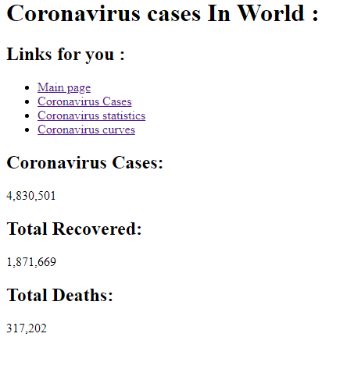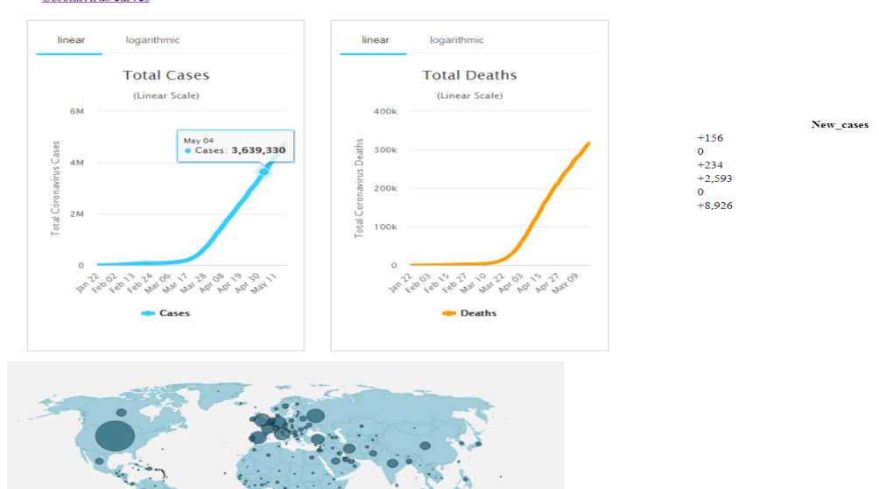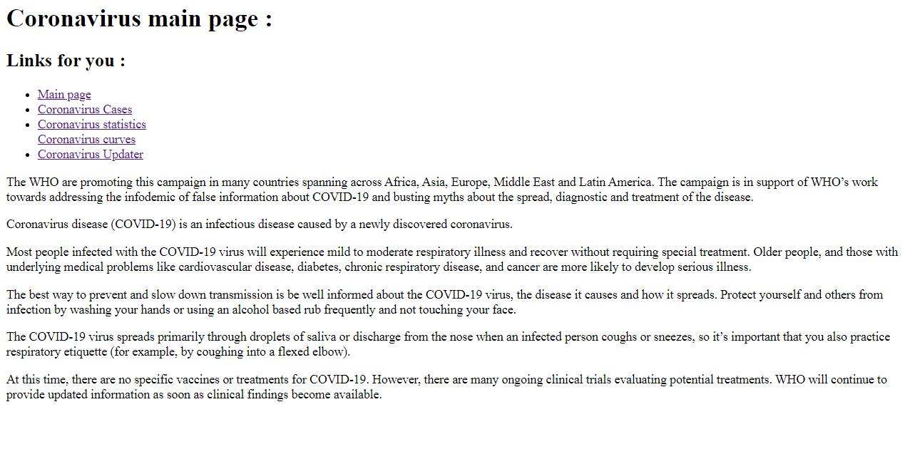

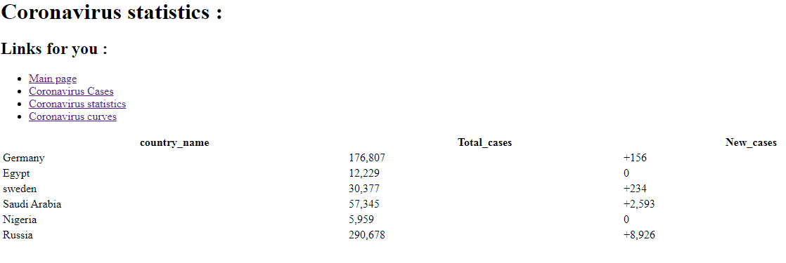

**Source Code**

