**Programmable Interval Timer (PIT)**

**ASIC Diploma**

**Najah Now**

**Introduction**

**About PIT**

The Programmable Interval Timer Module, PIT, is a simple timer to generate a periodic signal for a microcontroller system. This signal may be used for a variety of purposes such as triggering the start of an Analog to Digital or Digital to Analog conversion, as a periodic system interrupt, or to synchronize the start of various other hardware processes.

The PIT core has 4 primary blocks:

* WISHBONE Interface
* Control Registers
* Prescale Counter
* Main Counter

**PIT structure**

**Clocks**

**We have only a master clock for the whole system named wb_clk_i with max frequency = 200MHz so its period = 1/200*10^6 = 5ns.**

**Tools**

Synopsys tools were used to implement this project such as:

Design Compiler – ICC2 Compiler – Prime Time

**== == == == == == == == == == == == ==**

**Synthesis**

Synthesis was performed using Design Compiler tool.

We used saed32nm library to implement the project.

1. **Design libraries**

link and target libraries were set with min and max libraries to perform the correct timing analysis.

We used:

Min corner: ff1p16vn40c for Hold timing analysis

Max corner: ss0p75v125c for Setup timing analysis

1. **Design Constraints**

* Clock definition with clock period = 5ns
* Input delay = 0.2 * clock_period
* Output delay = 0.4 * clock_period
* wire load model “35000”
* operating conditions

“ff1p16vn40c” for min corner and “ss0p75v125c” for max corner

* input transition (using “AND2X1_HVT” from max corner to derive the input)
* output load = 1 ff

1. **compile stage**

We compiled the design using compile_ultra command and some app options to optimize the design.

1. **Generating design files**

* SDC file
* Design netlist

*Synthesis results summery*

|  |  |
| --- | --- |
| **Report** | **Result** |
| **Setup Time** | **0.02 (MET)** |
| **Hold Time** | **0.05 (MET)** |
| **Area** | **1311.83** |
| **Power** | **6.8310e+03 uW** |

1. **reports**

**setup Report**

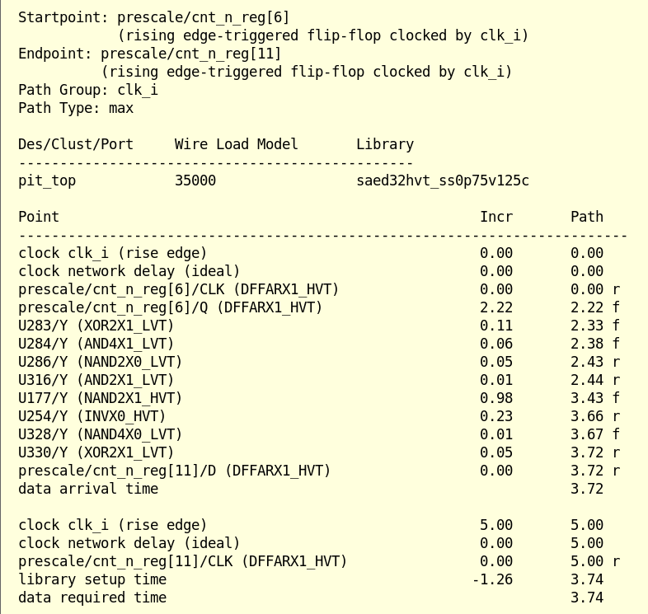

**Hold Report**

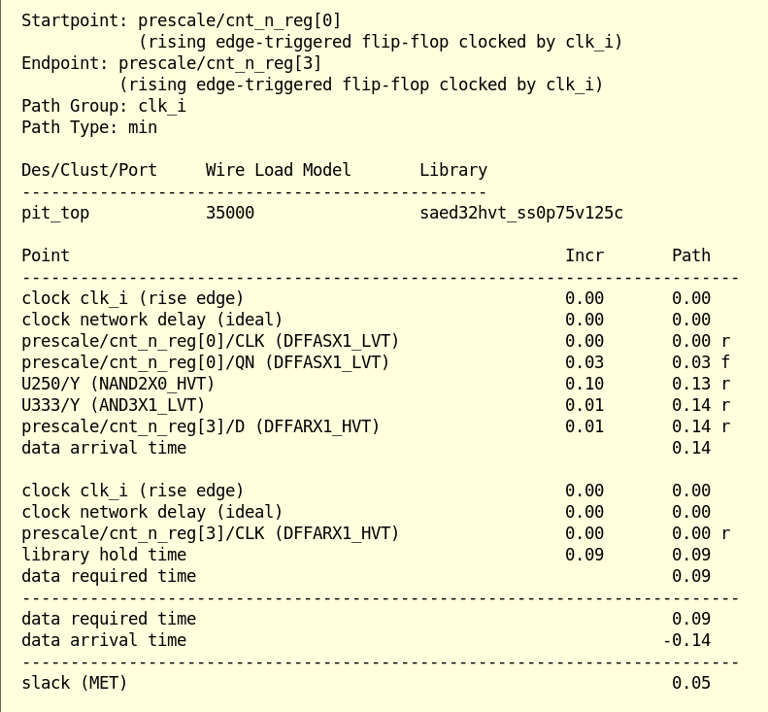

**Area Report**

**Power Report**

**QOR Report**

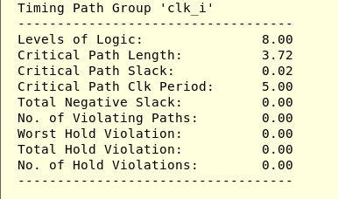

**PnR**

PnR stage was done using ICC2 tool from Synopsys.

In this stage we performed all PnR stages such as: floorplanning, Powerplanning, Placement, CTS, Routing.

First stage was data setup to set the libraries, ndm, technology file, read parasitics tluplus files, read design netlist and source design constraints.

* Floorplanning
* In this stage we defined routing tracks (M1 to M9) directions and placed the pins arround the rectangular core.
* Utilization was 40%

* Powerplanning

We used M8 metal layer for vertical mesh and M9 for the horizontal mesh.

* Placement

MMMC file was sourced to set the needed files and corners for timing checking.

* CTS
* Clock network was built on metal layers M5, M6, M7.
* Trget skew was setted by 0.2.
* Clock latency was computed by the tool.

* Routing

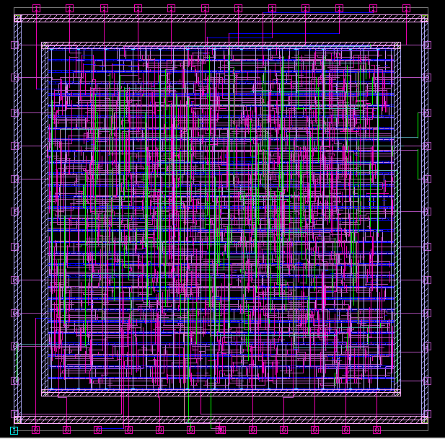

*PnR results summery*

|  |  |
| --- | --- |
| **Report** | **Result** |
| **Setup Time** | **0.00 (MET)** |
| **Hold Time** | **-0.44 (VIOLATED)** |
| **Area** | **2264.17** |
| **Power** | **2.59e+08 pW** |

**QOR Report**

**Timing Area**

**DRC**

**Congestion Report**

**Prime Time Session**

First, we set up the libraries and important files such as: design netlist, parasitics file(.spef), constraints file.

Then we updated the timing, power, and noise info to start checking timing, power, and noise.

After this we performed an ECO fixing Session to fix timing and DRC violations.

After the ECO fixing, we get these results on PrimeTime tool

*Results summery*

|  |  |
| --- | --- |
| **Report** | **Result** |
| **Setup Time** | **0.265 (MET)** |
| **Hold Time** | **0.002 (MET)** |

**Costraints**

**Hold**

