Link to the challenge : https://www.root-me.org/fr/Challenges/Web-Serveur/HTML-Code-source
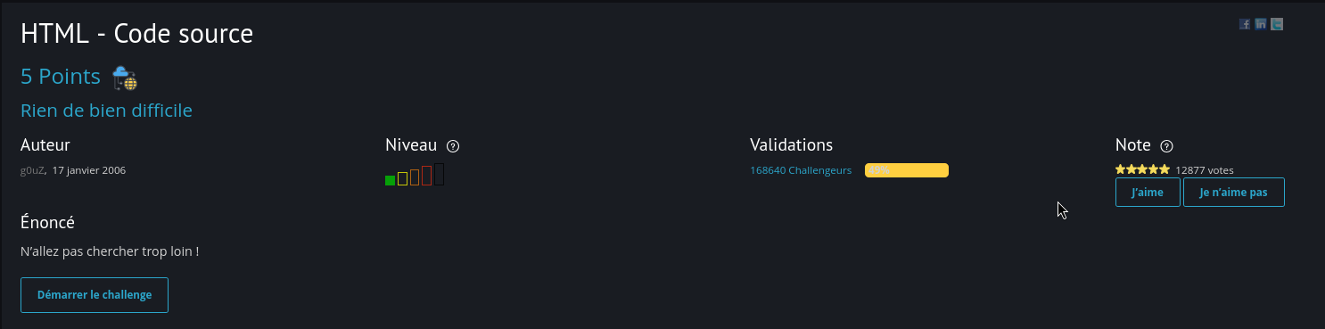
Here when you click on the start the challenge (Démarrer le challenge) . You'll be redirected to the page below
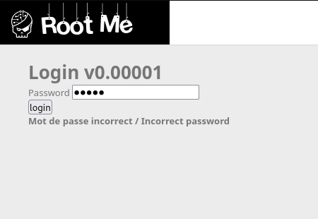
As you can see the we need a password to get the flag , I've tried default logins (admin ,
123456,admin123456 ,... ) But nothing seemed to work so as the name of the challenge is
HTML SOURCE (we need to check the source code
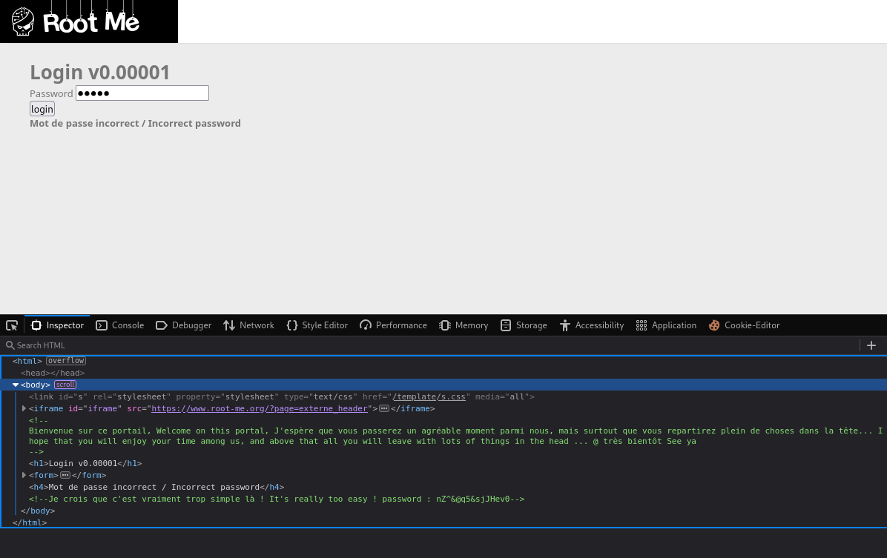
And here we can see our needed password in clear text
Password : nZ^&@q5&sjJHev0
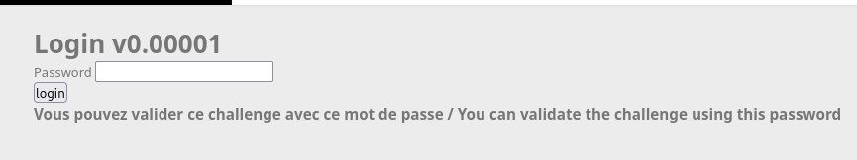
And use the same password to validate the challenge

