Project name: Fix-up
Project sponsor: ministry of manpower and Total (Equipment Company)
Project number: 92
Business case:
Due to the poor quality of the raw materials for electrical appliances and sanitary ware in the governorate, this leads to problems in household appliances, which makes choosing a craftsman with a high level of experience to repair the damage is required at the lowest costs and in a short time, the application provides a solution to this equation, which is to find the craftsman The best and the closest geographically, at lower costs and in a faster time .
Executive Summary:
In our project, we will solve the problem of difficulty reaching craftsmen. We will make an application that connects the users to craftsmen.
For Example:
You can request a craftsman to fix what you want in your home in an easy and flexible way.
In the application, you can know the level of service provided to you by the rate of each worker.
You can agree with the craftsman about the fare before you request him.
Through the app, you can ensure safety for yourself and your home.

Defined business problem or opportunity:
- The app gives the opportunity to a lot of freelancers’ craftsmen to work.
- Help the users to connect with craftsmen by easy way.

Requirements and purpose of the study:
The goal of the feasibility study is to figure out the best model to solve our problem for the least amount of money and with the simplest tools possible, so we can save money and develop our app easily. And this will help our project succeed by demonstrating the necessary investments, the predicted return, and the initiative's impact on our lives.
Assumptions Used in the Study:
We will assume that our project will take place in the most famous governorates in Egypt and the most populous (Cairo 10.1 million people, Alexandria 5.38 million people) and the app will be uploaded on two platforms (google play and app store).

Audience Impacted:
Our app will have two versions
Regular users’ version:
This version will be available for all the users that need any repairs in their home, car, computers, ETC...
All users who will use this app will save money, time, effort in searching for the right craftsmen and make life more comfortable.
craftsmen’s version:
This version will be available for the craftsmen who need to work
Options Assessed:
First option: making an office to hire the craftsmen and if anyone needs a craftsman can call this office
Advantages: reducing the unemployment
disadvantages: wasting time, more cost, and less revenue
second option: developing an app to link between the user that needs any repair and the craftsmen who need work.
Advantages: reducing the unemployment, saving money, less cost, more revenue, Appreciation of experienced workers
disadvantages: force customer to have internet so that he can connect to the app

Financial Obligations:
- We will start with a 100k fund from The Ministry of Manpower and from (Total Equipment Company)
- We will spend about 5k L.E for the financial stage to manage the fund and to manage the budget
- The coding and the testing stages will cost 50k L.E
- The pr stage will cost 10k L.E to get sponsors and more fund
- The marketing stage will cost about 35k L.E to make the audience familiar to our app.

Recommended Action:
Following final approval, a project charter will be written, and the team will be put together. For the implementation, a plan of action will be developed.
The application will be installed when you arrive, and then we will configure it to function.
with these devices, test them, and fix any issues that arise.
If the project goes well, we will be able to publish it, and we will have succeeded in bringing in money.
Then we can decide whether we should revisit the feasibility or discard it.

OBJECTIVES:
According to research, the unemployment rate in Egypt has risen to 7.5%.
So, we decided to make an application that connects the user with the craftsmen
The general objective is divided into two parts
First: Providing job opportunities for craftsmen to reduce unemployment
Second: For the user, providing auxiliary labor whether for plumbing, carpentry, electricity, etc., in an easy, safe, and money-saving way.
The project should be completed within 4 months and at a cost that does not exceed 200k

TECHNICAL REQUIREMENTS:
the application will be written in Java: - Java is an object-oriented programming language that supports all principles like Data Abstraction, Encapsulation, Polymorphism, Overloading, Overriding, and Inheritance. Great collection of Open-Source libraries. It has Platform Independent and Free.
The app will be on Android and IOS because we target all classes.

LIMITS & EXCLUSIONS:
Work on-app is allowed only between the hours of 08:00 pm - 05:00 am
The application will be reviewed and maintained for two months after its release.
The user will join the app and request the craftsman and the deal will be direct between them and the application will be just a broker.

REVIEWS WITH CUSTOMERS:
Has the service been fully provided?
Have you had any difficulties with the app?
Please evaluate the application or ask you later?

Project resources:
1-Programming team
2-Marketing team
3-PR team
4- Financial team

Budget:
100,000 EG (includes servers, project licenses, developers, designers, training, marketing)

Project scope
1-Project scope description:
-It is an application you use to communicate with craftsmen at a high level of professionalism to fix any defect in your house.
-The application will display all craftsmen in Starting from the neighborhood in which you live, passing through the city in which you live, and ending with the whole governate.
2-Project acceptance criteria’s:
- Choose the best craftsman easily
- Easy to use, faster and comfortable.
- Updates based on feedback.

3-Project milestones and deliverables:
- In the first five days the finance team collects and divides the budget.
- From day 6 to day 55 coders will build and debug the application.
- From day 56 to 70 coders will test the application when the PR team look for supplies and sponsors and deal with them.
- From day 71 to day 90 coders will review the application from users after launch.
- From day 91 to day 120 We will market the application and the project

4-Project execution:
One of customer’s requirements that the app show him each craftsman, his rate, his location, and his cost.

5-Project constrains:
1-The app must take less than 4 months.
2-The app must be written in Java.
3-The app must be in the app store and apple store.
4-The project must not exceed 500,000 EG.

6-Assumptions:
1- The app does not take more than 4 months.
2- The cost is no more than 200,000 EG.
3- The quality of the app will be very high.

-In scope:
-Periodic updates and maintenance after launch.
-Feedback from clients after every order.
- Quarterly reports on project status, application troubleshooting, and feedback discussion.
-Out of scope:
-Application runs on Android OS (Starting from Android 8.0.3) and IOS (starting from IOS 9.0.2)

The Work Breakdown Structure
(WBS)
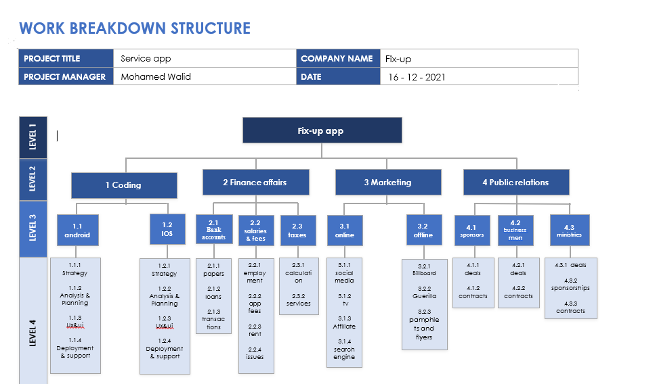

The Responsibility matrix

 | Team members
List of tasks | Ahmed Hamada | Mahmoud Mostafa | Mohamed Walid | Ahmed Hassan | Abdelrahman Elsayed | Mohamed Abdo
Design the App | A | R | I | R | C | I
Marketing | R | C | C | I | I | R
Public relations | I | I | R | C | R | C
Test | R | A | R | I | A | C
Finance | C | R | C | A | I | A
Review | C | I | A | R | C | I

The Project Network
And
Recourses
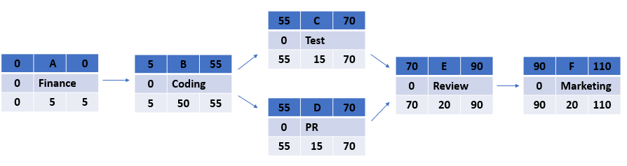

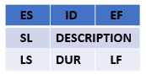

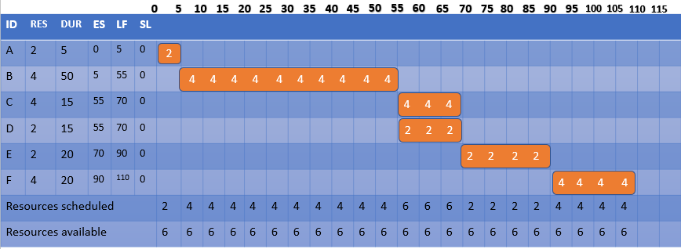

Gantt Chart

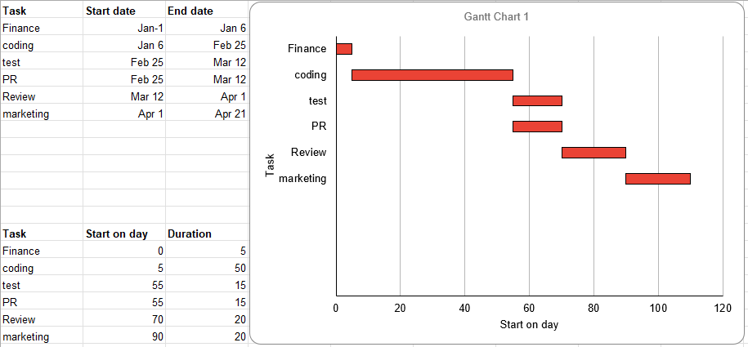

Time-Phased Budget

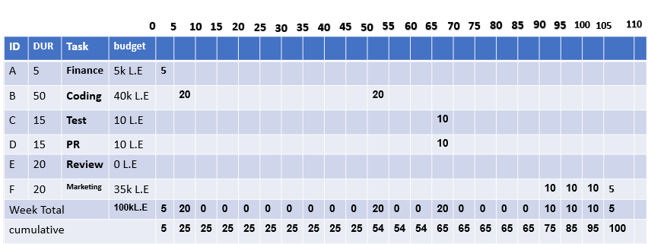

Risk
- Negative risks:
- Internet problems.
-Response : 1-Providing alternative servers in the event of any problems with the Internet.
2- Make the application store the data that was previously present in the application, such as the data of craftsmen and their conversations with customers.
- Lack of craftsmen experience about using the application.
-Response :
- Make short and simple training videos to make craftsmen more experienced in dealing with the application and customers.
- The application does not reach the expected number of audience at first.
-Response :
1-Promote the idea more on all social media platforms.
- Problems between new members in staff.
-Response :
1-Creating the right atmosphere for teamwork.
2-Organizing events to increase the strength of relationships between company members.
- Late processing time.
-Response :
Intensifying the number of working hours in a way that does not conflict with the comfort of individuals.
- Financial problems.
-Response :
Providing the appropriate budget and making a budget reserve.
- Positive risks:
1. A potential upcoming change in policy that could benefit your project.

-Response.
Studying these changes and deducing what is required to make good use of them.
2. Over budget.
-Response.
Budget reserve work.
3. A unique idea.
-Response.
Good use of the idea to attract people's attention and make the application a way of life for them.
Team members:
1- Abdelrahman EL-SAYED
2- Ahmed HASSAN
3- Ahmed HAMADA
4- Mahmoud MOSTAFA
5- Mohamed ABDO
6- Mohamed WALID

