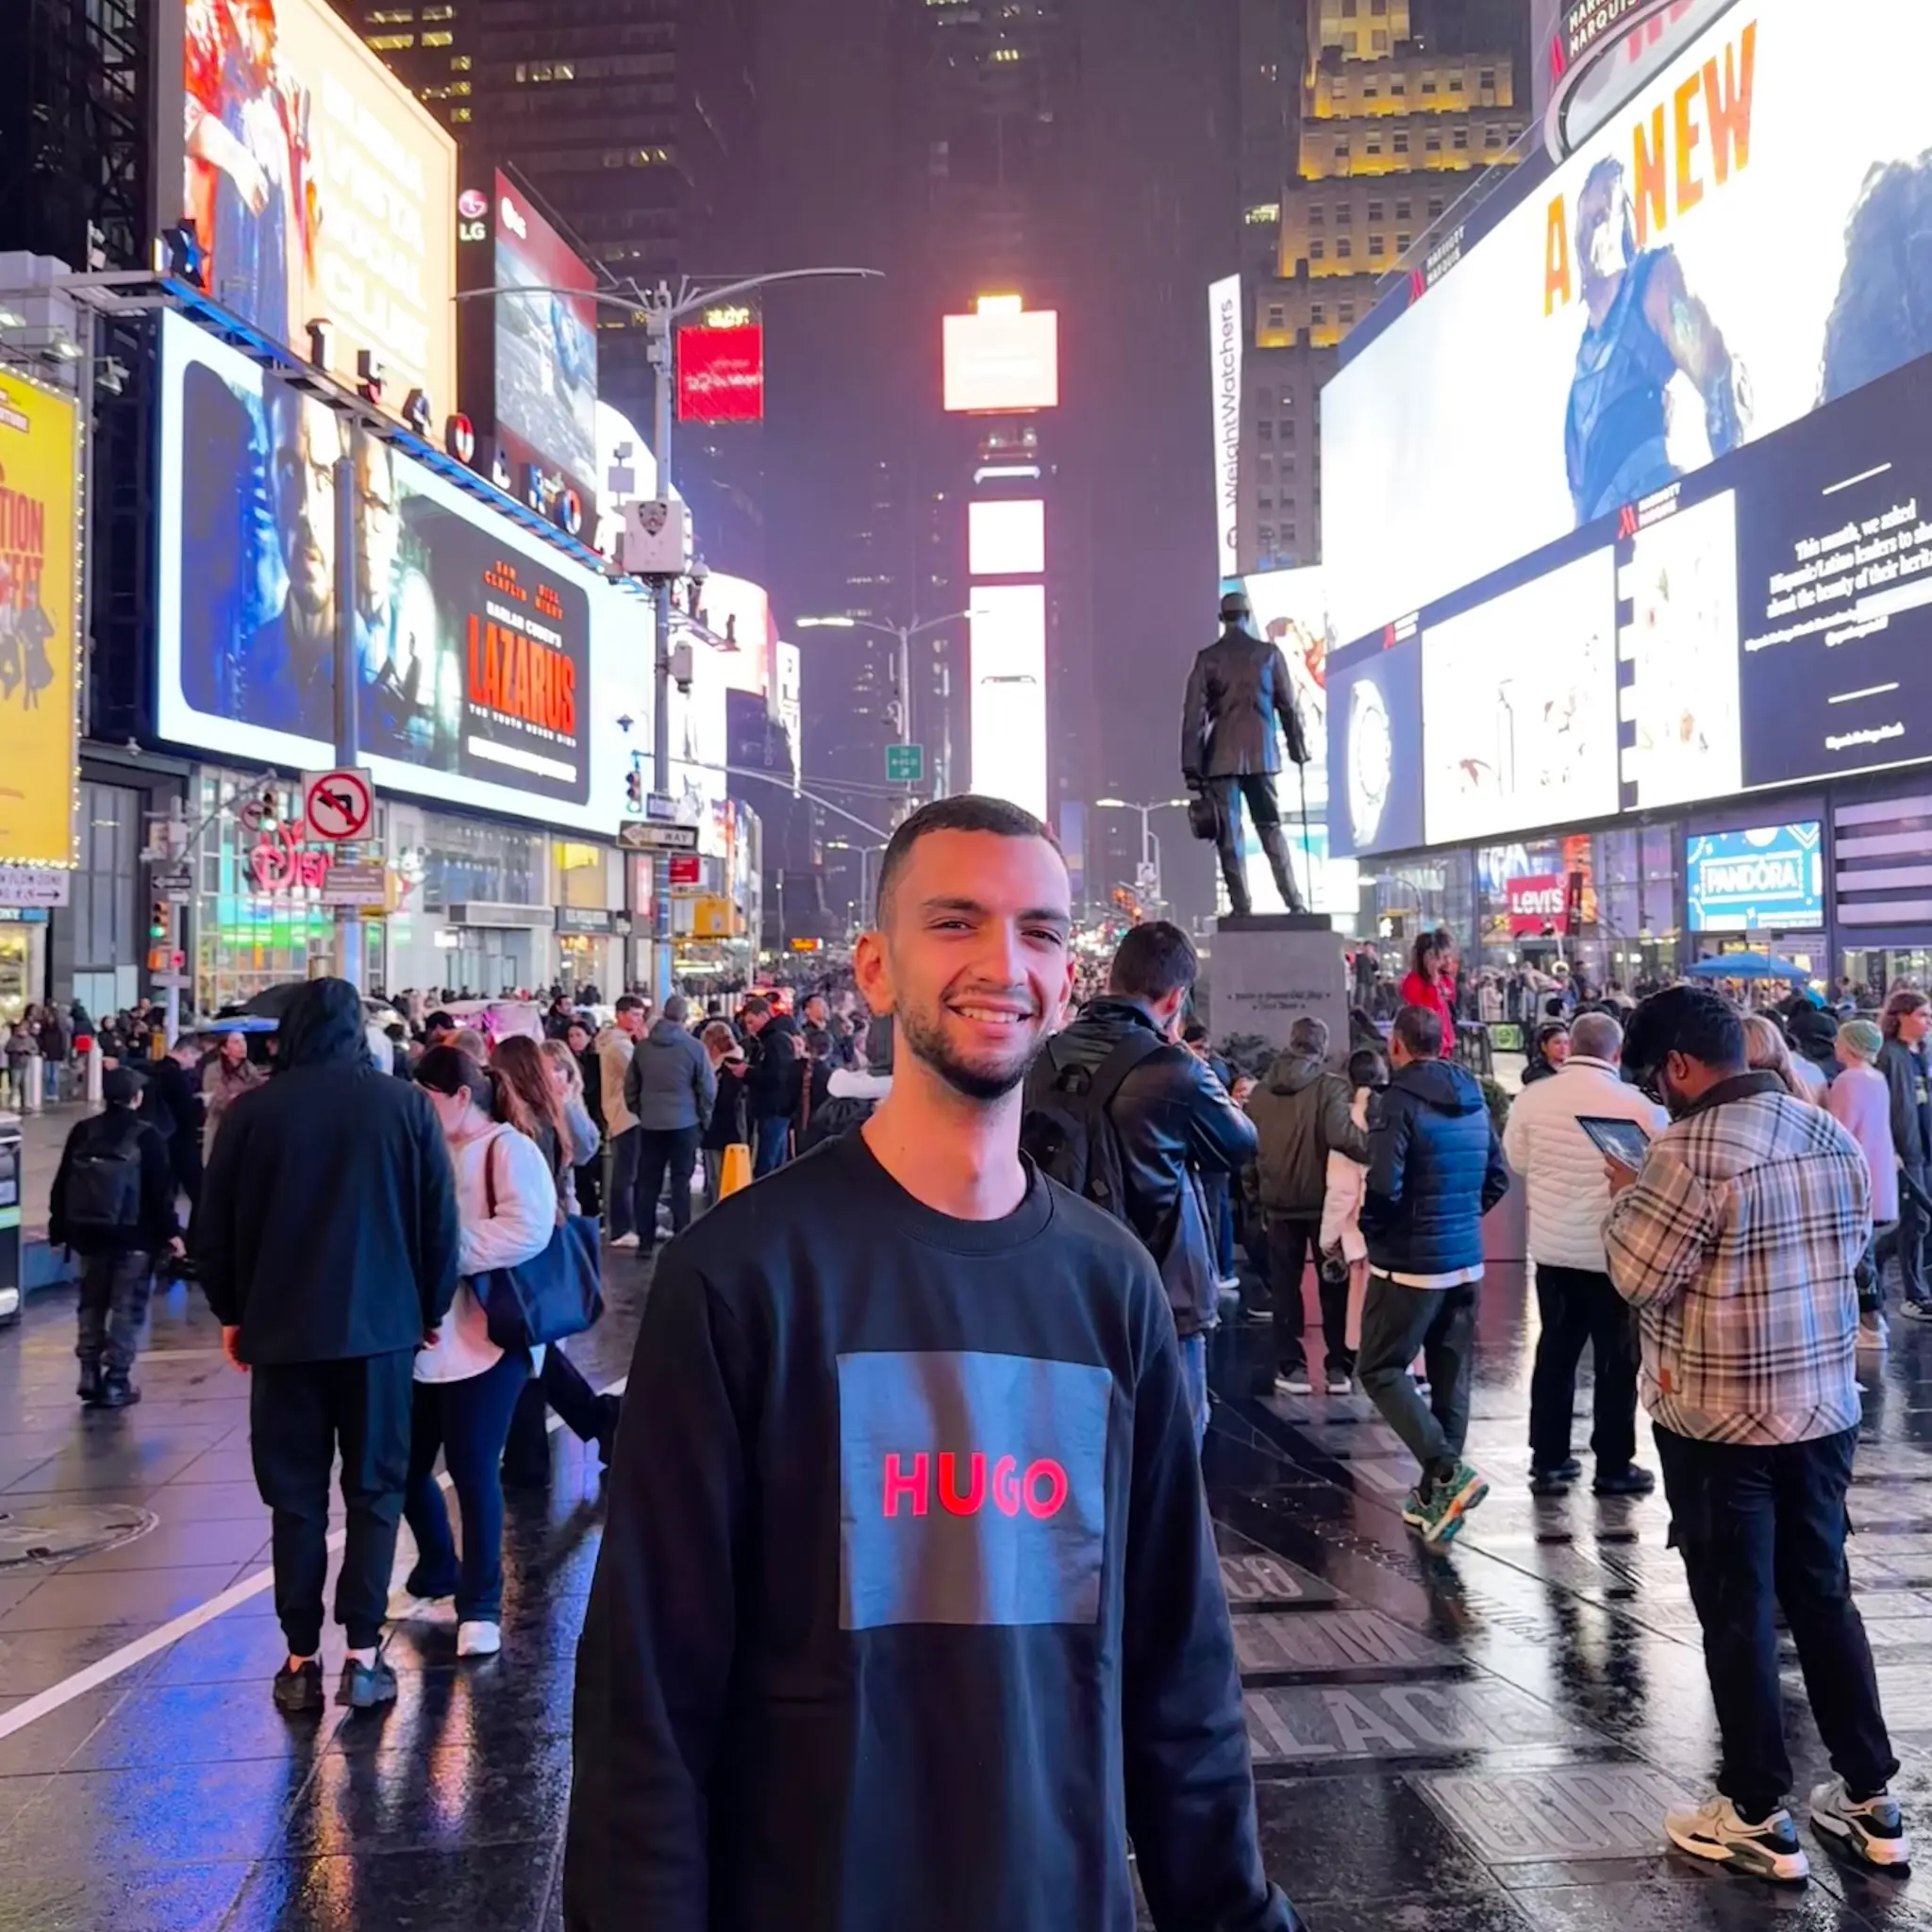  Ahmed  El Dessouky  Computer Engineer  Contact  Phone: +20 106 669 6903  Email: adessouky@aucegypt.edu  Address: 125, Area F, South of Police Academy, New Cairo, Cairo, Egypt, 11835  About Me  Passionate computer engineer with a strong foundation in software development, embedded systems, and digital design, complemented by extensive extracurricular leadership experience. Through multiple roles in the AUC Student Union, including Crisis Member, Logistics Head, Crisis Allocation Manager, General Manager, and Treasurer, I have developed strong skills in event management and production, team leadership, planning, procurement, budgeting, fundraising, and crisis management. My experience organizing large-scale events, concerts, tournaments, screenings, and student activities has strengthened my problem-solving, communication, negotiation, creativity, conflict resolution, delegation, and time management skills. I bring a balance of technical knowledge, operational experience, and leadership capabilities, allowing me to work effectively under pressure and deliver solutions in dynamic environments.  Skills  Programming  C++, C, Python  Rust, Arduino, VHDL  Professional  Leadership, Problem  Solving, Teamwork,  Project Management | Education  Bachelor of Sciences in Computer Engineering (June 2026)  The American University in Cairo  Comprehensive computer engineering program covering software development, digital design, embedded systems, and advanced algorithms. Relevant coursework includes Machine Learning, Cybersecurity, and Distributed Systems.  A-Levels (2020 - 2021)  Modern English School Cairo  Computer Science (A*) • Physics (A*)  Experience  Artificial Intelligence Team Intern (2025)  E&  Working on AI initiatives and implementations  IT Audit Intern (2025)  PwC  IT audit and compliance assessment  Event Setup and Management (2024)  Perfect Touch Events  Event coordination and logistics management  Automation Introduction Intern (2024)  Global Technical Services  Introduction to DCS, PLC, and SCADA systems  AI and Information Visualization Intern (2023)  Teradata  Introduction to Artificial Intelligence and data visualization  Projects  • RISC-V FPGA Implementation  Pipelined RISC-V processor on Nexys A7 FPGA supporting RV32I instruction set  • Shooter Game  Third-person shooter game in C++ using Qt Creator for graphics  • Video Game Database System  MySQL relational database with GUI for data analytics  • Search Engine  Webpage filtering and ranking system using relevance scoring  • Distributed Systems Platform  Instagram-like social media platform with data distribution  • Digital Forensics Investigation  Structured forensic analysis with data recovery techniques  • Machine Learning Model  Data analysis and prediction with preprocessing and evaluation  • Encryption Research  Research on encryption methods and their applications  • Thesis - Smart Planting  IoT-based smart agriculture system with AI-powered plant health monitoring and automation  Leadership & Activities  Student Union (2022-2026)  Multiple leadership roles including General Manager, Logistics Head, Crisis Manager and finally Treasurer. Organized major events including AUC Exotics, Cap’N’Gown, and El Mahata Cairokee Concert.  Student Senate (2023-2024)  CSCE Senator - Represented Computer Science and Engineering students  ​​Mashroo3 Kheir (2023)  Member of Bel Alwan 2023  3alRaseef (2024 - 2025)  Treasurer

