Documentation On

CateringServiceManager

# **CERTIFICATE OF COMPLETION**

**THIS IS TO CERTIFY THAT**

I COMPLETED ALL THE REQUIRED STATEMENTS OF THE PROJECT THAT WAS GIVEN TO ME.

1. Introduction

1.1 Purpose

The purpose of this document is to outline the software requirements for developing a basic

version of Catering Service Manager, focusing on Daig (large pot) management over a one-week

period. The system will allow the admin to manage Daig inventory and track their status

efficiently within this limited timeframe.

1.2 Scope

This one-week project will deliver a simplified web application/mobile applicatin with essential

functionalities, including:

• Daig inventory management

• Daig allocation and status tracking

• Basic notifications related to Daig availability

1.3 Definitions, Acronyms, and Abbreviations

• Admin: The user responsible for managing Daig inventory and tracking their status.

• Daig: A large pot used to prepare and serve food in catering services.

• Inventory: The collection of Daigs available for use.

2. Overall Description

2.1 Product Perspective

Catering Service Manager is a basic, self-contained product designed to provide a streamlined

experience for managing Daigs over one week.

2.2 Product Functions

• Admin Registration and Authentication

• Daig Inventory Management

• Daig Allocation and Status Tracking

• Basic Notifications

2.3 User Classes and Characteristics

• Admin: Manages Daig inventory and tracks their status.

2.4 Operating Environment

• Web Application: Compatible with modern web browsers (Chrome, Firefox, Safari,

Edge)

2.5 Design and Implementation Constraints

• Limited to essential features for one-week delivery

• Must be lightweight and easy to deploy

2.6 Assumptions and Dependencies

• Stable internet connection for accessing the web application

• Minimal system maintenance expected during the one-week period

3. System Features

3.1 Admin Registration and Authentication

• Description: Admin can register and log in to the system.

• Functional Requirements:

o The system shall allow the admin to register with an email and password.

o The system shall provide basic authentication using email/password.

3.2 Daig Inventory Management

• Description: Admin can manage the inventory of Daigs.

• Functional Requirements:

o The system shall allow the admin to add, update, and delete Daigs from the

inventory.

o The system shall display a list of all available Daigs.

3.3 Daig Allocation and Status Tracking

• Description: Admin can allocate Daigs and track their status.

• Functional Requirements:

o The system shall allow the admin to assign Daigs to specific tasks or purposes.

o The system shall enable the admin to update the status of each Daig (e.g., in use,

idle).

3.4 Basic Notifications

• Description: The system will send basic notifications related to Daig management.

• Functional Requirements:

o The system shall notify the admin of Daig status changes.

o The system shall alert the admin if a Daig becomes unavailable.

**Conclusion**

This SRS document outlines the requirements for developing a basic version of Catering Service

Manager, focusing on Daig management over a one-week period. The system will provide

essential functionalities to ensure efficient management of Daigs.

**Database Diagram**

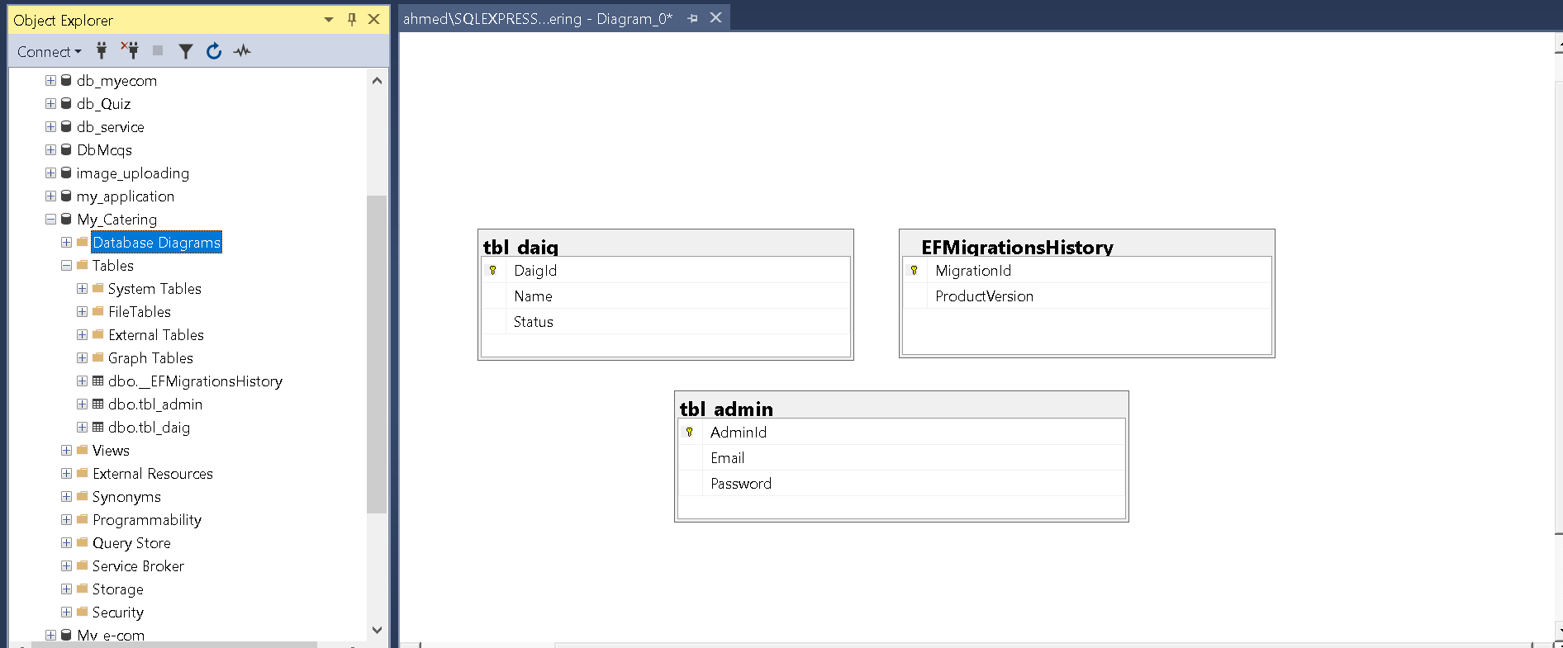

**Admin Panel**

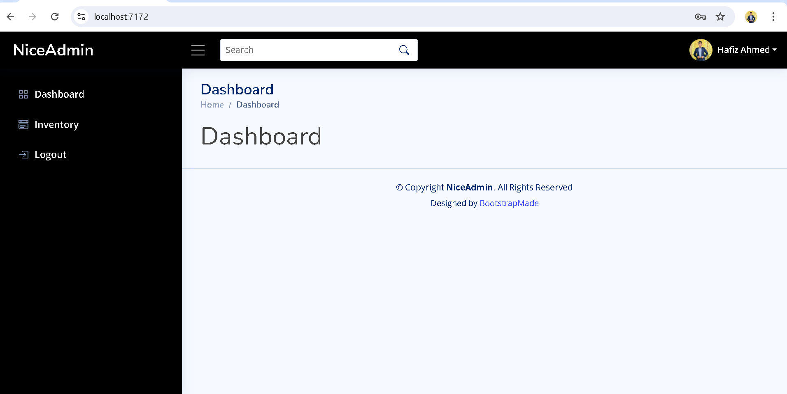**Admin Dashboard:**

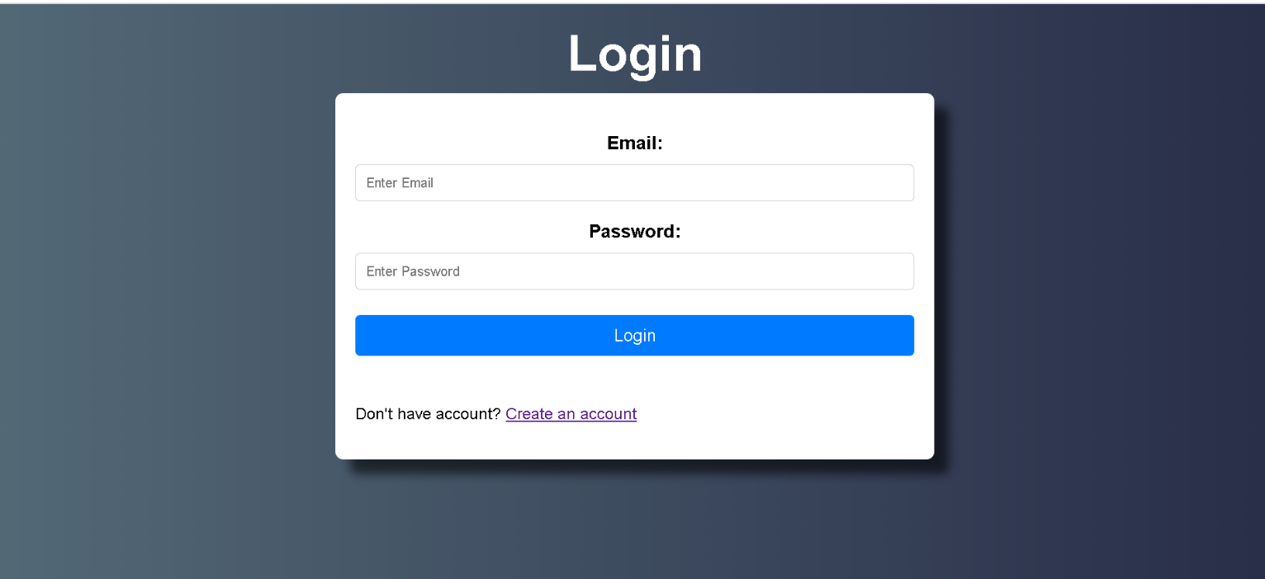**Admin Login:**

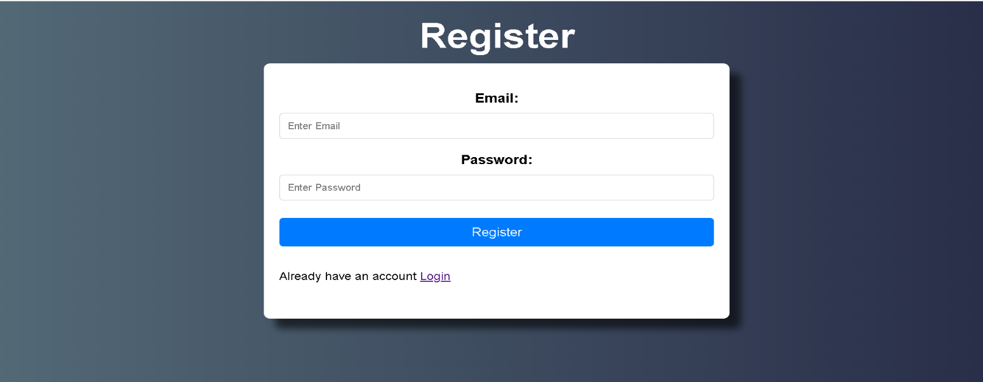**Admin Register (**Admin can also register this time**):**

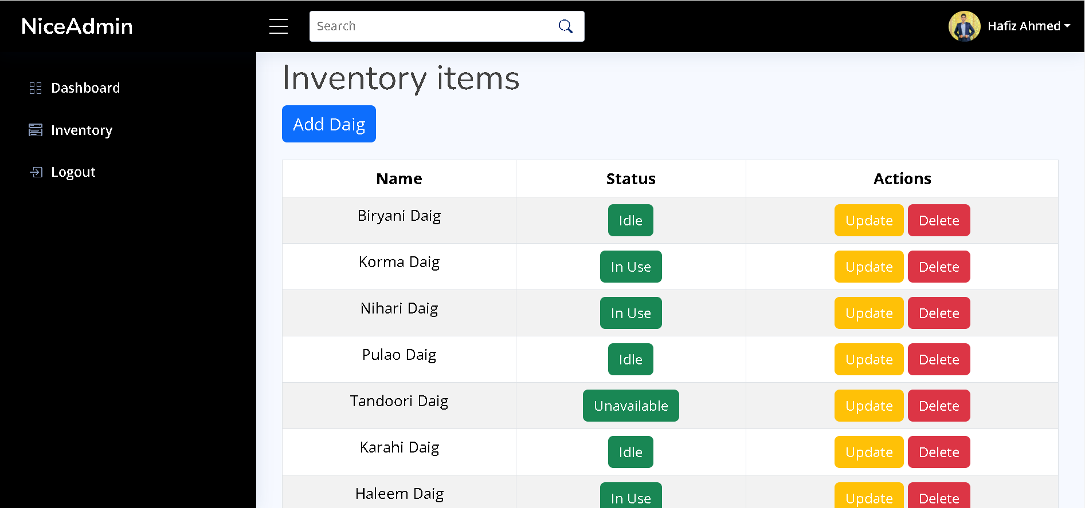**List of All Daigs:**

**Add Daigs.**

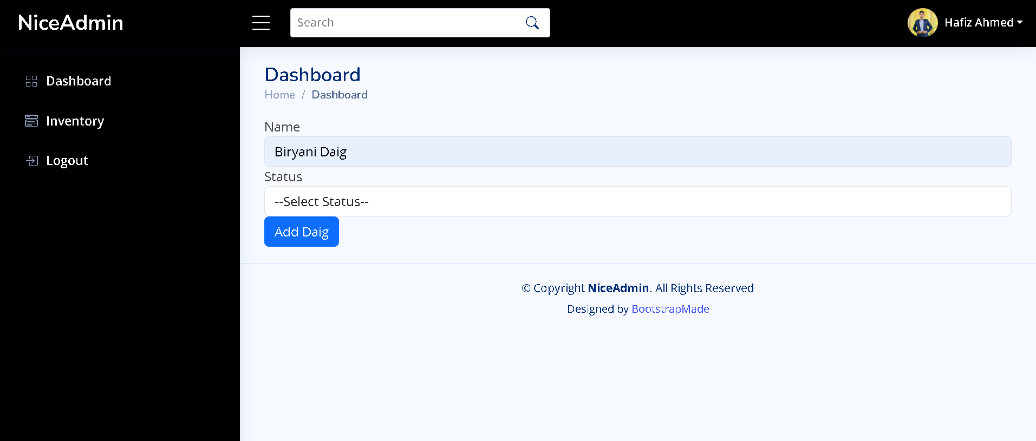

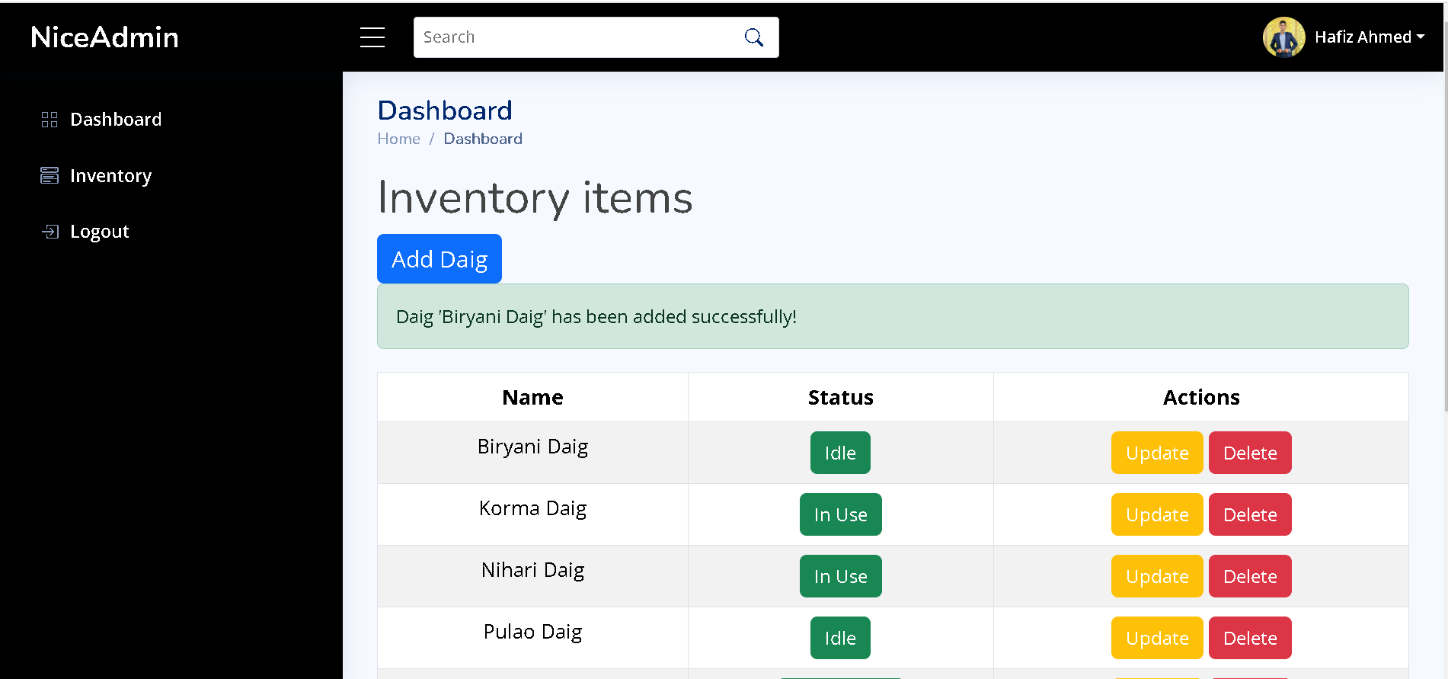**Notification says that the daig has added!**

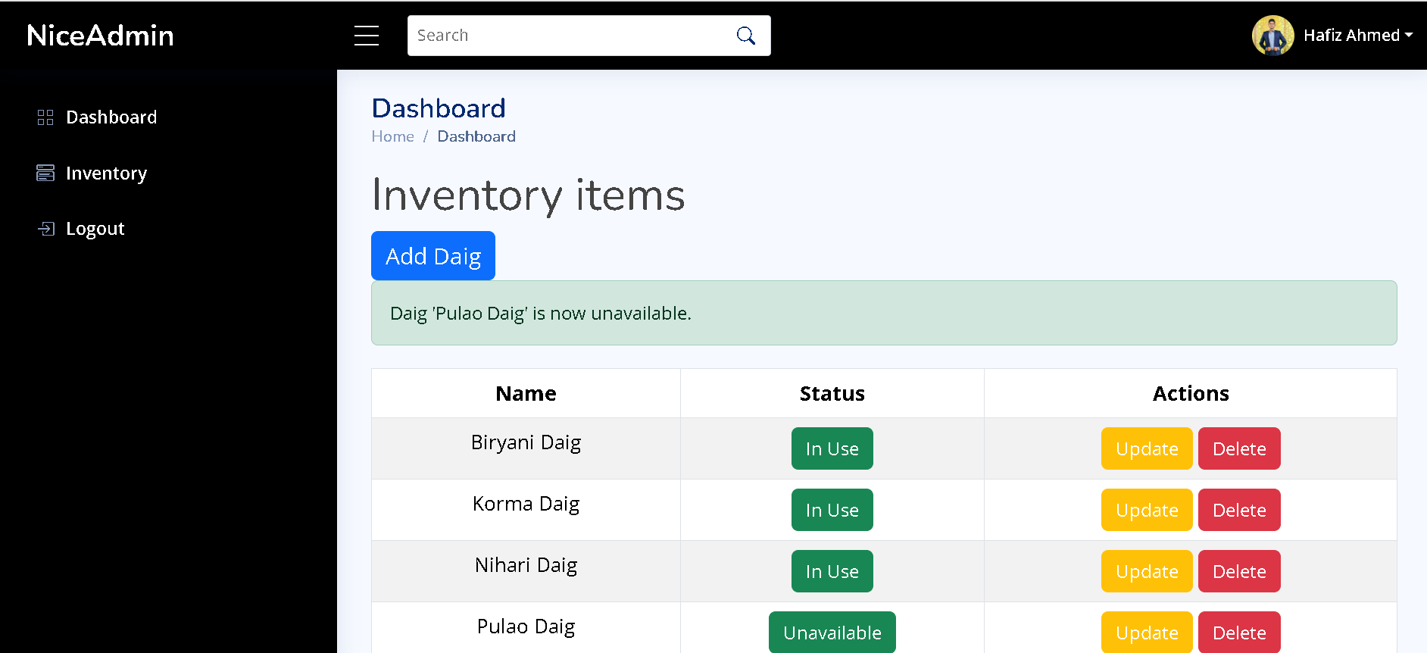**Notification (Status Changed!).**

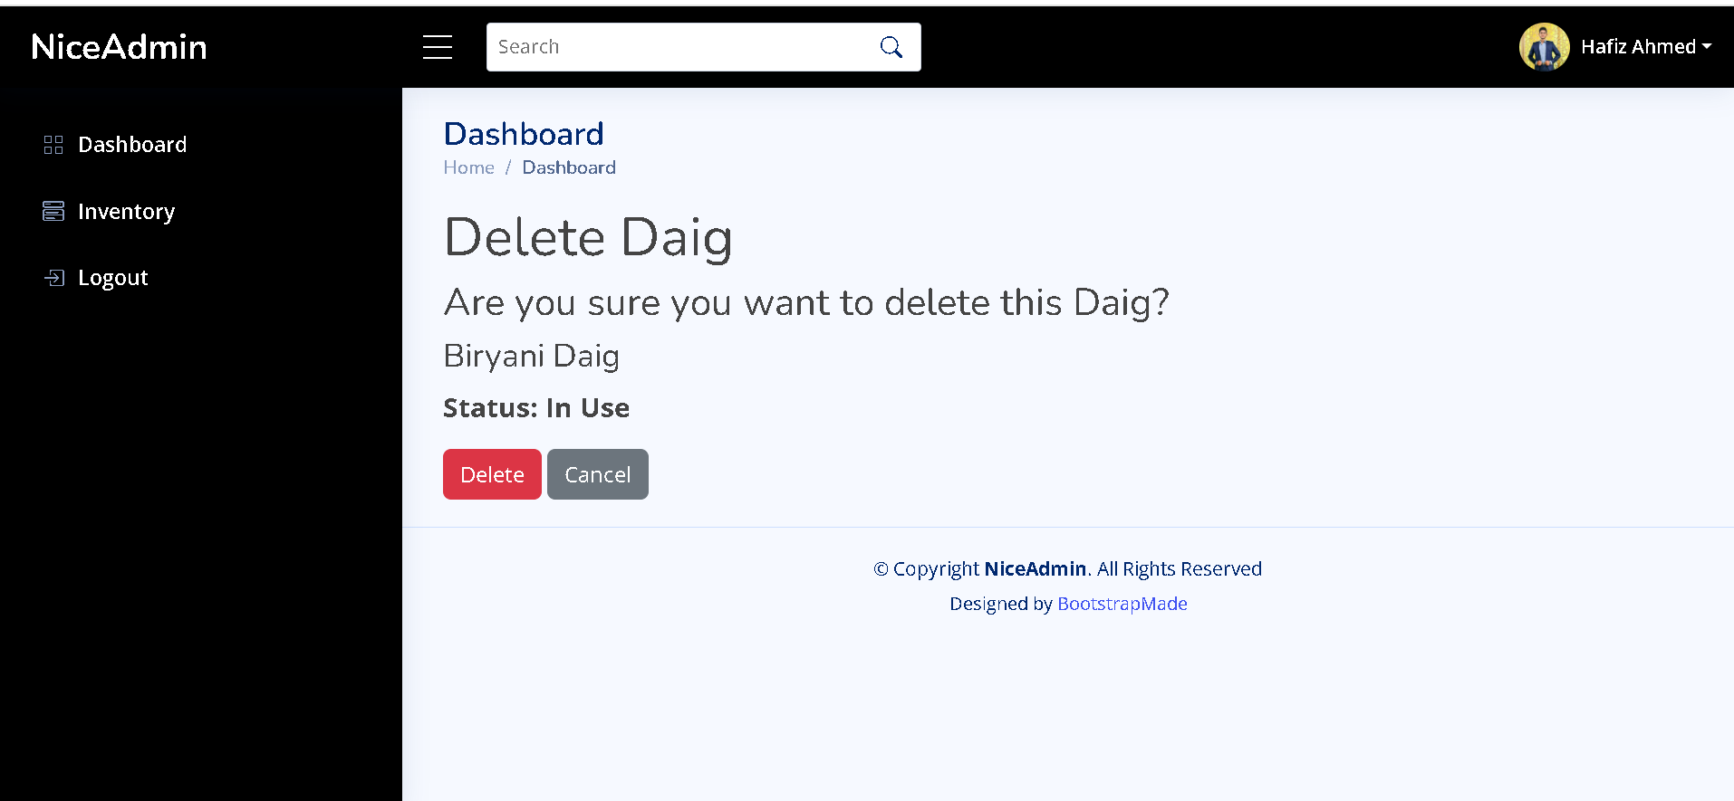**Delete Daig.**

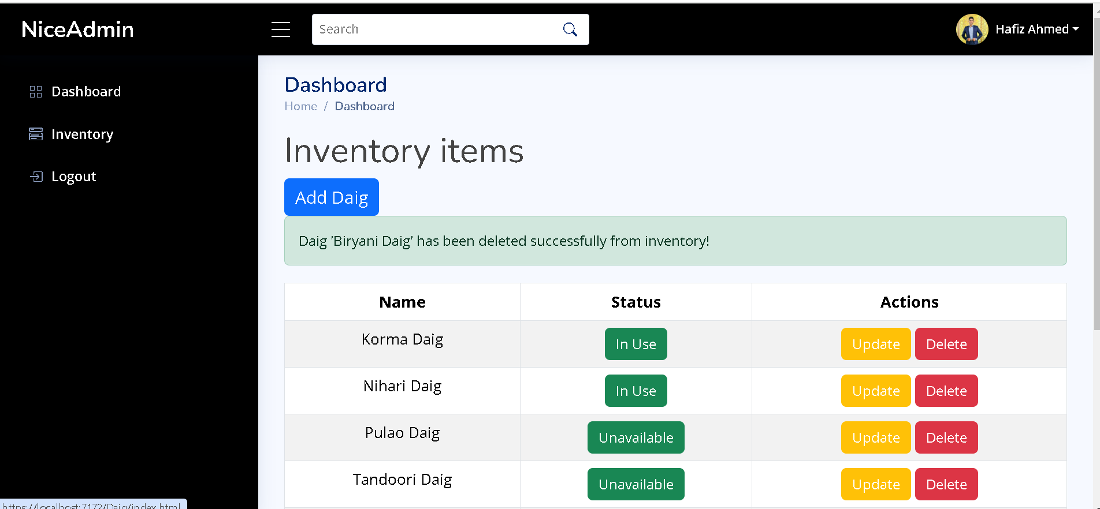**Daig delete successfully**

Thank You!