North East University Bangladesh
Department of Computer Science and Engineering



Improving Performance of Bangla OCR through Post-Processing

By
Tawhidul Islam  Reg. No: 130103020014  BSc(Engg) in CSE  4th year 3rd semester |  | Ahmed Dider Rahat  Reg. No: 140203020101  BSc(Engg) in CSE  4th year 3rd semester

Supervised By
Tasnim Zahan
Assistant Professor
Department of Computer Science and Engineering

14th October, 2017
Improving Performance of Bangla OCR through Post-Processing

A Thesis submitted to the Department of Computer Science and Engineering,
North East University Bangladesh, in partial fulfillment of the requirements
for the degree of Bachelor of Science in Computer Science and Engineering

By
Tawhidul Islam  Reg. No: 130103020014  BSc(Engg) in CSE  4th year 3rd semester |  | Ahmed Dider Rahat Reg. No:140203020101  BSc(Engg) in CSE  4th year 3rd semester

Supervised By
Tasnim Zahan
Assistant Professor
Department of Computer Science and Engineering

14th October, 2017
Recommendation Letter from Thesis Supervisor

These Students, Tawhidul Islam, Ahmed Dider Rahat, whose thesis/project entitled “Improving Performance of Bangla OCR trough Post-Processing”, is under my supervision and agrees to submit for examination.

Signature of the Supervisor ：

Tasnim Zahan
Assistant Professor
Department of Computer Science and Engineering
North East University Bangladesh
Qualification Form of BSc(Engg.) Degree
Student Name：Tawhidul Islam, Ahmed Dider Rahat
Thesis Title：Improving Performance of Bangla OCR trough Post-Processing

This is to certify that the thesis is submitted by the student named above in October, 2017. It is qualified and approved by the following persons and committee.

Head of the Dept.  Ahsan Habib  Associate Professor  Department of CSE  North East University Bangladesh | Supervisor  Tasnim Zahan  Assistant Professor  Department of CSE  North East University Bangladesh

Abstract

In the modern world of machine learning optical character recognition (OCR) is a very trending topic for researchers. There are many intensive works done for various scripts such as Roman, Chinese, and Japanese etc. A lot of work has been also reported on OCR efforts for Bangla script. But the performance of Bangla OCR system is not so remarkable. Bangla is a continuous scripting language and there is a huge set of characters, so the accuracy of recognition phase is little bit poor. Using post-processing, the overall performance of Bangla OCR system can be improved. For that, we try to find the errors which may occur in Bangla OCR system. In this paper we proposed a method with the combination of dictionary based method, minimum edit distance and n-gram model technique for error detection and correction. We have used a Bangla sentence corpus which contains 9,911 sentences and a dictionary with 58,534 words. For testing we use the recognition output of a Bangla book which contains 2814 words. By using our method we reduced the error rate 13.86 % to 1.39% which recover the 89.97% of errors.

Keywords: OCR, Bangla OCR, Post-processing, Error detection, Error correction, Dictionary lookup method, n-Gram, minimum edit distance.

Table of Contents
Abstract i
Table of Contents ii
List of Figures v
List of Tables vi
INTRODUCTION 2
1.1 Optical Character Recognition (OCR): 2
1.2 Characteristics of Bengali Script: 4
BACKGROUND STUDY 7
2.1 Literature Review: 7
2.2 Observation: 19
PROPOSED METHOD 23
3.1 Methodology: 23
3.2 Our Proposed method: 25
CONCLUSION 39
References 40

List of Figures

Figure 1: Bangla vowel characters 4
Figure 2: Bangla consonant characters 4
Figure 3: Vowel modifier of Bangla script 4
Figure 4: Consonant modifier of Bangla script 5
Figure 5: A subset of compound characters of Bangla script 5
Figure 6: System architecture of the proposed method (paper-1) 8
Figure 7: Dynamic lexicon reduction technique (paper-2) 9
Figure 8: Number of Candidates Vs Processing Time (Paper-3) 11
Figure 9: Block Diagram of the Algorithm (Paper-5) 13
Figure 10: System Architecture of Phase-1 27
Figure 11: System Architecture of Phase-2 28
Figure 12: System Architecture of Phase-3 29
Figure 13: System Architecture of Our Complete method 30
Figure 14: Errors which cannot correct with our system 36

List of Tables

Table 1: Accuracy Table of Paper-6 15
Table 2: Candidate Table 23
Table 3: Cost Table for Minimum Edit Distance 24
Table 4: Our Mapping Table 25
Table 5: Input set (OCR output) (Test Case-1) 32
Table 6: Suggestion List (Test Case-1) 33
Table 7: Detection File (Test Case-1) 34
Table 8: Correction File (Test Case-1) 35
Table 9: Accuracy Measurement of all Test sets 36

Chapter 1

INTRODUCTION
Bangla is the first language of Bangladesh and second language of India. Over 210 million people of the world speak in Bangla. It is also the sixth most popular script in the world. The objective of optical character recognition (OCR) is automatic reading of optically sensed document text materials to translate human-readable characters to machine-readable codes. OCR makes it possible to edit the text, search for a word or phrase, store it more compactly, display or print a copy free of scanning artifacts, and apply techniques such as machine translation, OCR is, therefore, one of the most contemporary and challenging areas of pattern recognition and more specifically in document image analysis. Like other languages, performance of Bangla OCR is not so remarkable. Researcher always tries to increase the performance of Bengali OCR system. There are some errors which can occur in segmentation and/or recognition phase. Languages such as English, Arabic, Devanagari - researchers handle those errors in post-processing phase. In post-processing, error correction is language dependent. So, direct use of other models may not suitable for Bangla script. For that reason, we tried to develop an effective technique to remove the OCR errors for improving the performance of Bangla OCR system. In this paper we also summarized some papers which are related to our work, described our proposed method and computed the accuracy of our system.

Optical Character Recognition (OCR):
Optical Character Recognition (OCR) is the electronic conversion of images of typed, handwritten or printed text into machine encoded text.
    - Application of OCR System:
- Now-a-days most of the books are stored in digital libraries. To convert a book OCR is used.
- Data entry for business documents, e.g. check, passport, invoice, bank statement and receipt.
- In automatic number plate recognition OCR is used.
- OCR is created a new era for blind and visually impaired people. Assistive technology is one of them.
- It is an active field of research in pattern recognition, artificial intelligence and computer vision.
    - OCR Procedure:

Most of the OCR system(s) are divided into five steps:
- Scanning: Scan the paper document and produce an electronic image.
- Zoning: Order the various regions of text in the image.
- Segmentation: Breaks the various zones into their respective components.
- Classification: Classify the segmented images into their respective (Unicode or ASCII) characters.
- Post-processing: Marge the character with each other and produce word, sentence etc.
    - Errors Occur In OCR System:

Errors associated with the primary OCR steps involved in the conversion process:
- Scanning error caused by the low paper/print quality of the original document or the poor condition of the scanning equipment.
- Zoning error caused by incorrect decolumnization or complex page layout.
- Segmentation error caused by the broken characters, touched characters, and nonstandard fonts in the document.
- Classification error caused by the incorrect mapping from segmented pixels to a single character.
    - Error Types of an OCR System:

We can divide overall errors in two categories:
- Non word error: The word which has no meaning.

Example: If ‘Amar’ (আমার) is changed with ‘Arar’(আরার). Here, ‘Arar’ (আরার) is not a valid word of Bangla script.
- Real word error: Correct word but not appropriate in the sentence.

Example: If ‘khala’(খালা) is changed with ‘thala’(থালা). Here, both words are valid in Bangla script. But ‘মা ও থালা নানা বাড়ী যাবেন’ is not a valid sentence where ‘মা ও খালা নানা বাড়ী যাবেন’ is a valid sentence.

Characteristics of Bengali Script:
- The character set is divided into two categories: basic and compound characters. Basic characters are the collection of 11 vowels and 39 consonants.
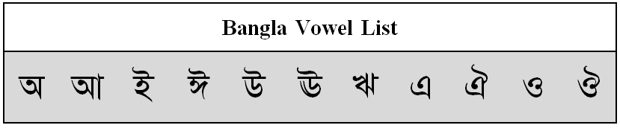
Figure 1: Bangla vowel characters
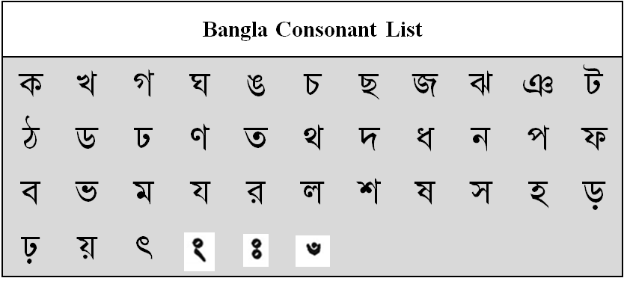
Figure 2: Bangla consonant characters
- When a vowel is added to a consonant the shape of the vowel is changed and the changed character is called a modified character.
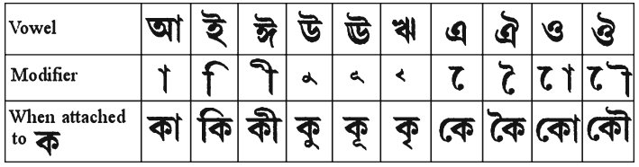
Figure 3: Vowel modifier of Bangla script
- In some situations, a consonant following another consonant is represented by a modifier called consonant modifier, such as (Reph), (Ra-phala) and (Ya-phala).
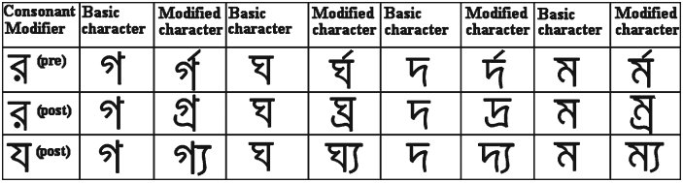
Figure 4: Consonant modifier of Bangla script
- Two or three consonants may also get combined into a complex shape, which is called compound characters. There are more than 250 such compound characters in Bengali language.
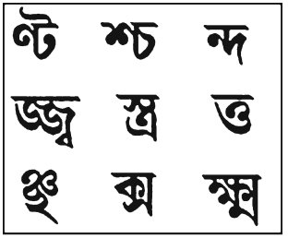
Figure 5: A subset of compound characters of Bangla script
- In Bengali most of the characters have a horizontal line at the upper part which is called matr¯ a¯.
Chapter 2

BACKGROUND STUDY

Literature Review:
Authors of paper [1] present an algorithm for OCR correction. In this paper they said that, in absence of a restricted lexicon, the output of an OCR is noisy. So, for noiseless output the system must use a restricted lexicon. The main objective of their research is to eliminate the spurious recognition choice using a topic based language model. They construct a topic based language model for every document using the training data which is manually categorized. In their research they organized the related work study into two categories.
- OCR Correction Based strategies.
- Lexicon Reduction Based Strategies.
In the first category there is done several works,
- Stochastic finite state machine algorithm.
- Morphological parsing where grammatical agreement between all candidate root-suffix pairs of each tested string.
- Interactive spelling correction with multiple information resources to propose correction candidates.
- Phrase based direct model where noisy OCR output is taken as the source language and clean output is taken as the target language. The alignment is obtained using a simple dynamic programming based minimum edit distance alignment.
They faced some the challenges, which are categorized into three categories:
- The techniques are highly depends on the language specific feature. So, such techniques are not applicable to a different language.
- Some of these techniques fail to use multiple recognition choices from the OCR and their performance is limited.
- None of these techniques uses topic information of the document to reject noisy words from the recognition output.
For removing the above barrier, the authors proposed a global language model by incorporating topic based language models.
In the second category the authors describes a Lexicon reduction based strategies which improve the performance of word recognizers’ by reducing the size of the lexicon based on a certain criteria. Lexicon reduction in this case serves as a method of eliminating irrelevant word choices from the OCR output.
Their proposed methods: They proposed a method where they manually categories the training data into several topics. Then apply the maximum likelihood (ML) estimate between OCR output and lexicon. So, the total language model is divided into several language models. Let us consider the total number of topic is n and each language model is represented by LM_{i} (where i=1, 2, 3 … n).
The total system architecture is given bellow:
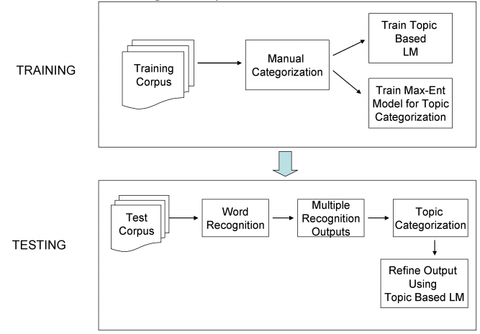
Figure 6: System architecture of the proposed method (paper-1)
Results Analysis:
- For the performance measures the authors used randomly 450 documents of the IAM database. They divided the total data set into two categories
- Training set: 380 documents which is divided into 13 categories.
- Testing set: 70 documents which contain 4033 words.
- They improve the raw accuracy up to 25%.
In the paper [2], the author describes two different strategies for OCR correction:
- Lexicon reduction based methods, and
- The combination of topic specific language model and maximum-entropy based topic categorization model.
The major drawback of topic based language is that, it is manually categorized. To remove the problem the authors used a dynamic lexicon reduction approach. They used adapted Naive Bayes model and also Maximum Entropy Model.
Dynamic lexicon reduction approach:
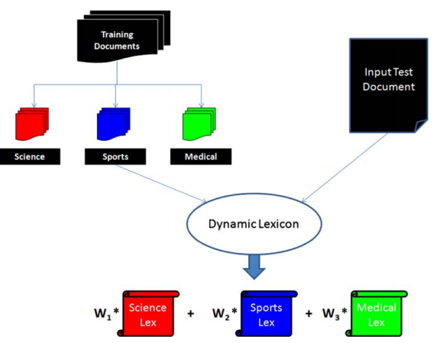
Figure 7: Dynamic lexicon reduction technique (paper-2)
For performance measure they used IAM database, which contains:
- 657 writers contributed samples of their handwriting
- 1,539 pages of scanned text
- 5,685 isolated and labeled sentences
- 13,353 isolated and labeled text lines
- 115,320 isolated and labeled words
- They improve the raw accuracy up to 25%.
In paper [3] the authors proposed a novel contextual post processing technique for Chinese script that integrates character-based bigram with word-based bigram. In their method they used three steps correction.
In the first phase they used character-based bigram to the test set, and find top m suggestions. In this phase they combine the OCR output and calculate their bigram probability. Though Chinese language has a huge amount of characters, there are huge numbers of possible word is being listed. And if the number of suggestion is increased then the computing time will be increased. For solving this problem, the authors sent the top m suggestion to the next phase.
In the second phase, the authors used forward–backward search in character-based bigram. This phase they ranked the suggestions by using forward bigram probability and backward bigram probability. So, the suggestion list is updated in this phase. After updating the suggestion list the suggestions are sent to the last phase.
For forward probability they used the formula which is,
Equation (1) is the joint probability of the partial feature sequence from the beginning to the position t and current candidate at position t.
Similarly, equation (2) is computed for backward probability.
In the third phase, they applied word-based bigram for getting the contextually higher sentence. After applying character-based bigram and forward-backward search, top m candidate is selected. They apply bigram to the all possible sentences and computed its score. After that, the top scored sentence is selected as an output sentence.
Equation (3) is represented the optimal string. Where, represent word string and represent the bigram probability of .
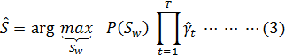
For training the algorithm they used 40,000,000 characters from people’s daily news paper corpus. For testing they use OCR recognition phase output of three documents, where each documents contain 22,000 characters. They dynamically showed that, if the value of m is increased then the run time is increased exponentially. So, after experiment they fixed the maximum value of m is 10.
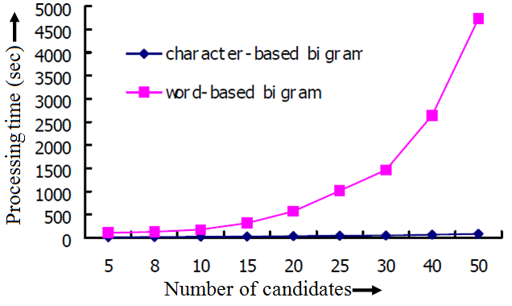
Figure 8: Number of Candidates Vs Processing Time (Paper-3)
Result: The total accuracy of their method is 95.75% and the average run time is 265 sec.
In paper [4] the authors describes a novel recognition driven segmentation methodology for Devanagari optical character recognition. They focused on the recognition of printed Devanagari text after pre-processing, and proposed a graph based representation that facilitates a recognition- driven segmentation approach, and a stochastic finite state automaton for word recognition.
In this paper the authors used post-processing using dictionary lookup and other techniques to improve recognition performance at the word level.
For performance measure they use:
- 10,606 words from the university buffalo ILT dataset.
- The dataset contain images scanned at 300dpi from varied sources.
- Their test set contains 8,209 samples of isolated consonant and vowels.
- The average accuracy of recognition such consonant/vowels is the range 94%-97%
In their future work section they said that they want to use post-processing tools such as n-gram or sentence-level grammar models to pick the top-n choice. They only used Hindi corpus to design the language model. In future they want to add other language.
In paper [5] the authors proposed context based error correction algorithm for detecting and correcting OCR errors. The proposed method works for both real and non word errors. Their method is based on Google’s online spelling suggestion which harnesses an internal database containing a huge collection of term and word sequence gathered from all over the web, convenient to suggest possible replacement for words that have been misspelled during OCR Process.
The proposed method is based on spelling suggestion and the ‘did you mean’ feature of Google’s online web search engine. In this paper the authors categorized the post processing approach into three broad categories:
- Manual error correction: In this approach errors are detect and correct by human. Though the accuracy of this technique is good, but it is very time consuming. If the test set is huge then manual error correction is quit impossible for human beings.
- Dictionary based error correction: This is another way to detect and correct errors in OCR system. This approach is also known as lexical error correction. In this approach, a lexicon or lookup dictionary is used to check the spelling of OCR recognized words and correct them if they are misspelled. In some case, a list of candidate is generated to assist in the correction of misspelled words. In this technique the major drawbacks are (i) requires a wide ranging dictionary that cover every single words in the language, (ii) there are no international dictionary which contain all language of the world, (iii) there are no dictionary which contain the proper noun, (iv) real word error is not detected and corrected by this approach.
- Context based error correction: Dictionary based error correction unable to correct errors based on their context, which is solved by this technique. In this approach errors are detected and corrected by the grammatical rules and semantic analysis. In context based error correction, majority of the researchers used statistical language models (SLMs) and feature based method. In the other hand, applying parts-of-speech (POS) tagger and some other grammatical rules are used to detect and correct errors.
Proposed Method:
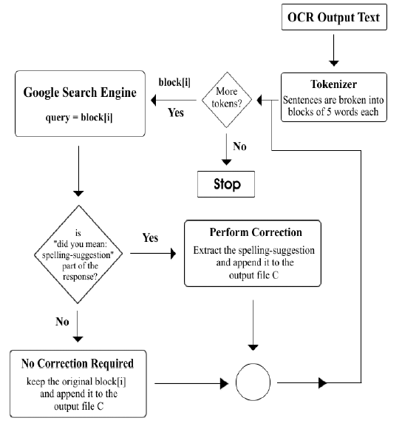

Figure 9: Block Diagram of the Algorithm (Paper-5)
The proposed algorithm has several steps to detect and correct the OCR output text.
- At the first step the OCR output text are divided into several blocks. The algorithm dividing the OCR output text B into a series of blocks {b₀, b₁, b₂… b_{n}} each blocks are made out of five words.
- In the second step, the blocks are sent one by one to the Google' online web search engine as a search query parameters. The search results are returned by Google, then parsed to identify whether or not they contain a ‘did you mean: c_{i}’ expression, where c_{i} is the spelling suggestion for block b_{i}.
- If true, then the block b_{i} must contain a misspelled word and hence, c_{i} is extracted from ‘did you mean: c_{i}’ and appended to the text file C which contain the entire correct block, where C= {c₀, c₁, c₂…c_{n}}.
- If b_{i} does not contain any ‘did you mean: c_{i}’, then b_{i} is appended to the correct file C. When all the blocks are finished, the algorithm halts and return the correct file C.
Result: The proposed algorithm tested for English and Arabic language. The accuracy is 88.89% and 96.87% respectively for English and Arabic language.
In paper [6] the authors, investigate the major challenge of developing error detection techniques for highly inflectional language such as Telugu and Malayalam. They also proposed a method which can detect errors for Telugu and Malayalam language, with F-score comparable to some less inflectional language like Hindi. Their method learns from error pattern and statistical language models (SLMs).
The authors classify some challenges which are responsible for developing error correction. The major of them are describes bellow:
- Inflectional language has an extremely large vocabulary. So here all unique words list is also large.
- In inflectional language there is lack of linguistic resources.
- Lack of reliable language model is another challenge.
The authors, categories the error model into three broad sectors and describes the methods to solve them.
- Natural erroneous data and artificial data: Artificial errors are non-word errors which are occurred due to multiple reasons such as degradations, noise etc. These types of errors are nearly impossible to solve with statistical language models. One possible way to correct these errors, by re-classification these words using better feature (and / or) pre-processing.
- Error at akshara level: These types of errors are detects by using the grammatical rules of the language. If a word violates the word building principal then this word is marked as error.
- Errors due to confusion among aksharas: Most of the languages have got a set of aksharas which can get confused with each other. Such confusion can be taken into account while correcting errors. When presented with the decision to select one replacement from a list, higher weight can be given to such high confusion pairs ahead of other choices.
Methodology: The authors implement both word level as well as sub-word (akshara) level methods.
- Dictionary based model: The simplest of the proposed error detection models involves using a binary dictionary. Every word from the test set is either considered as an in-vocabulary or as an out-of-vocabulary word. The success of such a method depends on the size of dictionary as a dictionary with larger size would infer larger word coverage.
- nGram model: The above mentioned method was improved so that for any given word, the list of all possible akshara nGram combinations to compare it with dictionary. i.e: For a word of length n, there are a list of all akshara (n-1) grams, (n-2) grams … and 2 grams to be compared against the corresponding dictionary. This method possesses significant advantage against simple word dictionary based method as the possibility of detecting an error was much higher. In this case,
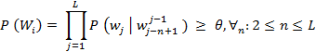
Here, θ is the threshold which decides if a word is valid or not. If there is at least one ‘n’ which satisfies the criteria, word is considered valid.
CIIL corpus is used to train the Statistical Language Models and 670,000 words dictionary is used for Malayalam and 700,000 words dictionary is used for Telugu. For testing the OCR output of 5000 printed pages are used.
Result:
Table 1: Accuracy Table of Paper-6
Method | Malayalam (%) | Telugu (%)
dictionary based model (dict.) | 72.36 | 94.32
nGram | 72.85 | 62.12
dict. + nGram | 67.97 | 65.01
dict. + SVM | 62.87 | 68.48
In paper [7] the authors developed a complete printed Bangla OCR system. They also proposed an algorithm for post-processing phase. This is the first complete Bangla printed OCR system.
The authors used dictionary lookup techniques with grammatical rules. For detect the errors they divided the dictionary into two categories:
- root word dictionary, and
- suffix dictionary
The algorithm for detect the misrecognition word is:
- Consider a new string W. Start from left and find all root word sub-strings R₁, R₂ ,…, R_{k} in W.
- If R_{k} = W, go to step 5. Else, start from right and find a valid suffix sub-string S.
- If W-S = R_{i}, for any i, then call the grammatical agreement test. If the test is passed then go to step 5.
- Find the next valid suffix sub-string. If no such sub-string exists then go to step 6. Else, go to step 3.
- Report success (the string is a valid surface word). Go to step 1
- Report failure. Call error correction algorithm and go to step 1
For correcting the errors, the authors used minimum edit distance with replacing, adding or deleting the characters with the similar root-suffix pairs.
For performance measure the authors used 60,000 root-suffix pairs.
This algorithm corrects 74.22% of single character errors.
Drawback:
  - This algorithm can’t correct the multiple characters error.
  - Real word errors are not detected and corrected by this algorithm.
Paper [8] is about the spelling checker. The authors proposed a method for Bangla spelling checker with methaphonic encoding. The method works as a spelling checker to improve the quality of suggestions for misspelled words.
In their introductory part they described the history of Bengali language and some causes of misspelling.
The authors also showed that they faced some challenges in creating a phonetic encoding for Bengali.
- Phonetic Similarity: Two or more characters have same pronunciation. Example- NA(ন), NNA(ণ), SA(শ), SAH(স), SSA(ষ) etc.
- Consonant Cluster : ন্দ, দ্দ, ব্দ etc
- Use of various Phalaa’s : In Bengali script, various types of Phalaa’s are used. Phalaa is the cluster of semi vowels.
For Example: BA Phalaa, YA Phalaa, RA Phalaa etc.
In their proposed method they used various mapping systems which they studied in their papers. They also use Unicode Normalization. For their encoding system they use 107 transformations in total.
They correct the misspelled words by using Phonetic Edit Distance.
They tested their algorithm with 1607 words.
The accuracy of their proposed work is 91.37%.
In paper [9] the authors proposed a method that improved the suggestions for misspelled word in Bangla language. The complex rules for Bangla spelling is creating a huge challenge in producing suggestion list.
The authors described some of the challenges of phonetic error:
- Consonant cluster or conjunct with unusual pronunciation.
- Different use of ‘Phala’.
- Different pronunciation of letters or conjunct in different context.
Proposed Algorithm for better suggestion:
In this phase the algorithm generated suggestions for the misspelled words, which includes words having edit distance maximum 2 between the misspelling word and words of word list for typographical error and this distance is marked as “Typo edit distance”.
There are also many words which have ‘edit distance 2’ between the phonetic code of misspelling word and the phonetic code of words of word list for phonetic error, this distance is marked as “Phonetic edit distance”.
The authors always prioritize phonetic error than typographical error. To rank they need to consider both the scores but they give a higher weight to the phonetic edit distance so that words with lower phonetic edit distance appear in the higher position in the suggestion list. They give weight of 60 to phonetic edit distance and a weight of 40 to typographical edit distance. Using these they will generate a score, which is the determinant to rank the suggestions.
For testing the used 1,607 commonly misspelled word and their accuracy is 91.67%.
In paper [10] the authors present a high performance domain specific OCR for recognizing Bengali Script. They examine the primary error types that mainly occurred in preprocessing and handled those errors by adding special error correcting module. Finally they added a dictionary and some error specific rules to correct the probable errors.
For post processing, the authors used a suggestion based spelling checker. They used Double Metaphone encoding where they used graphitic symbol table instead of phonetic encoding table.
Their proposed method provides certain number of suggestions of the error word instead of replacing it.
The post-processing technique handles 14% – 17% errors.
In paper [11] the authors proposed an approach for replace the misrecognized words produced by Bangla OCR system. To correct the misrecognized words the authors used minimum edit distance and character n-gram models.
The authors categorized the operations of edit distance into three categories:
- Add one character
- Remove one character
- Change one character
The authors implement the edit distance as bellow:
- Calculate the edit distance between the error word and dictionary words.
- Generate a suggestion list by sorting the list using minimum cost
- Replace the wrong world with the top word of suggestion list.
The authors implement the character n-grams model as bellow:
- The error word is split into n-grams.
- Calculate number of common n-gram between the error word and each word of the dictionary.
- Generate a word suggestion list, where the list is sorted.
- Replace the error word with the top suggestion word.
For testing, the authors used 541,167 words dictionary.
Using minimum edit distance the performance is increased into 15.87%
Using characters n-grams the performance is increased: 14.35%
Drawback: The major drawback of this algorithm can’t determine the real word error.

Observation:
- From our literature review we saw that all the authors used different techniques to detect and recover various OCR errors.
- Bangla is a continuous scripting language. So, in Bangla the error correction and detection in segmentation and recognition phase is too difficult. For, that reasons the only way to detects and corrects the error in the post processing phase.
- OCR post-processing is language dependent. So, by using the existing technique for different language could not perform better for Bangla language.
- We are analyzed the OCR output data and we find some of the error which occurred in Bangla OCR are given bellow:
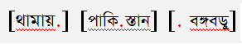
  - A single dot is appends with any word as a noise.
Example:
  - In Bangla OCR ‘ো’ (O-kar) is modified with ‘ে’ (A-kar) and ‘া’ (Ya-Kar)

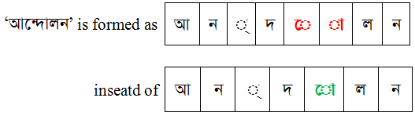
Example:

  - Position of ‘ঁ’ (Chandra-bindu) is another problem.
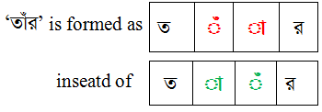
Example:

  - Change the characters: In Bangla scripts there are a huge number of characters and some of them are very similar, so the one character may be recognized by other.
Example 1: ণ (NNA) and ন (NA), ব (BA) ক (KA) etc.

Some modifiers are changed with each other.
Example 2: A-kar and YA-phalla.
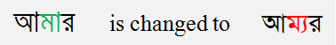
Vast number of compound cluster with similar shape.
Example 3: ন্দ and ব্দ
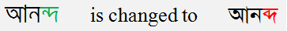
Use of ‘matra’ is in some characters.
Example 4: এ and ত্র
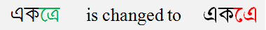

Chapter 3

PROPOSED METHOD

Methodology:
In this research we proposed a new technique for detecting and correcting OCR errors. There are three different phases in our method. We use key similarity technique, n-gram mode, and minimum edit distance.
For further discussion we describe the methods which we used in our algorithm:
- Key Similarity Technique: In this technique every characters of a word is replaced with their similar shaped characters. After replacement, if a word is in dictionary then this word is appended in a suggestion list. All the similar characters are predefined in a similar characters table. This table is called mapping table and the suggestion list is called candidate table.
Example:

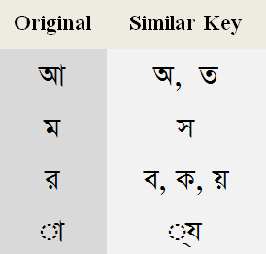
If a mapping table is:

And a word is ‘আমার’ then after using key similarity technique the outputs are given bellow, where the green marked word are actual candidate.
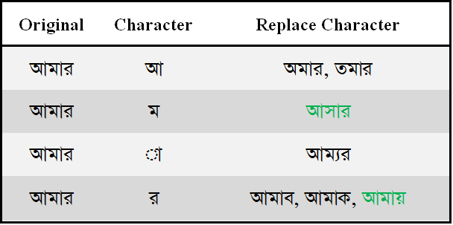
Table 2: Candidate Table
- n-Gram model: An n-gram model is a type of probabilistic language model for predicting the n^{th} word in such a sequence of previous(n-1) words. Here, the value of n is 1, 2, 3 … etc. If n is one then unigram, if n is 2 then bigram, if n is 3 then trigram etc.
Example: 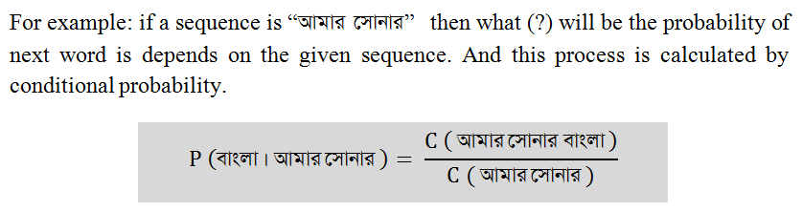
Here, P(বাংলা । আমার সোনার) is the probability of having “ আমার সোনার বাংলা”
- Minimum Edit Distance: The minimum edit distance between two strings, is the minimum numbers of editing operations (Insertion, Deletion and Substitution) needed to transform one into the other. It’s a dynamic process.
Examples: if two strings are s1 = ‘বাংলাদেশ’ and s2 = ‘বিশেষ’ then the minimum edit distance between these two strings is: 6.
This is a dynamic process. So, we need to store the previous value. For that we need to construct a table. The process of constructing the table is: if two characters are matched then copies the diagonal value otherwise assign the minimum value of (top+1, left+1, diagonal+1).
After construction the table becomes:
Table 3: Cost Table for Minimum Edit Distance
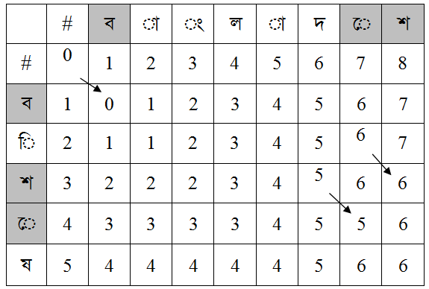

Our Proposed method:
- Phase-1 (Applying Key Similarity Techniques): In phase-1 we use key similarity technique. The technique is describes in the previous section. In this phase, the input is OCR’s output (output from recognition phase) and the output is a list, which contain all the suggestions. If the candidate set is increased than the computing time of second phase will increased. For saving time we want to picked top ‘3’ suggestions from the candidate list. To rank the suggestions we used a technique, where we assign a score to each candidate. The score is depends on statistical data. At first we create a mapping table (based on real OCR data), which contains the similarity of every characters with each other. If the character is changed into another then assign their similarity value as score.
Creating Mapping table: To create the mapping we used some real OCR data. The similarity of two characters i and j is S_{i, j} where,
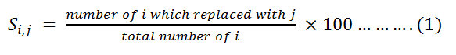
We also assign a minimum value to the characters which are graphically similar to avoid the risk.
Table 4: Our Mapping Table
ং->ৎ+1+হ+1  অ->ত্ম+4+প্র+3+গ্রে+2+ন্ম+3+আ+2+ত+2  আ->অ+1  ই->ঈ+1+হ+1  ঈ->ই+1  উ->ট্রে+2+ঊ+1+ঔ+1+ট+1+ঠ+1  ঊ->উ+1  ঋ->ঝ+2  এ-> ত্র+16+ব্র+4+ঐ+5+প্র+3  +গ্র+3+শ্রে+2+ঞ+1  ঐ->উ+1  ও->ভ+2+ন্তু+2+প+2+ত্ত+2+ত+1  +স্তু+3+ক্ত+4  ঔ->ঠ+1+উ+1  ক->ঝ+1+ফ+1+ব+1  ক্ষ->স্ফ+3+ব্দ+2  ক্ষু->সৃ+2  খ->স্ব+2+ঘ+1+থ+1  গ->প+1+ল+1  গ্র->প্র+5  ঘ->খ+1  ঘ্র->ন্ত্র+6+ন্ত্র+3  ঙ->ন্তু+2+ষ্ঠ+3+ড+1  চ->ঢ+1  চ্চ->শ্চ+2  চ্ছ->জ্জ+2  ছ->দ্র+2+হ+2+দ+1  জ->ত+55+ন্তু+5+ত্ব+3+ত্ত  +4+উ+6+ট্র+2+ড+7+ড়+1  জ্য->ত্য+5  ঝ->ন্ম+3+ব+1+ঋ+1+ক+1  ঞ->এ+1  ট->ঠ+1+উ+1  ঠ->ট+1+উ+1+ঔ+1  ড->ত+5+ভ+3+ঙ+1  ডু->ড়+2+ন্ধু+3  ঢ->ঢ়+1+চ+1  ণ->গ+3+ন+1+প+1  ণ্ড->ত্ত+2+ন্ড+2  ত->ভ+4+ভ+1+অ+1+ড+1+ও+1+জ+1  ত্ত->স্তু+2  থ->খ+2+য+1 | দ->ছ+1  দ্ধ->ক্ক+2  ন->ব+1+ণ+1+ল+1+ম+1  ন্ট->শ্চ+5  ন্ত->ম্ভ+3  ন্ত্র->স্ত্র+2  ন্থ->স্থ+2  ন্দ্র->দ্র+3  প->খ+2+গ+2+ণ+1+শ+1+ম+6  প্ল->প্ন+2+গ্ন+2+প্র+2  ফ->ক+1  ব->র+13+ধ+2+ন+  2+য+2+ক+1+ঝ+1  ভ->ড+1+ত+1  ম->স+1  মী->শ্লো+2  মু->ম্ভ+2  ম্ব->ন্ন+2+ম্ব+2+ম্ভ+2  ম্ম->ন্ম+2  য->ষ+5+য়+2+থ+1  র->ব+1+য়+1  রু->ধ্ব+2+ব্ব+2  ল->স+2+জ+2+চ+2+গ+1+ন+1  ল্ল->শ্ল+2  শ->প+2+স+2  শু->গু+2+ন্ড+3  শ্ব->স্ব+16+ম্ব+3  শ্র->ন্দ্র+2  ষ->য+2+য়+8  স->ম+1  সু->ন্ম+3  স্ট->ল্ট+3  স্ত->স্তু+3+স্থ+2  স্ত্র->ন্ত্র+2  হ->ং+1+ছ+1  ু->ূ+6  ে->ৈ+14  ো->ৌ+7  ড়->জ+1  ঢ়->ঢ+1  য়->র+1  তু->ত্ব+4+আ+2+গ্র+2
The system architecture of Phase-1:
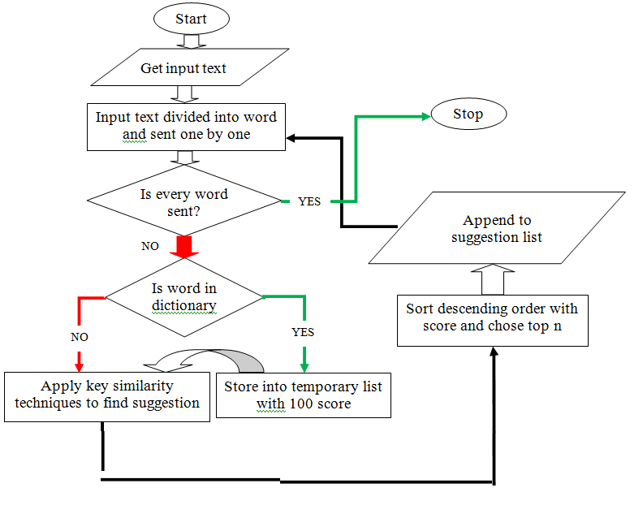
Figure 10: System Architecture of Phase-1
Phase-1 is divided by some steps. The steps are:
- Divided input text into several words and send each word (one by one) to the next step.
- If the word is in dictionary then store it to a temporary list with 100 score, otherwise apply key similarity techniques to find the actual candidate and their scores.
- Sort the candidate list in descending order (using their score) and store top 3 of them in the suggestion list.
- If all the words are finished then phase-1 halts.
- Phase-2 (Applying n-gram model): In this phase we find the best sequence from all possible sequences. Here input is the suggestion list and output is a sentence. To find the best sequence we use bigram and trigram approach. In our research, we pre-calculate the bigram and trigram list from our training corpus. For normalizing, we use Laplace smoothing. If there is no pairs and trios is found for any test case, equation (2) is used for Laplace smoothing:
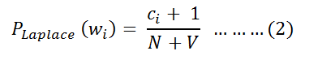
Here, c_{i} is the number of i, N is the total number of word tokens and V is the size of vocabulary.
The system architecture of Phase-2:
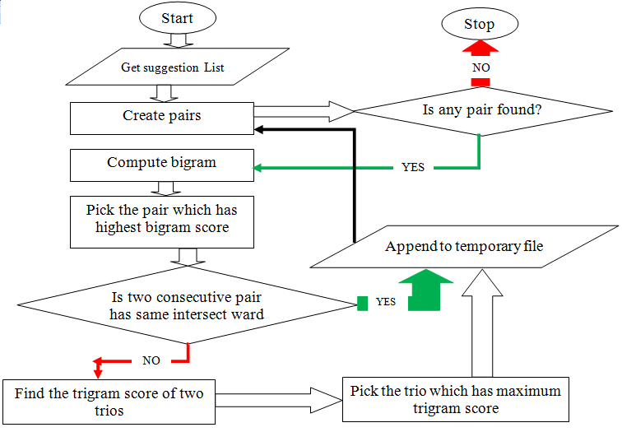
Figure 11: System Architecture of Phase-2
Phase-2 is divided by some steps. The steps are:
- In this step we create all possible pairs of suggestion[i] and suggestion[i+1] and assign the bigram probability as their score.
- Every time we choose the highest probabilistic pair. These are represented by:
- If two consecutive pairs have one common word in their intersect point, then store them in temporary output file, otherwise applies trigram and pick the sequence which has maximum trigram probabilistic score and store it into temporary output file.
- Phase-3 (Applying Minimum Edit Distance): In this phase we check every word from temporary output file. This is the last phase of our method. This phase is divided by several steps. They are:
The system architecture of Phase-3:
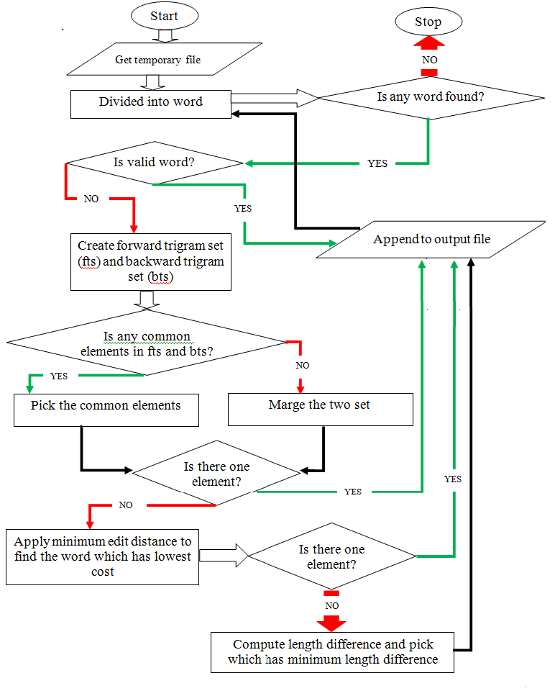
Figure 12: System Architecture of Phase-3
This phase is divided by several steps. They are:
Step-1: If word_{i} is valid (which has existence in dictionary), then we store it to the output file otherwise we create two sets S_{i}(1) and S_{i}(2) from forward trigram list and backward trigram list. Where,
S_{i} (1) = {all words in the trigram list which start with word_{i-2}word_{i-1}}
S_{i} (2) = {all words in the trigram list which end with word_{i+1}word_{i+2}}
Step-2: Then we compute S_{i}. Where S_{i} is defined in equation (4).
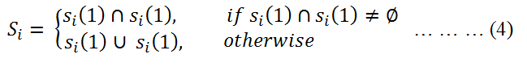
Step-3: If S_{i} has just one element then we store it to the out file otherwise we apply minimum edit distance and store them in a list.
Step-4: If there has just one word, which has lowest cost in minimum edit distance, then we store that word. Otherwise go to step-5.
Step-5: If there are more than two words have same cost (lowest cost) in minimum edit distance then we compute the length differences between the word_{i} and candidates of minimum edit distance (which has same lowest cost). After that we pick the candidate which has minimum length difference and store it in the output file.
Step-6: If all the words of temporary file are checked, our method returns the correct file.
Step-7: After creating the correct file we compare (word by word) it with our input file and detect the errors which are occurred in OCR system.
The Complete system architecture of our proposed method is:
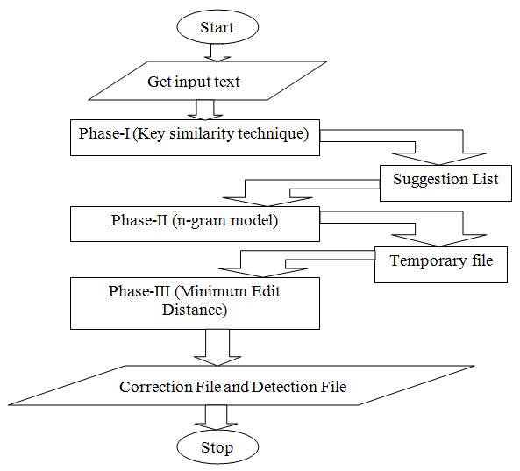
Figure 13: System Architecture of Our Complete method
Chapter 4

RESULTS AND DISCUSSION
In our method we use key similarity technique, n-gram model and minimum edit distance. For using key similarity technique we need a dictionary and for n-gram model we need a sentence corpus.
Training Set: We train our algorithm by the sentence corpus. In our sentence corpus there are 9,911 sentences and 1,29,517 words. For training, we have created unigram, bigram, forward trigram and backward trigram list along with their frequencies. We also use a 58,534 words dictionary where we added 22,190 words (from Society for Natural Language Technology Research).
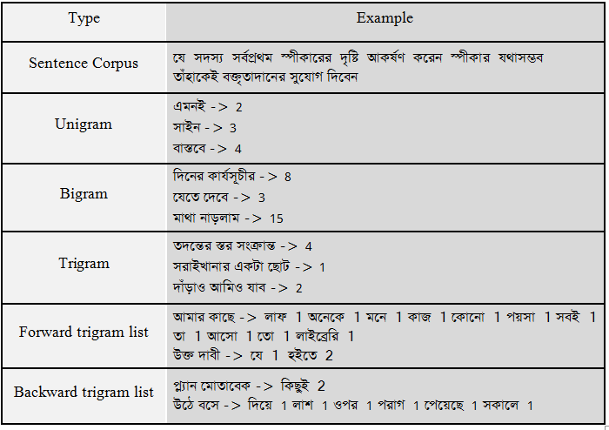
Tasting set: To test our algorithm, we need some OCR output (recognition phase output) data. For that reason we used some OCR data from a Bangla book ‘Muktijuddher Itihas, By-Prof. Dr. Muhammed Zafar Iqbal’. In our testing set there are 9 pages of OCR output which contains 2,811 words.
Table 5: Input set (OCR output) (Test Case-1)
মুক্তিযুদ্ধের ইজিহাস দেশ মানুষের যতগুলো অনুভূতি আছে তার মাঝে সবচেয়ে সুন্দর অনুভূতি হচ্ছে ভালোবাসা । আর এই পৃথিবীতে যা কিছুকে ভালোবাসা সমুব তার মাঝে সবচেয়ে তএী ভালোবাসাটুকু হতে পারে শুধুমাএ মাতৃভূমির জন্যে । যারা কখনো নিজের মাজৃভূমির জন্যে ভালোবাসাটুকু অনুভব করেনি তাদের মতো দুর্ভাগা আর কেউ নেই । আমাদের খুব সোভাগ্য আমাদের মাতৃভূমির জন্যে যে স্বাধীনতা যুদ্ধ হয়েছিল তার ইতিহাস হচ্ছে গভীর আঅত্যাগের ইতিহাস, অবিশ্বাস্য সাহস ও বীরতুের ইতিহাস এবং বিশাল এক অজর্নের ইতিহাস । যখন কেউ এই আঅজ্যাগ, বীরত্ব আর অজর্নের ইতিহাস জানবে, তখন সে যে শুধুমাএ দেশের জন্যে একটি গভীর ভালোবাসা আর মমতা অনুভব করবে তা নয়, এই দেশ, এই মানুষের কথা ভেবে গর্ব তার বুক ফুলে উঠবে । শূর্ব ইজিহাস . যেকোনো কিছু বর্ণনা করতে হলে সেটি একটু আগে থেকে বলতে হয়, তাই বাংলাদেশের ইতিহাস জানার জন্যেও একটু আগে গিয়ে এিটিশ আমল থেকে শুরু করা যেতে পারে । এিটিশরা এই অঞ্চলটিকে প্রায় দুইশ. বছর শাসন-শোষণ করেছে । তাদের হাত থেকে শ্বাধীনতার জন্যে হাজার হাজার মানুষ প্রাণ দিয়েছে, জেল খেটেছে. দ্বীপান্তরে গিয়েছে । ১৯৪ ০ সালে লাহোর প্রস্তাব০-এ ঠিক করা হয়েছিল ভারতবর্ষর যে অঞ্চলগুলোতে মুসলমান বেশি, সেরকম দুটি অঞ্চলকে নিয়ে দুটি দেশ এবং বাকি অঞ্চলটিকে নিয়ে আর একটি দেশ তেরি করা হবে ।কিঙ ১৯৪ ৭ সালের ১ ৪ আণস্ট যে এলাকা দুটিতে মুসলমানরা বেশি সেই এলাকা দুটি নিয়ে দুটি ভিন্ন দেশ না হয়ে পাকি.স্তান নামে একটি দেশ এবং ১ ৫ আগস্ট বাকি অঞ্চলটিকে ভারত নামে অন্য একটি দেশে ভাগ করে দেয়া হলো ।পাকিস্তান নামে পৃথিবীতে তখন অত্যন্ত বিচিএ একটি দেশের জঝ হলো, যে দেশের দুটি অংশ দুই জায়গায় । এ খন যেটি পাকিস্তান সেটির নাম পন্টিম পাকিস্তান এবং এখন যেটি বাংলাদেশ তার নাম পূর্ব পাকিস্তান । মাঝখানে প্রায় দুই হাজার কিলোমিটার দুরত্ব, এবং সেখানে রয়েছে ভিন্ন একটি দেশ- ভারত ! বিওেদ, বেষন্য, শোষণ আব ষডুষঘ্র পূর্ব আর পন্টিম পাকিস্তানের মাঝে শুধু যে প্রায় দুই হাজার কিলোমিটার দূরত্ব তা নয়, মানুষগুলোর ভেতরেও ছিল বিশাল দূরত্ব । তাদের চেহারা, ভাযা, খাবার, পোশাক, সংক্ষুতি, এতিন্ধ সবকিছু ছিল ভিন্ন, শুধু একটি বিষয়ে সংখ্যাগরিষ্ঠ মানুষগুলোর মাঝে মিল ছিল- সেটি হচ্ছে ধর্ম ।এরকম বিচিএ একটি দেশ হলে সেটি টিকিয়ে রাখার জন্যে আলাদাভাবে একটু বেশি চেষ্টা করার কথা, কিজ
In test case-1 there are 32 errors where 1 of them is real-word (marked with green) and rests of them are non-word errors (marked with red).
- Now After passing these data to phase-1 the suggestion list is created. Here, we added the suggestion list of first line:
Table 6: Suggestion List (Test Case-1)
Line-1:  মুক্তিযুদ্ধের->মুক্তিযুদ্ধের  ইজিহাস->ইতিহাস  দেশ->দেশ  মানুষের->মানুষের  যতগুলো->যতগুলো  অনুভূতি->অনুভূতি | আছে->আছে আহে  তার->তার তায় ভার  মাঝে->মাঝে মাকে  সবচেয়ে->সবচেয়ে  সুন্দর->সুন্দর  অনুভূতি->অনুভূতি  হচ্ছে->হচ্ছে  ভালোবাসা->ভালোবাসা

After passing the suggestion list to 2nd and 3rd phase, two files are created - one for error detection and one for error correction:
Table 7: Detection File (Test Case-1)
মুক্তিযুদ্ধের [ইজিহাস] দেশ মানুষের যতগুলো অনুভূতি আছে তার মাঝে সবচেয়ে সুন্দর অনুভূতি হচ্ছে ভালোবাসা । আর এই পৃথিবীতে যা কিছুকে ভালোবাসা [সমুব] তার মাঝে সবচেয়ে [তএী] ভালোবাসাটুকু হতে পারে [শুধুমাএ] মাতৃভূমির জন্যে । যারা কখনো নিজের [মাজৃভূমির] জন্যে ভালোবাসাটুকু অনুভব করেনি তাদের মতো দুর্ভাগা আর কেউ নেই । আমাদের খুব [সোভাগ্য] আমাদের মাতৃভূমির জন্যে যে স্বাধীনতা যুদ্ধ হয়েছিল তার ইতিহাস হচ্ছে গভীর [আঅত্যাগের] ইতিহাস, অবিশ্বাস্য সাহস ও [বীরতুের] ইতিহাস এবং বিশাল এক [অজর্নের] ইতিহাস । যখন কেউ এই [আঅজ্যাগ,] বীরত্ব আর [অজর্নের] ইতিহাস জানবে, তখন সে যে [শুধুমাএ] দেশের জন্যে একটি গভীর ভালোবাসা আর মমতা অনুভব করবে তা নয়, এই দেশ, এই মানুষের কথা ভেবে গর্ব তার বুক ফুলে উঠবে । [শূর্ব] [ইজিহাস] যেকোনো কিছু বর্ণনা করতে হলে সেটি একটু আগে থেকে বলতে হয়, তাই বাংলাদেশের ইতিহাস জানার জন্যেও একটু আগে গিয়ে [এিটিশ] আমল থেকে শুরু করা যেতে পারে । [এিটিশরা] এই অঞ্চলটিকে প্রায় দুইশ বছর শাসন-শোষণ করেছে । তাদের হাত থেকে [শ্বাধীনতার] জন্যে হাজার হাজার মানুষ প্রাণ দিয়েছে, জেল [খেটেছে] দ্বীপান্তরে গিয়েছে । ১৯৪ ০ সালে লাহোর [প্রস্তাব০-এ] ঠিক করা হয়েছিল [ভারতবর্ষর] যে অঞ্চলগুলোতে মুসলমান বেশি, সেরকম দুটি অঞ্চলকে নিয়ে দুটি দেশ এবং বাকি অঞ্চলটিকে নিয়ে আর একটি দেশ [তেরি] করা হবে । [কিঙ] ১৯৪ ৭ সালের ১ ৪ [আণস্ট] যে এলাকা দুটিতে মুসলমানরা বেশি সেই এলাকা দুটি নিয়ে দুটি ভিন্ন দেশ না হয়ে পাকিস্তান নামে একটি দেশ এবং ১ ৫ আগস্ট বাকি অঞ্চলটিকে ভারত নামে অন্য একটি দেশে ভাগ করে দেয়া হলো । পাকিস্তান নামে পৃথিবীতে তখন অত্যন্ত [বিচিএ] একটি দেশের [জঝ] হলো, যে দেশের দুটি অংশ দুই জায়গায় । [এ] খন যেটি পাকিস্তান সেটির নাম [পন্টিম] পাকিস্তান এবং এখন যেটি বাংলাদেশ তার নাম পূর্ব পাকিস্তান । মাঝখানে প্রায় দুই হাজার কিলোমিটার [দুরত্ব,] এবং সেখানে রয়েছে ভিন্ন একটি [দেশ-] ভারত ! [বিওেদ,] [বেষন্য,] শোষণ [আব] [ষডুষঘ্র] পূর্ব আর [পন্টিম] পাকিস্তানের মাঝে শুধু যে প্রায় দুই হাজার কিলোমিটার দূরত্ব তা নয়, মানুষগুলোর ভেতরেও ছিল বিশাল দূরত্ব । তাদের চেহারা, [ভাযা,] খাবার, পোশাক, [সংক্ষুতি,] [এতিন্ধ] সবকিছু ছিল ভিন্ন, শুধু একটি বিষয়ে সংখ্যাগরিষ্ঠ মানুষগুলোর মাঝে মিল [ছিল-] সেটি হচ্ছে ধর্ম । এরকম [বিচিএ] একটি দেশ হলে সেটি টিকিয়ে রাখার জন্যে আলাদাভাবে একটু বেশি চেষ্টা করার কথা, [কিজ] ।
Table 8: Correction File (Test Case-1)
মুক্তিযুদ্ধের [ইতিহাস] দেশ মানুষের যতগুলো অনুভূতি আছে তার মাঝে সবচেয়ে সুন্দর অনুভূতি হচ্ছে ভালোবাসা । আর এই পৃথিবীতে যা কিছুকে ভালোবাসা [সম্ভব] তার মাঝে সবচেয়ে [তীব্র] ভালোবাসাটুকু হতে পারে [শুধুমাত্র] মাতৃভূমির জন্যে । যারা কখনো নিজের [মাতৃভূমির] জন্যে ভালোবাসাটুকু অনুভব করেনি তাদের মতো দুর্ভাগা আর কেউ নেই । আমাদের খুব [সৌভাগ্য] আমাদের মাতৃভূমির জন্যে যে স্বাধীনতা যুদ্ধ হয়েছিল তার ইতিহাস হচ্ছে গভীর [আত্মত্যাগের] ইতিহাস, অবিশ্বাস্য সাহস ও [বীরত্বের] ইতিহাস এবং বিশাল এক [অর্জনের] ইতিহাস । যখন কেউ এই [আত্মত্যাগ,] বীরত্ব আর [অর্জনের] ইতিহাস জানবে, তখন সে যে [শুধুমাত্র] দেশের জন্যে একটি গভীর ভালোবাসা আর মমতা অনুভব করবে তা নয়, এই দেশ, এই মানুষের কথা ভেবে গর্ব তার বুক ফুলে উঠবে । [পূর্ব] [ইতিহাস] যেকোনো কিছু বর্ণনা করতে হলে সেটি একটু আগে থেকে বলতে হয়, তাই বাংলাদেশের ইতিহাস জানার জন্যেও একটু আগে গিয়ে [ব্রিটিশ] আমল থেকে শুরু করা যেতে পারে । [ব্রিটিশরা] এই অঞ্চলটিকে প্রায় দুইশ বছর শাসন-শোষণ করেছে । তাদের হাত থেকে [স্বাধীনতার] জন্যে হাজার হাজার মানুষ প্রাণ দিয়েছে, জেল [জেলখেটেছে] দ্বীপান্তরে গিয়েছে । ১৯৪ ০ সালে লাহোর [প্রস্তাবএ] ঠিক করা হয়েছিল [ভারতবর্ষের] যে অঞ্চলগুলোতে মুসলমান বেশি, সেরকম দুটি অঞ্চলকে নিয়ে দুটি দেশ এবং বাকি অঞ্চলটিকে নিয়ে আর একটি দেশ [তৈরি] করা হবে । [কিন্তু] ১৯৪ ৭ সালের ১ ৪ [আগস্ট] যে এলাকা দুটিতে মুসলমানরা বেশি সেই এলাকা দুটি নিয়ে দুটি ভিন্ন দেশ না হয়ে পাকিস্তান নামে একটি দেশ এবং ১ ৫ আগস্ট বাকি অঞ্চলটিকে ভারত নামে অন্য একটি দেশে ভাগ করে দেয়া হলো । পাকিস্তান নামে পৃথিবীতে তখন অত্যন্ত [বিচিত্র] একটি দেশের [জন্ম] হলো, যে দেশের দুটি অংশ দুই জায়গায় । [ঐ] খন যেটি পাকিস্তান সেটির নাম [পশ্চিম] পাকিস্তান এবং এখন যেটি বাংলাদেশ তার নাম পূর্ব পাকিস্তান । মাঝখানে প্রায় দুই হাজার কিলোমিটার [দূরত্ব,] এবং সেখানে রয়েছে ভিন্ন একটি [দেশ] ভারত ! [বিভেদ,] [বৈষম্য,] শোষণ [আর] [ষড়যন্ত্র] পূর্ব আর [পশ্চিম] পাকিস্তানের মাঝে শুধু যে প্রায় দুই হাজার কিলোমিটার দূরত্ব তা নয়, মানুষগুলোর ভেতরেও ছিল বিশাল দূরত্ব । তাদের চেহারা, [ভাষা,] খাবার, পোশাক, [সংস্কৃতি,] [ঐতিহ্য] সবকিছু ছিল ভিন্ন, শুধু একটি বিষয়ে সংখ্যাগরিষ্ঠ মানুষগুলোর মাঝে মিল [ছিল] সেটি হচ্ছে ধর্ম । এরকম [বিচিত্র] একটি দেশ হলে সেটি টিকিয়ে রাখার জন্যে আলাদাভাবে একটু বেশি চেষ্টা করার কথা, [কিন্তু] ।
In the above text, the corrected word are marked by ‘[ ]’. But our algorithm cannot correct all the errors. The red marked cannot be corrected by our method. We tested total 9 cases.
Table 9: Accuracy Measurement of all Test sets
Test Case | Number of Words | Number of errors | Error (%)  before Post-Processing | Number of error detected | Number of Error Corrected | Error (%)  after Post-Processing | Error recovery rate (%)
1 | 333 | 40 | 12.012 % | 40 | 38 | 0.601 % | 95.0 %
2 | 312 | 29 | 9.295 % | 34 | 23 | 1.923 % | 79.31 %
3 | 321 | 57 | 17.757 % | 56 | 55 | 0.623 % | 96.49 %
4 | 337 | 53 | 15.727 % | 53 | 51 | 0.593 % | 96.23 %
5 | 320 | 39 | 12.186 % | 35 | 31 | 2.5 % | 79.49 %
6 | 305 | 50 | 16.393 % | 48 | 46 | 1.311 % | 92.0 %
7 | 307 | 42 | 13.681 % | 40 | 34 | 2.606 % | 80.95 %
8 | 293 | 47 | 16.041 % | 44 | 44 | 1.024 % | 93.62 %
9 | 286 | 33 | 11.538 % | 31 | 29 | 1.399 % | 87.88 %
Total | 2814 | 390 | 13.86 % | 381 | 351 | 1.39 % | 89.97 %
Limitations: The major limitation of our system is the size of the corpus. We train our system with only 9,911 sentenses. Some error examples are given below:
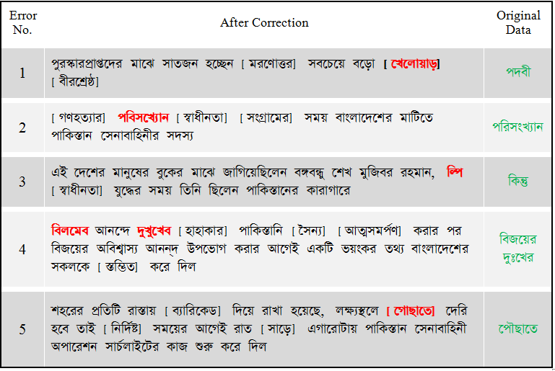
Figure 14: Errors which cannot correct with our system
Operating Environment:
Hardware: For testing our algorithm we use a personal computer. Which configuration is, Processor: Intel ® 2.16 GHz, RAM: 2 GB, HDD: 84 GB
Operating System: Windows 8.1
Programming Language: Python (2.7)
Chapter 5

CONCLUSION
Conclusion: In our research we developed a new technique for detecting and correcting OCR errors. We also analyze the state-of-art techniques of OCR post-processing. We have used the combination of key similarity technique, n-gram model and minimum edit distance. Our system reduces the OCR errors 13.86 % to 1.39% which means its recover 89.97% of errors.

References

- Bhardwaj, A., Farooq, F., Cao, H., Govindaraju, V., “Topic Based Language model for OCR Correction”, AND’08 - 2nd Workshop on Analytics for Noisy Unstructured Text Data, ACM (pp 107-112) (2008).
- Bhardwaj, A., Farooq, F., Govindaraju, V., “Using Topic Based Language model for OCR Correction”, International Journal on Document Analysis and Recognition (Springer), Volume 12, (pp 153–164).
- LI, Y., DING, X., TAN, C.L., “Combining Character-Based Bigrams with Word-Based Bigrams in Contextual Postprocessing for Chinese Script Recognition”, ACM Transactions on Asian Language Information Processing, ACM, Vol. 1, No. 4, (pp. 297–309) (2002).
- Kompalli, S., Setlur, S., Govindaraju, V., “Devanagari OCR using a recognition driven segmentation framework and stochastic language models”, International Journal on Document Analysis and Recognition (Springer), July 2009, Volume 12, Issue 2, pp 123–138.
- Bassil, Y., Alwani, M., “OCR Post-Processing Error Correction Algorithm Using Google’s Online Spelling Suggestion”, Journal of Emerging Trends in Computing and Information Sciences, Vol. 3, No. 1, (2012).
- Sankaran, N., Jawahar, C.V., “Error detection in Highly Inflectional Languages”, 12th International Conferences on Document Analysis and Recognition, IEEE, (2013).
- Chaudhuri, B.B., PAL, U., “A Complete Printed Bangla OCR System”, Pattern Recognition, Elsevier, Vol. 31, (pp. 531—549) (1998).
- UzZaman, N., Khan, M., “A Double Metaphone Encoding for Bengali and its application in Spelling Checker”,IEEE International Conference Natural Language Processing and Knowledge Engineering, (2005).
- UzZaman N., Khan, M., “A Comprehensive Bangla Spelling Checker” Center for Research on Bangla Language Processing, BRAC University Bangladesh, (2006).
- Hasnat, M.A., Habib, S.M.M., Khan, M., “A High Performance Domain Specific OCR for Bengali Script”, Novel Algorithms and Techniques in Telecommunications, Automation and Industrial Electronics, Springer (pp 174-178) (2008).
- Ahmed, M.S., Gonçalves, T., Sarwar, H., “Improving Bangla OCR output through correction algorithms”, 10th International Conference on Software, Knowledge, Information Management & Applications, IEEE (2016).

