|  |
| --- |
| **Submitted By: Ahmed Dider Rahat**  Matriculation Number: 916146 |

Assignment 1

Software Setup for CS4DS

1. **Set up Unix-bash:**

Set up the terminal using <https://www.cygwin.com>

Test, open terminal window and type shell commands:

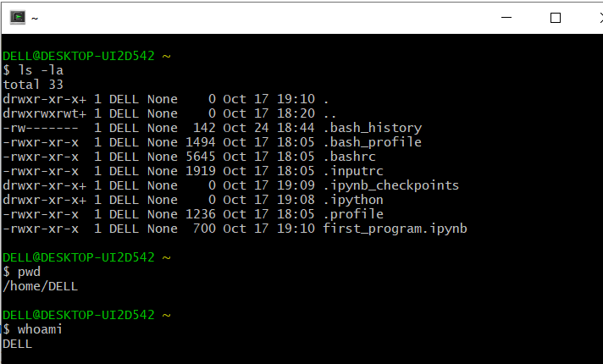

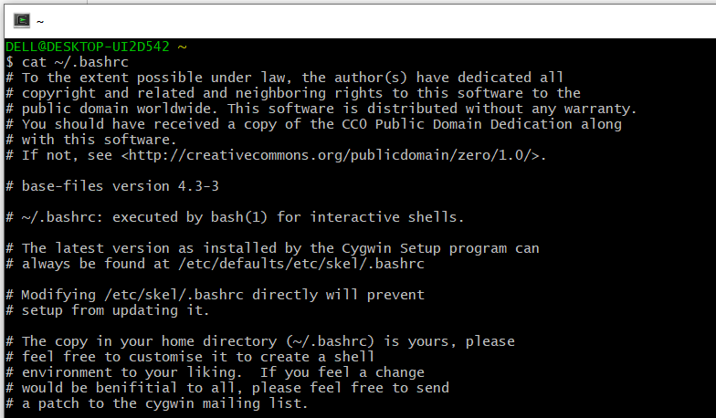

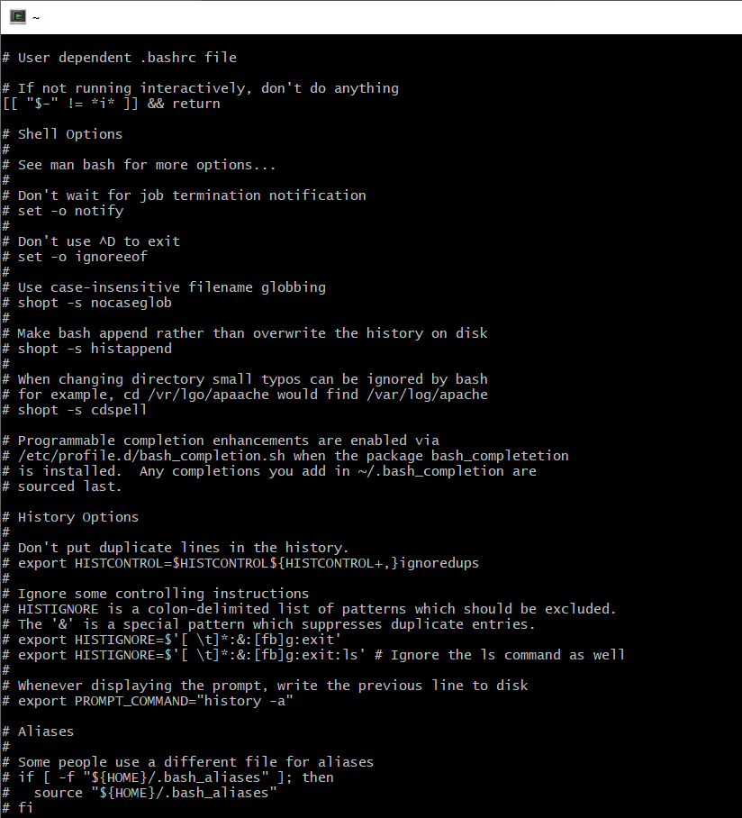

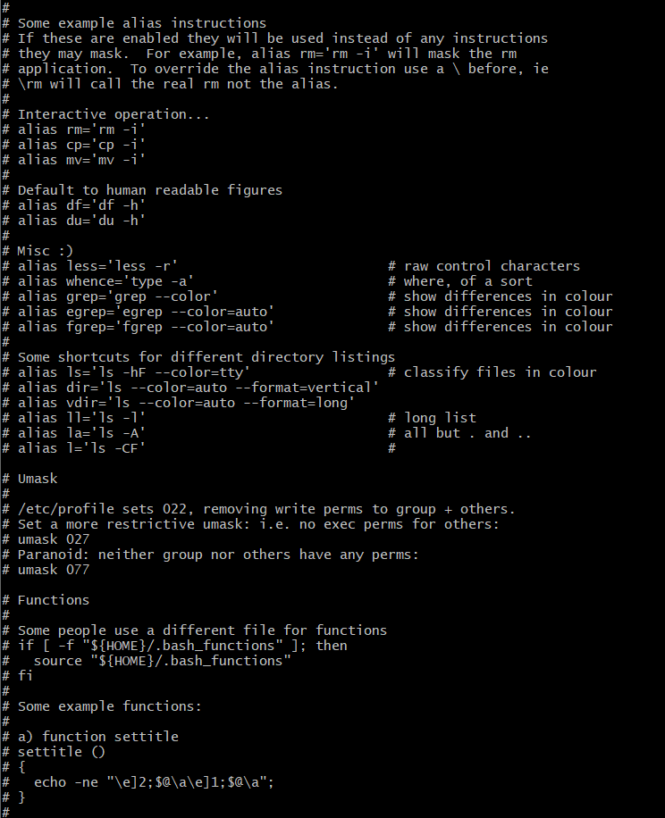

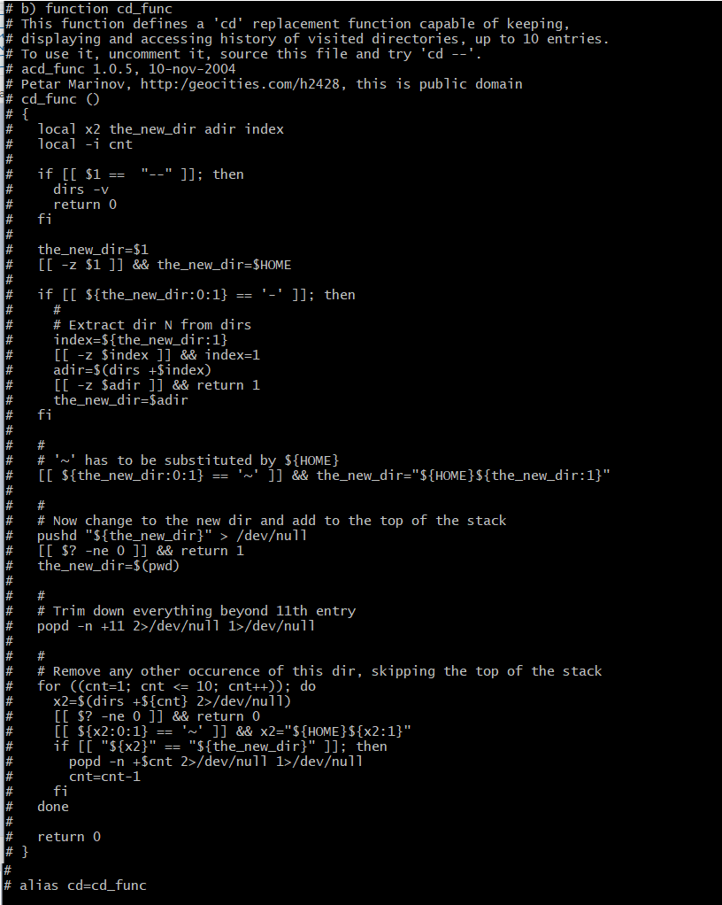

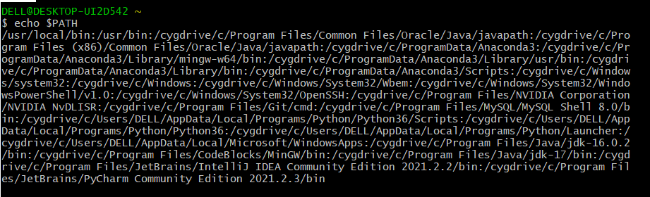

1. **Install Python 3+:** I have installed **python and pip** earlier in March 2021. So, I just put the screen short of python version.

Test, open terminal window and type:

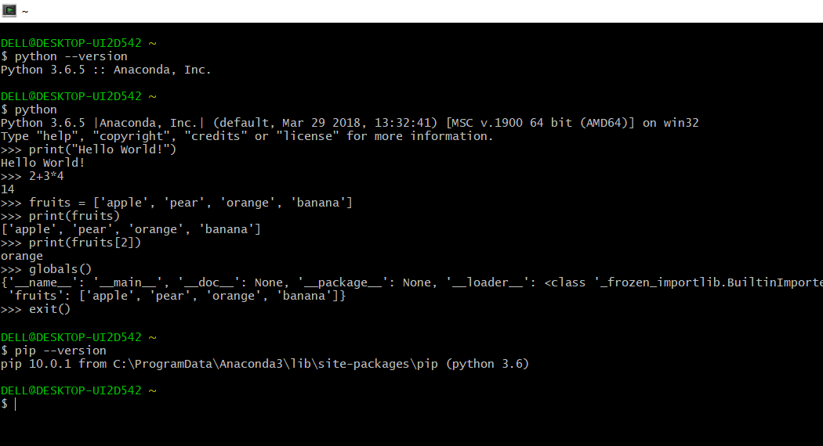

1. **Install Jupyter Lab:**  I have installed jupyter lab earlier in March 2021. So, I just put the screen short of python version.

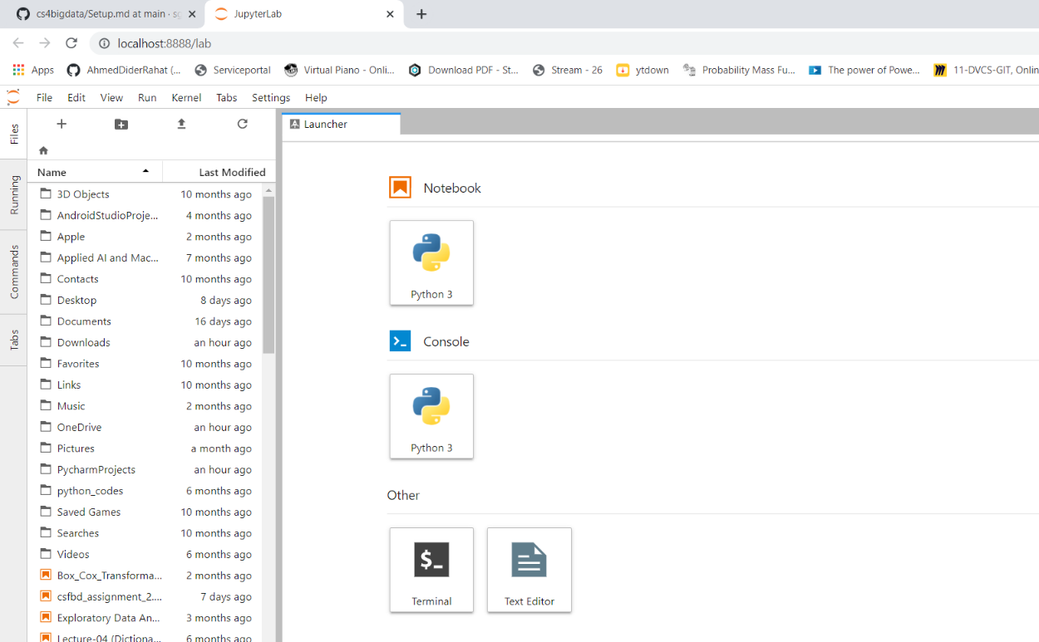

1. **Print-“Hello World” in jupter notebook:**

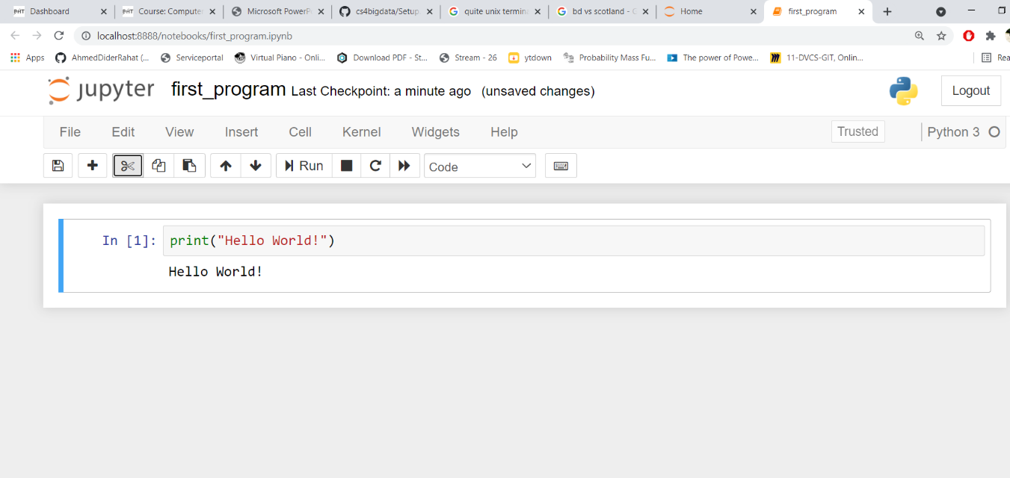

1. **Install a Python IDE:** I have installed pyCharm as python IDE.

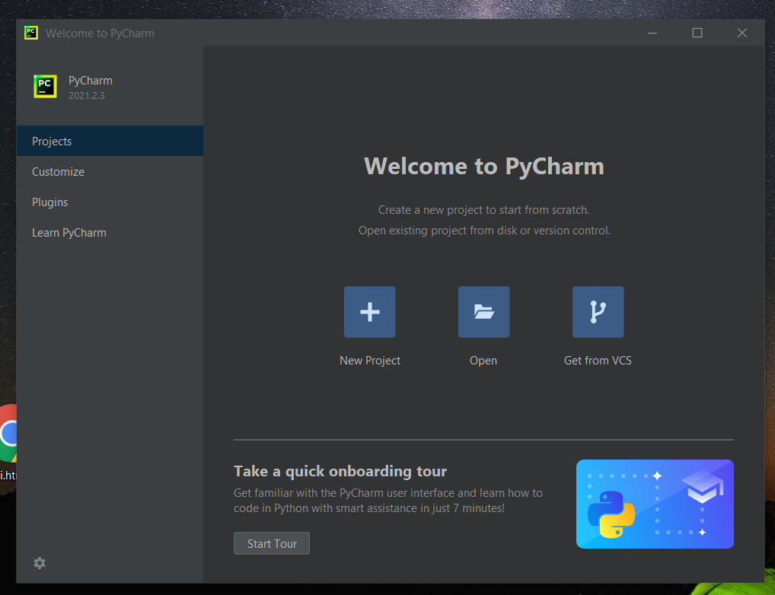

1. **Print-“Hello World” in pyCharm:**

