py

|  |
| --- |
| **Submitted By: Ahmed Dider Rahat**  Matriculation Number: 916146 |

Assignment D4

Combinatorial Algorithms for CS4B

**Assignment Code:** After implementing all the assignment I pushed my code on my [Github](https://github.com/AhmedDiderRahat/csfb-wise2122/tree/main/assignment_7) link.

**Answer to the question no. 1**

The implementation is done in Qustion1.py file.

**Answer to the question no. 2**

After running the code, the following output is found:

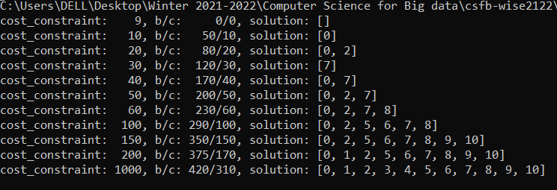

**Answer to the question no. 3**

**Limiting factors of my approach:**

1. I elemenate the two large element just intutionally. So, the approach is not always produce good result.
2. Sort the element just using their cost aslo may not always prodecure optimal solution.
3. If the data set become larger, its really tough to compute the optimal solution.

**Answer to the question no. 4**

The code of this question is implemented in Question_5.py file. The optimal solution under cost constaint of 200 is given bellow:

**a) Total benefit:** 580

**b) Total Cost:** 200

**c) Task arrangement:** [0, 2, 5, 6, 7, 8, 13, 14, 15, 16, 17]

**Answer to the question no. 5**

When uncommented the last two task and run the code, the execution took much time then before. Because of,

1. Now there are 20 item so all possible combination become 2^20 = 1,048,576 > 1 M.
2. For 18 items, 2^18 = 262,144. So, total number of operation increse almost 4 times.

**Answer to the question no. 6**

For 20 tasks total solution space become, 2^20 = 1,048,576.

For 11 tasks total solution space become, 2^11 = 2048.

So, the expansion become: (1,048,576 - 2048) = 1046528 > 1M.