py

|  |
| --- |
| **Submitted By: Ahmed Dider Rahat**  Matriculation Number: 916146 |

Assignment D4 (Extra)

Combinatorial Algorithms for CS4B

**Assignment Code:** After implementing all the assignment I pushed my code on my [Github](https://github.com/AhmedDiderRahat/csfb-wise2122/tree/main/assignment_8) link.

**Answer to the question no. 2**

The implementation is done in Qustion1.py file.

Dynamic solution of scrum task:

1. Get the benefit and cost of each tasks and assume value is benefit and weight is cost.
2. Initialize a 2D array for memoisation.
3. For each cell of the memo, apply:

$$m\left(i,w\right)=\left\{\begin{aligned}m(i-1, w), &w_{i}>w \\ max(m\left(i-1, w\right), (m\left(i-1, w-w_{i}\right) + v_{i}) ), & otherwise\end{aligned}\right.$$

And the output is following:

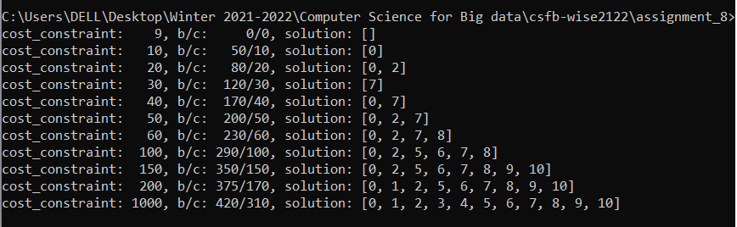

**Complexity Analysis:** As the algorithm need to memoize the all possible solution. So, we have to fill all cell of the memo. As a result, the **time complexity** become **O(n x w)** and the **space complexity** become same as time complexity. Here, **n** is number of tasks and **w** is the cost.

**Answer to the question no. 3**

If we added more data to the original list, n of the previous question will incese. So, the time and space compexity will increse but not in a polynolial fassion. If we added 4 x 9 = 36 more tasks to the list, the complexity will increse 36 times cost.