|  |
| --- |
|  |
| **VISUALIZE NEWYORK CITY AIRBNB DATA** |
| **TANIA SULTANA**  s******@bht-berlin.de  &  **AHMED DIDER RAHAT**  s40183@bht-berlin.de |
| Submitted on: 13th July 2022 |

**Abstract:** The Abstract is a self-contained synopsis of the report - an informative summary of what you did and what you found out.

The Abstract should include the following:

Objectives (as outlined in the Introduction) and scope of the investigation.

A brief reference to the Materials and Methods.

A summary of the results and conclusions - a brief but thorough statement of the outcome/s of the experiment.

If there is a hypothesis, you may state what it is and whether it was supported or refuted.

The following should not be included in the Abstract:

Literature citations.

Formulae and abbreviations, references to tables.

Although the Abstract comes first in a report, it is best to write it last, after you have the results and conclusions.

# Introduction

This provides a summary of the analysis to be undertaken. The purpose of the Introduction is to put the reader in the picture and place the research/experiment within a context.

The following may be included in the Introduction:

Background about the analysis to be carried out.

A brief review of previous research (relevant literature) to give a background - paraphrase relevant facts from the scientific literature, citing the sources to support each statement.

Reason/s why the research was undertaken.

Statement of the hypothesis (an idea or concept that can be tested by experimentation) if there is one.

An explanation of the different techniques and why they are used.

A statement of the objective/s - what you hope to achieve.

The Introduction is the what and why of the experiment, and should answer the following questions:

What was the purpose or objective of the experiment/research?

Why was the experiment/research conducted in a particular manner?

Why was it important in a broader context?

The Introduction should not include any results or conclusions.

# Chapter 2: The data set

We use a data set downloaded from [kaggle.com](https://www.kaggle.com/datasets/dgomonov/new-york-city-airbnb-open-data). The data set contains 48,896 data points with 16 columns or features.

**Features of the Dataset:**

1. **id:** The id assigned to each airbnb to identify them uniquely.
2. **name:** The name assigned to each airbnb.
3. **host_id:** The id assigned to each host to identify them uniquely.
4. **host_name:** The name assigned to each host.
5. **neighbourhood_group:** The 5 boroughs that New York City is divided into: Manhattan, Queens, Brooklyn, Staten Island and Bronx.
6. **neighbourhood:** The neighborhood where the airbnb is located within the boroughs.
7. **latitude:** The latitude of the location where the airbnb is situated.
8. **longitude:** The longitude of the location where the airbnb is situated.
9. **room_type:** The type of airbnb which is divided into two: Entire home/Apartment, Private room and Shared Room.
10. **price:** The rent of the airbnb per night.
11. **minimum_nights:** The minimum number of nights the airbnb can be rented for.
12. **number_of_reviews:** Total number of reviews posted by customers.
13. **last_review:** Date of the last review posted by a customer.
14. **reviews_per_month:** Monthly total of reviews posted by customers.
15. **calculated_host_listings_count:** Number of total listings by a host.
16. **availability_365:** Yearly number of days the airbnb is available for rent.

**Visualizing the data of Airbnb data sets:**

* **Basic statistics of the dataset:** In this portion we load the data set and see some basic statistics of different features.

1. **Data load in Pandas:** At first we load the data from csv file to pandas data-frame.



**Figure 01- data loading**

1. **Observe the data type:** In this section we analyze the data type of different feature.

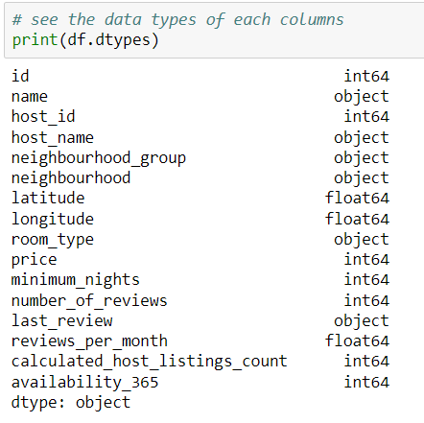

**Figure 02- get the data type for each columns**

# Result:

# Discussions:

References:

* <https://www.kaspersky.com/resource-center/definitions/what-is-cryptocurrency>
* <https://en.wikipedia.org/wiki/Long_short-term_memory>
* <https://en.wikipedia.org/wiki/Time_series>
* <https://machinelearningmastery.com/stacked-long-short-term-memory-networks/>
* <https://machinelearningmastery.com/difference-between-a-batch-and-an-epoch/>
* <https://finance.yahoo.com/>
* Source code: <https://github.com/AhmedDiderRahat/crypto_price_prediction/tree/main/code>

***Consent:*** *Any one can use the code and other resources from this project.*