Cairo University Faculty of Computers and Information



**CS352 – Software Engineering II**

**Phase 1-b Template**

**2015**

**Project Team**

|  |  |  |  |
| --- | --- | --- | --- |
| **ID** | **Name** | **Email** | **Mobile** |
| 20130015 | **Ahmed Rabei El-Kollaly** | [**Ahmed_elkollaly@hotmail.com**](mailto:Ahmed_elkollaly@hotmail.com) | 01118419922 |
| 20130018 | **Ahmed Salah Mohamed** | [A7mad.saala7@live.com](mailto:A7mad.saala7@live.com) | 01110779975 |
| 20130092 | **Ayman Ali Ali** | [aymanaliali@ymail.com](mailto:aymanaliali@ymail.com) | 01092428287 |
| 20130011 | **Ahmad Hamed Taher** | [Ahmad_hamed95@yahoo.com](mailto:Ahmad_hamed95@yahoo.com) | 01280033976 |
| 20130034 | **Ahmed Mohamed AbdElhamid** | Ahmode2003@gmail.com | 01287256781 |

Contents

Instructions [To be removed] 3

Your Restful API 3

Trello workspace screenshot 4

Daily scrum Meetings 5

Github repository link 5

# 

# Your Restful API

* Get Following List

|  |  |
| --- | --- |
| **Service URL** | http://localhost:8080/FCISquare/rest/getFollowingList |
| **Input type** | POST |
| **Parameters** | |  |  | | --- | --- | | **Parameter name** | **Description** | | ID | User ID | |
| **Example request** | POST  http://localhost:8080/FCISquare/rest/getFollowingList?id=1 |
| **Example response** | {" id0":5," id1":4," id2”:3," id3":2} |

* Follow

|  |  |
| --- | --- |
| **Service URL** | http://localhost:8080/FCISquare/rest/follow |
| **Input type** | POST |
| **Parameters** | |  |  | | --- | --- | | **Parameter name** | **Description** | | **Id1** | **User ID** | | Id2 | The User that will be followed | |
| **Example request** | POST  <http://localhost:8080/FCISquare/rest/follow?id1=1?id2=2> |
| **Example response** | {" id2":5} |

* unFollow

|  |  |
| --- | --- |
| **Service URL** | http://localhost:8080/FCISquare/rest/unfollow |
| **Input type** | POST |
| **Parameters** | |  |  | | --- | --- | | **Parameter name** | **Description** | | **Id1** | **User ID** | | Id2 | The User that will be unfollowed | |
| **Example request** | POST  [http://localhost:8080/FCISquare/rest/unfollow?id1=1?id2=2](http://localhost:8080/FCISquare/rest/follow?id1=1?id2=2) |
| **Example response** | {" id2":5} |

* Get Last Position

|  |  |
| --- | --- |
| **Service URL** | http://localhost:8080/FCISquare/rest/getLastPosition |
| **Input type** | POST |
| **Parameters** | |  |  | | --- | --- | | **Parameter name** | **Description** | | Email | User Email | |
| **Example request** | POST  http://localhost:8080/FCISquare/rest/getLastPosition?email=mhmdsamir91@gmail.com |
| **Example response** | {“lat”: 30.031003,”long”: 33.031003} |

# Trello workspace screenshot

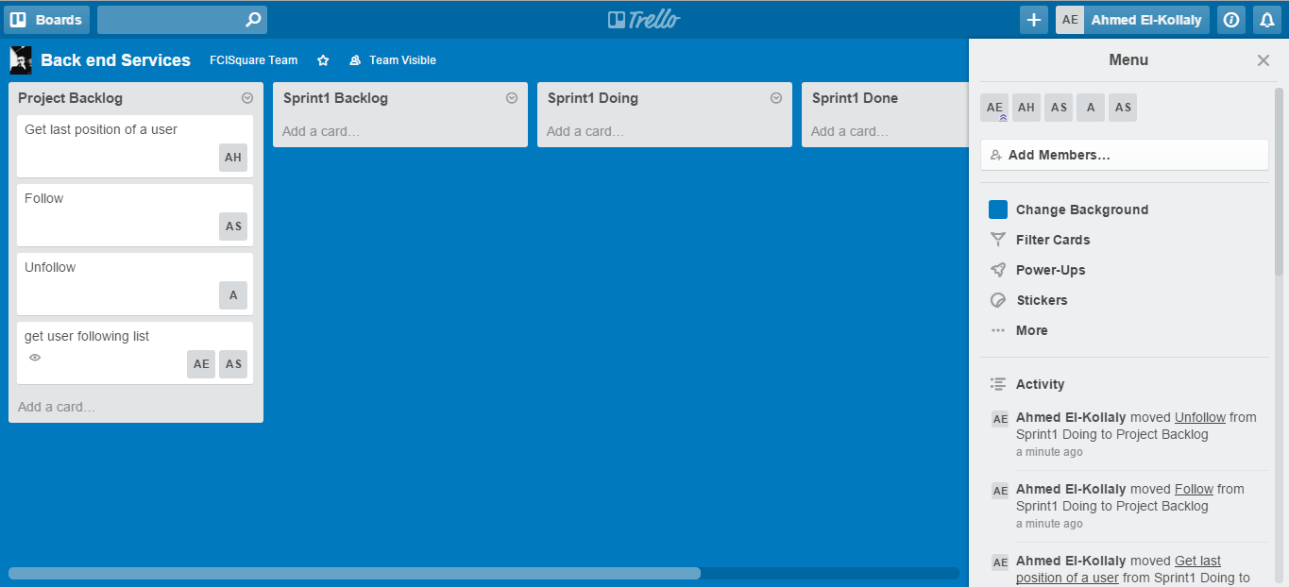

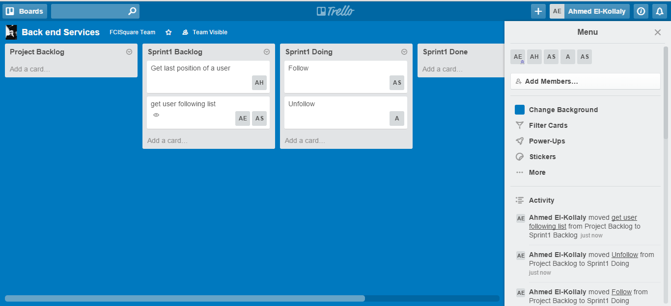

# 

# Github repository link

-The backend repository link:

<https://github.com/AhmedEl-Kollaly/FCISquareBackend>

-The frontend repository link:

<https://github.com/AhmedEl-Kollaly/FCISquareWebFontend>