
School of Computing, Engineering and Mathematics
Cloud Computing Bootcamp

Working with Flask and SQL 3
This worksheet requires installs of Virtualbox and Ubuntu
We are going to use the virtual machine we created last week.
If you have not already done that, please go through the worksheet for 4.4.
In this worksheet we are going to create a database of movies which we can add too and query using Python.

1 Software change!
Flask-SQLAlchemy, which we used as part of our web development suite of tools in worksheets 1 and 2 of this project, has undergone a major new release which has changed its behaviour.
For this reason, we’ll be using a different approach from here on, using sqlalchemy, which is decoupled from Flask and allows us to do what we need to do.

2 Create a new project
Open your ubuntu vm.
Open a browser.
Go to the CC_BOOTCAMP_STUDENTS onedrive space. Under Week 5, 5.3, you will find a folder called flaskapp. We will be working with this as a new project (similar to the one we already made, but simplified and using sqlalchemy rather than Flask-SQLAlchemy).
Create the project on your vm.
The easiest way to do this is to download the folder (and unzipping the result if necessary), then dragging into your Home folder, which should sit on your ubuntu desktop.
An alternative way of doing things is through the command line. Create a new director: mkdir flaskapp, then do mv Desktop/flaskapp/* flaskapp/

3 Check the database
This time, the database has been pre-created.
Make sure you are in the Python virtual environment by doing . venv/bin/activate
Now, as you did last time, do .tables
This will return movie
Now, again as last time, do select * from movie
Check that you have 10 records!

4 Fix the typo!
There is a typo in the Star Wars record (‘A Neew Hope’). Fix it.
Here is the example used before to edit the record:
UPDATE movie SET rating = '5' WHERE id = '2';
Work out how you can update the title.

5 Run the app
Make sure you are in the venv at the default location
For me that is (venv) animal-laminate@ubuntu22: $
Now do flask --app flaskapp/app run
Next, you should see this:

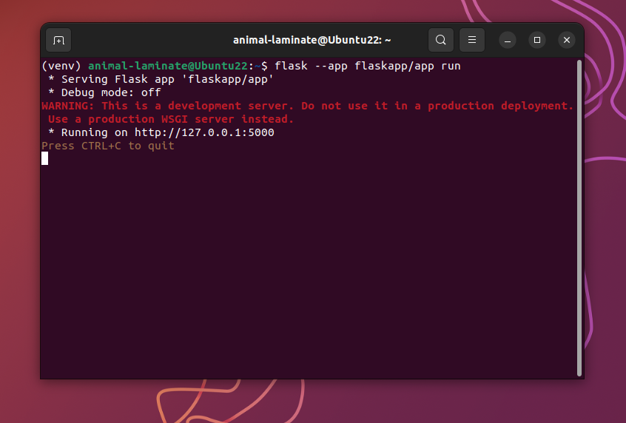

(over)
Now, hover over the URL http://127.0.0.1:5000
You should see a line appear beneath it
Now right click, and select Open Link
This will open a browser, which will look like this:

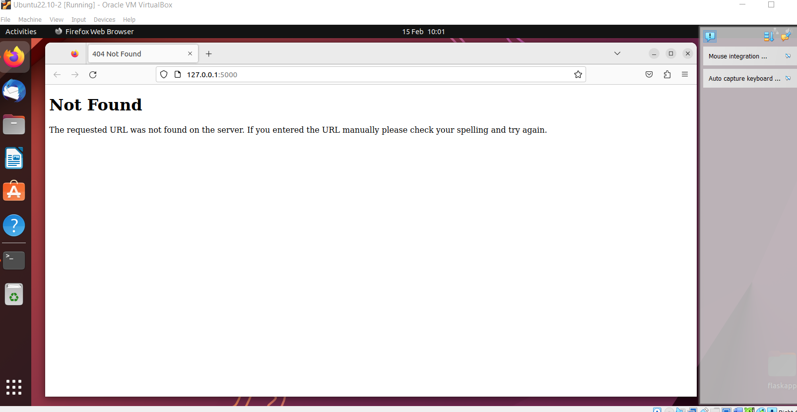

This looks a lot like an error, but it’s not!
In the app.py file, we have defined some ‘routes’, and one of these is @app.route(‘/movies’)
Here is the complete code (over):

@app.route(‘/movies’)
def movies():
movie_list = Movie.query.all()
movies = []
for movies in movie_list:
movies.append({‘id’ : movie.id, ‘title’ : movie.title, ‘rating’ : movie.rating})
return jsonify({‘movies’: movies})

@app.route is the default url, the one we’ve just opened, http://127.0.0.1:5000
If we add /movies to the url, something happens! Try it. You should get this result (over):
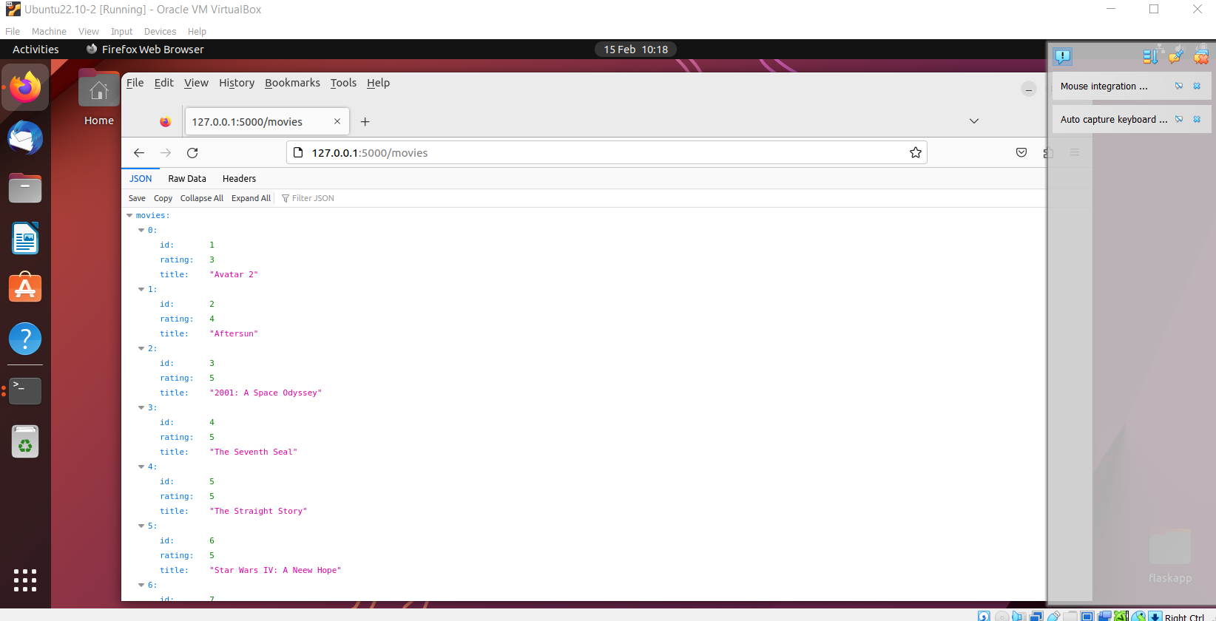

6 Analysis
When we enter the route /movies, this triggers a function movies(). Let’s go through it:

@app.route(‘/movies’)
Get everything in the database and assign it to a variable movie_list
def movies():
movie_list = Movie.query.all()
movies = []
for movies in movie_list:
movies.append({‘id’ : movie.id, ‘title’ : movie.title, ‘rating’ : movie.rating})
return jsonify({‘movies’: movies})

@app.route(‘/movies’)
Define a new empty list called movies
def movies():
movie_list = Movie.query.all()
movies = []
for movies in movie_list:
movies.append({‘id’ : movie.id, ‘title’ : movie.title, ‘rating’ : movie.rating})
return jsonify({‘movies’: movies})

@app.route(‘/movies’)
Go through movie_list, which has all our data
def movies():
movie_list = Movie.query.all()
movies = []
for movies in movie_list:
movies.append({‘id’ : movie.id, ‘title’ : movie.title, ‘rating’ : movie.rating})
return jsonify({‘movies’: movies})

@app.route(‘/movies’)
Copy the data to the movies list and format it
def movies():
movie_list = Movie.query.all()
movies = []
for movies in movie_list:
movies.append({‘id’ : movie.id, ‘title’ : movie.title, ‘rating’ : movie.rating})
return jsonify({‘movies’: movies})

@app.route(‘/movies’)
def movies():
movie_list = Movie.query.all()
movies = []
for movies in movie_list:
movies.append({‘id’ : movie.id, ‘title’ : movie.title, ‘rating’ : movie.rating})
return jsonify({‘movies’: movies})
Return the jsonified list. This packages the info so that it can be seen in a browser

7 JSON / Raw Data
The data shown above is in JSON format. You can switch to raw Data, which shows the data as passed from the movies() function.

