
School of Computing, Engineering and Mathematics
Cloud Computing Bootcamp

Working with Flask and SQL 4

This worksheet requires installs of Virtualbox and Ubuntu
We are going to use the virtual machine we created last week.
If you have not already done that, please go through the worksheet for 4.4.
In this worksheet we are going to create a database of movies which we can add too and query using Python.

1 Changing the data
So far, all the data in the database is displayed.
This session will generate a series of challenges to change the data displayed.
When you change the code, make sure you have a clean copy so you have something working to revert to if you break it:
So at the prompt do e.g. cp app.py app_original.py. Then work on app.py.
After each change you need to run the app again. Before you make any change, exit the running app by closing the browser and doing control C at the command line.
Here is the first challenge. This one has been solved for you. From there, the other challenges should be doable.

.1 Challenge One! Display only the movies which have a rating of 5

@app.route(‘/movies’)
def movies():
movie_list = Movie.query.all()
movies = []
for movie in movie_list:
movies.append({‘id’ : movie.id, ‘title’ : movie.title, ‘rating’ : movie.rating})
return jsonify({‘movies’: movies})

Solution (new code in red; note also the movies.append line gets a further indent as under a condition):

@app.route(‘/movies’)
def movies():
movie_list = Movie.query.all()
movies = []
for movie in movie_list:
if movie.rating == 5:
movies.append({‘id’ : movie.id, ‘title’ : movie.title, ‘rating’ : movie.rating})
return jsonify({‘movies’: movies})

.2 Challenge Two! Display only the movies which have a rating of 4

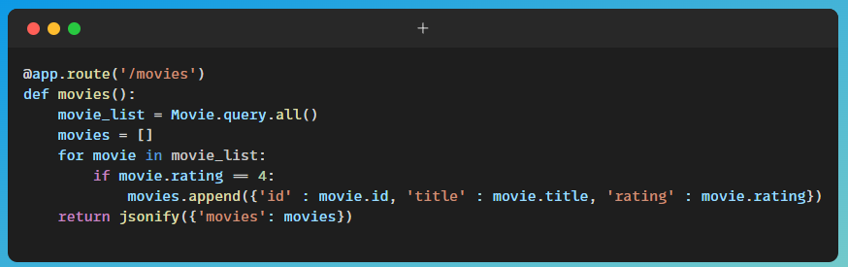

.3 Challenge Three! Display only the movies which have a title beginning with A
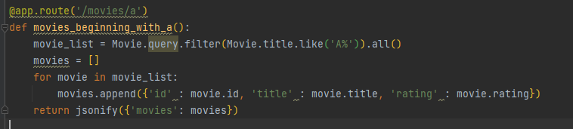

.4 Challenge One! List the movies in order of rating, so for example all the 5 star movies first, then all the 4 star movies, and so on
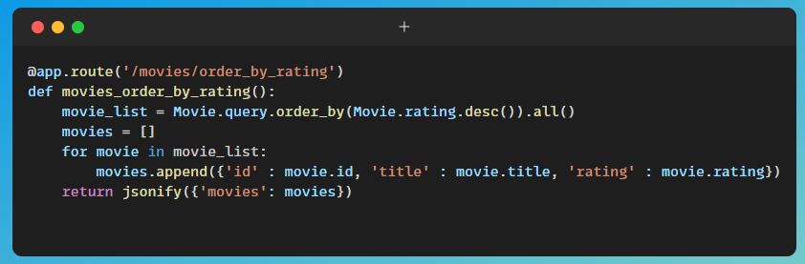

.5 Challenge Five! Get the system to inform us if a rating has not been used, for example ‘There are no 2 Star movies in the database’

.3, .4 and .5 are a bit more difficult than .1 and .2! Hint: for .4, you need a sort.

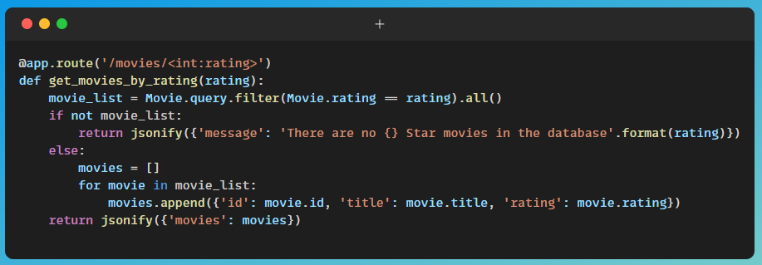

Querying data at the interface
What we’ve done in this session is to change code to do different things with the data. But it would be better – and make more sense – to be able to query the data from the browser.
Another possibility is that we have multiple routes to reflect the different functionalities.
This is is something we will come back to.

