***Q1: List the access method in memory?***

To access data from any memory, first it must be located and then the data is read from the memory location. Following are the methods to access information from memory locations:

1. **Random Access**: Main memories are random access memories, in which each memory location has a unique address. Using this unique address any memory location can be reached in the same amount of time in any order.
2. **Sequential Access**: This method allows memory access in a sequence or in order.
3. **Direct Access**: In this mode, information is stored in tracks, with each track having a separate read/write head.

***Q2: write notes about “word” in memory?***

In [computing](https://en.wikipedia.org/wiki/Computing), a **word** is the natural unit of data used by a particular [processor](https://en.wikipedia.org/wiki/Central_processing_unit) design. A word is a fixed-sized [piece of data](https://en.wikipedia.org/wiki/Data_(computing)) handled as a unit by the [instruction set](https://en.wikipedia.org/wiki/Instruction_set) or the hardware of the processor. The number

of [bits](https://en.wikipedia.org/wiki/Bit) in a word (the *word size*, *word width*, or *word length*) is an important characteristic of any specific processor design or [computer architecture](https://en.wikipedia.org/wiki/Computer_architecture).

The size of a word is reflected in many aspects of a computer's structure and operation; the majority of the [registers](https://en.wikipedia.org/wiki/Processor_register) in a processor are usually word sized and the largest piece of data that can be transferred to and from the [working memory](https://en.wikipedia.org/wiki/Computer_memory) in a single operation is a word in many (not all) architectures. The largest possible [address](https://en.wikipedia.org/wiki/Memory_address) size, used to designate a location in memory, is typically a hardware word (here, "hardware word" means the full-sized natural word of the processor, as opposed to any other definition used).

***Q3: write notes about memory hierarchy?***

In [computer architecture](https://en.wikipedia.org/wiki/Computer_architecture), the **memory hierarchy** separates [computer storage](https://en.wikipedia.org/wiki/Computer_storage) into a hierarchy based on response time. Since response time, complexity, and capacity are related, the levels may also be distinguished by their performance and controlling technologies.[[1]](https://en.wikipedia.org/wiki/Memory_hierarchy#cite_note-toyzee-1) Memory hierarchy affects performance in computer architectural design, algorithm predictions, and lower level [programming](https://en.wikipedia.org/wiki/Computer_programming) constructs involving [locality of reference](https://en.wikipedia.org/wiki/Locality_of_reference).

Designing for high performance requires considering the restrictions of the memory hierarchy, i.e. the size and capabilities of each component. Each of the various components can be viewed as part of a hierarchy of memories (m1 ,m2 ,...,Mn) in which each member mi is typically smaller and faster than the next highest member mi+1 of the hierarchy. To limit waiting by higher levels, a lower level will respond by filling a buffer and then signaling for activating the transfer.

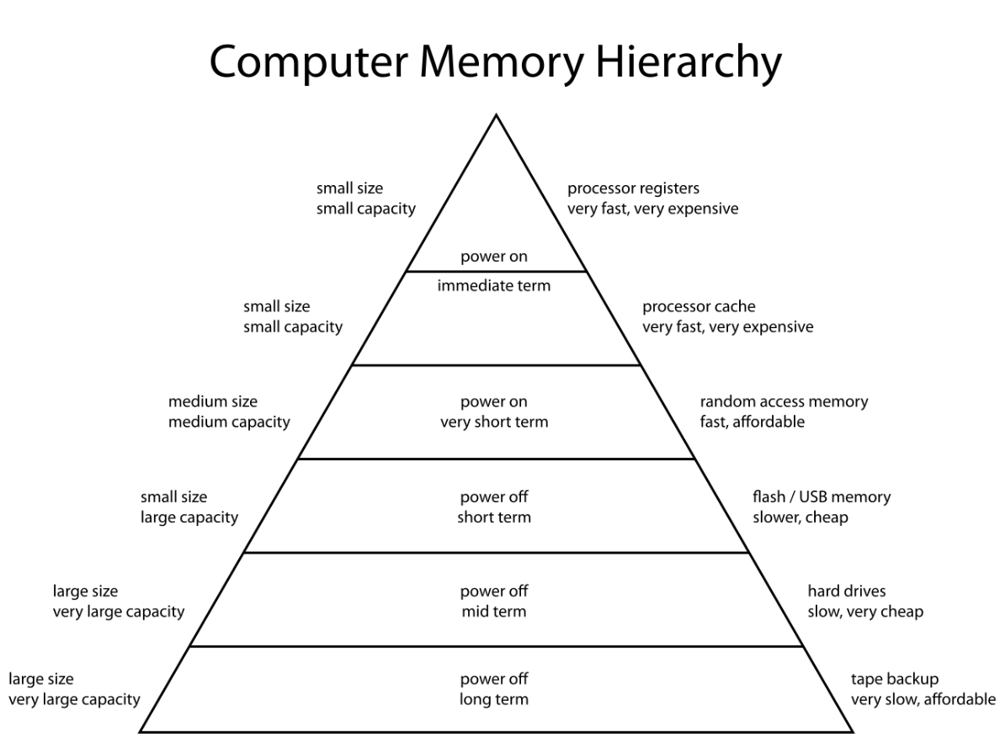

***Name: Haneen Medhat Zakaria.***

***Section: 3.***