xStore
Phase 2 Roadmap
Business capabilities that don't exist anywhere in the app today, and how they'd work
A companion to the xStore Business & Module Process Reference (Phase 1)
Prepared for the Development, Marketing, and Customer Service teams, and for xStore stakeholders
Grounded in a full search of the current xStore Flutter codebase as of 10 August 2026

Contents
As in the Phase 1 document, headings use Word/Google-Docs heading styles throughout for live navigation. The list below is a map of what's inside.

How This Document Relates to Phase 1
Suggested Build Sequence
Part 1: Buyer ↔ Vendor Chat
Part 2: Customer Support & Ticketing
Part 3: Return & Refund Requests
Part 4: Vendor Analytics & Insights
Part 5: Loyalty, Referral & Rewards
Part 6: Admin-Configurable Marketing & Merchandising
Closing Note

How This Document Relates to Phase 1
The xStore Business & Module Process Reference (Phase 1) documents the 15 modules that exist in the app today — what's built, what's mocked, and what's genuinely broken. While preparing it, a follow-up question came up: not “what's incomplete in what exists,” but “what capability is missing entirely — nowhere in the app, not even as a stub?”
This document answers that question. Each of the six capabilities below was confirmed absent by searching the full codebase (lib/features/* and lib/shared/*) for any trace of it — not assumed from a feature list. Two are already visibly promised to users: the product page's ‘Chat with seller’ button is wired to a literal ‘coming soon’ message, and Profile's ‘Help Center’ is a static page with no way to actually contact anyone.
Each Part below covers one capability the same way Phase 1 covers a module: why it matters, what a lean first version should include, a proposed flow diagram, how it would connect to the modules that already exist, and the open business questions that need an answer before engineering can build it — these are deliberately flagged as questions, not decisions, since several of them (how a refund actually pays a buyer back, whether a referral discount comes out of xStore's commission or the vendor's price) are calls only the business can make.

Suggested Build Sequence
Most of these capabilities are sub-flows of a real order (a return, a support ticket about an order, a referral reward triggered by a first order) or depend on real push notifications to be genuinely useful — both are Phase 1 Critical gaps (no live Orders backend, no push infrastructure). The order below sequences around those dependencies rather than by raw business value alone, so it doubles as a reason not to start several of these before Phase 1's Critical items close.

# | Capability | Why this order
1 | Admin-Configurable Marketing & Merchandising | No Phase-1 dependency — mobile side is already ready. The single fastest win on this list.
2 | Vendor Analytics & Insights | Only needs the Orders backend; reuses data the app already tracks (no new data model).
3 | Return & Refund Requests | Needs the Orders backend; reuses the existing courier network and the commission-void logic already built.
4 | Customer Support & Ticketing | Needs Orders (for ticket context) and ideally Notifications for timely replies; becomes urgent once real cash-on-delivery volume exists.
5 | Buyer ↔ Vendor Chat | Needs Notifications to be genuinely useful — build after push exists, or buyers won't know they got a reply.
6 | Loyalty, Referral & Rewards | A multiplier on a working funnel, not a fix for one — sequence last, after Orders/Notifications/Support are solid.

PART 1

Buyer ↔ Vendor Chat
Priority: High
How we know it's missing: The “Chat with seller” button on the product page already exists in the UI and is wired to a literal ‘coming soon’ message (l10n key chatSellerSoon in product_detail_screen.dart) — buyers already see the affordance and expect it to work.

Why It Matters
Pre-purchase questions (“is this still available in blue?”, “can you deliver to 6th of October?”) currently have nowhere to go inside the app, so they either don't get asked — costing a sale — or they leak out to WhatsApp/phone, which is invisible to xStore and unsupported by any other module here. A working chat also reduces Customer Service load by letting vendors self-serve routine questions.

Proposed Scope for Phase 2
One conversation thread per buyer–vendor pair, optionally anchored to a specific product or order. Text only for v1 — no voice/video, no attachments beyond a single image. A vendor-side “Messages” inbox mirroring the existing Notifications inbox pattern. Buyers can start a thread from the product page (the existing button); vendors reply from their inbox or an order detail screen.

Proposed Flow
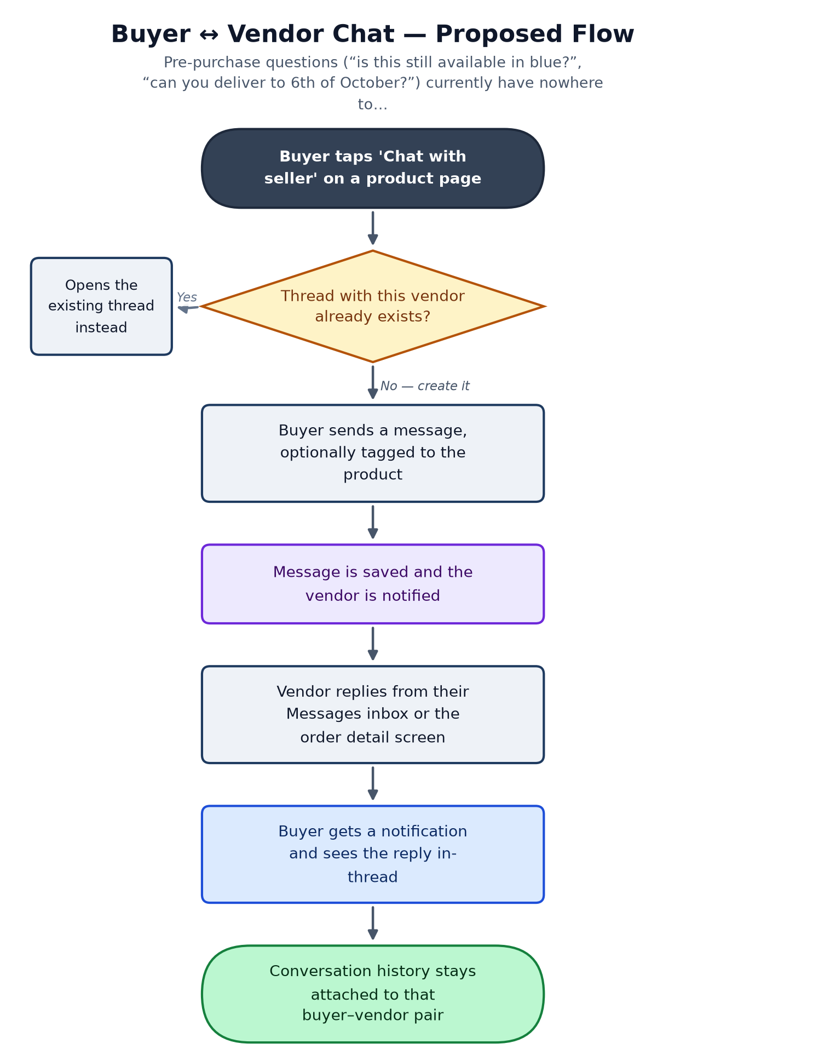

Connects With
Module | Relationship | Direction
Product Catalog & Detail | Entry point — the existing 'Chat with seller' button. | launches from
Orders & Fulfillment Status | A thread can be anchored to a specific order for support context. | reads context from
Notifications | New-message alerts need real push to be useful — depends on that gap closing first. | depends on
Profile & Vendor Store Page | Vendor identity (name, avatar, store) shown in the thread header. | reads
Depends on Phase 1: Notifications (real push) — usable without it, but far less valuable; buyers won't know they got a reply unless they reopen the thread.

Open Questions for the Business
- Does a vendor with multiple staff need a shared inbox, or is it one login = one inbox for the pilot?
- Abuse handling: report/block a user, and who moderates it?

PART 2

Customer Support & Ticketing
Priority: High
How we know it's missing: Profile's ‘Help Center’ menu entry (profile_menu_blocks.dart) opens HelpCenterInfoScreen — a static info page with a message and two shortcut buttons (View Orders, Notifications). There is no ticket, no contact form, and no support inbox anywhere in the codebase.

Why It Matters
As soon as real orders and real cash-on-delivery are live, real problems follow: a courier who never showed up, a vendor who sent the wrong item, a payment dispute over how much cash was collected. Today none of that has a tracked, accountable path inside the app — it becomes an unstructured phone call or WhatsApp message with no record, no SLA, and no way for Customer Service to see what's outstanding.

Proposed Scope for Phase 2
A buyer or vendor opens 'Contact Support' from the Help Center, picks a category (order issue, payment/cash issue, account issue, other), optionally attaches an order and a photo, and submits. The ticket appears in a queue on the Admin Dashboard for triage and reply. The submitter is notified when it's answered or resolved. No live chat for v1 — async ticket replies are enough to start.

Proposed Flow
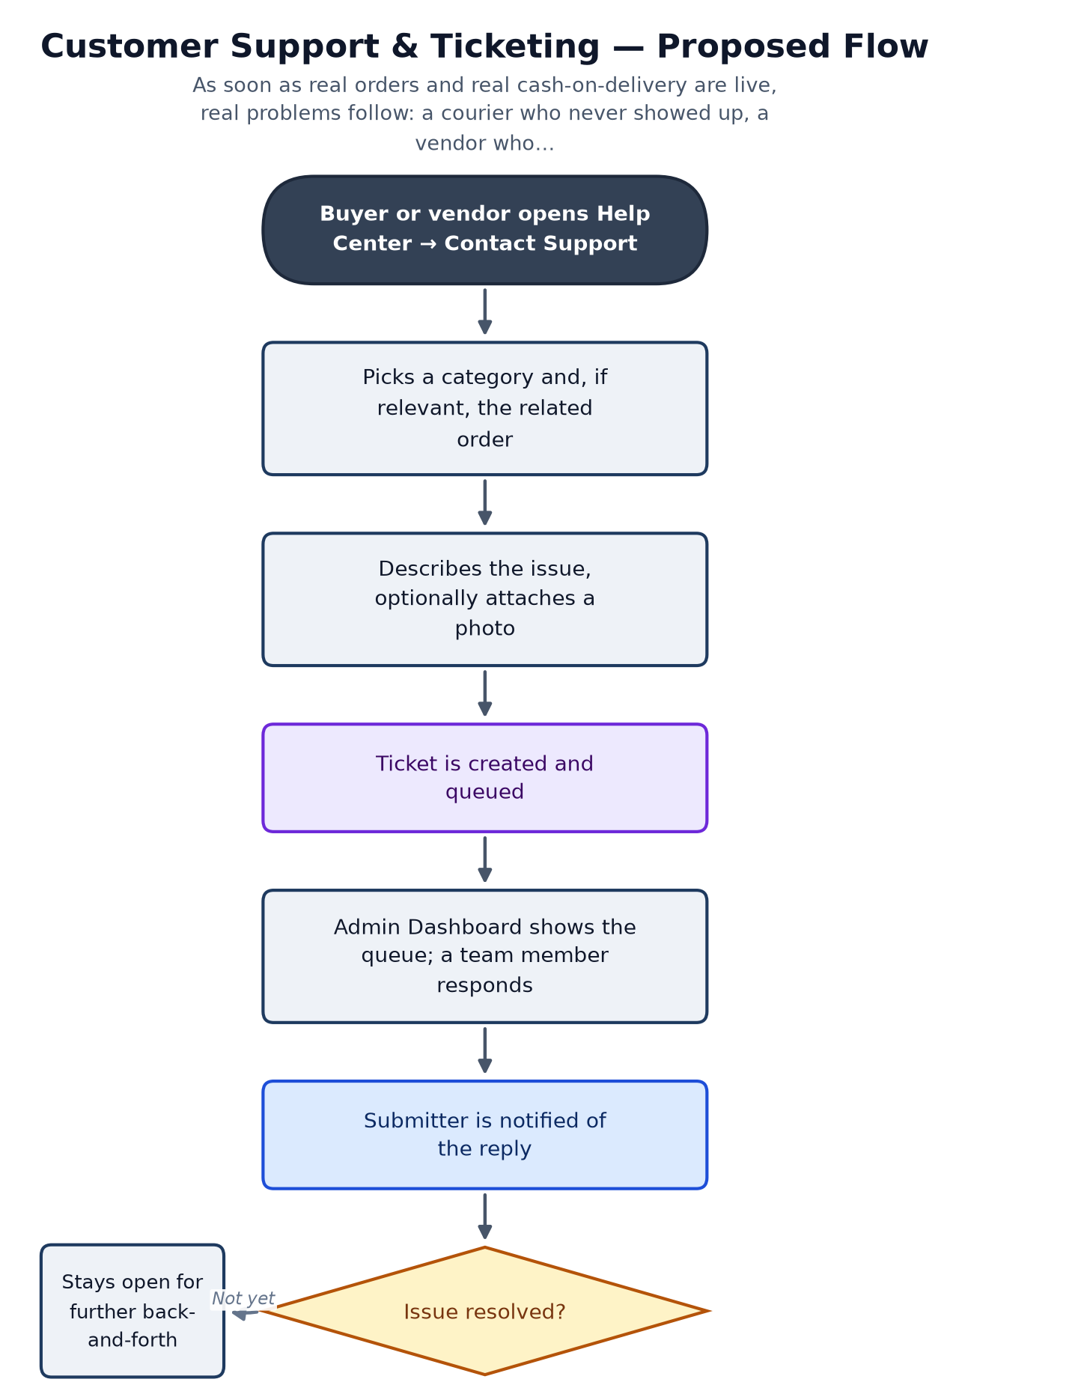

Connects With
Module | Relationship | Direction
Orders & Fulfillment Status | A ticket can be filed against a specific order for context. | reads context from
Notifications | Reply alerts depend on real push to reach the user promptly. | depends on
Delivery (Courier Operations / Package Sending) | Courier no-shows and delivery disputes are a likely top ticket category. | reads context from
Depends on Phase 1: Orders backend going live (so a ticket can reference a real order) and Notifications (so replies reach the user).

Open Questions for the Business
- Who staffs the ticket queue at launch — is this the same person doing courier admin?
- Should urgent categories (e.g. 'courier never arrived, buyer holding cash') page someone in real time, or is next-business-day response acceptable at pilot scale?

PART 3

Return & Refund Requests
Priority: High
How we know it's missing: OrderStatus.refunded exists as an enum value and CommissionStatus.voided already accounts for it (see Part 10 of the Phase 1 document), but there is no buyer-facing flow anywhere in the codebase that lets a buyer request a return — nothing greps for a return-request screen, use case, or route.

Why It Matters
In a cash-on-delivery marketplace, buyers pay before they can fully inspect what they received — wrong item, damaged item, or not-as-described is a real and expected occurrence, not an edge case. Without a formal request path, every one of those becomes an ad-hoc negotiation between buyer and vendor (or a Customer Service escalation) with no record and no consistent policy. This is also a trust signal: buyers are measurably more willing to purchase from a marketplace that visibly has a return path, even if they never use it.

Proposed Scope for Phase 2
From a delivered order, the buyer selects 'Request Return / Refund', picks a reason (wrong item, damaged, not as described, other), and optionally attaches photos. The vendor (or admin, for xStore-delivered orders) approves or rejects it. If approved, the existing courier network (Part 11 of the Phase 1 document) is reused to collect the item back from the buyer. The commission fee on that order voids, consistent with the already-built commissionStatusForOrder logic.

Proposed Flow
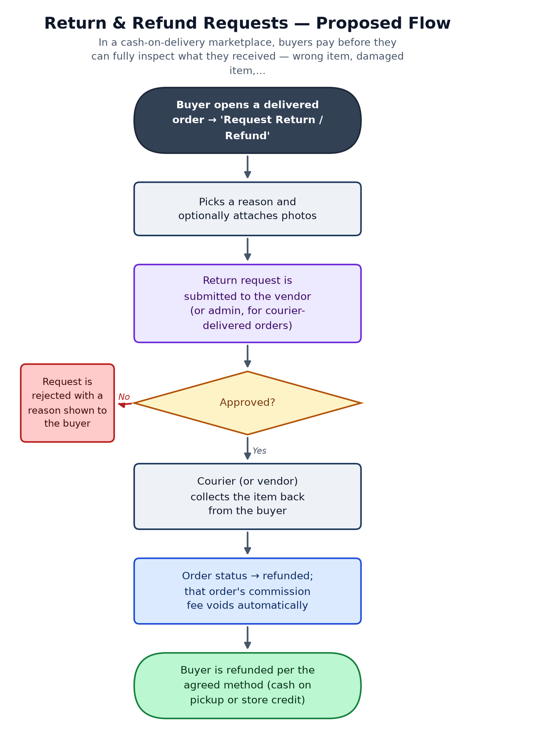

Connects With
Module | Relationship | Direction
Orders & Fulfillment Status | A return request is a new sub-flow off a delivered order. | extends
Commission & Vendor Wallet | A voided order already has a defined commission outcome — no new logic needed there. | reuses
Delivery (Courier Operations) | The same courier network can run the reverse pickup leg. | reuses
Customer Support & Ticketing | Disputed or rejected returns are a natural escalation path. | escalates to
Depends on Phase 1: Orders backend going live — this is a sub-flow of a real order, so it cannot be built ahead of real order data.

Open Questions for the Business
- Since the app never holds money, how does a 'refund' actually pay the buyer back — cash handed over at pickup, or store credit toward a future order? This is a business decision, not a technical one, and it changes the flow.
- Who eats the cost of a return the vendor disputes (buyer says damaged, vendor says it left the warehouse fine)?

PART 4

Vendor Analytics & Insights
Priority: Medium
How we know it's missing: Listing already tracks per-product viewCount/saveCount/inquiryCount and Orders already has an OrderStatsEntity for a vendor dashboard counter banner — but nothing in the codebase turns that into a trend, a comparison, or a real insights screen; a full search for any vendor analytics/insights screen returns nothing.

Why It Matters
Vendors who can't see whether their store is actually working — which products sell, which don't, whether this week beat last week — have no basis to decide what to invest more effort into, and are more likely to disengage from the platform. This is a retention lever for the supply side of the marketplace, not a buyer-facing feature.

Proposed Scope for Phase 2
A vendor-only 'Insights' screen: sales over time (a simple line/bar chart), top and bottom performing listings, and a per-listing funnel from the numbers Listing already tracks (views → saves → inquiries → orders). Built entirely from data the app already models — this is a new read-only screen and a couple of aggregation endpoints, not a new data model.

Proposed Flow
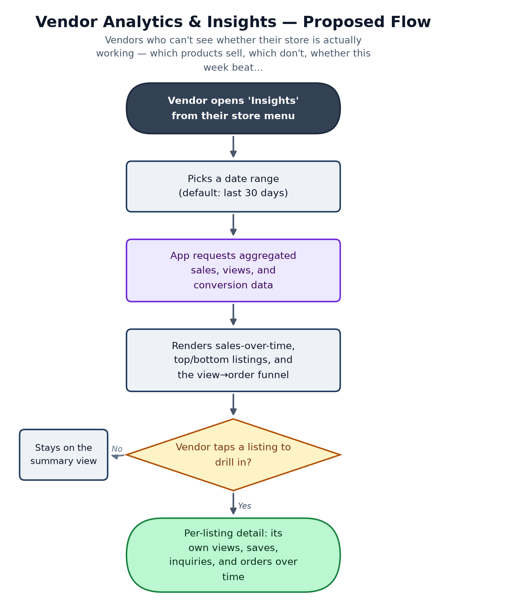

Connects With
Module | Relationship | Direction
Listing (Vendor Product Management) | Source of view/save/inquiry counts per listing. | reads
Orders & Fulfillment Status | Source of sales and delivered/cancelled data. | reads
Commission & Vendor Wallet | Earnings trend is a natural companion view alongside sales. | reads
Depends on Phase 1: Orders backend going live — without real order data, any trend chart is just visualizing mock numbers.

Open Questions for the Business
- Is this a phase-2a (basic charts) / phase-2b (benchmarking against category averages) split, or built in one pass?

PART 5

Loyalty, Referral & Rewards
Priority: Low–Medium
How we know it's missing: No loyalty, referral, or points/rewards code exists anywhere in the app. The existing coupon system (Cart's 'Apply coupon' — see Part 8 of the Phase 1 document) is unrelated infrastructure that a referral program could reuse for the reward itself.

Why It Matters
A referral program is one of the cheapest acquisition channels available once there's a base of happy buyers to refer from — but it is a multiplier on an existing engine, not a fix for a broken one. Building this before Orders, Notifications, and the other Phase 2 items above are solid would be optimizing a funnel that doesn't reliably convert yet.

Proposed Scope for Phase 2
v1: a referral code shown at signup; when a new user registers with it, both the referrer and the new buyer get a discount coupon on their next order, using the coupon system that already exists in Cart. No points balance or tiered loyalty program for v1 — that's a natural v2 once the referral mechanic is proven.

Proposed Flow
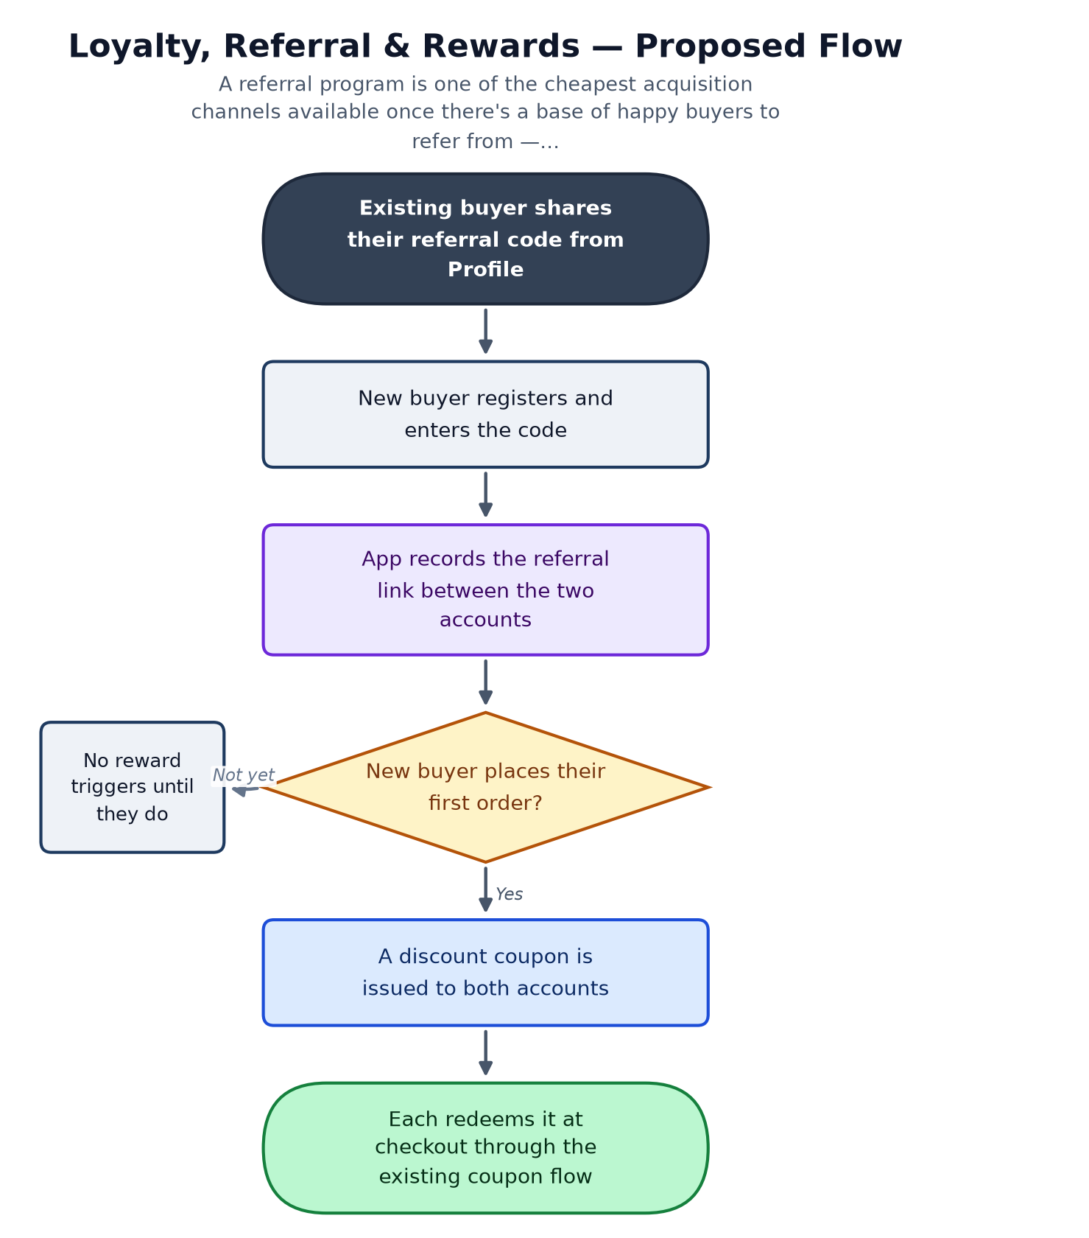

Connects With
Module | Relationship | Direction
Authentication & Identity | Referral code capture happens at registration. | extends
Cart & Checkout | Rewards are delivered as coupons through the system already built there. | reuses
Orders & Fulfillment Status | The first-order completion is what triggers the reward. | reads
Depends on Phase 1: Orders backend going live — the trigger is a real completed order.

Open Questions for the Business
- Flat discount amount, or a percentage — and does it come out of xStore's commission or the vendor's price?
- Fraud guardrails: does self-referral (same person, two accounts) need to be blocked at launch?

PART 6

Admin-Configurable Marketing & Merchandising
Priority: High
How we know it's missing: Home's banners, hot deals, and category shortcuts are fixed at build time (see Part 3 of the Phase 1 document); there is no screen anywhere — mobile or admin — that lets anyone change what's featured without shipping a new app release.

Why It Matters
Home is xStore's most valuable in-app marketing real estate, and today Marketing cannot run a seasonal push, feature a new vendor, or promote a slow-moving category without engineering shipping a release for it. This is the single highest-leverage item on this list for the Marketing team specifically, and the mobile side is already mostly ready to receive it — Home already calls a real endpoint when one exists (see Part 3).

Proposed Scope for Phase 2
An Admin Dashboard screen to create and schedule banners (image, link target, start/end date) and to flag specific listings as 'featured' or 'hot deal' for a time window. Home already has the client-side plumbing to call a real endpoint for this — this is primarily a backend + admin-dashboard build, not a mobile-app build.

Proposed Flow
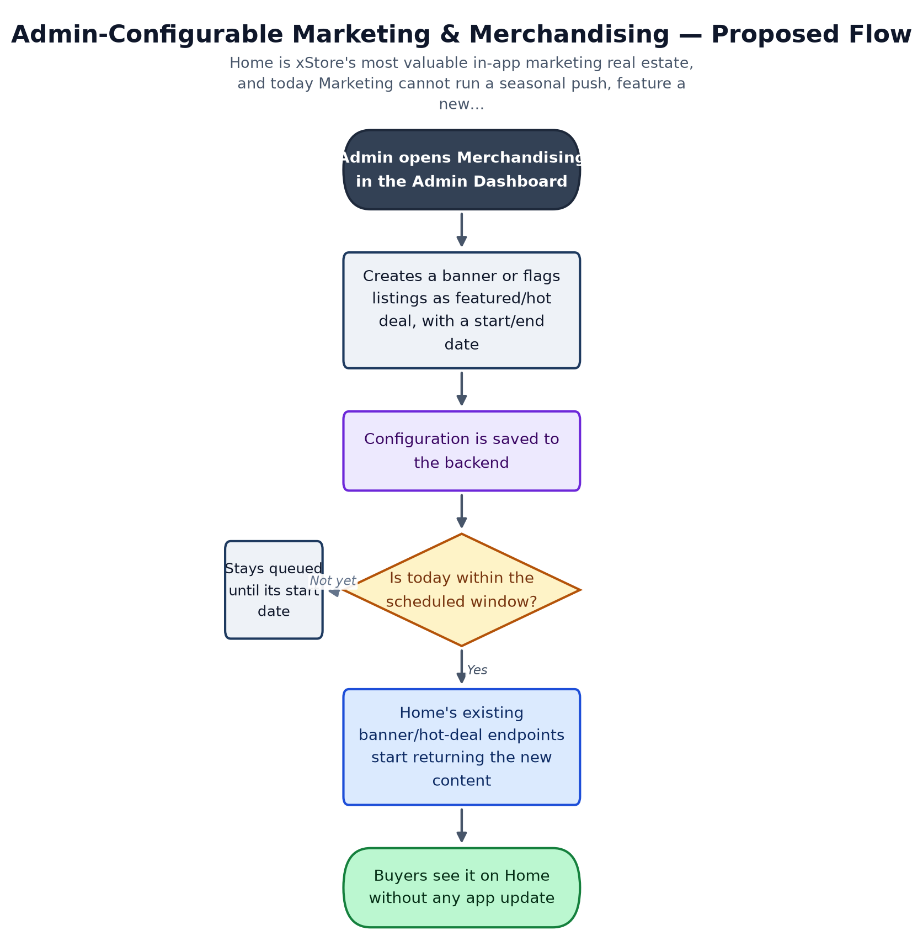

Connects With
Module | Relationship | Direction
Home (Merchandising Feed) | Home already calls a real endpoint for this when one exists — minimal mobile-side work. | feeds
Listing (Vendor Product Management) | Source of which products can be flagged as featured/hot deal. | reads
Depends on Phase 1: None — this is one of the few Phase 2 items that does not depend on the Orders backend or push notifications, and could be built first.

Open Questions for the Business
- Does featuring a listing cost the vendor anything (paid placement), or is it purely admin-curated at this stage?

Closing Note
None of these six capabilities exist today, even partially — that's what separates this document from the Risk Register in Phase 1, which covers things that are built but broken or incomplete. Treat this as a proposal to react to, not a committed plan: priorities, scope, and the open business questions above all need real sign-off before any of this becomes a sprint.
This document should be read alongside the Phase 1 Business & Module Process Reference, which it assumes as context throughout — module names and Part references above point back to it.

