

Automotive door control system design

Dynamic design Report

**Name: Ahmed Mohamed Hussein Elshehry**

**Email :** [elshehry97@gmail.com](mailto:elshehry97@gmail.com)

Dynamic Design:

* **For ECU 1:**

1. **state machine diagram for ECU 1 component:**

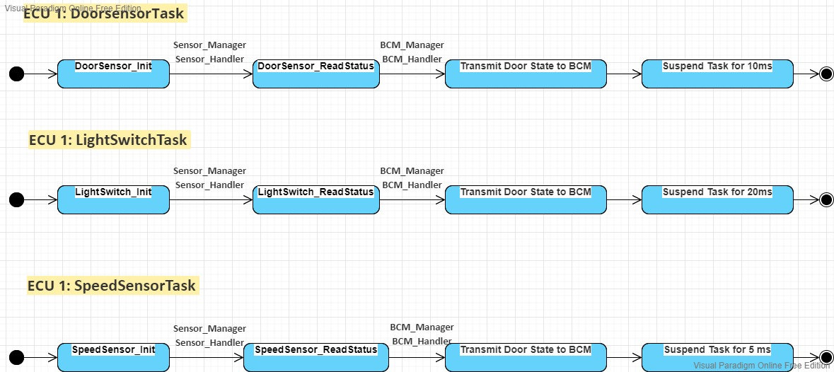

**Notes: IDEL task exaction when the processor not exaction any task.**

1. **state machine diagram for the ECU 1 operation:**

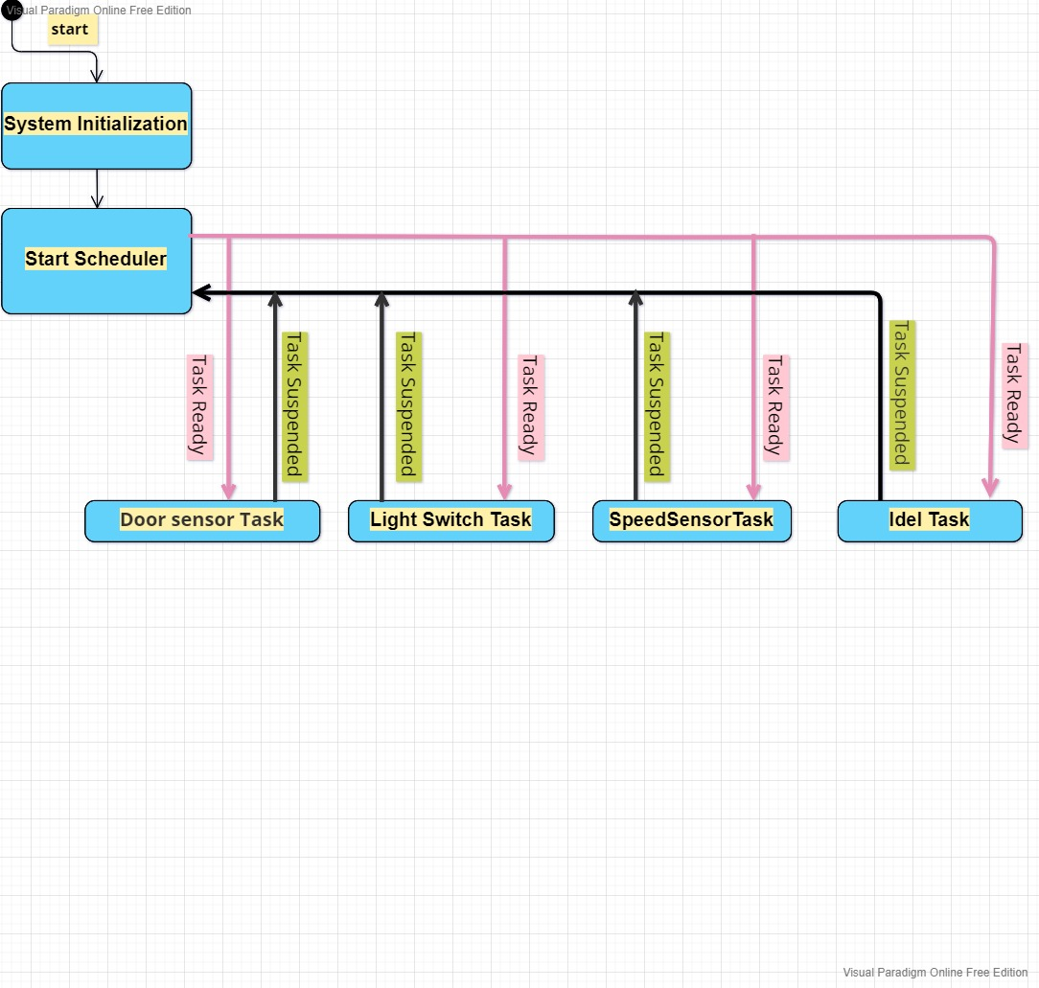

1. 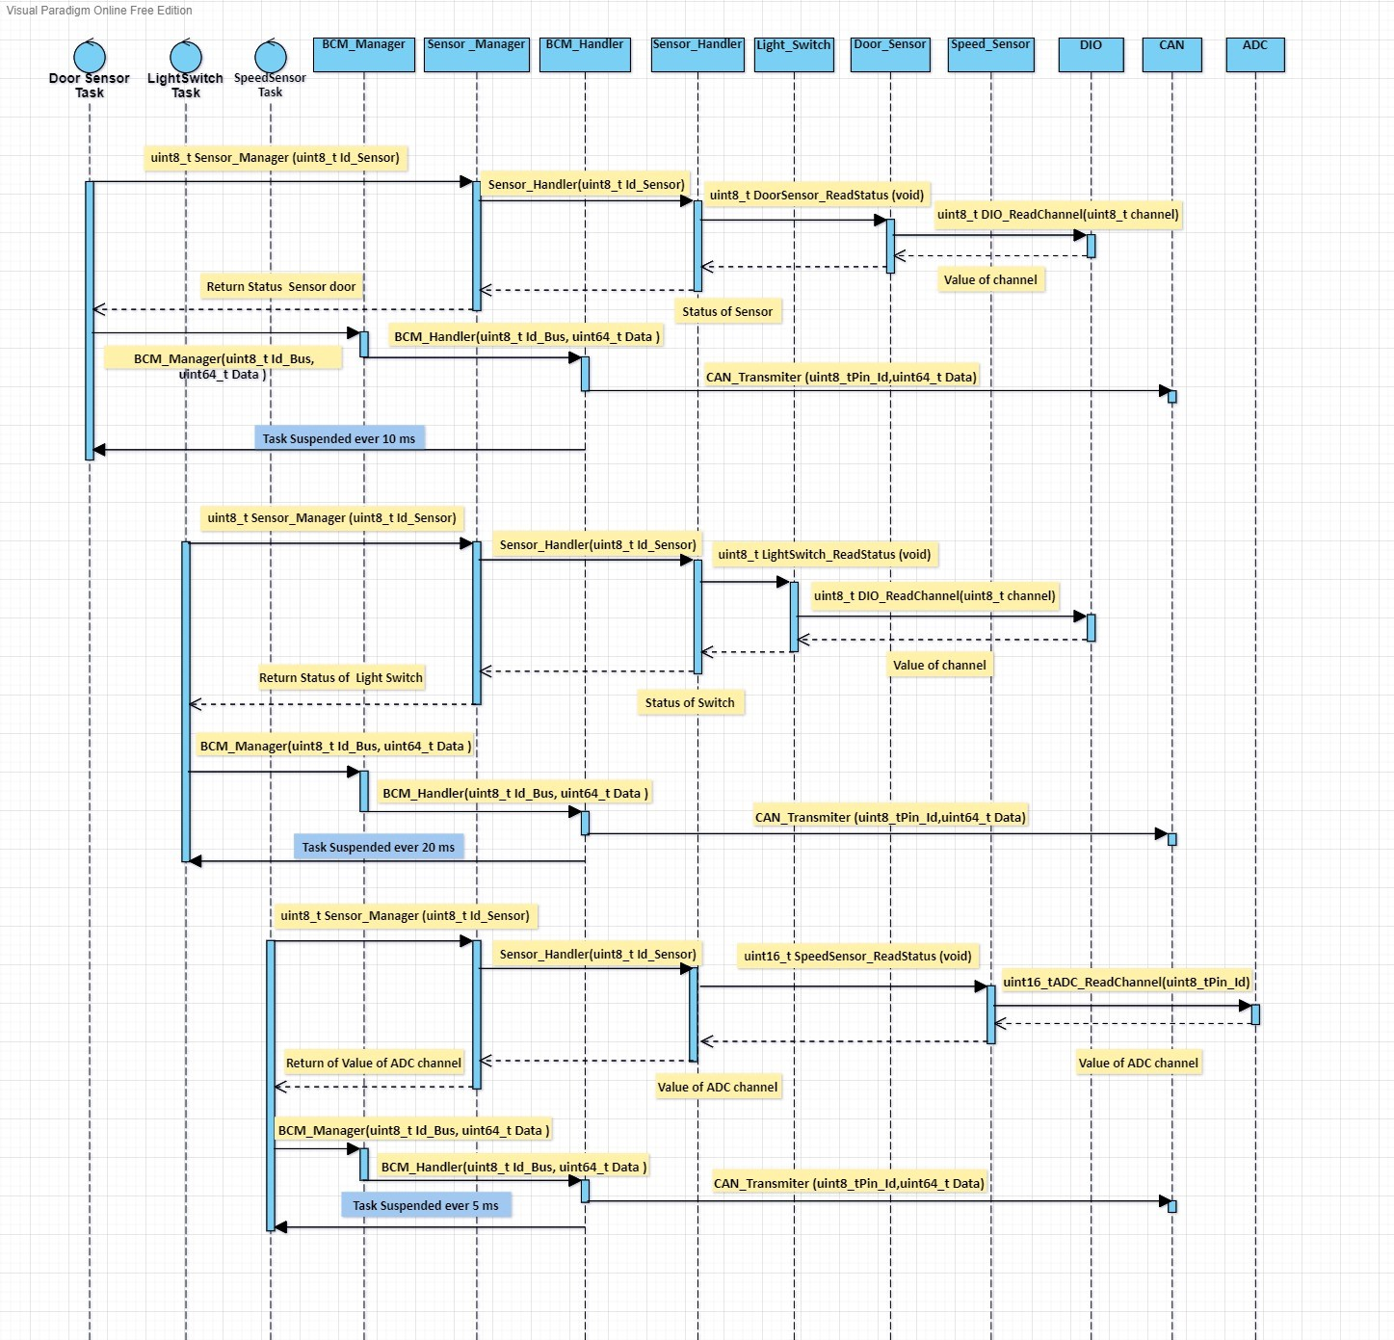**sequence diagram for the ECU 1 :**
2. **Calculate CPU load for the ECU 1:**

The system contains three tasks assuming worst case scenario that the execution time of task is **500 µs.**

|  |  |  |
| --- | --- | --- |
| Name Task | Periodicity | Execution Time |
| **Door Sensor Task** | **10 ms** | **500 µs** |
| **Light sensor Task** | **20 ms** | **500 µs** |
|  |  |  |
| **Speed Sensor Task** | **5 ms** | **500 µs** |

H (Hyper Period) = LCM(Pi) = 20 ms  
CPU Load = ∑ E / H = (0.5*2 + 0.5*4 + 0.5*1) /20 * 100 = 17.5 %

* **For ECU 2:**

1. **state machine diagram for ECU 2 component:**

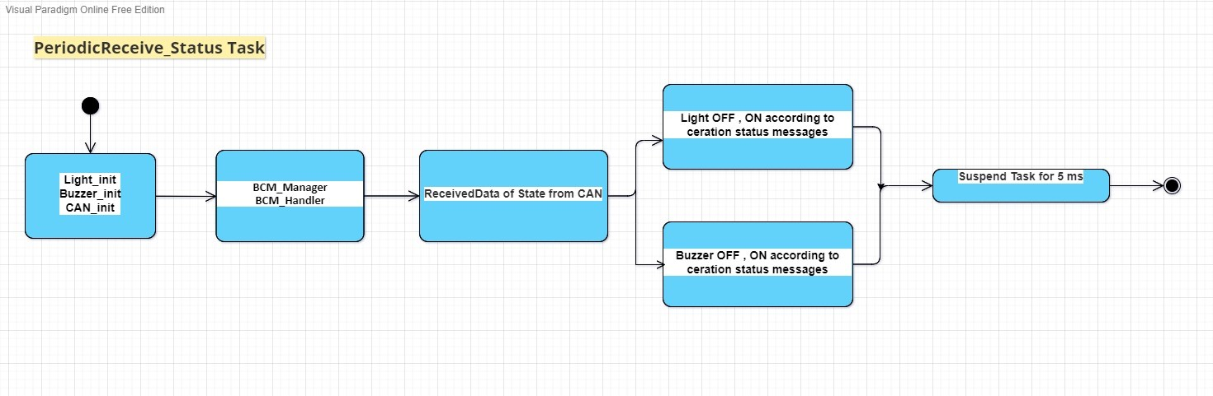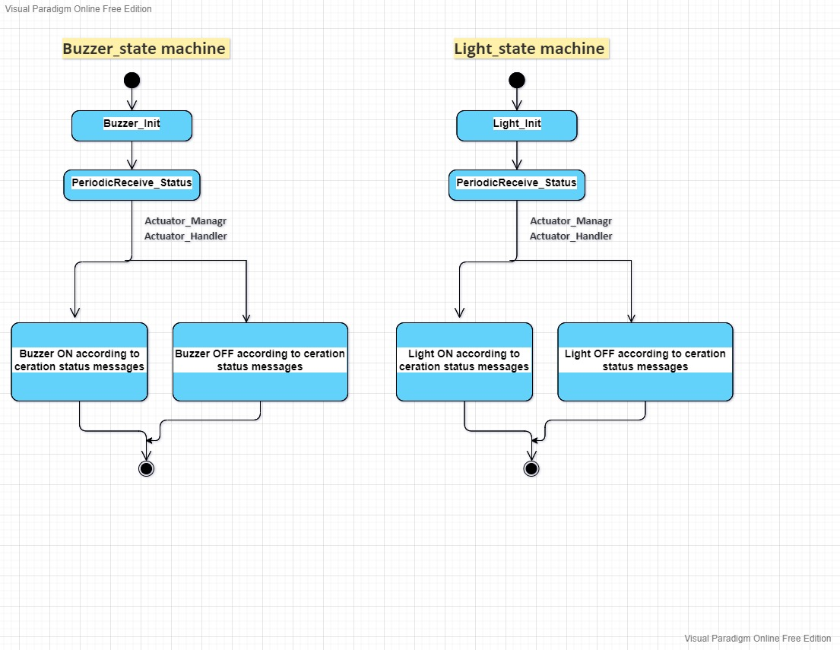

1. 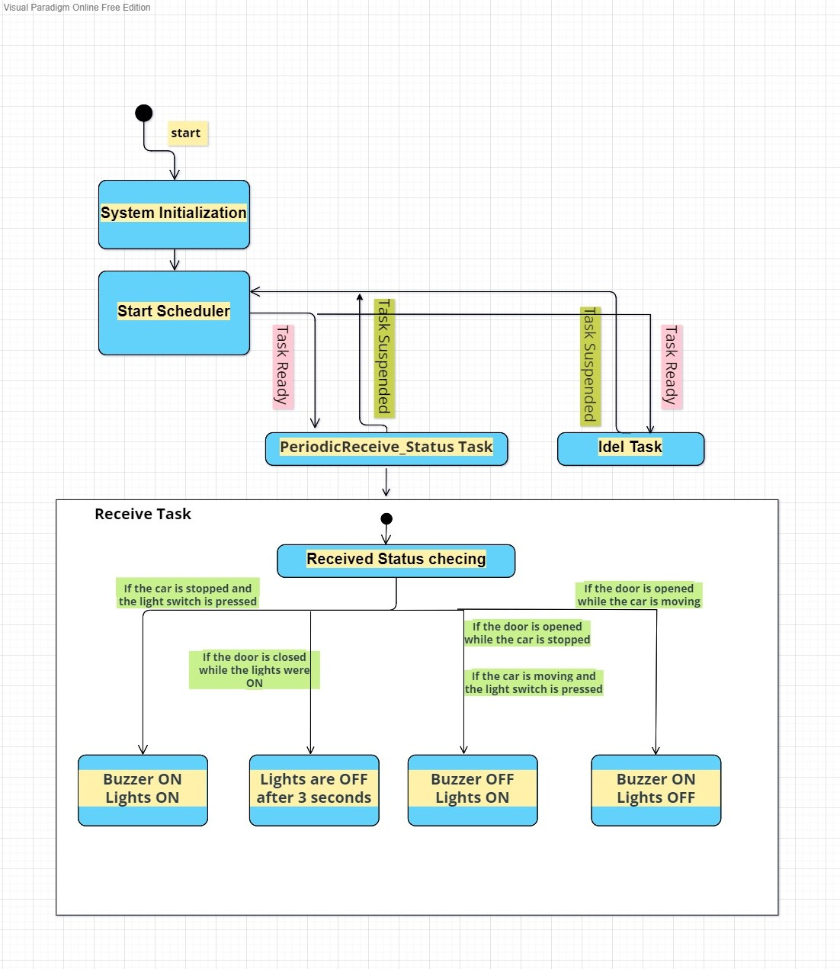**state machine diagram for the ECU 2 operations:**
2. 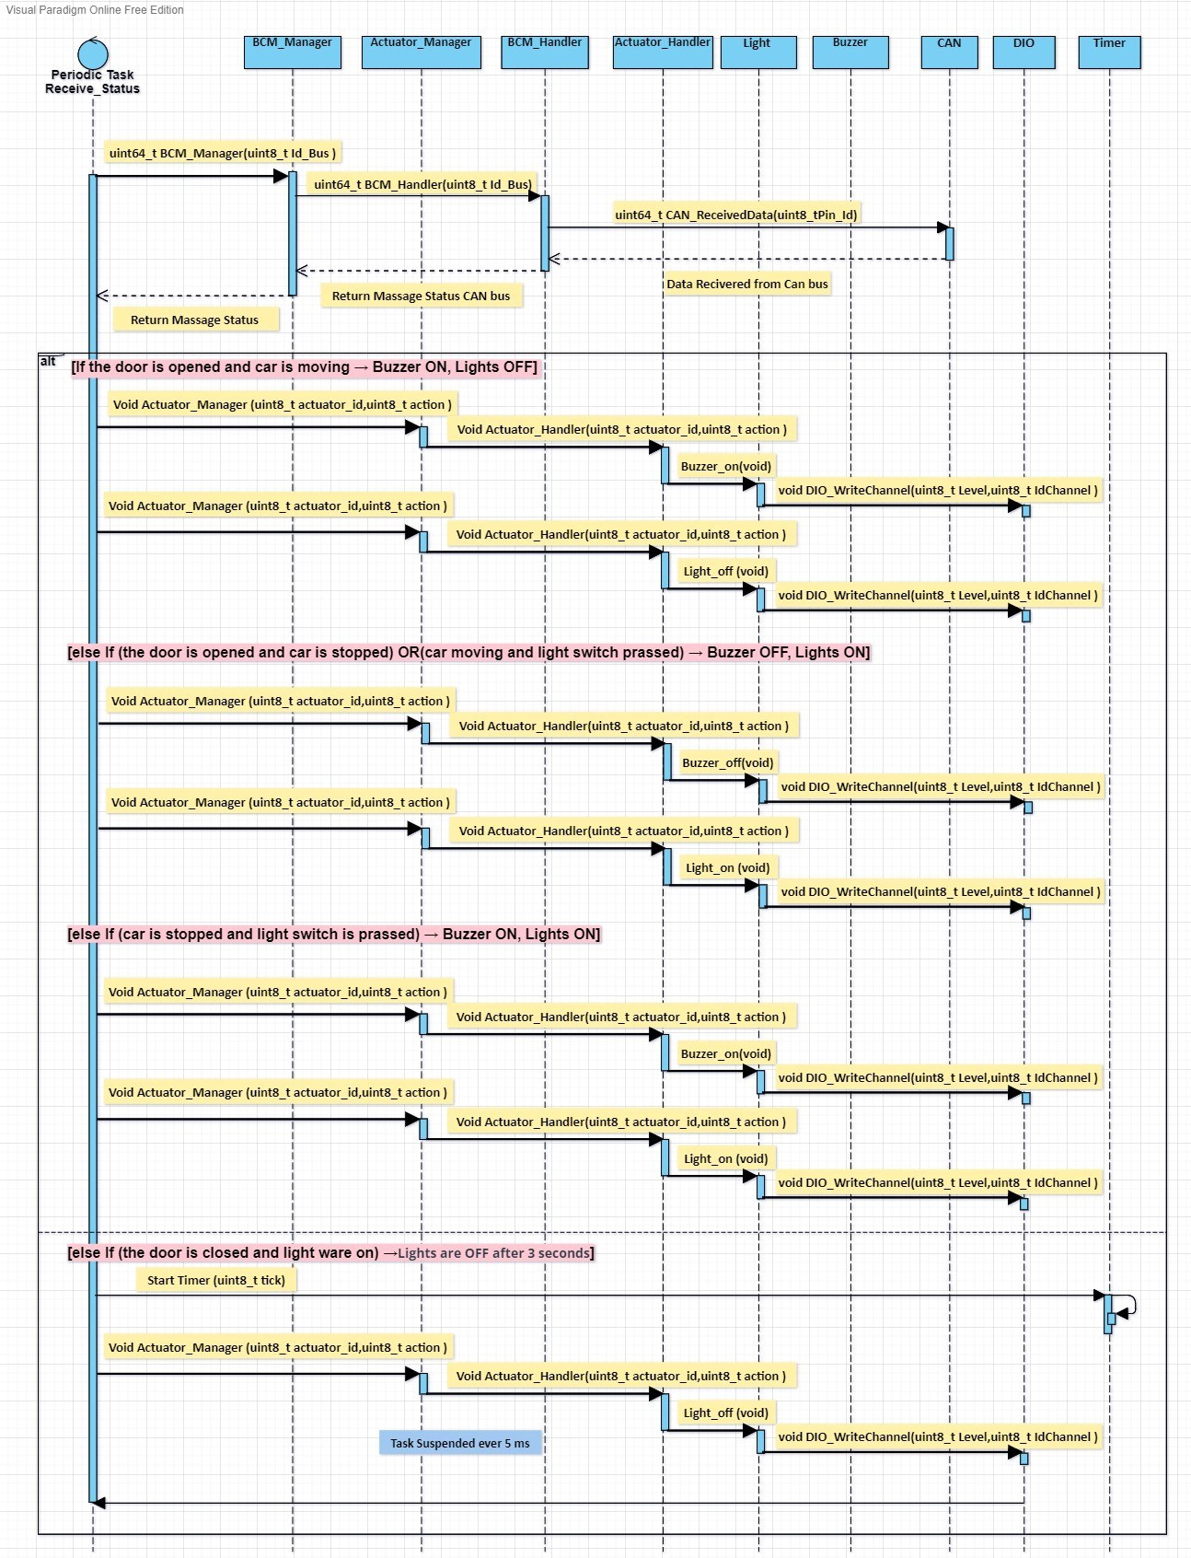**sequence diagram for the ECU 2 :**
3. **Calculate CPU load for the ECU 2:**

The system contains one tasks assuming worst case scenario that the execution time of task is 1 ms.

|  |  |  |
| --- | --- | --- |
| Name Task | Periodicity | Execution Time |
| **Periodic Task Receive Status** | **5 ms** | **1 ms** |

H (Hyper Period) = LCM(Pi) = 5 ms  
CPU Load = ∑ E / H = (1*1) /5 * 100 = 20%

* **Calculate bus load in your system:**

Notes: With what percentage of system bus was busy per 1 second

CAN Bus Load in System: time the CAN bus loaded with data  
1 CAN frame contains approximately 125 bits.  
assume we are using a 500 Kbit/s bit rate.  
bit time = 1 / bit rate = 1 / (500 * 1000) s = 2 µs  
Approximate time to transfer 1 frame = (2 µs/bit * 125 bit) = 250 µs.   
We have multiple sending intervals on the bus:

1 frame every 5 ms 🡪 200 frames every 1000 ms  
1 frame every 10 ms 🡪 100 frames every 1000 ms

1 frame every 20 ms 🡪 50 frames every 1000 ms  
This is in total = 350 frames every 1000 ms  
Total time on bus = (total number of frames) * (time of 1 frame )

Total time on bus = 350 * 250 =87500 µs  
Bus load = {( (87500 µs *1000 )\ 1000 )* 100 %} = 8.75 %