 

# Automotive door control system design Static Design Report

**Name: Ahmed Mohamed Hussein Elshehry**

**Email :** [elshehry97@gmail.com](mailto:elshehry97@gmail.com)

**system schematic (Block Diagram) according to your requirements understanding.**

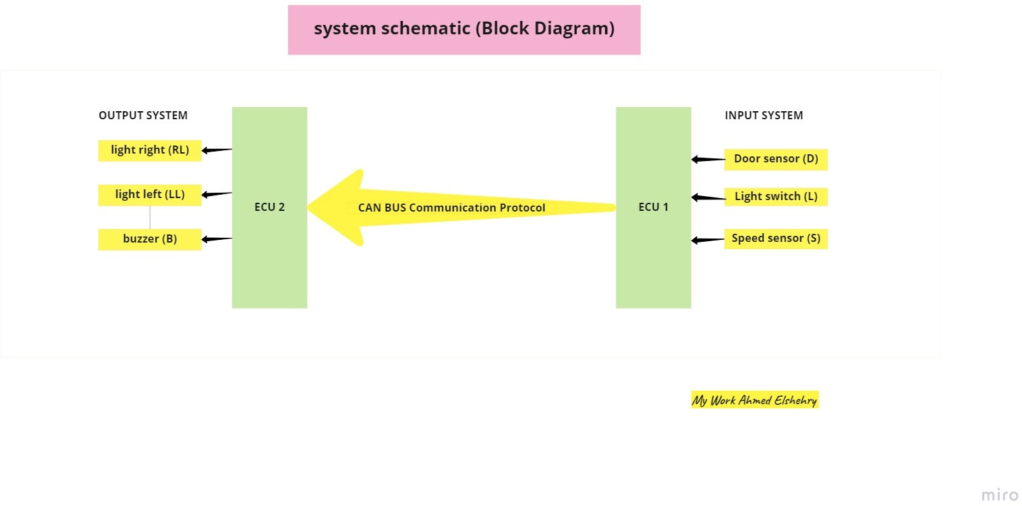

# Static Design:

## For ECU 1:

### the layered architecture:

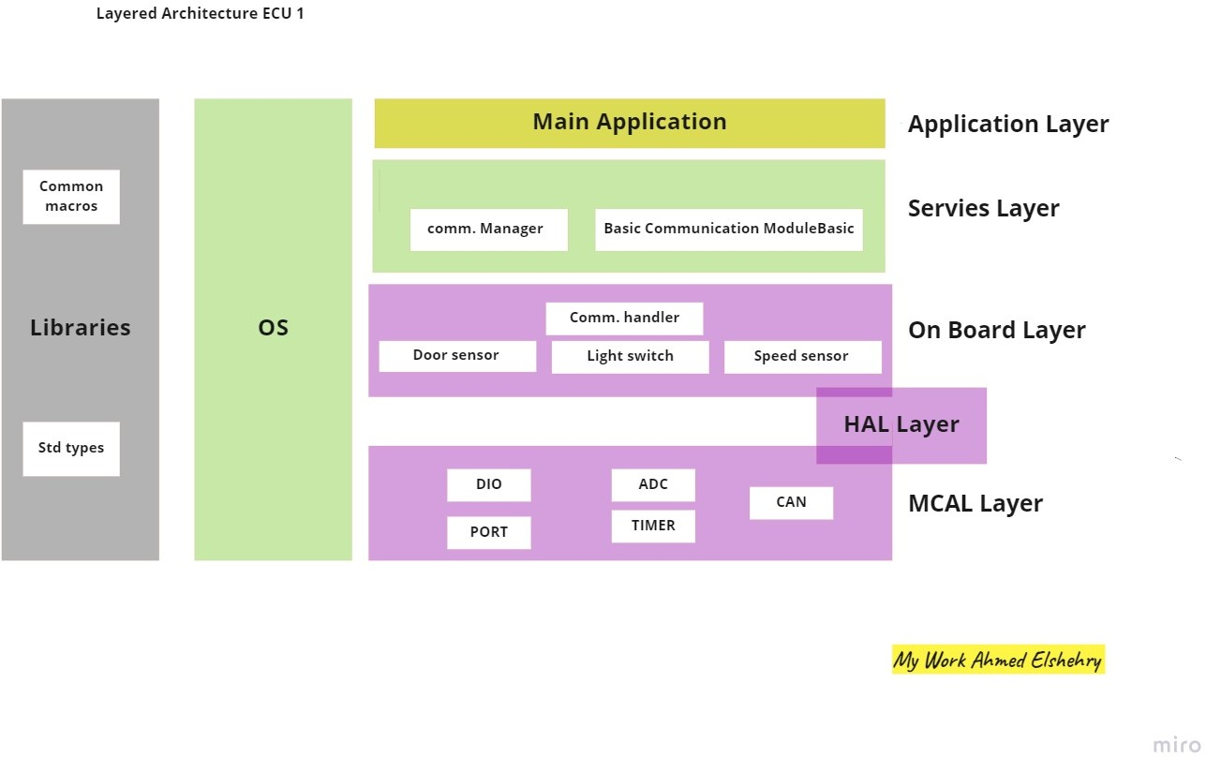

* 1. **Specify ECU components and modules Components connected:**

1. CAN BUS Communication Protocol (for communication between the two ECUs)
2. Light switch
3. Speed Sensor
4. Door Sensor

### Modules:

#### External hardware:

1. CAN transiver module
2. Switch module
3. Speed Sensor module
4. Door Sensor module

#### Internal hardware:

1. Port Module (initialize all pins required with modes)
2. DIO Module (switch module, Door Sensor module)
3. TIMER module (timer for application)
4. ADC module (for speed sensor)
5. CAN Module (for can transiver data )

### Provide full detailed APIs for each module as well as a detailed description

* 1. **That three Tasks to creation in Application Layer**

|  |  |  |  |  |
| --- | --- | --- | --- | --- |
| Layer | Module | APIs | API Details | |
| Application Layer | Main Application | DoorSensorTask |  | |
| **Syntax:** | void DoorSensorTask(void); |
| **Sync/Async:** | Synchronous |
| **Reentrancy:** | Non-Reentrant |
| **Parameters:** | None |
| **Return:** | None |
| **Description:** | Manage Door Sensor Task |
|  | |

|  |  |  |  |  |
| --- | --- | --- | --- | --- |
| Layer | Module | APIs | API Details | |
| Application Layer | Main Application | LightSwitchTask  SpeedSensorTask |  | |
| **Syntax:** | void LightSwitchTask(void); |
| **Sync/Async:** | Synchronous |
| **Reentrancy:** | Non-Reentrant |
| **Parameters:** | None |
| **Return:** | None |
| **Description:** | Manage Light Switch Task |
|  | |
| **Syntax:** | void SpeedSensorTask(void); |
| **Sync/Async:** | Synchronous |
| **Reentrancy:** | Non-Reentrant |
| **Parameters:** | None |
| **Return:** | None |
| **Description:** | Manage Speed Sensor Task |
|  | |

* 1. **That module in Servies Layer**

|  |  |  |  |
| --- | --- | --- | --- |
| Layer | Module | APIs | API Details |
| Servies Layer | Basic Communication ModuleBasic  (BCM Manager) | BCM_Manager | |  |  | | --- | --- | | Syntax: | void BCM_Manager (uint8_t Id_Bus, uint64_t Data ); | | Sync/Async: | Synchronous | | Reentrancy: | Non-Reentrant | | Parameters: | **Id_Bus**: that the ID commutation protocol want to connect it,  **Data** :that the data want to send by BCM manager | | Return: | None | | Description: | Manage request the data Transmitter by CAN Bus W.R.T Id Bus selection | |
| Servies Layer | comm. Manager | Sensor_Manager  (do Monitoring Sensors) | |  |  | | --- | --- | | Syntax: | Level_States Sensor_Manager (Id_sensor Id_Sensor_read); | | Sync/Async: | Synchronous | | Reentrancy: | Non-Reentrant | | Parameters: | **Id_Sensor_read** : that id Sensor selection want to read states | | Return: | Date of states Read from sensor | | Description: | Manage request read states of data from sensor selection | |

Types define of argument of APIs :

|  |  |
| --- | --- |
| Types | Define |
| typedef unsigned char uint8_t | Used in armament Id_Bus to select bus connect  range{0,255 } that range depended commutation to managed by BCM ,size 8bit |
| typedef unsigned long long uint64_t | used because max width of data in CAN frame is 64 bits and used in argument Data transmitter API  BCM_manager and Handler |
| Level_States | typedef enum {Low, High } Level_States  range{0,1} size 1bit |
| Id_sensor | typedef enum {Sensor_1, sensor_2, sensor_3} Id_sensor  range{0,2 max sensor in project } size 2 bit |

* 1. **That module in On Board Layer**

|  |  |  |  |
| --- | --- | --- | --- |
| Layer | Module | APIs | API Details |
| On Board Layer | Comm. Handler | BCM_Handler | |  |  | | --- | --- | | Syntax: | void BCM_ Handler (uint8_t Id_Bus, uint64_t Data ); | | Sync/Async: | Synchronous | | Reentrancy: | Non-Reentrant | | Parameters: | **Id_Bus**: that the ID commutation protocol want to connect it,  **Data** :that the data want to send by BCM manager | | Return: | None | | Description: | Manage request the data Transmitter by CAN Bus W.R.T Id Bus selection but deals with Hardware directly | |
| On Board Layer | Comm. Handler | Sensor Handler | |  |  | | --- | --- | | Syntax: | Level_States Sensor_Handler (Id_sensor Id_Sensor_read); | | Sync/Async: | Synchronous | | Reentrancy: | Non-Reentrant | | Parameters: | **Id_Sensor_read** : that id Sensor selection want to read states | | Return: | Date of states Read from sensor | | Description: | Manage request read states of data from sensor selection but deals with Hardware directly | |
| On Board Layer | Door Sensor | DoorSensor_Init  DoorSensor_ReadStatus | |  |  | | --- | --- | | Syntax: | void DoorSensor_Init (void); | | Sync/Async: | Synchronous | | Reentrancy: | Non-Reentrant | | Parameters: | None | | Return: | None | | Description: | Initialize the used DIO pins for digital input |  |  |  | | --- | --- | | Syntax: | Status_door DoorSensor_ReadStatus (void); | | Sync/Async: | Synchronous | | Reentrancy: | Non-Reentrant | | Parameters: | None | | Return: | Status of the sensor door closed or opened | | Description: | Get the status of the sensor door  (closed or not ) | |

|  |  |  |  |  |  |  |  |  |  |  |  |  |  |  |  |  |  |  |  |  |  |  |  |  |  |  |  |
| --- | --- | --- | --- | --- | --- | --- | --- | --- | --- | --- | --- | --- | --- | --- | --- | --- | --- | --- | --- | --- | --- | --- | --- | --- | --- | --- | --- |
| On Board Layer | Light Switch | LightSwitch_Init  LightSwitch_ReadStatus | |  |  | | --- | --- | | Syntax: | Void LightSwitch_Init (void); | | Sync/Async: | Synchronous | | Reentrancy: | Non-Reentrant | | Parameters: | None | | Return: | None | | Description: | Initialize the used DIO pins for digital input |  |  |  | | --- | --- | | Syntax: | Status_switch LightSwitch_ReadStatus (void); | | Sync/Async: | Synchronous | | Reentrancy: | Non-Reentrant | | Parameters: | None | | Return: | Status of the light switch  Pressed or unpressed ) | | Description: | Get the status of the Light Switch  (Pressed or unpressed ) | |
| On Board Layer | Speed Sensor | SpeedSensor_Init  SpeedSensor_ReadStatus | |  |  | | --- | --- | | Syntax: | void SpeedSensor_Init (void); | | Sync/Async: | Synchronous | | Reentrancy: | Non-Reentrant | | Parameters: | None | | Return: | None | | Description: | Initialize the used DIO pins for analog input For (ADC) |  |  |  | | --- | --- | | Syntax: | Status_speed SpeedSensor_ReadStatus (void); | | Sync/Async: | Synchronous | | Reentrancy: | Non-Reentrant | | Parameters: | None | | Return: | Status of the sensor speed of car that can be moving or stopped | | Description: | Read the Status value of the speed sensor (moving or stop) | |

Types define of argument of APIs:

|  |  |
| --- | --- |
| Types | Define |
| typedef unsigned char uint8_t | Used in armament Id_Bus to select bus connect  range{0,255 } that range depended commutation to managed by BCM ,size 8bit |
| typedef unsigned long long uint64_t | used because max width of data in CAN frame is 64 bits and used in argument Data transmitter API  BCM_manager and Handler |
| Level_States | typedef enum {Low, High} Level_States  range{0,1} size 1bit |
| Id_sensor | typedef enum {Sensor_1, sensor_2, sensor_3} Id_sensor  range{0,2 max sensor in project } size 2 bit |
| Status_door | typedef enum {closed, opened} Status_door  range{0,1} size 1bit |
| Status_switch | typedef enum {undressed, pressed} Status_switch  range{0,1} size 1bit |
| Status_speed | typedef enum {stopped, moving} Status_speed  range{0,1} size 1bit after convert value adc |

* 1. **That module in MCAL Layer**

|  |  |  |  |
| --- | --- | --- | --- |
| Layer | Module | APIs | API Details |
| MCAL Layer | DIO | DIO_Init  DIO_ReadChannel  DIO_WriteChannel | |  |  | | --- | --- | | Syntax: | Void DIO_Init (void); | | Sync/Async: | Synchronous | | Reentrancy: | Non-Reentrant | | Parameters: | None | | Return: | None | | Description: | Initialize the used DIO pins with required configuration file . |  |  |  | | --- | --- | | Syntax: | LevelType DIO_ReadChannel( Id_channel channel); | | Sync/Async: | Synchronous | | Reentrancy: | Non-Reentrant | | Parameters: | **Channel**: the value of channel want to read it the value of enum **Id_channel** | | Return: | Status of pin High or low that value from Dio_LevelType | | Description: | Read the channel required |  |  |  | | --- | --- | | Syntax: | void DIO_WriteChannel (LevelType Level ); | | Sync/Async: | Synchronous | | Reentrancy: | Non-Reentrant | | Parameters: | **Level** : Level want to write channel high level or low level | | Return: | None | | Description: | Write the level of the channel required | |

|  |  |  |  |  |  |  |  |  |  |  |  |  |  |  |  |
| --- | --- | --- | --- | --- | --- | --- | --- | --- | --- | --- | --- | --- | --- | --- | --- |
| MCAL Layer | PORT | Port_init(*Port_cfg_ptr) | |  |  | | --- | --- | | Syntax: | void Port_init(*Port_cfg_ptr) | | Sync/Async: | Synchronous | | Reentrancy: | Non-Reentrant | | Parameters: | This API takes pointer to the configuration container of the port driver to initialize the configured pins | | Return: | None | | Description: | Initialize the used Port with required configuration of the pointer | |
| MCAL Layer | PORT | void SetPinValue(port_of_Id port_Id,Pin_of_num Pin_num, Dio_LevelType level ) | |  |  | | --- | --- | | Syntax: | void SetPinValue(port_of_Id port_Id,Pin_of_num Pin_num, Dio_LevelType level ) | | Sync/Async: | Synchronous | | Reentrancy: | Non-Reentrant | | Parameters: | This API takes to the configuration **port_Id** that type of port_of_Id to port_1 or port_2 …. , **Pin_num** the number of pin want to configure, **level** that initiation of level of pin high or low | | Return: | None | | Description: | Initialize the used Port with required configuration of the Parameters. | |
| MCAL Layer  MCAL Layer | Timer  Timer | Timer_Init  Timer_Start  Timer_Stop | |  |  | | --- | --- | | Syntax: | void Timer_Init (void); | | Sync/Async: | Synchronous | | Reentrancy: | Non-Reentrant | | Parameters: | None | | Return: | None | | Description: | Initialize timer required configuration |  |  |  | | --- | --- | | Syntax: | void Timer_Start (timer_ChannelType channel, timer_ValueType value_count ); | | Sync/Async: | Synchronous | | Reentrancy: | Non-Reentrant | | Parameters: | **Channel**: that the channel wanted to start timer , **value_count**  value of counter to count tick the mix value depend of over flow timer count | | Return: | None | | Description: | Initialize timer required configuration of Parameters to start count |  |  |  | | --- | --- | | Syntax: | Void Timer_Stop (timer_ChannelType channel); | | Sync/Async: | Synchronous | | Reentrancy: | Non-Reentrant | | Parameters: | **Channel:** channel Id of timer wanted to stopped | | Return: | None | | Description: | Stop timer required configuration id channel | |
| MCAL Layer | CAN | CAN_Init  CAN_Transmiter | |  |  | | --- | --- | | Syntax: | void CAN_Init (void); | | Sync/Async: | Synchronous | | Reentrancy: | Non-Reentrant | | Parameters: | None | | Return: | None | | Description: | Initialize CAN bus required configuration and Hardware pin CAN |  |  |  | | --- | --- | | Syntax: | void CAN_Transmiter (uint8_t Pin_Id,uint64_t Data); | | Sync/Async: | Synchronous | | Reentrancy: | Non-Reentrant | | Parameters: | Data transmitter by the can bus , Pin_id the agreement to selection the id of bus wanted connected | | Return: | None | | Description: | Transmitter data by CAN Bus | |
| MCAL Layer | ADC | ADC_Init  ADC_ReadChannel | |  |  | | --- | --- | | Syntax: | void ADC_Init (void); | | Sync/Async: | Synchronous | | Reentrancy: | Non-Reentrant | | Parameters: | None | | Return: | None | | Description: | Initialize ADC required configuration and Hardware pin ADC connect speed sensor | |
|  |  |  | |  |  | | --- | --- | | Syntax: | uint16_tADC_ReadChannel(Pin_of_num Pin_Id); | | Sync/Async: | Synchronous | | Reentrancy: | Non-Reentrant | | Parameters: | Pin_Id of ADC to read value | | Return: | The value of channel ADC | | Description: | Read the value of channel ADC | |
|  |  |  |  |

Types define of argument of APIs:

|  |  |
| --- | --- |
| Types | Define |
| LevelType | typedef enum {LOW, HIGH} Dio_LevelType  range{0,1} size 1bit |
| Id_channel | typedef enum {Channel_1, Channel_2, Channel_3, Channel_4, Channel_5, Channel_6, Channel_7,  Channel_8}Dio_LevelType range{0,8} size 1bit |
| Port_cfg_ptr that of struct to configuration  Typedef struct{uint8_t Port_Pin_Direction,  uint8_t PORT_PIN_INTERNAL_ATTACH, uint8_t PORT_PIN_LEVEL_VALUE ,  uint8_t PORT_def_PORTx,  uint8_t PORT_def_PINx,  uint8_t PORT_def_Mode_x}port_config; | |  |  | | --- | --- | | Port_Pin_Direction | Used to set the direction input or output | | PORT_PIN_INTERNAL_ATTACH | Used to select the internal resistance | | PORT_PIN_LEVEL_VALUE | Used to specify the initial value | | PORT_def_PORTx | This typedef used to point to specific port , if x equal A then this is portA | | PORT_def_PINx | This typedef used to point to specific pin , if x equal 0 then this is pin0 | | PORT_def_Mode_x | This typedef used to point to specific mode , if x equal adc then this is adc mode | |
| port_of_Id | typedef enum {Port_1, Port _2 Port _3, Port l_4, Port _5, Port _6 Port _7} port_of_Id range{0,8} size 1bit |
| ,Pin_of_num | typedef enum {Pin_1, Pin _2 Pin _3, Pin l_4, Pin _5, Pin_6, Pin _7,Pin_8} Pin_of_num range{0,8} size 1bit |
| typedef uint32_t T timer_ValueType; | Value of tick range from 0 to 2^32 -1 size 32 bit |
| Typedef enum {T1 = T1PR,T2 = T2PR,Etc:}  timer_ChannelType; | This enum types stores the identifier for the Channel like  its name. |

* 1. folder structure according to the previous points:

|  |  |  |
| --- | --- | --- |
| Application folder | Servies folder | On Board Layer |
| main.c | Operting_system.c | BCM_Handler.c |
|  | BCM_Manager.c | Sensor_Handler.c |
|  | Sensor_Manager.c | Door_sensor.c |
|  |  | Light_switch.c |
|  |  | Speed_sensor.c |

|  |  |
| --- | --- |
| MCAL folder | Configure folder |
| dio.c | Timer_config.c |
| port.c | Adc_config.c |
| adc.c | Can_config.c |
| Timer.c | Port_config.c |
| can.c | Dio_config.c |
|  | Door_sensorconfig.c |
|  | Light_switchconfig.c |
|  | Speed_sensorconfig.c |

|  |
| --- |
| Commen folder (all the header (name.h)) |
| Mainapp.h / os.h / servies.h |
| BCS_manager.h/Sonser_manager.h |
| Light_switch.h / speed_sonser.h / Door_sensor.h |
| Dio.h / port.h / timer.h /can.h/adc.h |
| dio_config.h/port_config.h / timer_config.h /can_config.h /adc_config.h |
| Stdtypes.h /comman_macro.h /Hw.h |

## For ECU 2:

### the layered architecture:

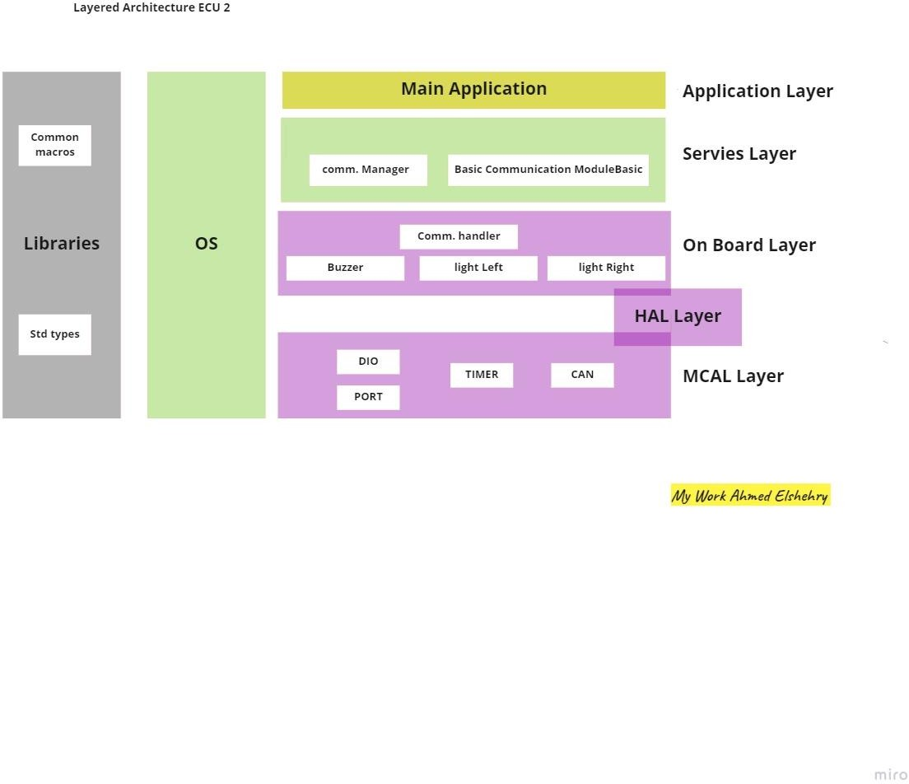

1. **Specify ECU components and modules Components connected:**
2. CAN BUS Communication Protocol (for communication between the two ECUs)
3. Light right
4. Light left
5. Buzzer

### Modules:

#### External hardware:

1. CAN transiver module
2. Light left module
3. Light right module
4. Buzzer module

#### Internal hardware:

1. Port Module (initialize all pins required with modes)
2. DIO Module (switch module, Door Sensor module)
3. TIMER module (timer for application)
4. CAN Module (for can transiver data)

### Provide full detailed APIs for each module as well as a detailed description

* 1. **That module in Application Layer**

|  |  |  |  |  |
| --- | --- | --- | --- | --- |
| Layer | Module | APIs | API Details | |
| Application Layer | Main Application | PeriodicReceive_Status |  | |
| **Syntax:** | Void PeriodicReceive_Status(uint64_t *  data ,uint8_t* id_CAN); |
| **Sync/Async:** | Synchronous |
| **Reentrancy:** | Non-Reentrant |
| **Parameters:** | Pointer to data act as buffer for data  ,pointer of CAN bus id to id cheek it |
| **Return:** | None |
| **Description:** | Manage received data periodicity status of  ECU1 |

* 1. **That module in Servies Layer**

|  |  |  |  |
| --- | --- | --- | --- |
| Layer | Module | APIs | API Details |
| Servies Layer | Basic Communication ModuleBasic  (BCM Manager) | BCM_Manager | |  |  | | --- | --- | | Syntax: | uint64_t BCM_Manager (uint8_t Id_Bus); | | Sync/Async: | Synchronous | | Reentrancy: | Non-Reentrant | | Parameters: | **Id_Bus**: that the ID commutation protocol want to connect it to received data | | Return: | Return Data frame of CAN bus that the data want to receive by CAN bus from ECU1 | | Description: | Manage request the data received by CAN Bus W.R.T Id Bus selection | |
| Servies Layer | comm. Manager | Actuator_Manager (do Monitoring Action ) | |  |  | | --- | --- | | Syntax: | Void Actuator_Manager ( actuator_Id  actuator , action_status_action ); | | Sync/Async: | Synchronous | | Reentrancy: | Non-Reentrant | | Parameters: | **actuator_id** selection want to do action  states , **action** want to do(on ,off ) Actuator | | Return: | None | | Description: | Monitoring action request to do actuator selection | |

Types define of argument of APIs:

|  |  |
| --- | --- |
| Types | Define |
| typedef unsigned char uint8_t | Used in armament Id_Bus to select bus connect  range{0,255 } that range depended commutation to managed by BCM ,size 8bit |
| typedef unsigned long long uint64_t | used because max width of data in CAN frame is 64 bits and used in argument Data received API  BCM_manager and Handler |
| Status_action | typedef enum {OFF,ON } status_action  range{0,1} size 1bit |
| actuator_Id | typedef enum { actuator_1, actuator_2} actuator_Id  range{0,1} max actuator in project Buzzer and light } size 1 bit |

* 1. **That module in On Board Layer**

|  |  |  |  |  |  |
| --- | --- | --- | --- | --- | --- |
| Layer | Module | APIs | | API Details | |
| On Board Layer | Comm. Handler | BCM_Handler | | |  |  | | --- | --- | | Syntax: | uint64_t BCM_Handler (uint8_t Id_Bus); | | Sync/Async: | Synchronous | | Reentrancy: | Non-Reentrant | | Parameters: | **Id_Bus**: that the ID commutation protocol want to connect it to received data | | Return: | Return Data frame of CAN bus that the data want to receive by CAN bus from ECU1 | | Description: | Handler request the data received by CAN Bus W.R.T Id Bus selection but deals with Hardware directly | | |
| On Board Layer | Comm. Handler | Actuator_Handler | | |  |  | | --- | --- | | Syntax: | Void Actuator_Handler ( actuator_Id  actuator , action_status_action ); | | Sync/Async: | Synchronous | | Reentrancy: | Non-Reentrant | | Parameters: | **actuator_id** selection want to do action  states , **action** want to do(on ,off ) Actuator | | Return: | None | | Description: | Handler request to do action actuartor selection but deals with Hardware directly | | |
| On Board Layer | Buzzer | Buzzer_Init  Buzzer_on  Buzzer_off |  | | | |
| **Syntax:** | | **Void Buzzer_Init (void);** | |
| **Sync/Async:** | | Synchronous | |
| **Reentrancy:** | | Non-Reentrant | |
| **Parameters:** | | None | |
| **Return:** | | None | |
| **Description:** | | Initialize the used DIO pins for digital output respect to configuration | |
|  | | | |
| **Syntax:** | | **void Buzzer_on(void);** | |
| **Sync/Async:** | | Synchronous | |
| **Reentrancy:** | | Non-Reentrant | |
| **Parameters:** | | None | |
| **Return:** | | None | |
| **Description:** | | Set Buzzer to turn on states | |
|  | | | |
| **Syntax:** | | **void Buzzer_off(void);** | |
| **Sync/Async:** | | Synchronous | |
| **Reentrancy:** | | Non-Reentrant | |
| **Parameters:** | | None | |
| **Return:** | | None | |
| **Description:** | | Set Buzzer to turn off states | |
| On Board Layer | Light Switch | Light_Init  Light_off  Light_on |  | | | |
| **Syntax:** | | **Void Light_Init (void);** | |
| **Sync/Async:** | | Synchronous | |
| **Reentrancy:** | | Non-Reentrant | |
| **Parameters:** | | None | |
| **Return:** | | None | |
| **Description:** | | Initialize the used DIO pins for digital  output base the configuration | |
|  | | | |
| **Syntax:** | | **void Light_off(void);** | |
| **Sync/Async:** | | Synchronous | |
| **Reentrancy:** | | Non-Reentrant | |
| **Parameters:** | | None | |
| **Return:** | | None | |
| **Description:** | | Set Light to turn off states | |
|  | | | |
| **Syntax:** | | **Void Light_on(void);** | |
| **Sync/Async:** | | Synchronous | |
| **Reentrancy:** | | Non-Reentrant | |
| **Parameters:** | | None | |
| **Return:** | | None | |
| **Description:** | | Set light to turn on states | |

Types define of argument of APIs:

|  |  |
| --- | --- |
| Types | Define |
| typedef unsigned char uint8_t | Used in armament Id_Bus to select bus connect  range{0,255 } that range depended commutation to managed by BCM ,size 8bit |
| typedef unsigned long long uint64_t | used because max width of data in CAN frame is 64 bits and used in argument Data received API  BCM_manager and Handler |
| Status_action | typedef enum {OFF,ON } status_action  range{0,1} size 1bit |
| actuator_Id | typedef enum { actuator_1, actuator_2} actuator_Id  range{0,1} max actuator in project Buzzer and light } size 1 bit |

* 1. **That module in MCAL Layer**

|  |  |  |  |
| --- | --- | --- | --- |
| Layer | Module | APIs | API Details |
| MCAL Layer | DIO | DIO_Init  DIO_ReadChannel  DIO_WriteChannel | |  |  | | --- | --- | | Syntax: | Void DIO_Init (void); | | Sync/Async: | Synchronous | | Reentrancy: | Non-Reentrant | | Parameters: | None | | Return: | None | | Description: | Initialize the used DIO pins with required configuration file . |  |  |  | | --- | --- | | Syntax: | LevelType DIO_ReadChannel( Id_channel channel); | | Sync/Async: | Synchronous | | Reentrancy: | Non-Reentrant | | Parameters: | **Channel**: the value of channel want to read it the value of enum **Id_channel** | | Return: | Status of pin High or low that value from Dio_LevelType | | Description: | Read the channel required |  |  |  | | --- | --- | | Syntax: | void DIO_WriteChannel (LevelType Level ); | | Sync/Async: | Synchronous | | Reentrancy: | Non-Reentrant | | Parameters: | **Level** : Level want to write channel high level or low level | | Return: | None | | Description: | Write the level of the channel required | |

|  |  |  |  |  |  |  |  |  |  |  |  |  |  |  |  |
| --- | --- | --- | --- | --- | --- | --- | --- | --- | --- | --- | --- | --- | --- | --- | --- |
| MCAL Layer | PORT | Port_init(*Port_cfg_ptr) | |  |  | | --- | --- | | Syntax: | void Port_init(*Port_cfg_ptr) | | Sync/Async: | Synchronous | | Reentrancy: | Non-Reentrant | | Parameters: | This API takes pointer to the configuration container of the port driver to initialize the configured pins | | Return: | None | | Description: | Initialize the used Port with required configuration of the pointer | |
| MCAL Layer | PORT | void SetPinValue(port_of_Id port_Id,Pin_of_num Pin_num, Dio_LevelType level ) | |  |  | | --- | --- | | Syntax: | void SetPinValue(port_of_Id port_Id,Pin_of_num Pin_num, Dio_LevelType level ) | | Sync/Async: | Synchronous | | Reentrancy: | Non-Reentrant | | Parameters: | This API takes to the configuration **port_Id** that type of port_of_Id to port_1 or port_2 …. , **Pin_num** the number of pin want to configure, **level** that initiation of level of pin high or low | | Return: | None | | Description: | Initialize the used Port with required configuration of the Parameters. | |
| MCAL Layer  MCAL Layer | Timer  Timer | Timer_Init  Timer_Start  Timer_Stop | |  |  | | --- | --- | | Syntax: | void Timer_Init (void); | | Sync/Async: | Synchronous | | Reentrancy: | Non-Reentrant | | Parameters: | None | | Return: | None | | Description: | Initialize timer required configuration |  |  |  | | --- | --- | | Syntax: | void Timer_Start (timer_ChannelType channel, timer_ValueType value_count ); | | Sync/Async: | Synchronous | | Reentrancy: | Non-Reentrant | | Parameters: | **Channel**: that the channel wanted to start timer , **value_count**  value of counter to count tick the mix value depend of over flow timer count | | Return: | None | | Description: | Initialize timer required configuration of Parameters to start count |  |  |  | | --- | --- | | Syntax: | Void Timer_Stop (timer_ChannelType channel); | | Sync/Async: | Synchronous | | Reentrancy: | Non-Reentrant | | Parameters: | **Channel:** channel Id of timer wanted to stopped | | Return: | None | | Description: | Stop timer required configuration id channel | |
| MCAL Layer | CAN | CAN_Init  CAN_ReceivedData | |  |  | | --- | --- | | Syntax: | void CAN_Init (void); | | Sync/Async: | Synchronous | | Reentrancy: | Non-Reentrant | | Parameters: | None | | Return: | None | | Description: | Initialize CAN bus required configuration and Hardware pin CAN |  |  |  | | --- | --- | | Syntax: | uint64_t CAN_ReceivedData (uint8_t Pin_Id); | | Sync/Async: | Synchronous | | Reentrancy: | Non-Reentrant | | Parameters: | **Pin_id** the agreement to selection the id of bus wanted connected to received Data | | Return: | Data Received by the can bus | | Description: | Received data from CAN Bus | |

Types define of argument of APIs:

|  |  |
| --- | --- |
| Types | Define |
| LevelType | typedef enum {LOW, HIGH} Dio_LevelType  range{0,1} size 1bit |
| Id_channel | typedef enum {Channel_1, Channel_2, Channel_3, Channel_4, Channel_5, Channel_6, Channel_7,  Channel_8}Dio_LevelType range{0,8} size 1bit |
| Port_cfg_ptr that of struct to configuration  Typedef struct{uint8_t Port_Pin_Direction,  uint8_t PORT_PIN_INTERNAL_ATTACH, uint8_t PORT_PIN_LEVEL_VALUE ,  uint8_t PORT_def_PORTx,  uint8_t PORT_def_PINx,  uint8_t PORT_def_Mode_x}port_config; | |  |  | | --- | --- | | Port_Pin_Direction | Used to set the direction input or output | | PORT_PIN_INTERNAL_ATTACH | Used to select the internal resistance | | PORT_PIN_LEVEL_VALUE | Used to specify the initial value | | PORT_def_PORTx | This typedef used to point to specific port , if x equal A then this is portA | | PORT_def_PINx | This typedef used to point to specific pin , if x equal 0 then this is pin0 | | PORT_def_Mode_x | This typedef used to point to specific mode , if x equal adc then this is adc mode | |
| port_of_Id | typedef enum {Port_1, Port _2 Port _3, Port l_4, Port _5, Port _6 Port _7} port_of_Id range{0,8} size 1bit |
| ,Pin_of_num | typedef enum {Pin_1, Pin _2 Pin _3, Pin l_4, Pin _5, Pin_6, Pin _7,Pin_8} Pin_of_num range{0,8} size 1bit |
| typedef uint32_t T timer_ValueType; | Value of tick range from 0 to 2^32 -1 size 32 bit |
| Typedef enum {T1 = T1PR, T2 = T2PR,Etc:}  timer_ChannelType; | This enum types stores the identifier for the Channel like  its name. |

### folder structure according to the previous points:

|  |  |  |
| --- | --- | --- |
| Application folder | Servies folder | On Board Layer |
| main.c | Operting_system.c | BCM_Handler.c |
|  | BCM_Manager.c | Actuator_Handler.c |
|  | Actuator_Manager.c | Buzzer_sensor.c |
|  |  | Light.c |

|  |  |
| --- | --- |
| MCAL folder | Configure folder |
| dio.c | Timer_config.c |
| port.c | Can_config.c |
| can.c | Dio_config.c |
| Timer.c | Port_config.c |
|  | Light_config.c |
|  | Buzzer_config.c |

|  |
| --- |
| Commen folder (all the header (name.h)) |
| Mainapp.h / os.h / servies.h |
| BCS_manager.h/ Actuator_manager.h |
| Light_.h / light.h |
| Dio.h / port.h / timer.h /can.h |
| dio_config.h/port_config.h / timer_config.h /can_config.h |