

**Architecture Final Assessment**

**Submitted by:**

|  |  |  |
| --- | --- | --- |
| Name | Sec | BN |
| Ahmed Essam Eldeen | 1 | 3 |
| Philopateer Nabil Atia | 2 | 4 |
| Mazen Amr Fawzy | 2 | 8 |
| Mahmoud Ahmed Sebak | 2 | 20 |

**Table of Contents**

**Processor Design**3

**One operand**4

Without forwarding units and hazard detection units 4

With the forwarding units added 7

Speed up due to adding forwarding units 8

**Two operands**9

Without forwarding units 9

With the forwarding units added 12

Speed up due to adding the forwarding units. 13

**Memory**14

Code 14

Without Forward unit and hazard detection 15

With Forward unit only 16

With Forward unit and hazard detection 16

**Cache**18

Without Forward unit and hazard detection 18

With forward unit 19

**Branch**20

Unhandled instructions 20

Modified code 20

Without Forward unit and hazard detection 21

With forwarding unit 24

Calculating Speed up on using both forwarding and hazard detection units 25

**Not working modules**26

# Processor Design

Schematic link for better resolution:

<https://drive.google.com/file/d/1zErDoxThT1pvpNCppryKj9otKL1R4Lfs/view?usp=sharing>

# 

# One operand

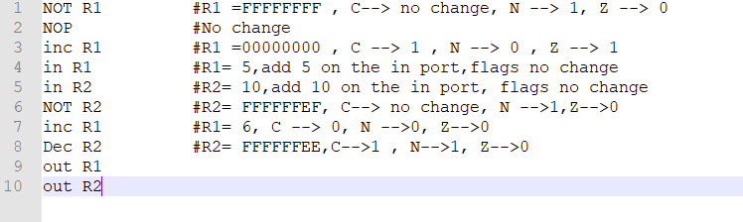

(Fig. 1)

## Without forwarding units and hazard detection units

* **Hazards detected:**
* Read after write hazard detected between instruction 1 and instruction 3 (Look Fig. 1).

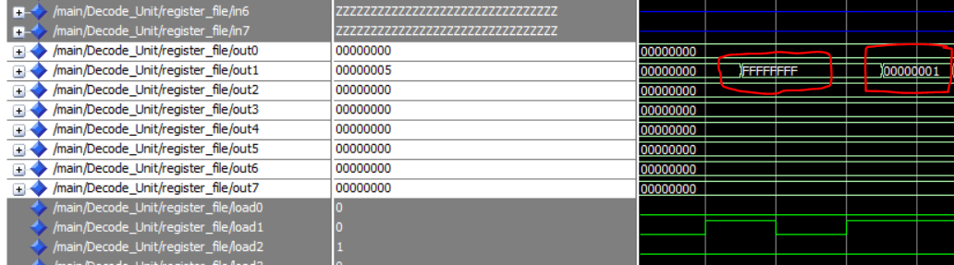

(Fig. 2)

As shown in (Fig. 2) (a screenshot from our simulation wave), R1 (out1) was incremented on the old value (00000000) not the new one (FFFFFFFF) so it became 00000001, however the correct result is 00000000.

* Read after write hazard detected between instruction 5 and instruction 6 (Look Fig. 1).

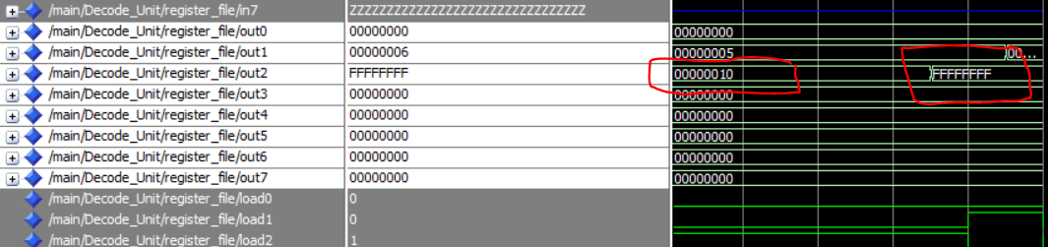

. (Fig. 3)

As shown (Fig. 3) R2 is “FFFFFFFF” which is the not operation of “00000000” (the old value), however the correct answer is “FFFFFFEF” which is the not operation of (“00000010”) which is taken from the input port.

* Read after write hazard detected between instruction 6 and instruction 8 (Look Fig. 1)

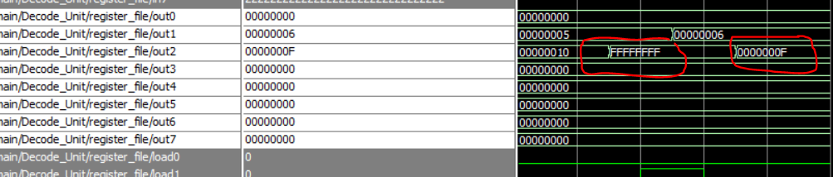. (Fig. 4)

* Read after write hazard detected between instruction 8 and instruction 10 (Look Fig. 1)
* Read after write hazard detected between instruction 7 and instruction 9 (Look Fig. 1)

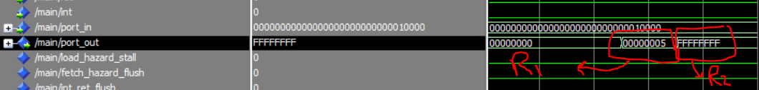

(Fig. 5)

As shown in (Fig. 5), the out port contains wrong values of R1, and R2. The correct values should have been “00000006” and “FFFFFFE”. This happened because of a lot of read after write hazards.

* **Solving the hazards by inserting “nop” in the code**

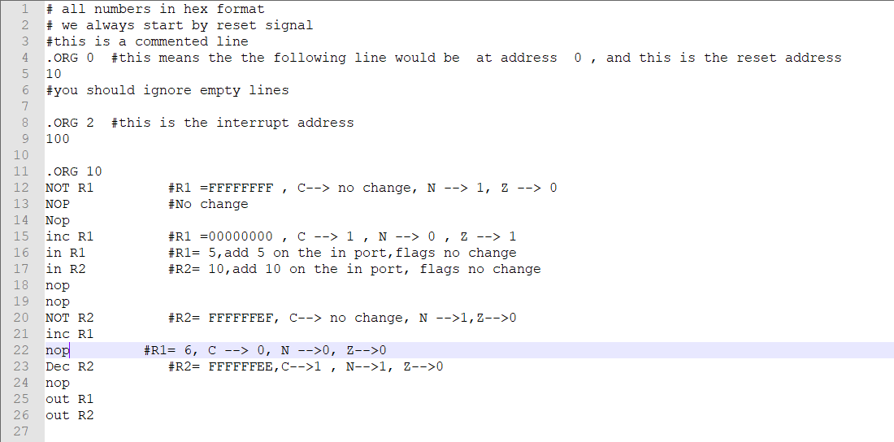

(Fig. 6)

As shown in (Fig. 6), we inserted no operations between any dependencies to prevent hazards. The output port contains the right values after these modifications (look Fig. 7).

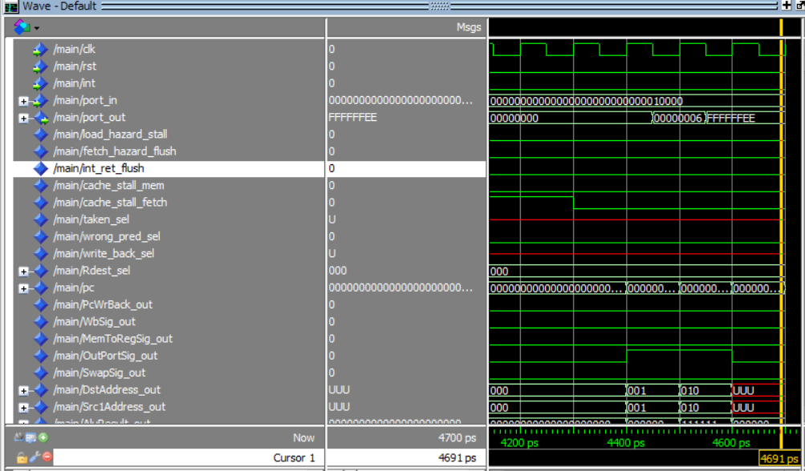

(Fig. 7)

## With the forwarding units added

By adding the forwarding units there is no hazards and the output was correct (look Fig. 8)

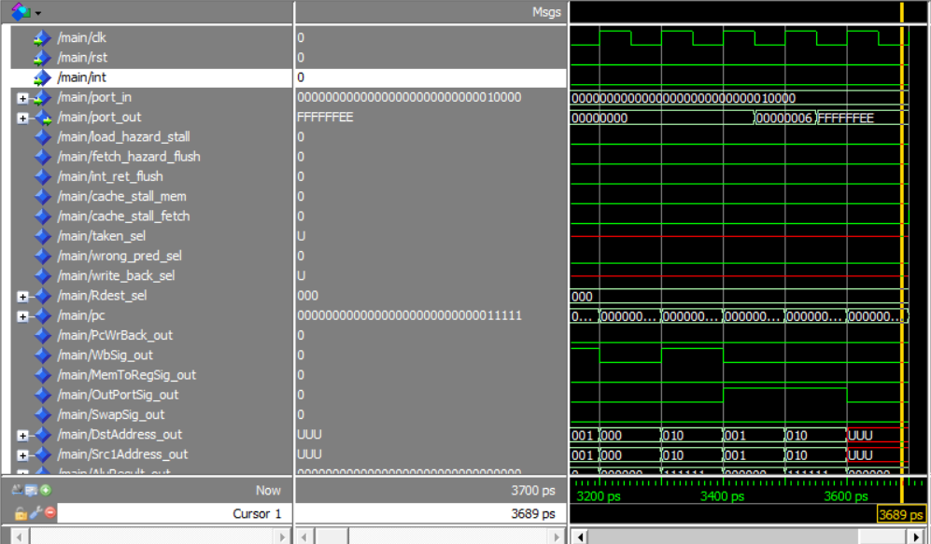

(Fig. 8)

## Speed up due to adding forwarding units

As shown in (Fig. 7), in case of no forwarding units and handling hazards by inserting no operations, the program is executed in 4600 ps.

As shown in (Fig. 8), after adding all forwarding units, the program is executed in 3600 ps.

**So the speed up equals (4600/3600) 1.278.**

# Two operands

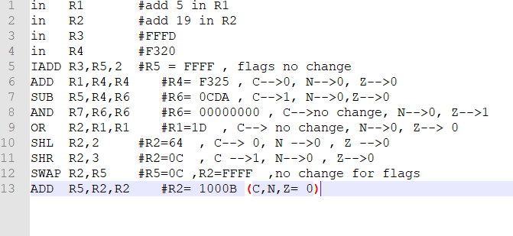

(Fig. 10)

## Without forwarding units

* **Hazards detected**
* Read after write hazard detected between instruction 3 and instruction 5 (see Fig. 10)

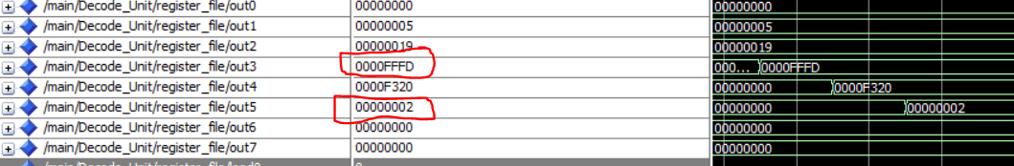

(Fig. 11)

As shown in (Fig. 11) R5 is 00000002 not FFFF, this happened because that instruction 5 depends on instruction 3 which has not written back in R3 yet.

* Read after write hazard detected between instruction 7 and instruction 5 and 6. See (Fig. 12)

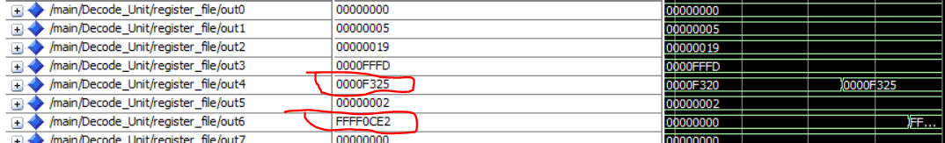

(Fig. 12)

* Read after write hazard detected between instruction 7 and instruction 8.
* Read after write hazard detected between instruction 10 and instruction 11. See (Fig. 13)

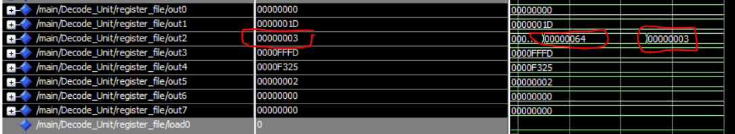

(Fig. 13)

* Read after write hazard detected between instruction 12 and instruction 11. See (Fig. 14)

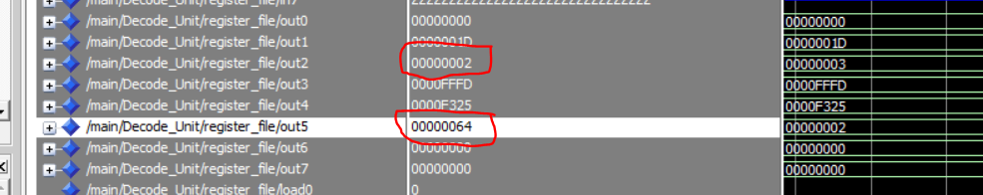

(Fig. 14)

* Read after write hazard detected between instruction 12 and instruction 13
* **Solving the hazards by inserting no operations**

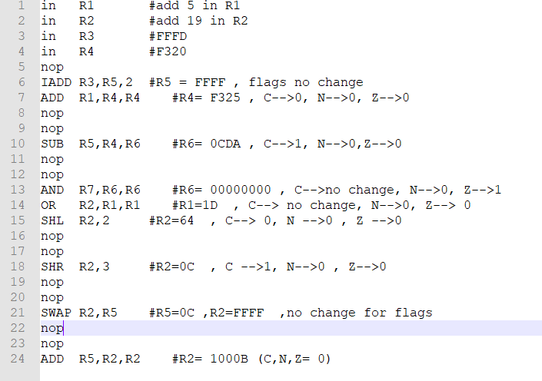

(Fig. 15)

As shown in (Fig. 15), we inserted no operations between any dependencies to prevent hazards. The output contains the right values after these modifications (look Fig. 16).

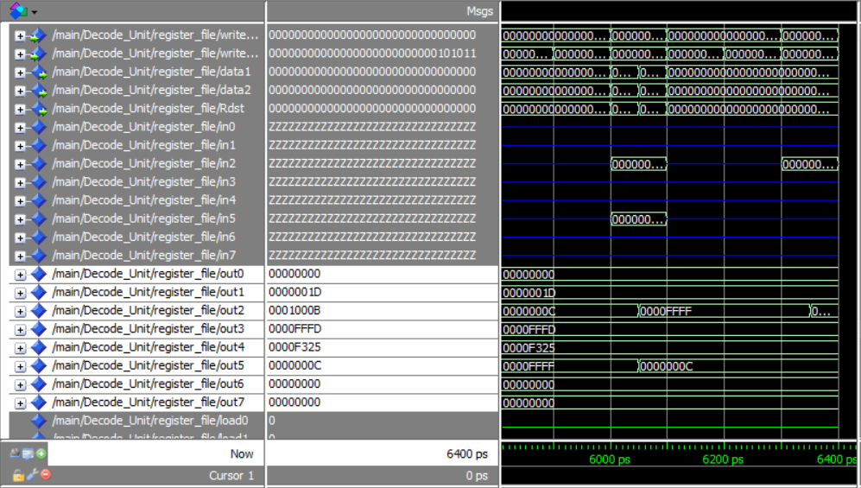

(Fig. 16)

## With the forwarding units added

By adding the forwarding units there is no hazards and the output was correct (look Fig. 17)

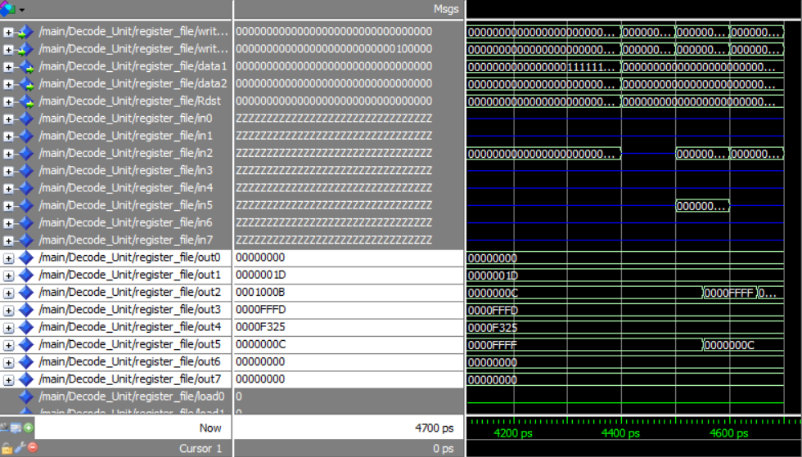

(Fig. 17)

## Speed up due to adding the forwarding units.

As shown in (Fig. 16), in case of no forwarding units and handling hazards by inserting no operations, the program is executed in 6400 ps.

As shown in (Fig. 17), after adding all forwarding units, the program is executed in 4600 ps.

**So the speed up = 6400/4600 = 1.4.**

# Memory

Note ram is filled with garbage (UUUUU ) in the beginning.

Assuming cache is 1 indexed.

## Code

|  |
| --- |
| .ORG 2 #this is the interrupt address  100  .ORG 10  **in** R2 #R2**=**0CDAFE19 **add** 0CDAFE19 **in** R2  **in** R3 #R3**=**FFFF  **in** R4 #R4**=**F320  LDM R1**,**F5 #R1**=**F5  **PUSH** R1 #**SP=**7FC**,** M**[**7FE**,** 7FF**]** **=** F5  **PUSH** R2 #**SP=**7FA**,**M**[**7FC**,** 7FD**]=**0CDAFE19  **POP** R1 #**SP=**7FC**,**R1**=**0CDAFE19  **POP** R2 #**SP=**7FE**,**R2**=**F5  **STD** R2**,**200 #M**[**200**,** 201**]=**F5  **STD** R1**,**202 #M**[**202**,** 203**]=**0CDAFE19  LDD R3**,**202 #R3**=**0CDAFE19  LDD R4**,**200 #R4**=**5 |
|  |

## Without Forward unit and hazard detection

* Read after write in PUSH R1
  + cache[ 32 ][ 4 ] = F5 cache[ 32 ][ 4 ] = 0

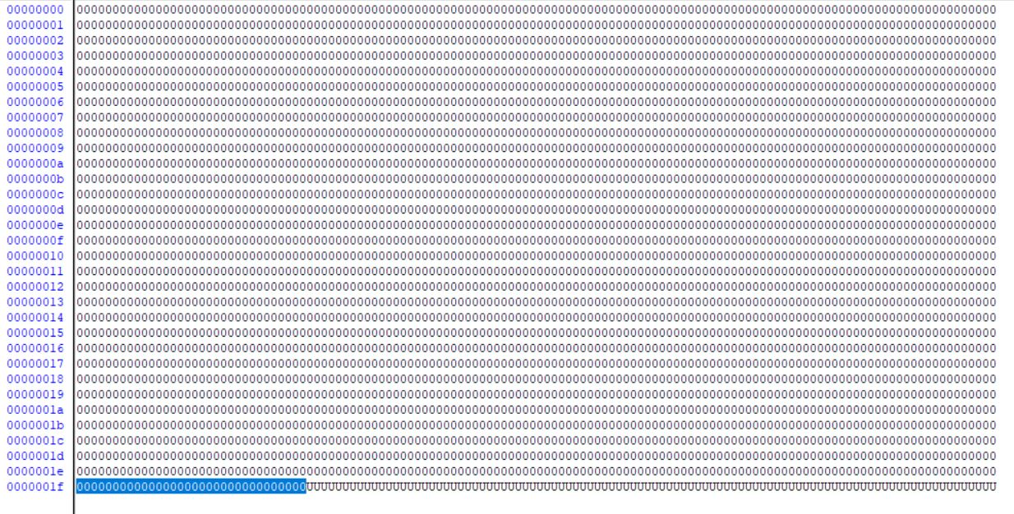

* Read after write in STD R2,200
  + cache[ 0 ][ 0 ] = 0 depending on wrong push cache[ 0 ][ 0 ] = 0CDAFE19

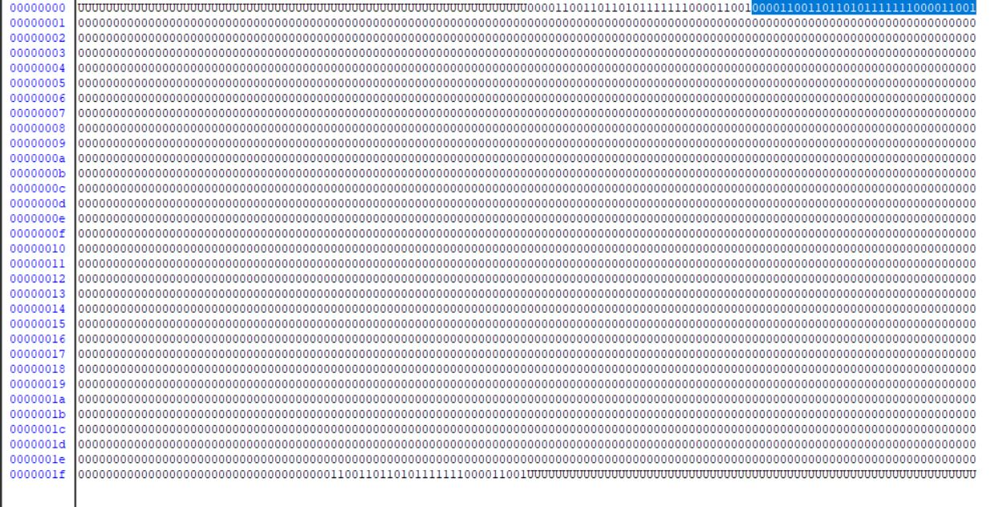

Solution : add **2** no operations before **each** hazard.

## With Forward unit only

* Read after write in STD R2,200

Forward unit forwards wrong data ( sp ) as no hazard detection unit to stall processor [ load use case ]

* + cache[ 0 ][ 0 ] = F5 cache[ 0 ][ 0 ] = FFFFFFFE

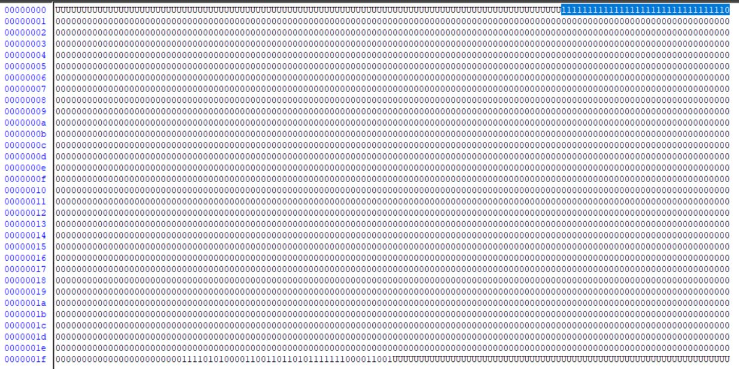

* Solution to add **2** no operations before STD R2,200

## With Forward unit and hazard detection

* Registers values are valid

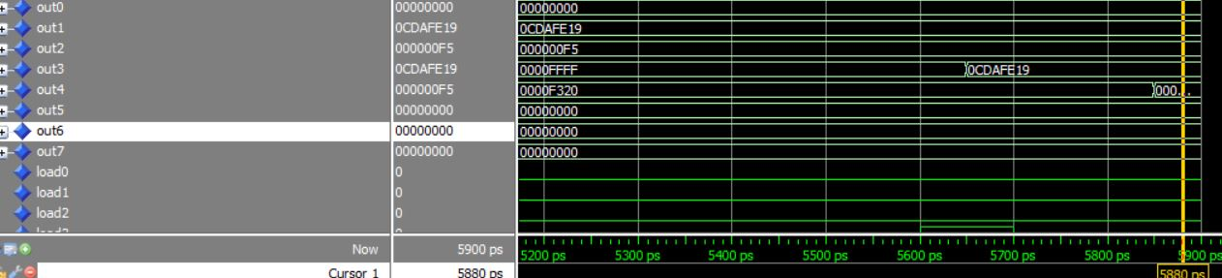

* Memory data is valid

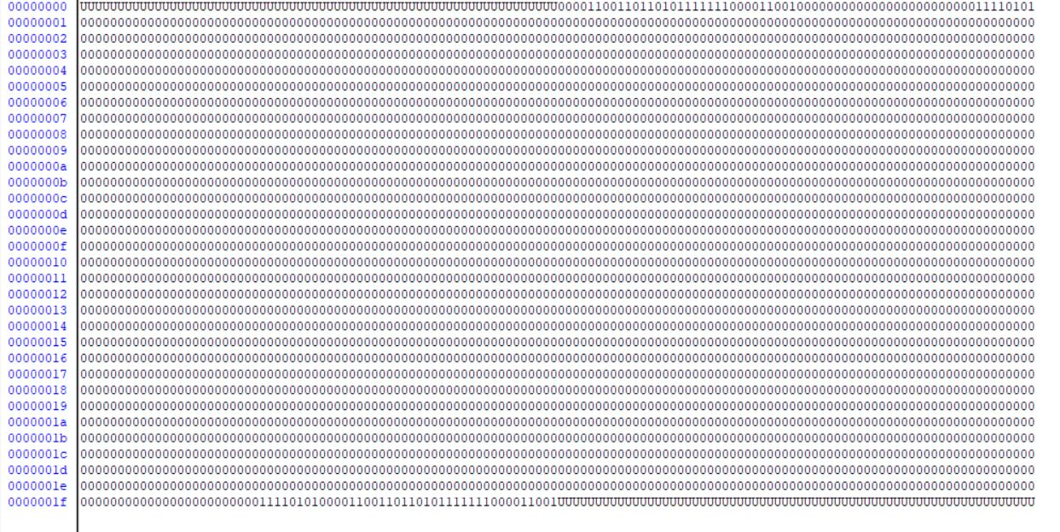

Hazard detection units are important for validating data.

The forward unit overcomes two installs which will also increase 4 cycles to fetch new block from ram to instruction cache.

Speed up = (6500/5900) = 1.1

# Cache

Substitute call R0 → jmp r0.

Ret → LDM R7, 1B

JMP R7

So returning 3B is impossible so the test case is valid until 18850ps.

## Without Forward unit and hazard detection

* Read after write line 49 : STD R6,312
  + cache[ 3 ][ 2 ] = 0 cache[ 3 ][ 2 ] = 0

Lucky wrong data is the same as valid data

Error is repeated each iteration

Solution : add 2 no operations before this instruction

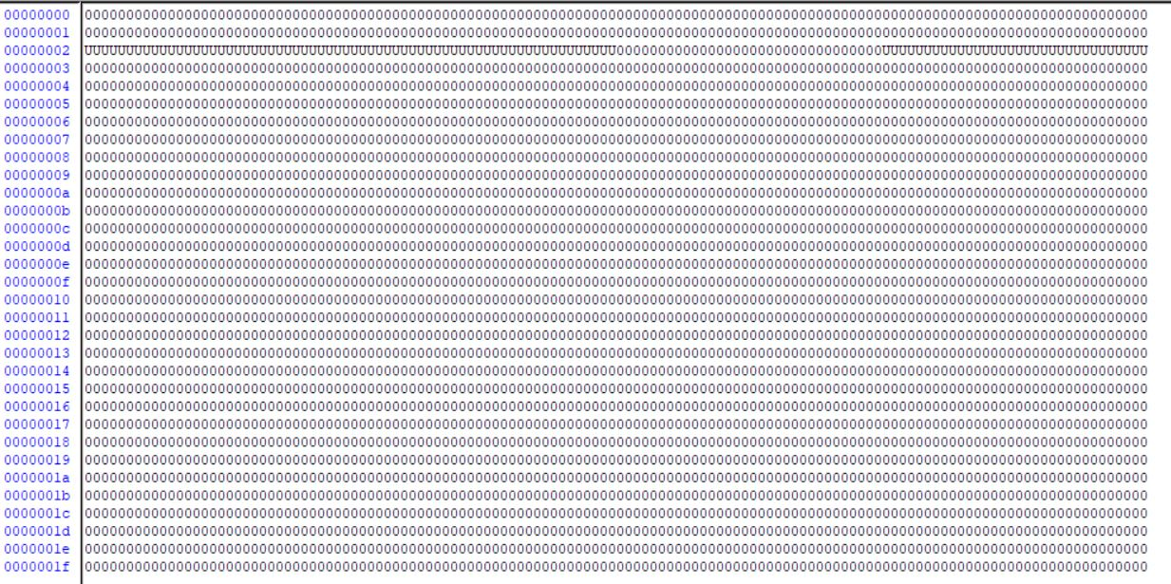

* Read after write line 53 : OR R5,R5,R6
  + R[6] = 1 R[6] = 0

Error is repeated each iteration

Solution : add 2 no operations before this instruction

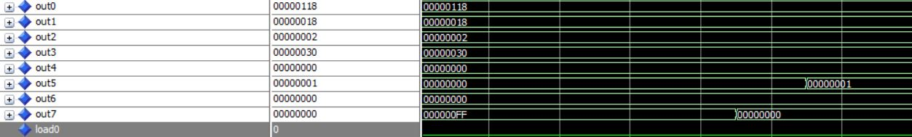

Having no flushes will execute two instructions after each jump or call.

## With forward unit

* All problems are solved

R[6] = 1 after OR R5,R5,R6

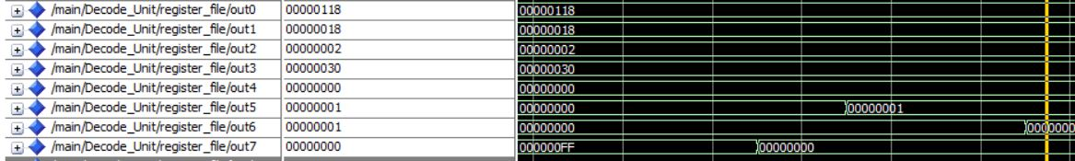

Adding a Hazard detection unit won’t change anything as forward units solves all problems.

Using forward units the test case runs at 18850ps.

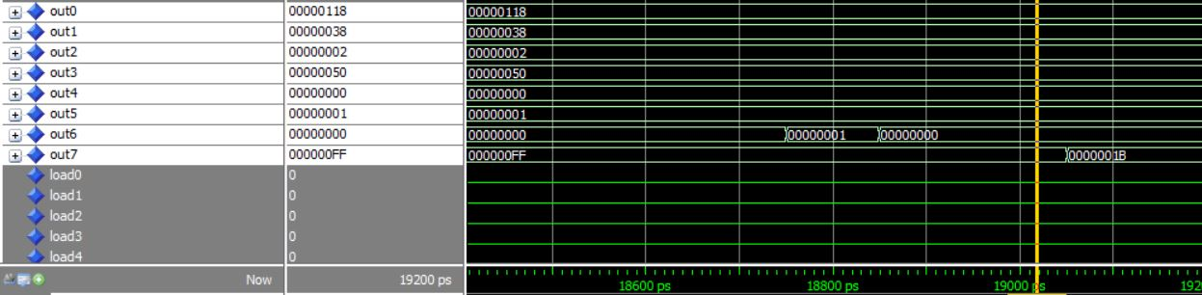

Inserting stalls the case runs at 20600ps.

Speed up = (20600/18850) = 1.09

# Branch

## Unhandled instructions

* CALL instruction: replaced with JMP.
* RET instruction: replaced with LDM with any not used reg and JMP.

## Modified code

.ORG 0 #this means the the following line would be at address 0 **,** **and** this is the reset address

10

#you should ignore empty lines

.ORG 2 #this is the interrupt address

100

.ORG 10

**in** R1 #R1**=**30

**in** R2 #R2**=**50

**in** R3 #R3**=**100

**in** R4 #R4**=**300

**in** R6 #R6**=**FFFFFFFF

**in** R7 #R7**=**FFFFFFFF

**Push** R4 #**sp=**7FC**,** M**[**7FE**,** 7FF**]=**300

**JMP** R1

**INC** R7 # this statement shouldn't be executed,

#check flag forwarding

.ORG 30

**AND** R1**,**R5**,**R5 #R5**=**0 **,** Z **=** 1

#try interrupt here

**JZ** R2 #Jump taken**,** Z **=** 0

**INC** R7 #this statement shouldn't be executed

#check on flag updated on jump

.ORG 50

**JZ** R3 #Jump **Not** taken

#check destination forwarding

**NOT** R5 #R5**=**FFFFFFFF**,** Z**=** 0**,** **C-->** **not** change**,** N**=**1

**INC** R5 #R5**=**0**,** Z**=**1**,** **C=**1**,** N**=**0

**in** R6 #R6**=**200**,** flag no change

**JZ** R6 #jump taken**,** Z **=** 0

**INC** R1 #this statement shouldn't be executed

.ORG 100

**ADD** R0**,**R0**,**R0 #N**=**0**,**Z**=**1**,C=**0

**out** R6

rti

#check on load use

.ORG 200

**POP** R6 #R6**=**300**,** **SP=**7FE

**JMP** R6 #**SP=**7FC**,** M**[**7FF**]=**half next PC**,**M**[**7FE**]=**other half next PC

#try interrupt here

**INC** R6 #R6**=**401**,** this statement shouldn't be executed till call returns, C--> 0, N-->0,Z-->0

**NOP**

**NOP**

.ORG 300

**Add** R3**,**R6**,**R6 #R6**=**400

**Add** R1**,**R2**,**R1 #R1**=**80**,** **C->**0**,**N**=**0**,** Z**=**0

LDM R0**,** 202

**JMP** R0

**INC** R7 #this should **not** be executed

.ORG 500

**NOP**

**NOP**

## Without Forward unit and hazard detection

* + **Hazards types:**
    - Control hazards as in lines 20 and 21:

**JMP** R1

**INC** R7 # this statement shouldn't be executed.

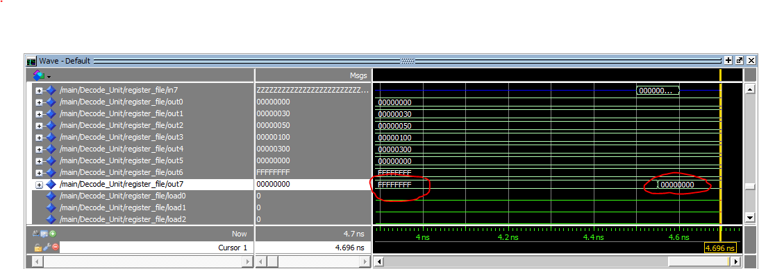

As shown in the figure: the increment instruction is executed.

Similarly, for the instructions in lines 38 and 39.

**JZ** R6 #jump taken**,** Z **=** 0

**INC** R1 #this statement shouldn't be executed

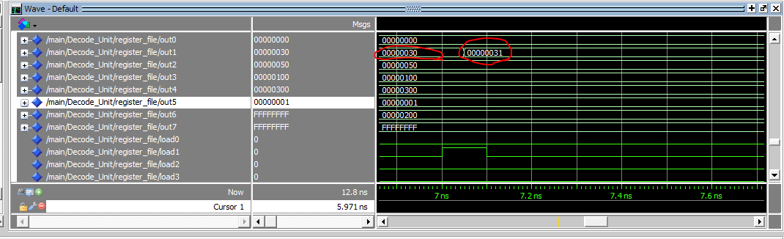

* Data hazards:

1. Read after write for R5 in lines 35 and 36:

**NOT** R5 #R5**=**FFFFFFFF**,** Z**=** 0**,** **C-->** **not** change**,** N**=**1

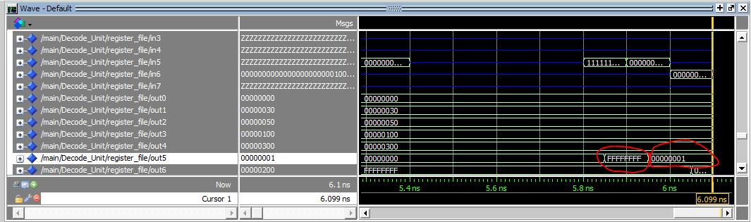**INC** R5 #R5**=**0**,** Z**=**1**,** **C=**1**,** N**=**0

As shown in the figure the increment instruction is executed on the old value of R5 which is zero instead of using the new value resulted after not instruction.

1. Read after write for R6 in lines 37 and 38:

**NOT** R5 #R5**=**FFFFFFFF**,** Z**=** 0**,** **C-->** **not** change**,** N**=**1

**INC** R5 #R5**=**0**,** Z**=**1**,** **C=**1**,** N**=**0

**in** R6 #R6**=**200**,** flag no change

**JZ** R6 #jump taken**,** Z **=** 0

**INC** R1 #this statement shouldn't be executed

Another problem is that Zero flag is lost due to data hazard in R5. So, the jump will not be executed and the increment instruction will be executed as shown in the figures.

1. Load use case for R6 in lines 48 and 49:

**POP** R6 #R6**=**300**,** **SP=**7FE

**JMP** R6 #**SP=**7FC**,** M**[**7FF**]=**half next PC**,**M**[**7FE**]=**other half next PC

* + **Solving hazards using no operations the processor ends in 12350 ps with following code:**

.ORG 0 #this means the the following line would be at address 0 **,** **and** this is the reset address

10

#you should ignore empty lines

.ORG 2 #this is the interrupt address

100

.ORG 10

**in** R1 #R1**=**30

**in** R2 #R2**=**50

**in** R3 #R3**=**100

**in** R4 #R4**=**300

**in** R6 #R6**=**FFFFFFFF

**in** R7 #R7**=**FFFFFFFF

**nop**

**Push** R4 #**sp=**7FC**,** M**[**7FE**,** 7FF**]=**300

**JMP** R1

**INC** R7 # this statement shouldn't be executed,

#check flag forwarding

.ORG 30

**AND** R1**,**R5**,**R5 #R5**=**0 **,** Z **=** 1

**JZ** R2 #Jump taken**,** Z **=** 0

**INC** R7 #this statement shouldn't be executed

#check on flag updated on jump

.ORG 50

**JZ** R3 #Jump **Not** taken

#check destination forwarding

**NOT** R5 #R5**=**FFFFFFFF**,** Z**=** 0**,** **C-->** **not** change**,** N**=**1

**Nop**

**Nop**

**INC** R5 #R5**=**0**,** Z**=**1**,** **C=**1**,** N**=**0

**in** R6 #R6**=**200**,** flag no change

**nop**

**nop**

**JZ** R6 #jump taken**,** Z **=** 0

**INC** R1 #this statement shouldn't be executed

.ORG 100

**ADD** R0**,**R0**,**R0 #N**=**0**,**Z**=**1**,C=**0

**out** R6

rti

#check on load use

.ORG 200

**POP** R6 #R6**=**300**,** **SP=**7FE

**nop**

**nop**

**jmp** R6 #**SP=**7FC**,** M**[**7FF**]=**half next PC**,**M**[**7FE**]=**other half next PC

**nop**

**nop**

**INC** R6 #R6**=**401**,** this statement shouldn't be executed till call returns, C--> 0, N-->0,Z-->0

**NOP**

**NOP**

.ORG 300

**Add** R3**,**R6**,**R6 #R6**=**400

**Add** R1**,**R2**,**R1 #R1**=**80**,** **C->**0**,**N**=**0**,** Z**=**0

LDM R0**,** 204

**nop**

**nop**

**jmp** R0

**nop**

**nop**

**INC** R7 #this should **not** be executed

.ORG 500

**NOP**

**NOP**

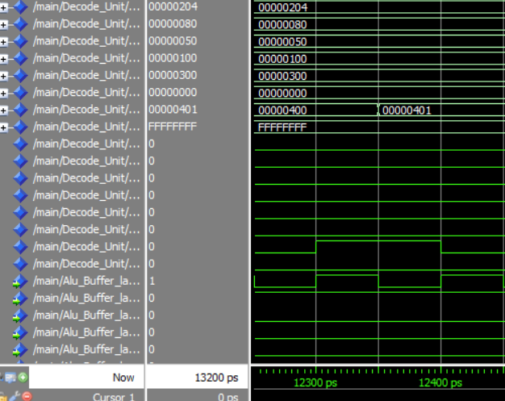

## With forwarding unit

* + **Hazards types:**
  + Control hazards as in lines 20 and 21:

**JMP** R1

**INC** R7 # this statement shouldn't be executed.

Similarly, for the instructions in lines 38 and 39.

**JZ** R6 #jump taken**,** Z **=** 0

**INC** R1 #this statement shouldn't be executed

* + **Solving hazards by stalling fetch when a branch operation is in the fetch stage until jmp is executed and Pc is updated :**

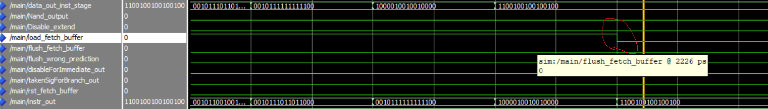

This is result with full forwarding and hazards removal which runs in 9950 ps

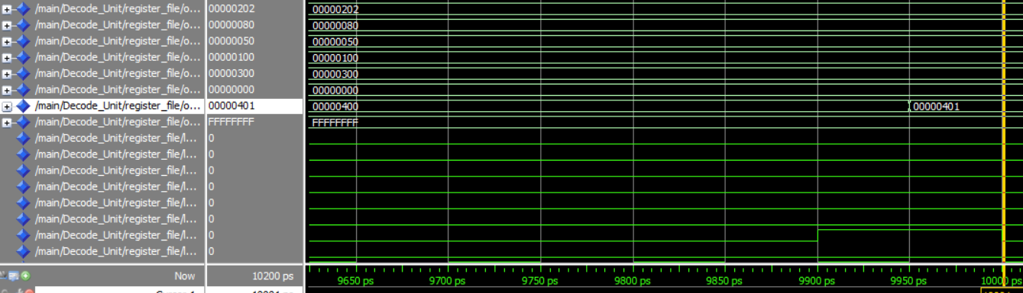

## Calculating Speed up on using both forwarding and hazard detection units

Speed up = (12350/9950)=1.24

# 

# Not working modules

* Branch prediction is not working correctly.it is fully implemented but there is a bug and there is no time to fix it.