# Blog App

## Overview

This is a blog application built using the MERN stack, with a focus on creating a dynamic and interactive platform for writing and reading blog posts.

## Table of Contents

* Setup Instructions
* Designing Phase
* Planning Phase
* Coding Phase
* Testing Phase
* Deployment Phase

## Setup Instructions

* run front-end part npm i npm run dev
* run backend part npm i npm run watch ## Designing Phase

During the designing phase, we focused on the overall user experience and interface of the blog app.

**Design Mockups**

* **Home Page Design** 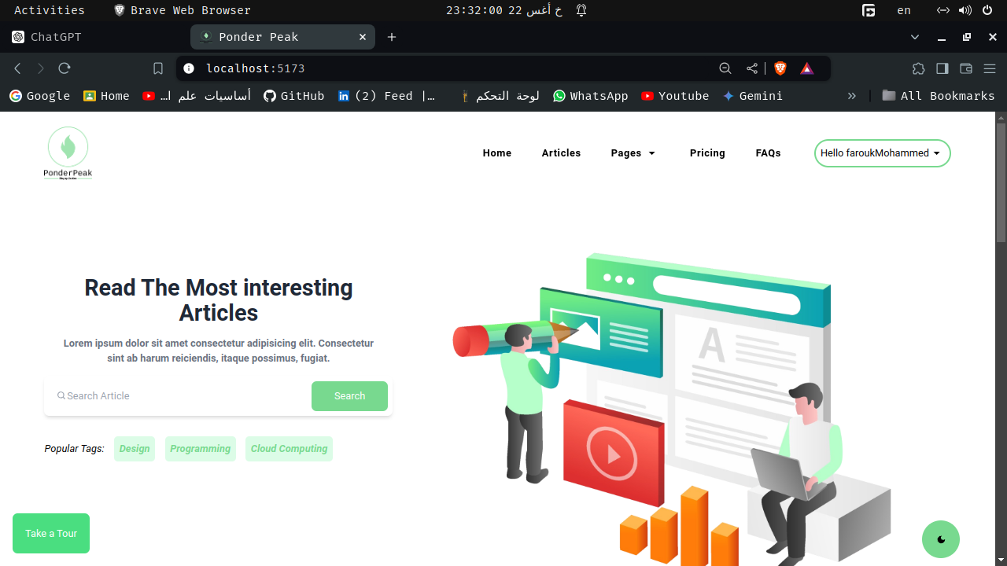
* **Post Page Design** 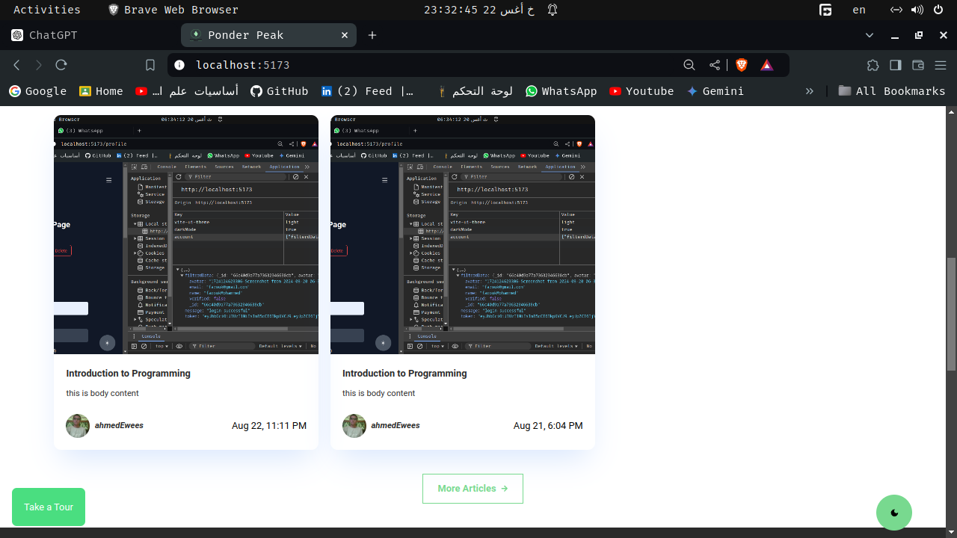
* **single post page** 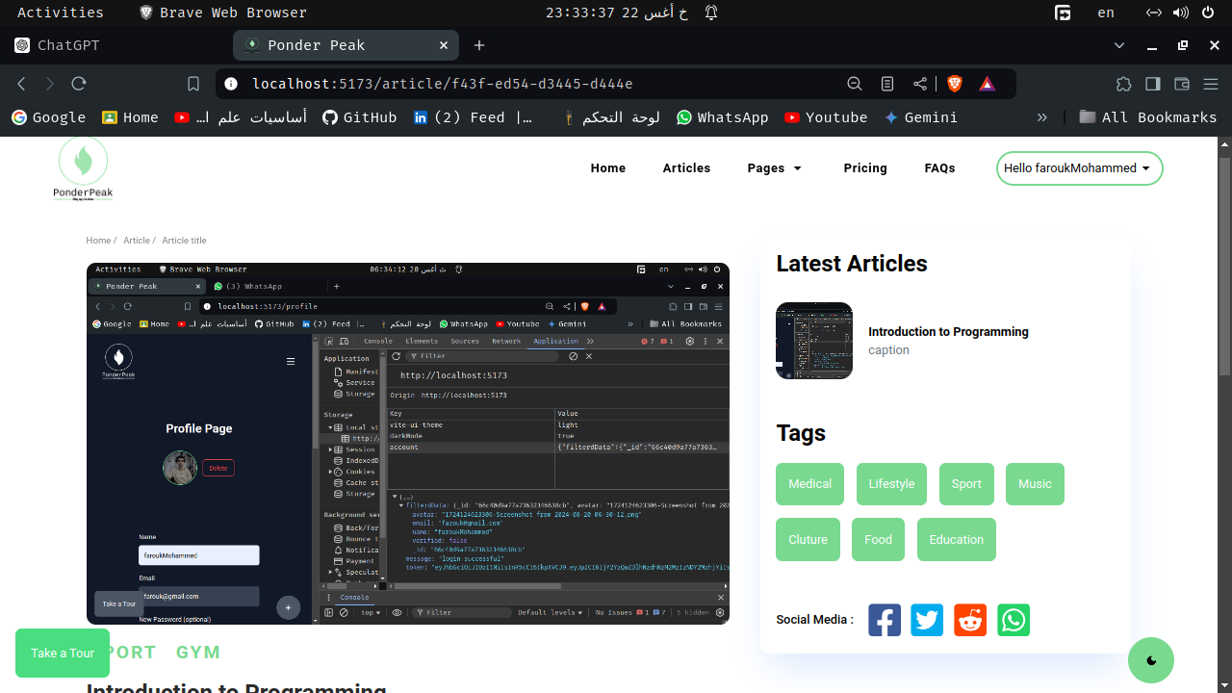
* **Login Page** 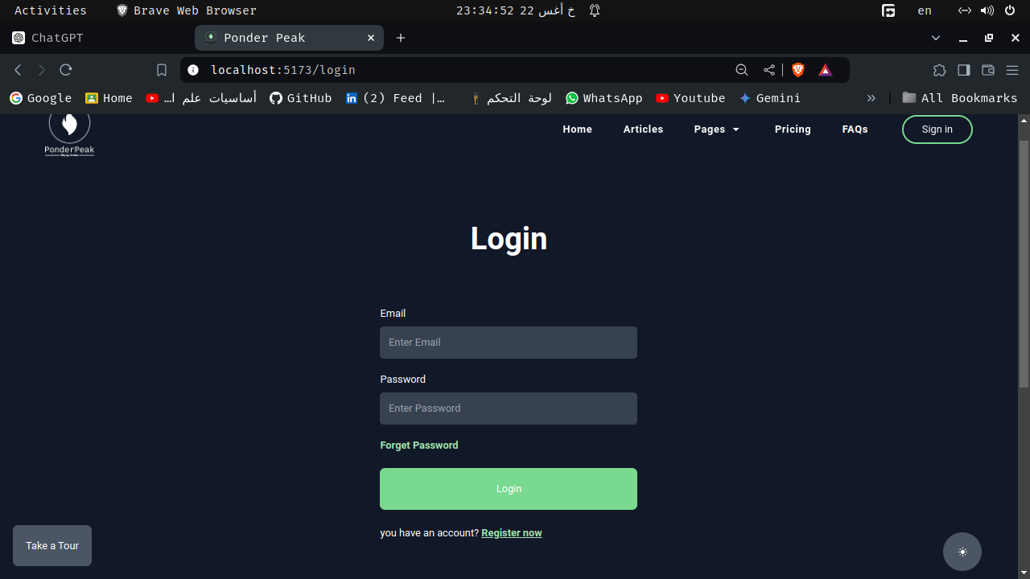
* **Register Page** 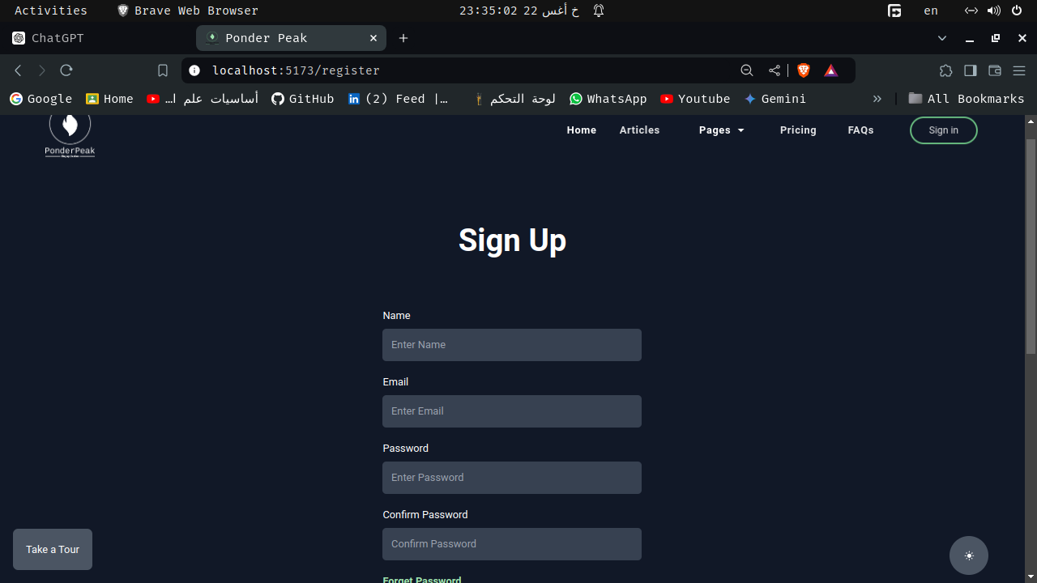
* **Profile Page** 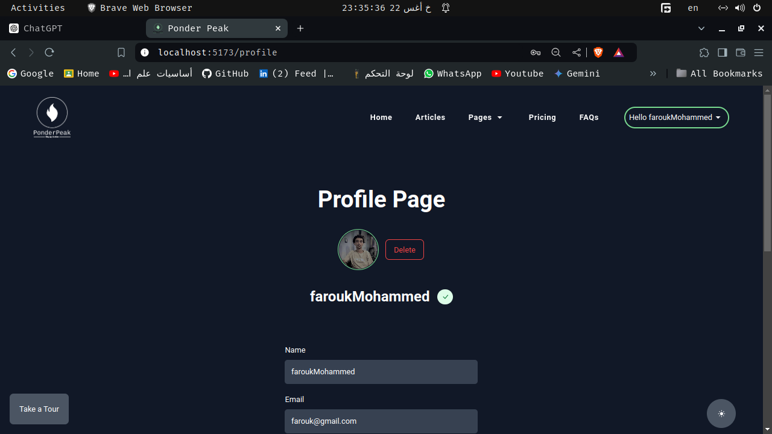
* **Create Post Page** 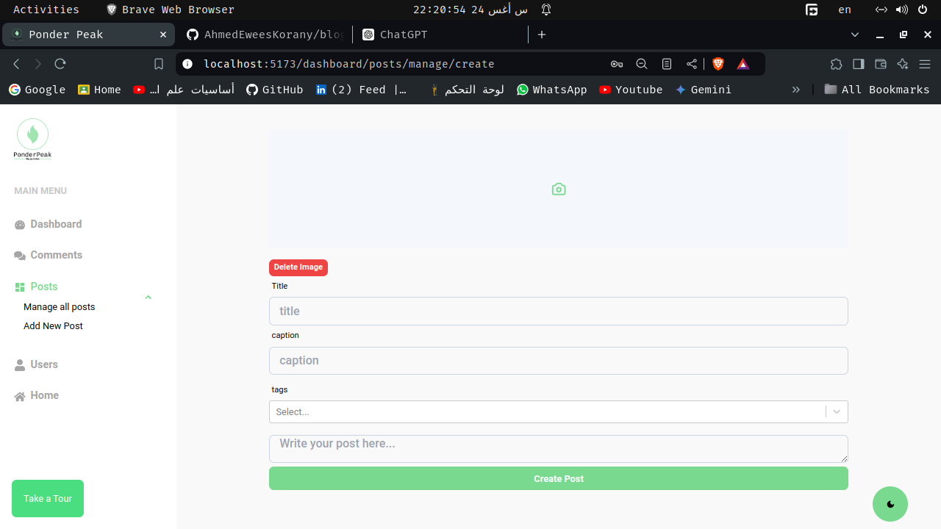
* **Edit Post Page** 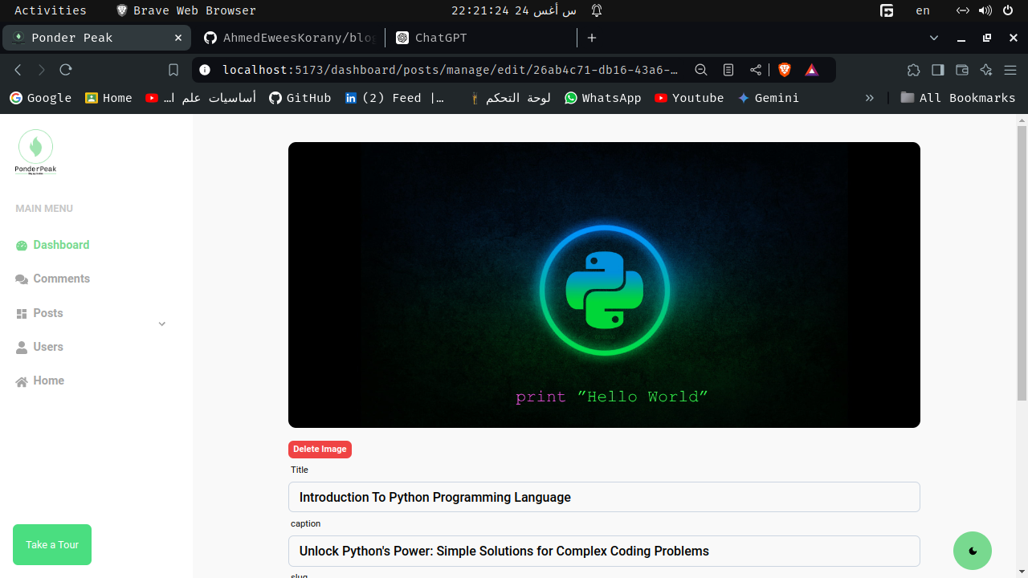
* **Manage Post Page** 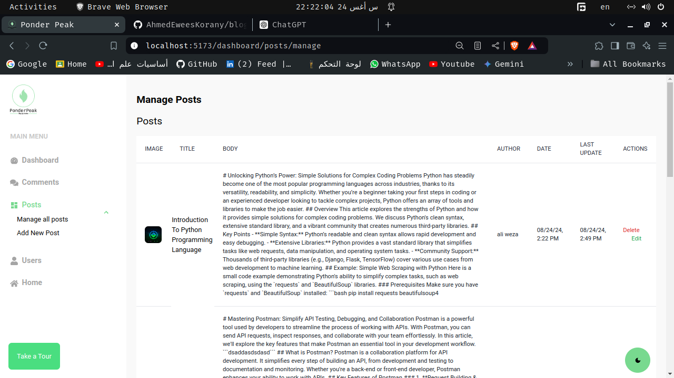
* **Mange Users Page** 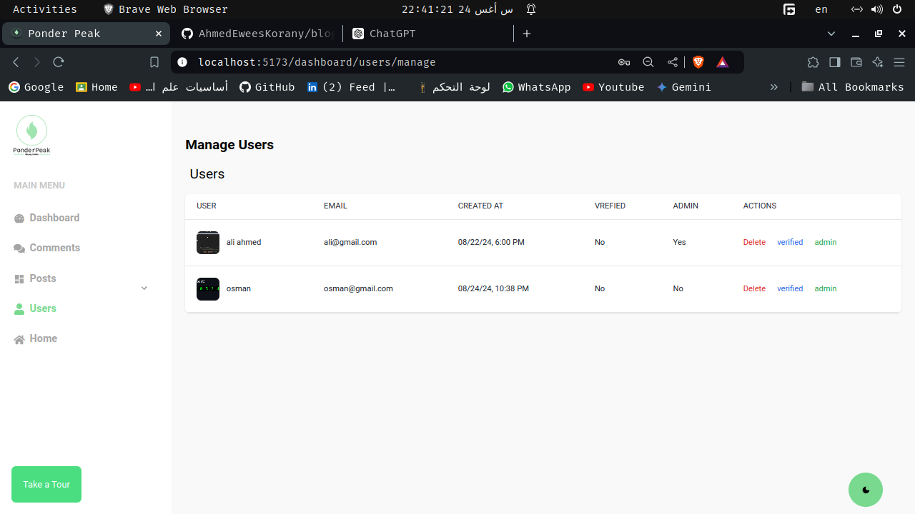
* **Manage Commments Page** 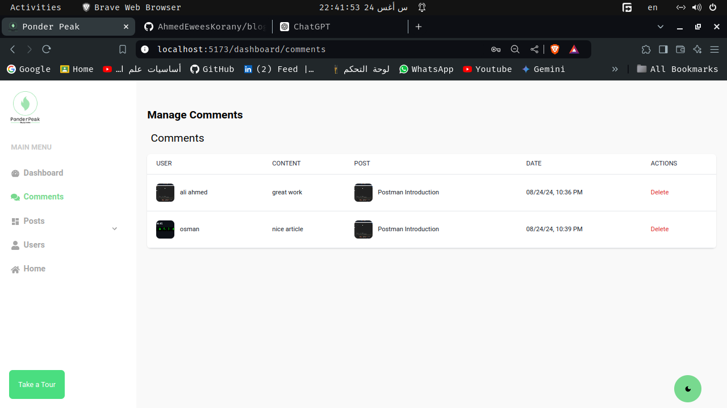

**Design Tools Used:**

* Figma for UI/UX design
* Adobe XD for interactive prototypes
* Dark Mode Support
* **dark mode**  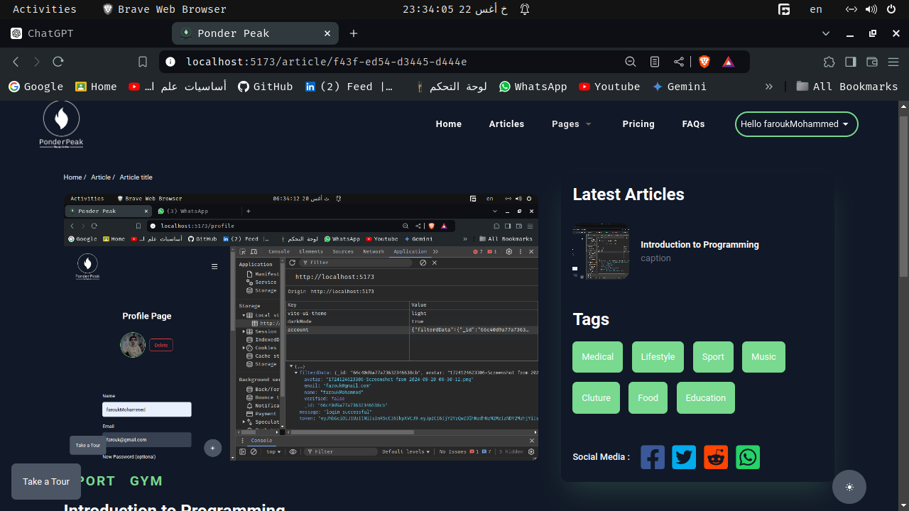
* **Light Mode** 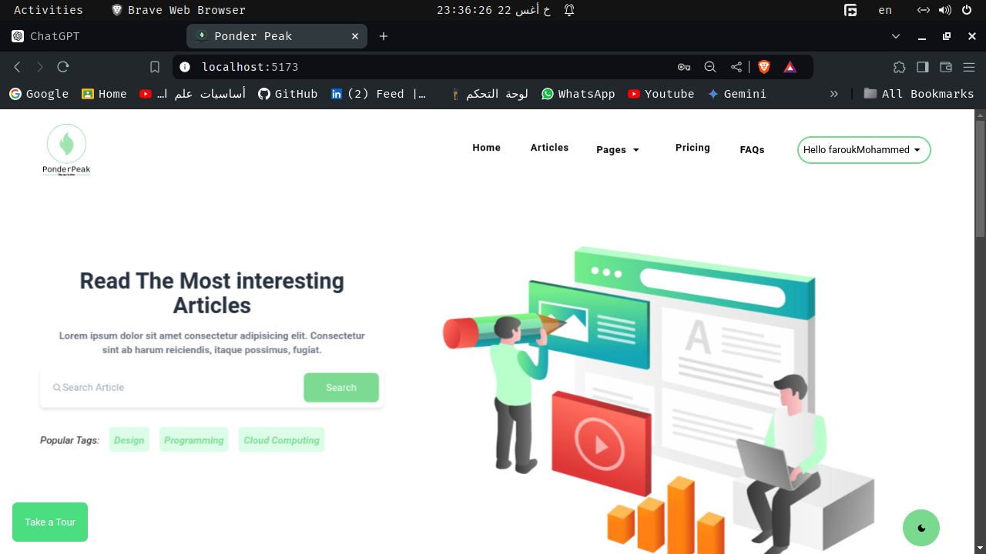
* **Responsive Design** 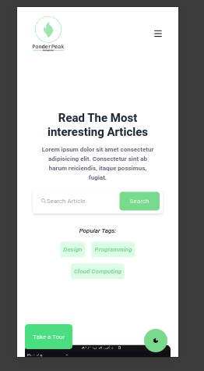

## Planning Phase

In the planning phase, we outlined the architecture and features of the blog app.

**Project Architecture**

* **Front-end:** React, Tailwind CSS
* **Back-end:** Node.js, Express
* **Database:** MongoDB

**Features to Implement:**

* User Authentication (Register, Login, Logout)
* Create, Read, Update, Delete (CRUD) for Blog Posts
* Commenting System
* Search and Filter Posts

**Technical Specifications:**

* REST API for server-client communication
* Responsive design for mobile and desktop views

## Coding Phase

The coding phase involved implementing the design and functionality as planned.

**Front-end Implementation**

* **React Components:**
  + HomePage
  + PostPage
  + Auth components (Login, Register)
* **Styling:**
  + Tailwind CSS for utility-first styling

**Back-end Implementation**

* **Express Routes:**
  + /api/posts - For CRUD operations on posts
  + /api/users - For user authentication
* **Database Models:**
  + Post Model
  + User Model

**Code Examples:**

* **React Component Example:** ```jsx import React from ‘react’;
* const Post = ({ title, content }) => (
* <h1>{title}</h1>  
  <p>{content}</p>
* );
* export default Post;
* **Node js Code Example:**

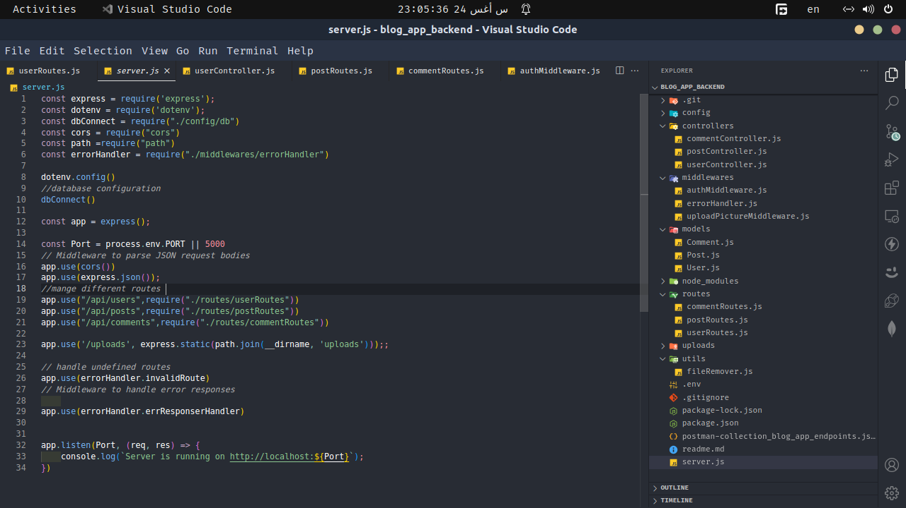

alt text

– **MongoDB Code Example:** 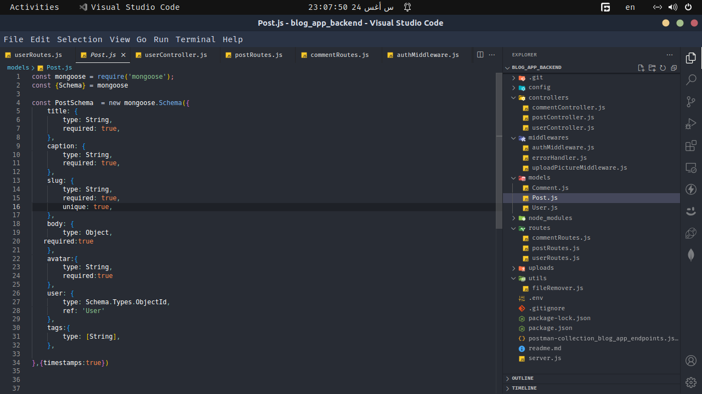

* **Update profile picture frontend code:** 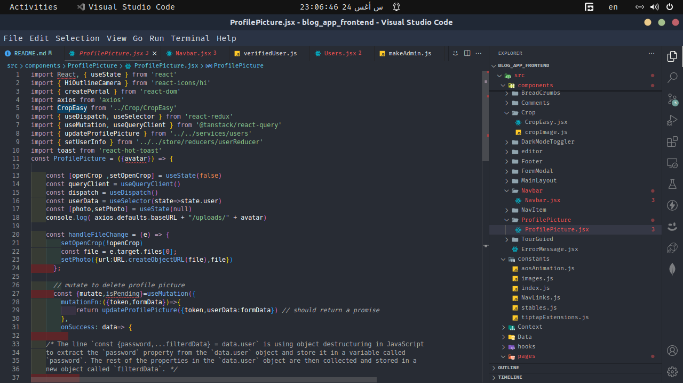 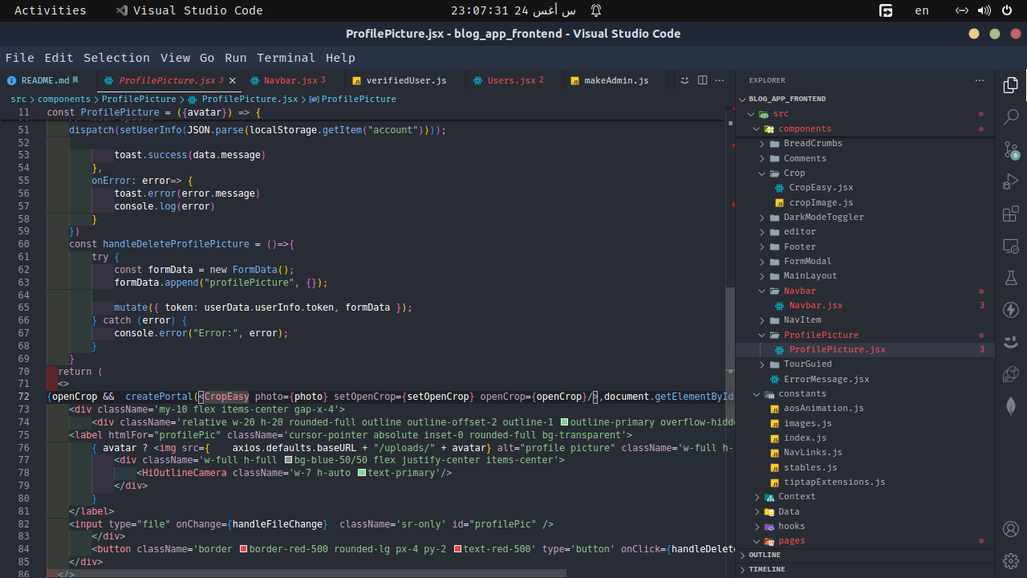 ## Testing Phase

Testing ensured that the blog app functions as expected and is free of major bugs. We used Postman to test the API endpoints.

**API Testing with Postman**

In this phase, we performed various tests on the API endpoints to verify their functionality and correctness. Below are some examples of how we tested different routes using Postman.

### Endpoints Tested

1. **Get All Posts**
   * **Request Type:** GET
   * **Endpoint:** /api/posts
   * **Description:** Retrieves a list of all blog posts.
   * **Postman Request:** 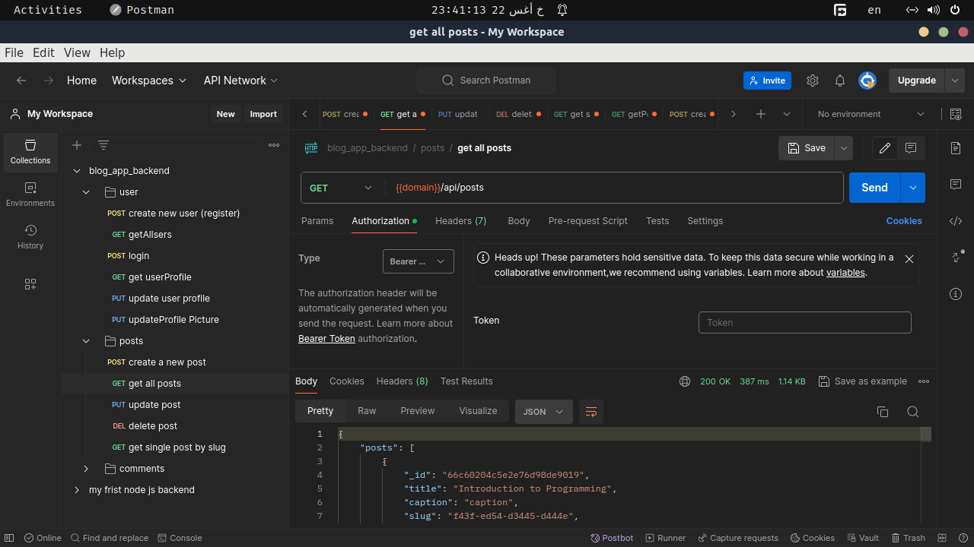
   * **Expected Response:**
   * [  
      {  
      "id": "1",  
      "title": "First Post",  
      "content": "This is the content of the first post."  
      },  
      {  
      "id": "2",  
      "title": "Second Post",  
      "content": "This is the content of the second post."  
      }  
     ]
2. **Create a New Post**
   * **Request Type:** POST
   * **Endpoint:** /api/posts
   * **Description:** Creates a new blog post.
   * **Postman Request:** 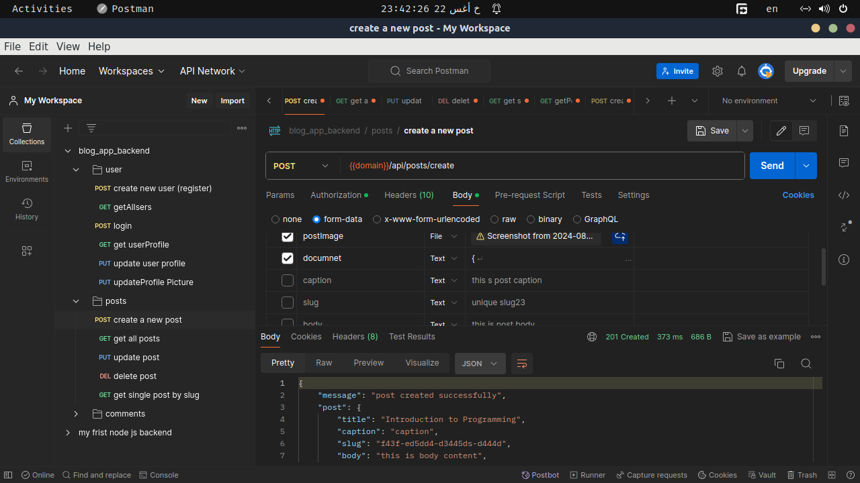
   * **Request Body:**
   * {  
      "title": "New Post",  
      "content": "This is the content of the new post."  
     }
   * **Expected Response:**
   * {  
      "id": "3",  
      "title": "New Post",  
      "content": "This is the content of the new post."  
     }
3. **Update a Post**
   * **Request Type:** PUT
   * **Endpoint:** /api/posts/:id
   * **Description:** Updates an existing blog post by ID.
   * **Postman Request:** 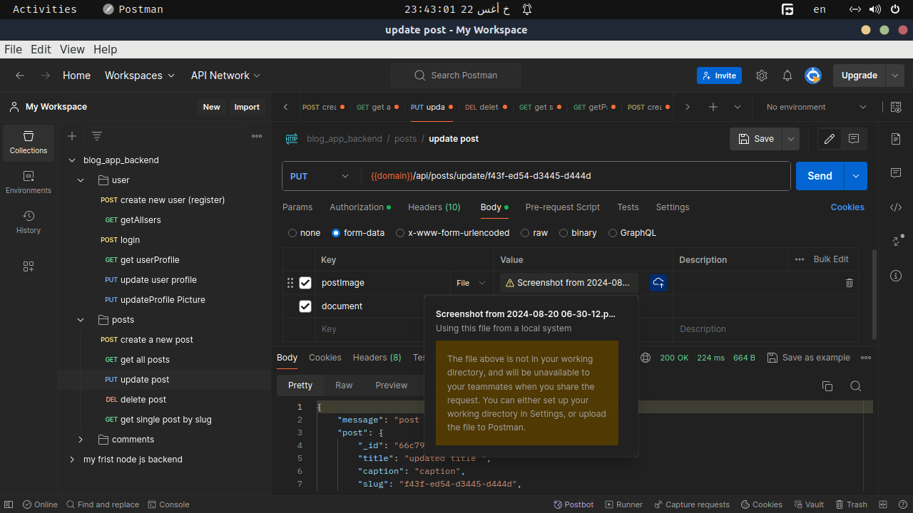
   * **Request Body:**
   * {  
      "title": "Updated Post Title",  
      "content": "Updated content of the post."  
     }
   * **Expected Response:**
   * {  
      "id": "1",  
      "title": "Updated Post Title",  
      "content": "Updated content of the post."  
     }
4. **Delete a Post**
   * **Request Type:** DELETE
   * **Endpoint:** /api/posts/:id
   * **Description:** Deletes a blog post by ID.
   * **Postman Request:** 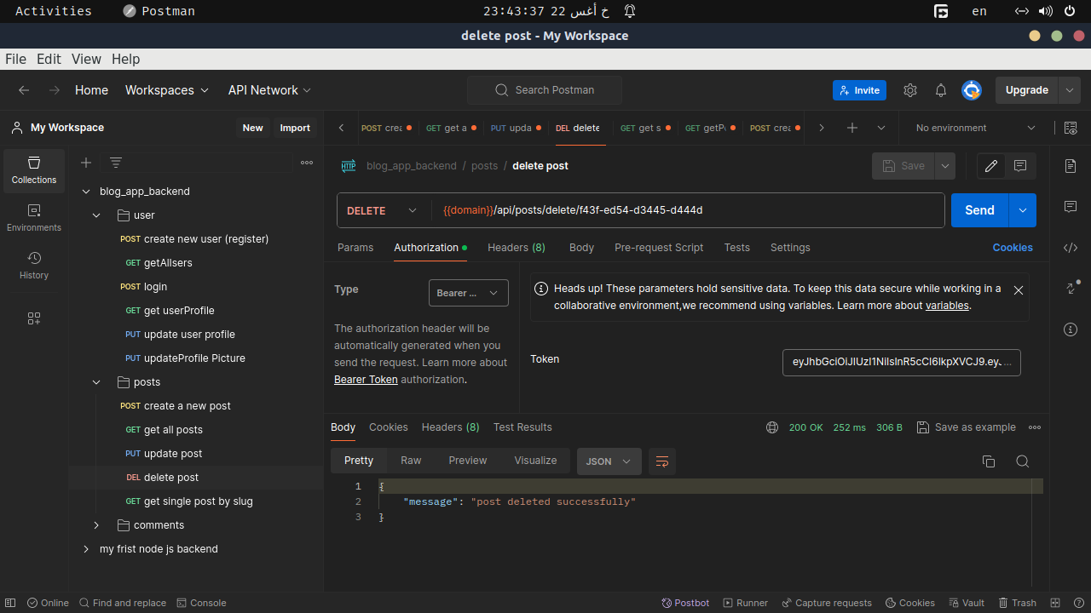
   * **Expected Response:**
   * {  
      "message": "Post deleted successfully."  
     }  
     For convenience, you can import the Postman collection that contains all the API endpoints for testing. [Download Postman Collection](path/to/postman-collection.json)

### Postman Collection

**Testing Results:**

* **Successful Responses:** 
* **Error Responses:** 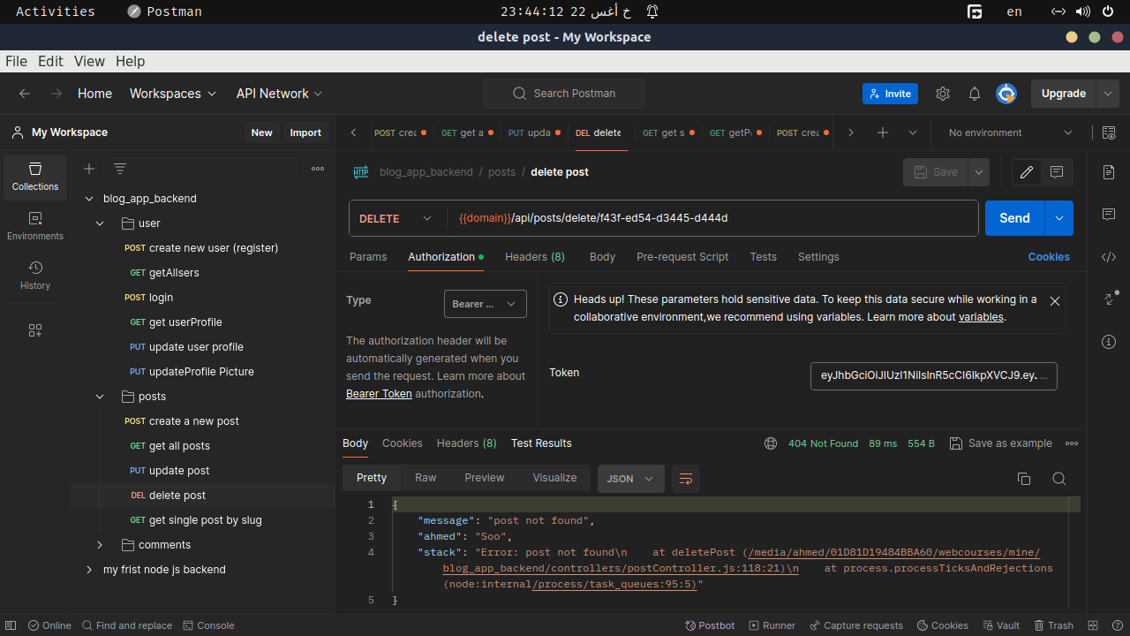

By following these steps and using the provided Postman collection, you can effectively test the blog app’s API endpoints to ensure they perform as expected.

## Deployment Phase

### Project Overview

I recently completed the deployment of my **Blog App**. This project consists of a **front-end** built with React and styled using **TailwindCSS**, which can be accessed [here](https://blog-app-frontend-black.vercel.app/).

### Deployment Process

#### Front-End Deployment: Vercel

1. **Hosting Service**: I used [Vercel](https://vercel.com/) for deploying the front-end of my blog app. Vercel provides seamless integration with GitHub repositories, making it an ideal platform for deploying React apps.
2. **Steps to Deploy**:
   * First, I pushed the latest version of the code to my **GitHub** repository.
   * Connected the repository to **Vercel**.
   * Vercel automatically detected the **React.js** framework and provided default settings for building and deploying the app.
   * I configured environment variables in Vercel if needed.
   * After deployment, the app was live on <https://blog-app-frontend-black.vercel.app/>.
3. **Advantages of Vercel**:
   * Automatic builds and previews for every push to the GitHub repository.
   * Fast and global CDN which ensures my app loads quickly from any location.
   * Integrated SSL for secure HTTPS access.

### Conclusion

The deployment process was smooth thanks to Vercel’s automation and easy-to-use interface. My blog app is now live and ready to be explored! Check it out [here](https://blog-app-frontend-black.vercel.app/).