Student Performance Prediction
Abstract:
This study aims to predict students’ risk of academic underperformance using the UCI Student Performance dataset for Mathematics and Portuguese courses. Both datasets were merged and subjected to data quality checks (missing values, duplicates, descriptive statistics) and exploratory data analysis of numerical and categorical features, as well as the distribution of risk levels. The target variable risk was defined into three categories (High/Medium/Low) based on the final grade G3. Categorical features were encoded using One-Hot Encoding, and scaling was performed with Min-Max normalization. Additional engineered features such as AttendanceRatio and AverageGrade were introduced to enrich the analysis. Several predictive models were implemented, including Logistic Regression, Decision Tree (depth-controlled), Random Forest, Support Vector Machine (RBF kernel), and a feed-forward Neural Network. Model performance was evaluated using test accuracy, per-class accuracy, and cross-entropy loss, supported by visualizations. Furthermore, synthetic student feedback samples were analyzed with TextBlob sentiment analysis to explore the relationship between sentiment and risk categories, serving illustrative rather than predictive purposes. Results indicated that tree-based models offered a strong balance between interpretability and performance, while SVM and Neural Networks achieved competitive predictive accuracy. The study concludes with a deployment plan using FastAPI to provide real-time inference endpoints, integrated with a lightweight dashboard to support early intervention strategies.

Problem:
Student academic performance is influenced by a wide range of factors, including demographic attributes, socio-economic background, school environment, attendance, and prior academic history. Early identification of students who are at risk of underperforming is a critical challenge for educators and policymakers, as late interventions often fail to prevent dropout or long-term academic difficulties. Traditional evaluation methods rely heavily on final grades, which only reveal performance after the learning process is completed, thereby limiting the opportunity for timely support.
The key problem addressed in this study is the need for a predictive and interpretable framework that can classify students into distinct risk categories (High, Medium, Low) before academic failure becomes irreversible. By leveraging machine learning models trained on historical performance data, the goal is to enable proactive interventions, targeted resource allocation, and improved student outcomes. Additionally, incorporating sentiment analysis from student feedback introduces a behavioral and psychological dimension, allowing a more holistic understanding of risk beyond numerical performance indicators.

Dataset:
The dataset used in this study is the Student Performance dataset obtained from the UCI Machine Learning Repository. It consists of two separate files: student-mat.csv (Mathematics) and student-por.csv (Portuguese). Each file contains detailed information about secondary school students in Portugal, including demographic, social, and academic attributes, as well as their academic performance across three grading periods (G1, G2, G3).
The two datasets were concatenated to form a unified dataset with an additional feature, subject, indicating whether the record corresponds to Mathematics or Portuguese. In total, the merged dataset contains approximately 1,046 records (395 for Mathematics and 651 for Portuguese), each described by 33 original features plus the engineered attributes introduced during preprocessing.
The attributes fall into several categories:
- Demographic features: age, sex, address type (urban/rural), family size, parental education, and parental occupation.
- Social features: free time, going out, romantic relationships, internet access, alcohol consumption (weekday/weekend).
- Academic features: study time, number of past failures, school support, paid classes, absences, and grades (G1, G2, G3).
- Engineered features: AttendanceRatio (derived from absences) and AverageGrade (mean of G1, G2, G3).
- Target feature: risk, categorized into High Risk, Medium Risk, and Low Risk based on the final grade (G3).
This dataset is particularly suited for educational data mining tasks because it combines both quantitative and qualitative factors, making it possible to explore not only the academic but also the social and behavioral influences on student outcomes.

Methodology:
The methodology of this study was structured into several key phases: data preprocessing, feature engineering, exploratory data analysis (EDA), model development, evaluation, sentiment analysis integration, deployment with FastAPI.
- Data Preprocessing
- The Mathematics and Portuguese datasets were merged, and a new categorical attribute (subject) was added to distinguish between them.
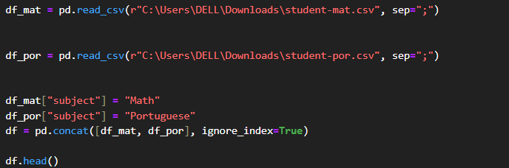
- Data quality checks were performed to identify missing values, duplicates, and inconsistencies.
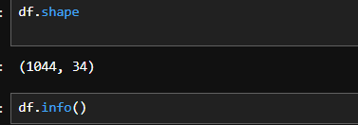
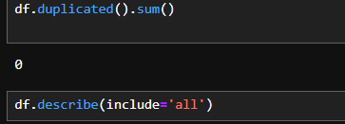

- Categorical variables were transformed into numerical representations using One-Hot Encoding.
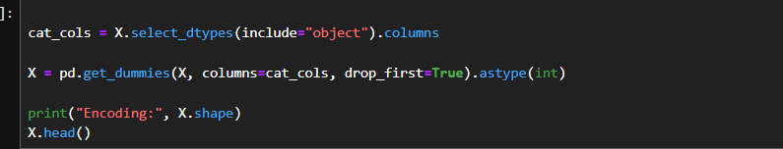
- All numerical features were normalized using Min-Max Scaling to ensure comparability across models
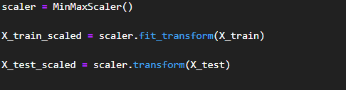
- Feature Engineering
- Two new features were introduced to enhance predictive capacity:
  - AttendanceRatio,
  - AverageGrade, computed as the mean of G1, G2, and G3.
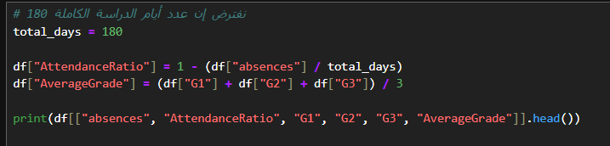

- The final grade (G3) was used to derive the risk variable, categorized into:
  - High Risk (G3 < 10)
  - Medium Risk (10 ≤ G3 ≤ 13)
  - Low Risk (G3 > 13).
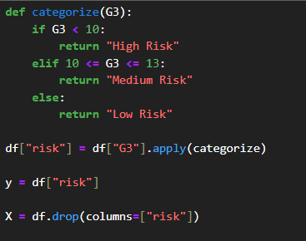

- Exploratory Data Analysis (EDA)
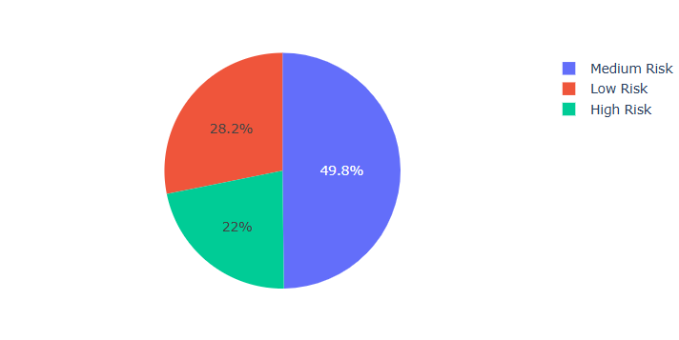
• A pie chart was created to show the proportion of students across different risk levels.

• Distributions of numerical features were visualized using histograms with kernel density estimates.
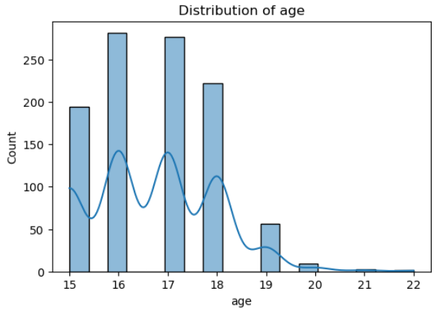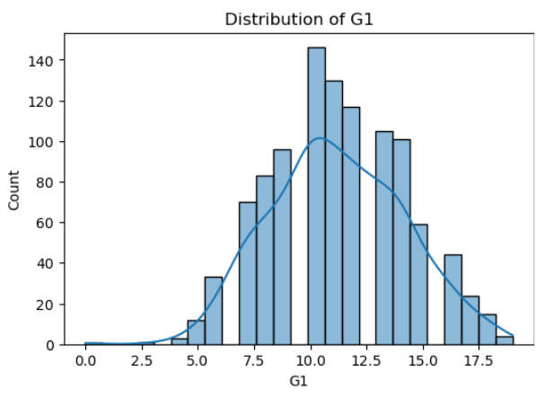

- Model Development
• Data was split into 80% training and 20% testing sets.
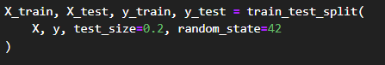
• Several supervised learning algorithms were implemented for multi-class
classification:
  - Logistic Regression (baseline model).
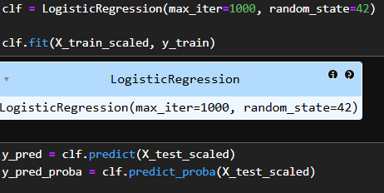
  - Decision Tree Classifier with controlled depth and minimum split size.
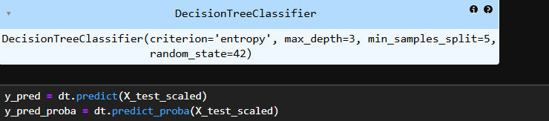
  - Random Forest Classifier with entropy criterion and 100 estimators.
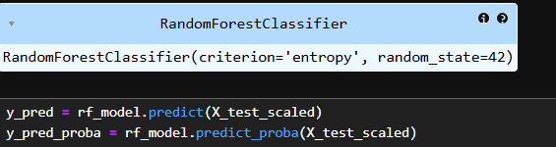
  - Support Vector Machine (SVM) with RBF kernel and probability estimates enabled.
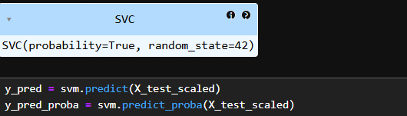

  - Neural Network (feed-forward, 2 hidden layers of 64 and 32 neurons, ReLU activation, and Softmax output).
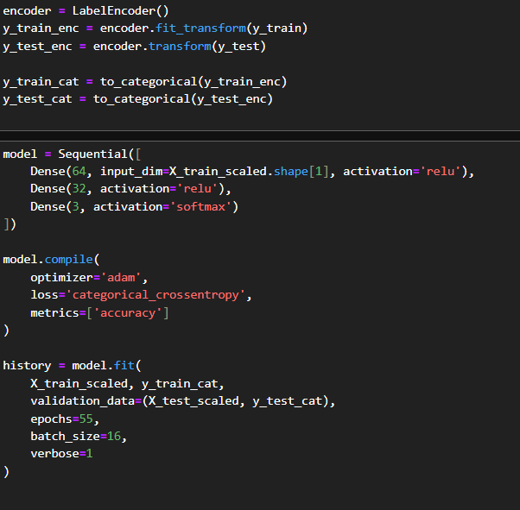

- NLP (Collect student feedback text)
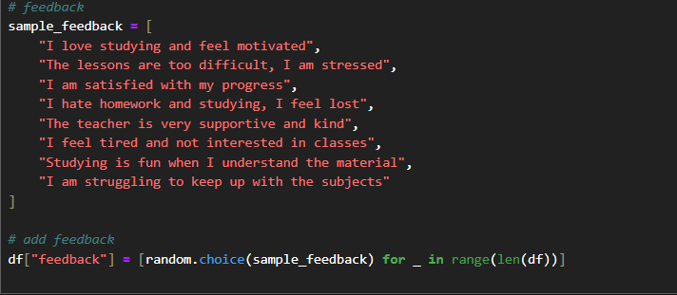
(Perform Sentiment Analysis )
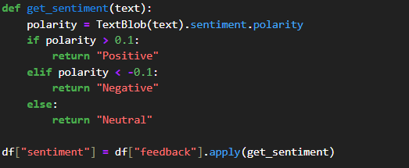

- Model Evaluation
Performance was assessed using:
  - Classification Report (precision, recall, F1-score).
  - Per-class accuracy to highlight imbalances between High, Medium, and Low risk categories.
  - Cross-Entropy Loss for probabilistic models.
- Visualization of results included bar charts of per-class accuracy and decision

Logistic Regression:
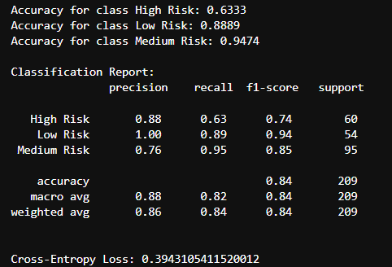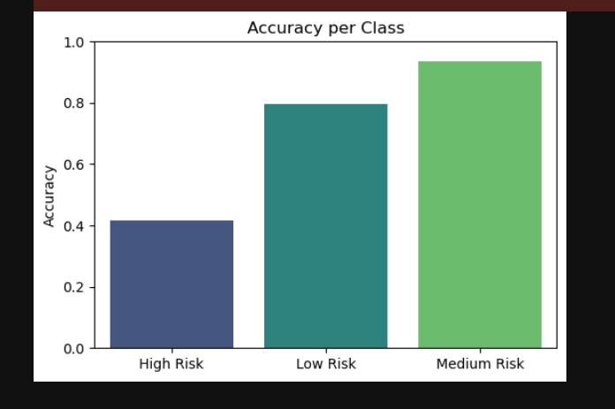
Decision Tree:
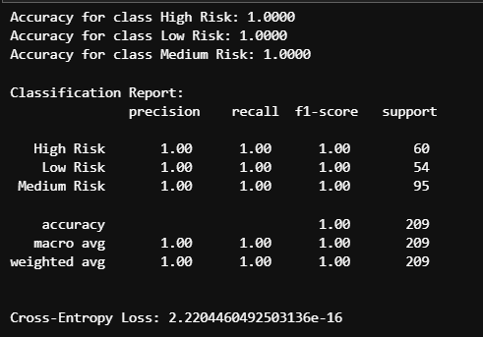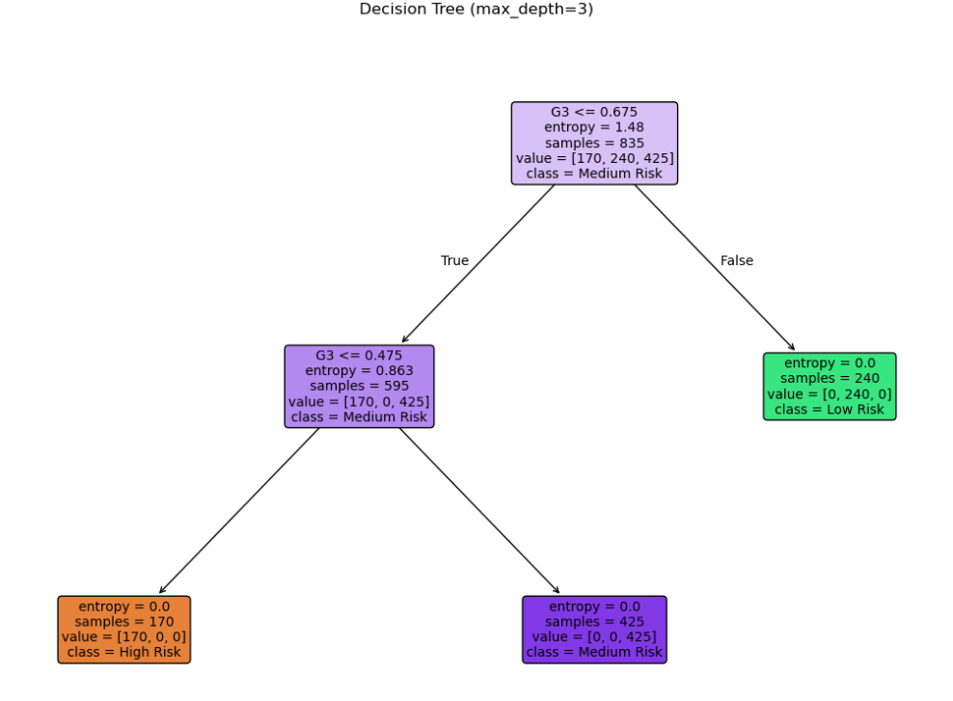
Note: The Decision Tree model showed clear signs of overfitting
Random Forest:
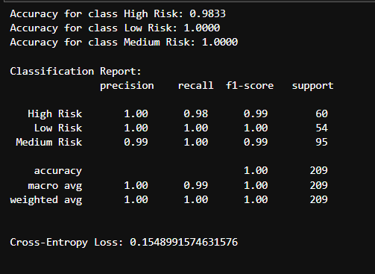
SVM:
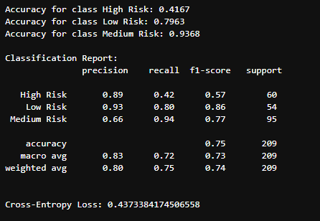
Neural Network:
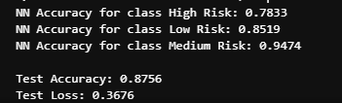

- Sentiment Analysis Integration
  - Synthetic student feedback samples were assigned to the dataset.
  - TextBlob was used to classify feedback into Positive, Negative, or Neutral sentiment.
  - Crosstab analysis examined the relationship between sentiment categories and student risk levels.
  - A stacked bar chart was used to visualize sentiment distribution across risk categories.
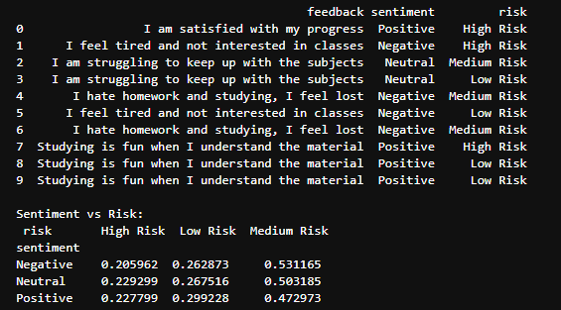
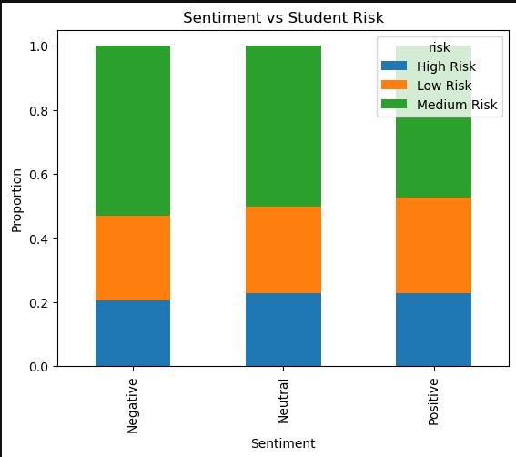
- Deployment
For deployment, the Random Forest model was chosen as the final classifier. To ensure consistent predictions during inference, the entire preprocessing pipeline was preserved, including:
- The trained Random Forest model.
- The Min-Max Scaler for feature normalization.
- The One-Hot Encoders/Label Encoders for categorical variables.
- The feature schema and ordering to match input data with the model.
- Defined numeric limits (e.g., valid ranges for absences, study time) and dropdown values for categorical inputs (e.g., parental education, school type, internet access).
Additionally, a simple HTML front-end was developed to interact with the FastAPI backend. This interface allows users to enter student details through forms (numeric fields and dropdown menus) and instantly receive the prediction.
The output of the system is a single categorical value, which can be one of the following: High Risk, Medium Risk, or Low Risk.
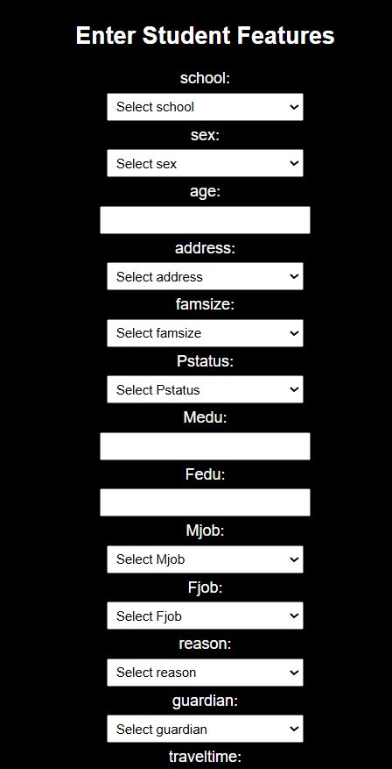
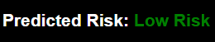
- Ethics in AI
Ethical considerations are essential when applying Artificial Intelligence (AI) in the educational domain. In this study, several precautions were taken and potential risks acknowledged:
- Data Anonymization
  - The dataset used does not include personally identifiable information (PII) such as student names or IDs.
  - All analysis was conducted on anonymized attributes (e.g., age, gender, parental education) to protect student privacy.
  - Any future deployment of the model should strictly ensure compliance with data protection standards such as GDPR or equivalent local regulations.
- Bias and Fairness
  - The dataset contains attributes such as gender, socioeconomic background, and parental education, which may introduce bias in predictions.
  - A risk exists that the model could unfairly associate certain demographic groups with higher or lower academic risk.
  - To mitigate this, model evaluation should include fairness metrics (e.g., performance comparison across subgroups) in addition to accuracy.
  - Continuous monitoring of predictions is necessary to ensure that interventions do not unintentionally reinforce social inequalities.
- AI Project Lifecycle:
